Tayyab Mansoor
18M00006
MPhil Thesis
Impact of Women’s Empowerment of Total Children Born.
Supervised by: Dr. Theresa Thompson

Acknowledgement
I want to thank Dr. Theresa Thompson Chaudry for all her help and guidance without which I would not have completed this research. I than thank Dr. Sohail Zafar for helping me to construct adequate models. I would like to thank all the head of departments of the Lahore School of Economics for their critical feedback during writing the thesis. Lastly I would like to thank my family and my friends who gave me devoted love and care and helped me throughout the completion of the thesis.

Contents
Abstract 3
Introduction 5
Literature Review 12
Methodology 19
Discussions 22
Summary Statistics 23
Correlations 25
Latent Variable Tables 28
Mediating Effect 36
Contraceptive Use 37
Worked After Marriage 38
Moderating Effect 40
By Region 43
By Wealth 46
By Education 50
Limitations 54
Conclusion 55
References 56
Appendix 62

Abstract
Population growth is one of the most salient problems faced by developing countries today. Population growth, if not checked, can decrease living standards and lead to high rates of unemployment in the future. South Asia, especially Pakistan, India and Bangladesh, still struggle to deal with this problem. This thesis looks at the relationship between total children born per women and women’s empowerment. The purpose of this analogy is not only to reduce the population growth but also to reduce the total births faced by a woman, which is correlated with maternal mortality, infant malnutrition, and even infant mortality. The study uses the Pakistan Demographic Household Survey’s (PDHS) woman-level data to analyze the impact of women’s empowerment on their total children born. To resolve the problems of endogeneity and reverse causality, techniques of Structural Equation Modeling will be applied. Even with promises and efforts to fulfil the Millennium Development Goals of increasing women’s empowerment, achieving these goals is not yet within reach, especially in the remote rural areas of the country.
This study looks at the mediating effects of the different attributes of a woman’s life that would establish a relationship between her degree of empowerment and total children born. We do not find reverse causality, so that the number of children does not significantly impact women’s empowerment. On the other hand, there is a negative relationship between women’s empowerment and children born, so that women who experience an increase in household decision making power and a decrease in beliefs that domestic violence is justified, have fewer children. There is little variation in these statistical relationships by region or woman’s age.
The mediation effect measures how much of the effect of the independent variable on dependent variable has been mediated. Anomalously, we found that contraceptive used increases total children born while the variables of family planning awareness holds no significance.
From the moderation results, we found that a woman on average have fewer children with increased wealth and education. Also important is the finding that the women who justify beating have more children: the overall moderation shows that a women who justifies beating on average have 3.55 children as compared to the women who do not justify beating and have an average of 2.91 children.

Introduction
Over the past 50 years, many countries have experienced steady declines in fertility rates (e.g., Van de Kaa, 1987). This drop in rates has spread across all regimes, those aiming explicitly at lower fertility rates as well those not (Strulik & Vollmer, 2013). The dynamics of such transitions in fertility have been studied initially within an economic framework. Empirical work supports the expectation that economic growth and fertility trends indeed have a correlation (e.g., Becker, Murphy, & Tamura, 1990; Fanti & Manfredi, 2003; Samuelson, 1975). Strulik and Siddiqui (2002) derived the “critical” level of income per person, higher than which, fertility decreases exponentially as income increases. Similarly, an inverse relationship was observed between disposable personal income and fertility when looked at in a cross-sectional manner, regardless if it be among countries or across households (Schultz, 2005).
Population trends have been studied from the beginning of economics by many historical economists including, Adam Smith (1776: ch. I.viii), Robert Malthus (1803), and John Maynard Keynes (1937). However, efforts at clarifying these macro-level tendencies through economic analyses – based, amongst other things, on a micro-economic theory of parental fertility choices – are a much more recent phenomenon. What is presently considered to be “the” economic concept of fertility can principally be taken to be a feature of literature initiated through the pivotal contribution by Becker (1960).
Another significant framework that is being used by researchers is to study the demographic transitions that is the effect of mortality reduction on fertility rates (Tamura, 2006). Such work has been expanded into using this mechanism and Becker and Lewis (1973) to understand the role played by mortality in reducing the fertility rates (e.g. Falcao & Soares, 2008; Largerlo f, 2003). A decrease in mortality risk is strongly positively correlated with decreases in fertility (Murphy, Simon, & Tamura, 2008).
Another factor that is considered to have an effect on the fertility rates is the education attainment levels. Amin and Behrman (2014) find a strong correlation between years of schooling and fertility, highlighting that with increased years of schooling for women results in them having fewer children and delaying childbirth intervals. Companionship has been assumed to be the main force encouraging parents in controlling their fertility and human capital investment (e.g., Becker & Barro, 1988). Ehrlich and Lui (1991) showed that with even a slight increase in the life expectancy of the parents, relying on their children’s support for old age, would eventually lead to an increase in the educational investment in their children as well as a reduction in fertility. Urbanization has also been acknowledged as a social structural change effects fertility transitions with the demographic evolution (e.g., Thompson, 1930), and fertility rates have been estimated to reduce with increased urbanization (e.g., Sato & Yamamoto, 2005)
In the new emerging literature of economic development, the importance and acceptance of women’s empowerment is becoming more evident (Malhotra et al, 2002). Countries are committing to reduce gender disparities and increasing the rights of women for better development and greater economic progress. International organizations such as the United Nations and the World Bank have emphasized these greatly in the Third Millennium Development Goal (MDG3) framework which included to increase women’s empowerment by improving factors such as health, employment, and reducing gender disparity. In today’s world, there is a great difference between women’s empowerment as understood by the richer developed countries and the poorer developing countries. From employment and rights for women, to fertility rates and infant and maternal mortality rates, the countries display astounding differences among each other.
Women’s empowerment is defined as agency, where women have the freedom to pursue and work toward advancing their own interests and goals. This includes household decision-making power, mobility, attitudes towards domestic violence, and violence (both physical and emotional). Other less frequent measures used by different studies are education, age, residence (urban/rural), marriage characteristics (age, choice, blood relative), household head and exposure to public life. To choose independently the number of children, their spacing and their timing is a basic human right of every woman, as stated at the International Conference on Population and Development in 1994 (United Nations Population Fund, 1994). Family planning programs are incorporated to reduce fertility and lower maternal mortality rates (Cleland et al, 2006). However, despite family planning programs providing awareness of contraceptives and other fertility reduction techniques, it is not evident these programs would be successful without increasing women’s empowerment.
The topic is critical for the betterment of any economy as the issue not only targets population growth but also affects the living standards of people of the country. With more children being born to a mother, the lower will be the living standard of each child. The ability to make family planning decisions improves child nutritional outcomes by allowing mothers to optimize childbirth timings and achieve an ideal family size (Hecker et al., 2019). If instead fertility remains high, lower living standards further result in the children attaining low levels of health and education, which in turn lead to low productivity, and eventually greater difficulty in escaping the poverty trap. With less children per woman, each child gets more resources and has better health and learning outcomes, which increase his future income, and he is more likely to break out of the poverty trap. A woman’s empowerment also has an important impact on children’s labor force participation and educational levels (Basu, 2006; Emerson & Souza, 2007). For daughters especially, the betterment of their schooling outcomes is associated with their mother’s educational attainment more than that of their father (Emerson & Souza, 2007).

This study focuses on the importance of women’s empowerment on fertility rates in Pakistan. The rationale is that Pakistan is a densely populated country with a high population growth rate. With 3.56 children born per woman on average, Pakistan surpasses Bangladesh and India whose fertility rates are 2.2 and 2.06 respectively. In examining these high fertility rates, it is important to understand the common cultural perspective that is believed and followed in Pakistan that children, especially sons, are an investments for the future and are expected to become the support systems for their parents at an old age, aiding them financially as well as emotionally and physically. This, coupled with high infant mortality due to poor medical institutions, lack of sanitation and lack of awareness, results in high mortality rates. For example, according to the UNICEF report on Pakistan in 2019, 22 million people still do not have a proper toilet facility and 40% of the population do not have adequate access to proper hygiene services.
When women have higher fertility, a feedback loop is created whereby additional children reduces the living standards of their siblings and also diminish the mother’s health. More than 50% of Pakistan’s population is between the ages of 0 and 25 which further indicates that the trend is likely to persist.
One country principally, to date, has taken steps in the way of policy restrictions and punishment of parents seen excessively increasing the population, China. China used a unique strategy to move towards women’s empowerment by reducing their fertility rates and introducing their One Child policy. This policy allowed women time and energy to work and fulfill their individual needs as well as encouraged households to spend on their child’s education regardless of their gender. This then in the second generation resulted in highly educated women who grew up seeing their mothers empowered and therefore having more freedom and knowledge about their rights as compared to the earlier generations (Liu, J., & Liu, T. 2018).
The main purpose of this study is to look at the impact of woman empowerment on fertility rates. The paper will look at techniques of Structural Equation Modeling (SEM). The data used will be from Pakistan Demographic Household Survey (PDHS) 2018. The data is collected by The National Institute of Population Studies (NIPS. This data consists of 15,068 female respondents, 3,691 male respondents and 14,540 household respondents.
“A woman's level of empowerment is defined here as a function of her relative physical mobility, economic security, ability to make various purchases on her own, freedom from domination and violence within her family, political and legal awareness, and participation in public protests and political”
(Schuler and Hashemi 1994)
1.1 Scope of Study
High fertility is usually associated with low income households where women’s empowerment is low. More children provide higher returns to parents when they are older and therefore the vast majority of poor families have a large number of children, but this results in low standards of living and low productivity for children individually. These children work as household helpers beginning at a young age (9—18), after which they find employment in low-skill jobs such as drivers, plumbers, sweepers, and laborers.
In a society with very low education attainment rates, it is important for the governments to encourage the limiting of fertility rates as they result in a scarcity of household resources per capita and worsen conditions in the future. From this perspective, this study analyzes the impact of women’s empowerment on the total children born along with the number of sons in the household using the Pakistan Demographic and Health Survey (PDHS), 2017-2018.
1.2 Research Gap
The relationship between fertility rates and women’s empowerment is examined from a different point of view. While some studies have looked at the effect of fertility on empowerment, others have pondered the reverse; I aim to consider both directions of causality. However, there is little research which takes the actual fertility rates into account; the closest to this idea are Doepke and Tertilt (2018) and Upadhyay and Karasek (2012), which look at the ideal family size for both genders. Also, my research uses a different technique than is typical for the study of fertility and empowerment, which is structural equation modelling. Ballon (2018) applies SEM to the question of empowerment but does not attempt to include fertility. This study will use the same technique to predict the women’s empowerment and use the result to predict fertility.
The study is divided into five sections. The second section reviews existing literature that has looked at women’s empowerment and fertility. The third section explains the methodology and the different econometric specifications that can be used to conduct this research. It further describes the data that has been used and the sources for each variable. The fourth section presents an analysis and a summary of the findings. The fifth section will conclude and state the limitations of the study and also give the policy implications that would help in future policymaking.

Literature Review
2.1) The role of a patriarchal society
In Pakistan, there is a significant gender bias in favor of males; in addition, there is a wide gap in gender roles where women are not given adequate authority. The extant literature claims that patriarchy results in high fertility rates (Sanderson et. al. 2000, Kolk, M., 2019; Tfaily, 2004). Women are deprived of their basic rights, restricted and controlled to the point of requiring permission for meeting or going outside of their homes from the men of their households, resulting in the ill treatment of women. A study in Oman by Riyami (2003) concluded that higher mobility to visit relatives resulted in fewer children and a higher decision-making power meant longer closed birth intervals.
In the 72 years since independence, Pakistan has seen only one woman allowed to rise to the highest ranks of political leadership, Benazir Bhutto (Ex-Prime Minister of Pakistan). Pakistan’s labor force predominantly consists of the male population or 78% of the total labor force (WDI 2019). In addition, women are not given adequate education, as only 37% of all women above 25 have passed the primary level in 2017, whereas for males it is almost double (60.4% of male above 25 have passed primary). Secondary education measures are even more disappointing so that only 6.2% of all women above 25 have passed the secondary level (WDI Indicators).
Anecdotally, in rural areas of Pakistan it is common practice for daughters or sisters to be married off to people in exchange of an outstanding debt. This action in local language is termed as “vanni”, where a female child at a very young age is forcefully married off to members of clans in order to resolve family feuds (Aurat Foundation). According to the same report, 21 cases of Vanni, 11 cases of child marriages, 8 cases of forced marriages and 27 cases of incest cases and other cases against women such as torture or injury add up to 7,548 cases that occurred just in Punjab in the year 2014. In Sindh, the total cases were 1,447 from which 8 cases were of early marriages and 10 cases of forced marriages.
In developing countries, sons are viewed as future income generators whereas daughters are considered liabilities in the family. This belief occupies an important position in the long-term theory of reproductive economics and therefore a critical role in the current research. Liebenstein (1957: 161-163) explains that a child's contribution to the future parent's income could be a primary source of investment in fertility. However, Becker's concept of the quality of the child (perceived and required by parents) can effectively represent the various "investments" of parents in their children to ensure the life of every child. Higher level in said quality can result in greater time spent with children, for example by helping them improve their education. Therefore, the concept may also be consistent with the concept of "human capital" (as an indicator of the income of children throughout life) contained in a child.
2.2) Wealth Inequality
High income countries, with better health and lower mortality, tend to have lower fertility rates as compared to lower income countries. Wealth is therefore an important driver of the fertility rates of the country. These countries also have better indicators of women’s empowerment and employment status. With high income, women receive access to better childcare facilities and earn a reasonable income, which allows them to be financially independent and less subject to domestic violence (Penn, 2003; Aarssen, 2005; Hilgeman & Butts, 2009). These high income countries also provide freedom of mobility, and, as stated be Deza (2019), greater ease of obtaining mobility and decreased fertility, Clark and Cummins (2009).
Our model can also be used in deriving provincial-level findings in Pakistan. Provinces or cities, which are wealthier, would have lower fertility rates as compared to provinces with lower income. The difference in the impact of wealth can also be shown as two individuals in the same region but having different wealth levels and number of children. This can be due to the lower income households fearing high infant mortality rates or in having more children to work when they are old enough. Child labor, although declared a crime by the UNICEF, is still persistent and under-documented in the developing world.
2.3) Women’s Attributes
As Jacobson (1992 p7) indicates, gender bias is the most critical cause of having a high population growth. Women are not given a say in decisions and are pressured into having a large number of children. When women’s autonomy is low, a higher number of children increases her decision-making power and autonomy to some extent (Ruthbah 2019). In this way, women would consider having more children a virtue as more children increases their decision-making power.
With more education, more empowerment and more awareness of basic rights, the fertility of women tends to fall. (Al-Riyami, & Afifi, 2003; Hyoung, 1997). Even in Pakistan, women who are employed are independent and have more autonomy compared to women who are not. In addition, these working women are less likely to be subjected to domestic violence as they can survive without the support of a male counterpart. With more educational opportunities, child marriages are reduced and women can seek further education. This attainment of education not only delays childbirth but also reduces the number of children born; hence, with education a woman will tend to have lower fertility. This also proven by Keats (2018) for Uganda. Education plays an important role in building up women’s empowerment. The more educated the woman is, the more she is able to contribute in household decisions (Orrefice & Bercea, 2007). Educated women are more likely to be hired for jobs that entail some form of basic prerequisite knowledge as compared to uneducated women. Thus, causing women’s empowerment and woman’s educational attainment to share a positive and a significant relationship (Handa, 1996).
However, women’s empowerment and autonomy may need to look beyond simple employment toward raising women’s positions in order to decrease the fertility rates, as a study by Sathar and Kazi (1990) established that in Karachi low paying jobs had little impact on women's autonomy or fertility. As a result, even if women are given jobs, it has to be at higher levels for developing countries to make a difference in the fertility rate. Sivasankaran (2014) also showed that if a women works then the spillover effects also move on to her siblings as her sisters’ age at marriage increases while the brothers’ dropout rate of schools decrease.
The negative correlation of fertility with women’s education is explained by several factors, which have been explored by both economists and sociologists. First, the longer a woman stays in school, the longer they are able to defer giving birth to their first child resulting in fewer years of fertility and hence, reduced chances of many successful childbirths. Moreover, with more education and exposure, women are more likely to understand and acquire knowledge about their biology and use that knowledge to make better informed decisions (Vavrus and Larsen, 2003; Singh, 1994). The positive impact of women’s education on their autonomy, leading to delayed marriages, increased use of contraceptives and lower fertility is found in Mason (1986). Further, women’s education has a stronger correlation with fertility than the education of men (Ainsworth et al., 1996).
2.4) Physical and Emotional Violence
Violence against women is any threat or action taken on basis of gender that causes or is likely to cause any sort of harm including to humiliate her or put unnecessary sanctions on her private or public life. It can also be initiated or implemented by the State through different policies and amendments (Aurat Foundation Pakistan).
The actions and problems of beating by a spouse or by any member of the family is termed as domestic violence. The fear of being abandoned and leaving their children, being humiliated in public, low self-esteem and failure to protect own child are some of the reasons that domestic violence against women are increasing. Prosecutors and the police often face the issue of complaints and cases being withdrawn by victimized women to preserve their own image in public (Aurat Foundation Pakistan).
Physical violence is termed as beating the wife and emotional violence is to make her feel poorly of herself. In the literature, both types of violence have a detrimental impact on women’s fertility (Upadhyay & Karasek, 2012). Women, when abused, have higher chances of having unintended pregnancy because their partners refuse to use birth control. Therefore, intimate partner violence causes women to have higher number of pregnancies (Liu et al, 2016; McCarthy, 2019).
2.5) Use of contraceptives
Women with greater control over decisions concerning the number of children born and the age gap between children show greater power in the household compared to their husbands. Within regions that have greater gender equity, women experience greater autonomy and are found to be more authoritative, resulting in fewer children desired and a greater use of contraceptives (Kritz & Makinwa-Adebusoye, 1999).
The use of contraceptives is also related to the awareness and support given by the men. With their husband’s support, women are more likely to indicate their desire for the use of contraceptives (Ezeanolue et al., 2015). A study done in southeast Nigeria showed that when men have awareness and support their wives for the use of contraceptives, spouses are five times more likely to express their desire to use contraception. According to Gee et al. (2009) it is the male spouse who creates difficulties for the women in the use of contraceptives. According to Do & Kurimoto, N. (2012), government intervention programs aimed at increasing contraceptive use may need to involve different approaches, including promoting couples' discussion of fertility preferences and family planning, improving women's self-efficacy in negotiating sexual activity and increasing their economic independence.
Women with education beyond secondary level tend to use more contraceptives and hence eventually lower fertility (Bbaale & Mpuga, 2011). Neoclassical theory suggests that as investment in human capital increases and women participate in the labor market, fertility rates among households will decrease (Singh, 1994). Empirical evidence from both developed and developing countries unambiguously reveal that female education is associated with a decrease in fertility (Sackey, 2005; Lam and Duryea, 1999; Ainsworth et al., 1996; Vavrus and Larsen, 2003; Singh, 1994; Ben-Porath, 1973; Gardner, 1973; Schultz, 1973). Increased participation of women in schooling and the labor market raises the economic value of their time, which increases the opportunity cost of raising children (Guilkey, 1998; Singh, 1994; Ben-Porath, 1973; Gardner, 1973; Schultz, 1973). Schultz (1993) confirms that women’s education is associated with smaller desired family sizes across the world.
2.6) Family structure
According to Sathar and Kazi (2000), women in rural Pakistan participate more in the intra-household decisions if they live in a family structure of a nuclear type. Woman’s power is likely to fall if her mother-in-law lives in the same household because the woman will have a lower share of influence in household decisions. In a case where the husband has more than one wife, a woman may experience an increase in her position to manage her household where her husband may be given a status of a visitor rather than a full-time member of the household (Goody, 1976).
2.7) Consanguinity
When a woman marries a man with whom she has a blood relationship, she will tend to have early births, marry at a younger age, yet have more marital stability (Islam, 2012). Islam (2012) however failed to establish that women’s empowerment rises if the women marries a blood relative.
To summarize, the literature highlights the preexisting notions that support the fact that greater women’s empowerment will result in them having lower fertility rates and a greater freedom to express their desires regarding the use of contraceptives, family planning and the ideal number of children. The quoted literature links most of the channels that explain the women’s empowerment affecting the fertility rates, however the case of Pakistan and the use of structural equation modelling to explain these linkages has not been seen to date. This study in particular will help to bridge this gap by modelling this relationship empirically.

Methodology
Earlier papers have looked at a number of different measures for women’s empowerment. From basic household attributes like decision-making and freedom of movement (Misra & Tripathi, 2011; Masood 2015), other papers have looked at more measureable variables like education, age at marriage, and the age difference between spouses (Bbaale & Mpuga, 2011). Another set of other papers have used a combination of decision making power and measurable variables (MacQuarrie and Edmeades, 2015). Most of the papers have employed a cross-sectional analysis (Wang and Sun, 2016; Nalwadda et al, 2010)
Our study uses the demographic household data similar to Mishra and Tripathi (2011) and is majorly focused on use the structural equation modelling as in Ballon (2018). The variable of woman’s (dis)empowerment being that she believes a “beating justified” is calculated by principle component analysis (PCA) , which was also used by Mishra and Tripathi (2011) to measure women’s empowerment as it gives a more centered result. The PCA is implemented on the five questions asked to a woman about different instances she believes that her husband is justified in beating her. We will only focus on the element of ‘beating justified’ aspects of women’s empowerment while other factors such as mobility, decision making power, physical and emotional violence will be outside the scope of the present research.
The mediating models will consist woman’s empowerment as the independent variable, a dependent variable (total children ever born to a woman) and a mediating variable (attribute of women’s daily life). Secondly, the moderation analysis will consist of the independent variable of empowerment and dependent variable of children born. The moderation is done with respect to i) wealth, ii) education and iii) region. The statistical technique used is Structural Equation Modelling (SEM) for mediation and Analysis of Variance (ANOVA) for moderation.
The following are the models for mediation.
Figure 1:
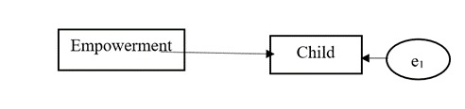
Figure 2:
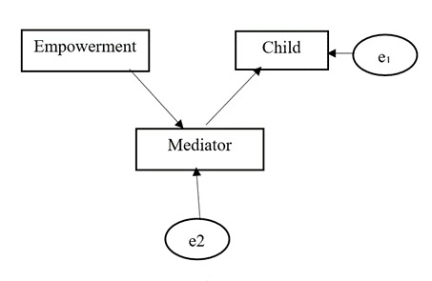
Figure 3
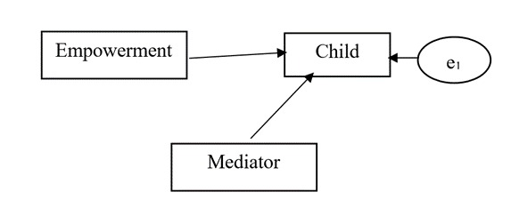
The 3 models can be summarized to the following:
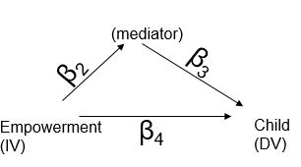
If there is a significant difference between empowerment and children born from the summarized model to the first model, the paper will conclude that there is a significant mediating effect of the mediating variable.
___________________________________________________________
The main research questions are
  - Does empowerment mediate from family planning awareness to total children born?
  - Does empowerment mediate from women worked after marriage to total children born?
  - Does empowerment mediate from contraceptive use to total children born?
  - Does wealth moderate a strong relationship between total children born and empowerment?
  - Does urbanization moderate a strong relationship between total children born and empowerment?
  - Does education moderate a strong relationship between total children born and empowerment?

There are a number benefits of using Structural Equation Modeling in the context of studying the relationship between women’s empowerment and number of children born.
First, SEM provides us a way to treat underlying constructs, in our case attitudes of spouses toward domestic violence, as latent variables constructed of a number of survey questions, and the modelling of this construct (including measurement error) is incorporated into the SEM. Secondly, SEM allows us to better understand complex relationships between variables by breaking down the total impact of a construct (like domestic violence attitudes) into its direct impact on an outcome (in our case, number of children) and its indirect impact (through the mediator of contraception). Second generation models such as SEM allow for a simultaneous analysis of all variables present in the model and takes into account the changes in the independent variables and their impact on other independent variables instead of just the basic impact on the dependent variable as in the case of typical regression analysis. SEM therefore provides an edge over multivariate regression that it takes into account the statistical changes in the independent variables as well. SEM analysis therefore helps in estimating the changes in the outcome variable with and without a connecting variable. In our context, both the direct effect and the indirect effect of women’s empowerment on total children born with an intervening variable can be shown in a singular, easy to understand but complete model. The structure that we impose on the model in terms of the relationships between variables is evaluated in SEM for goodness of fit.

Discussions
The purpose of this study is to use Structural Equation Modelling to determine the relationship between women’s empowerment and their fertility rates. The attributes of women’s empowerment used is of attitudinal dimensions initially given by Jensen and Oster (2009); that is, the variable of female attitude towards domestic violence measured by the principle component analysis is used in the study. A number of questions regarding these attitudes were included in the questionnaire of the Pakistan Demographic Survey (PDHS).

Summary Statistics
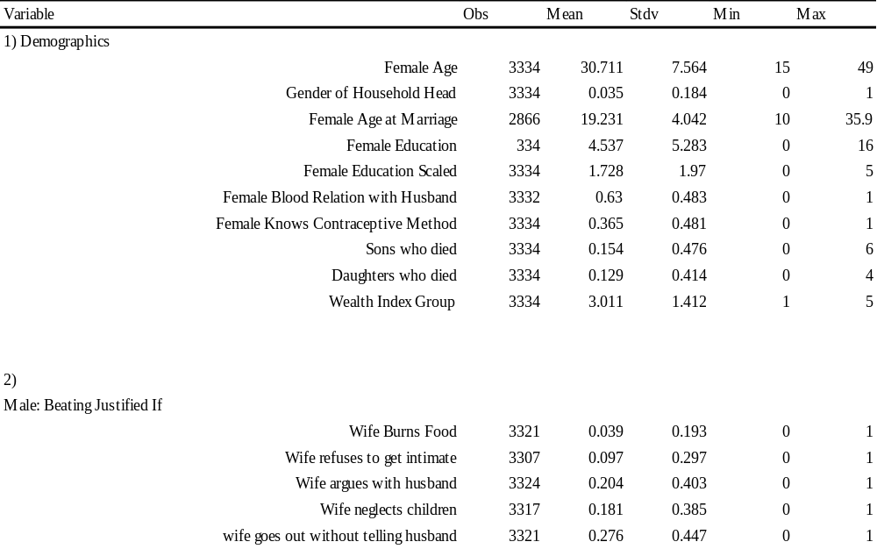
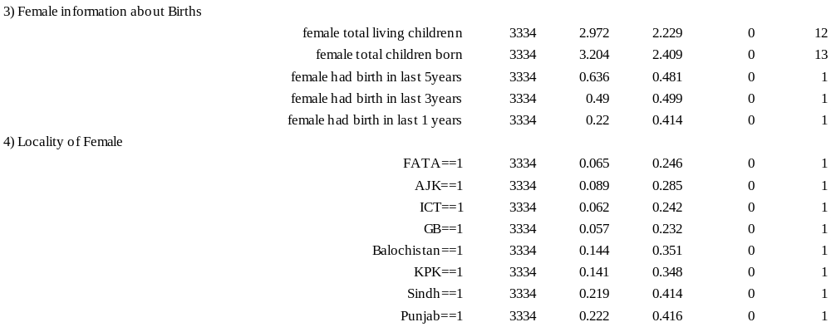

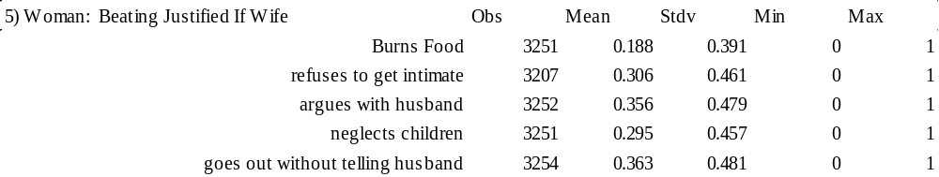
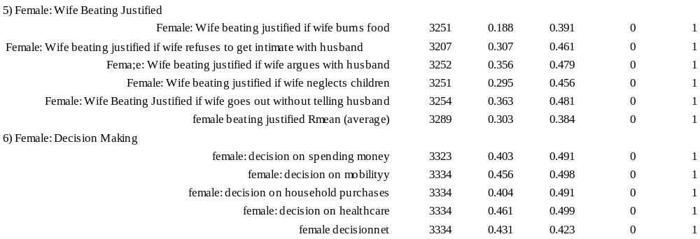
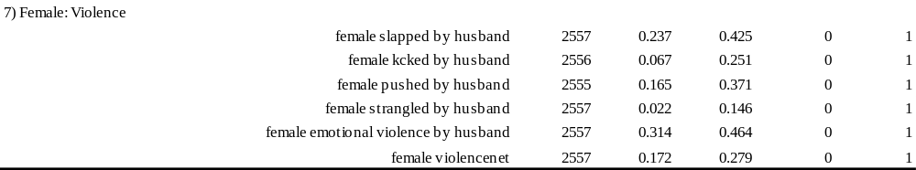
The demographics of the sample are that only 18.4 percent of the women are household heads while men are household heads in 81.6 percent of the households. The average age of marriage for the women is less than 20 years with the average education of women being less than primary school completed. The average age of the women in the sample is 31 years and only 6 percent have used family planning. It is interesting that 15 percent of the men have experienced death of their sons while a lower percentage, 12 percent, have experienced the death of their daughters. The average income of the sample is middle income households.
More than 60 percent of the women have a blood relationship with their husbands and only 36 percent know of a method of contraception. The information about births of the women in sample is that the average number of living children per women is 2.97 while the average number children born per women is 3.2. 63.6 percent of the women have experienced a birth in last 5 years while 49 percent of the sample has experienced births in the last 3 years and 22 percent of the sample has experienced a birth in the last one year. The sample is distributed provincially as: 22.2% in Punjab, 21.9% in Sindh, and 28.5% in KPK and Balochistan while 27% of the sample is from FATA, AJK, ICT, or GB. Only 40 percent of the women have decision-making power regarding spending money and on household purchases while 45 percent of the sample has a say in healthcare and mobility.
The statistics regarding domestic violence tell us that 16.5 percent of the women have been pushed by their husbands and more than 30 percent have experienced emotional violence. Around 30 percent of the women of the sample believe that it is justified for the husband to beat her if she does something not acceptable such as: burn food (18.8%), refuses to get intimate (30.7%), argues with husband (35.6%), neglects children (29.5%) or goes out with telling husband (36.3%).
The men of the sample have similar perceptions about beating wife, the situation where wife beating is justified the most is when i) wife goes out without telling husband (27%) and wii) wife argues with husband (20%). 18.1 percent male believe that beating is justified if wife refuses to get intimate while only 3.9 percent would justify beating wife for burning food.

Talking only on beating justified on women’s perception we can conclude the given sample differences based on age and education:
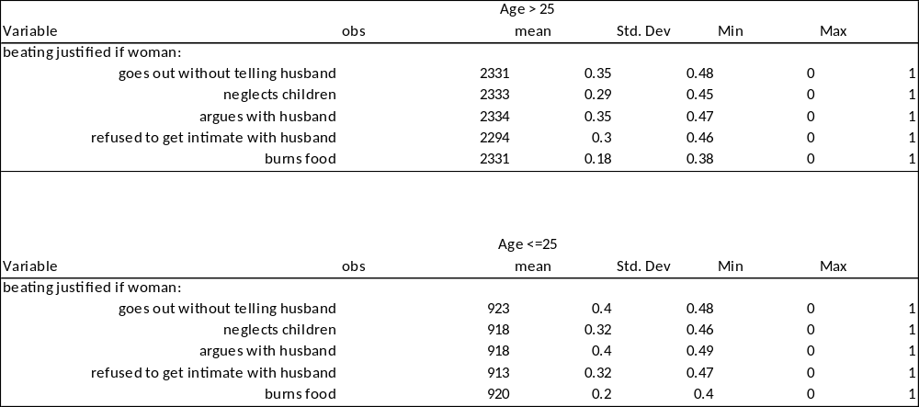
The above tables shows that when the beating justified is separated with age groups, the mean of justification falls with age. This means that as women grow older they realize that it is not justifiable for husband to beat her.
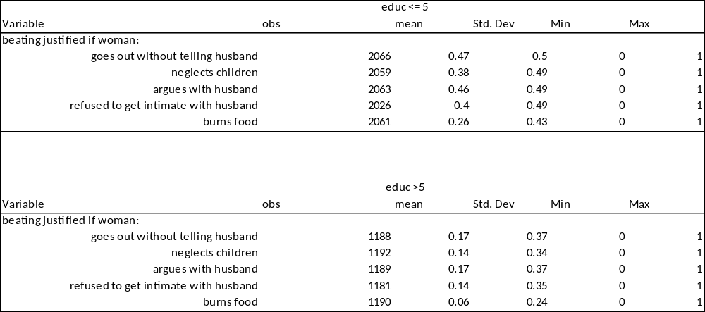
The above table segregates women by education. The table shows that with an increase in education, lesser women have a perception of beating justified by her husband in all five categories.
If we add all attributes and take average the research can see the following table
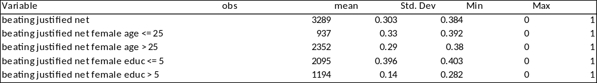
For age:
$$t= \frac{X_{2}- X_{1}}{\sqrt{(\frac{\left(n_{1}-1\right){S_{1}}^{2}+(n_{2}-1){S_{2}}^{2}}{n_{1}+n_{2}-2})(\frac{1}{n_{1}}+ \frac{1}{n_{2}})}}$$

$$t= \frac{0.33 - 0.29}{\sqrt{(\frac{\left(937-1\right){0.392}^{2}+(2352-1){0.38}^{2}}{937+2352-2})(\frac{1}{937}+ \frac{1}{2352})}}$$

$$t= \frac{0.04}{\sqrt{(\frac{143.82+339.48}{3288})(0.0014)}}$$
$$t= \frac{0.04}{\sqrt{(0.146)(0.0014)}}$$
$$t= \frac{0.04}{\sqrt{0.00020}}$$
$$t= \frac{0.04}{0.0141}$$
$$T_{stats}= 2.83$$
Which is significant at 99% confidence interval.
____________________________________________________________________________

Correlations
The SEM takes observed variables and uses them to establish the latent variable. SEM uses factor loadings, and the higher are the factor loadings with a latent variable, the higher is the correlation between the latent variable and observed variable. Factor loadings show which variables are more important in defining and estimating the latent variable.
- Female_Justified
Female_justified incorporates the combination of reasons such that a woman believes that that it is justified for a man to beat his wife. A value of 1 means that she believes the beating is justified in a particular situation and 0 is it is not justified. Out of these, the most important variable (i.e., the most highly correlated variable) is when she argues with her husband. The second most important variable that justifies a beating is when she goes out without telling the husband. The only positive result is that the women of the sample do not believe that beating her is justified if she has burnt the food. However, her husband beating her if she refuses to be intimate or neglects the children have a high scores.
- Male_Justified⁶
Male_Justified is a variable similar to female_justified. The same questions were asked to the husband that in what circumstances was beating the wife justified. This takes into account the thinking process of the man and what he believes. The variables given most importance was if the wife argues with her husband while the second most importance is given to the circumstance when the wife leaves without telling husband. Coincidently the top two variables for both men and women are the same. Although this latent variable is used to correlate with the woman’s belief about a beating being justified, this latent variable (male_justified) will not be used in the structural equations, as we limit the focus to the women only.
- Female_Decision
Women were also asked various questions about their decision making power in different areas of life. The SEM model gave the highest weight to the decisions regarding healthcare and lowest to the decisions regarding mobility (i.e., visiting relatives). These variables are again binary with 0 signifying that the women has no decision making power and 1 means she decides solely or jointly with her husband. According to the model, women have the least decision making power regarding her mobility and most in their healthcare. The women have the second lowest decision making power in decisions of spending money.
- Female_Violence
The latent variable female_violence is a combination of different forms of domestic violence propagated by the husband. This includes being slapped, punched, kicked, and pushed. The data shows that the highest value is given to the woman being pushed while the lowest value is given to emotional violence. Being slapped and being kicked have similar values although being slapped has the second highest factor value to determine the latent variable.

Latent Variable Tables
Tables (1-6) show how the latent variable is constructed using the observed variables.
The women’s empowerment variables of i) decision making, ii) violence and iii) beating justified are in the latent form below. The observed variables from different questions in the survey shape the latent variable.
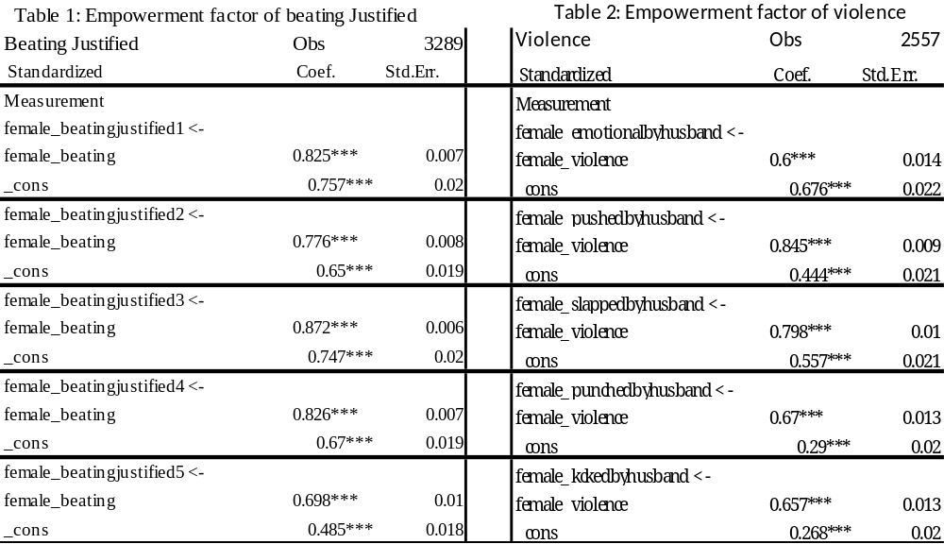
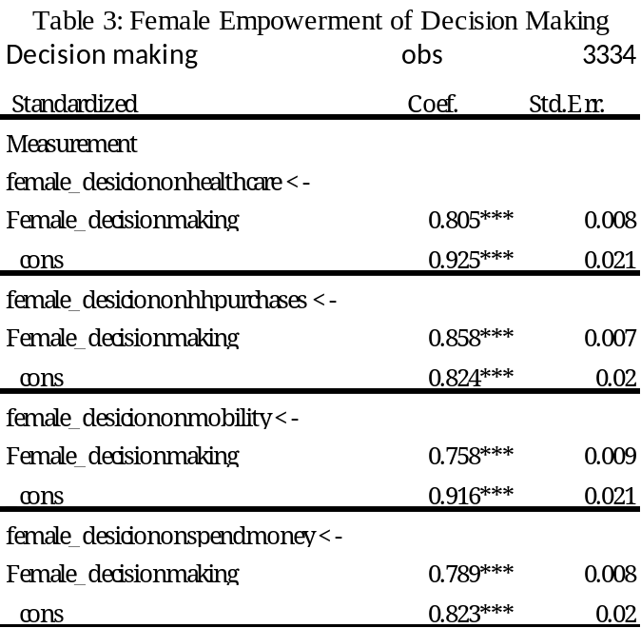
From the latent variables, the highest correlations are: beating justified is when wife argues with husband (to predict beating justified), domestic violence is when she is pushed by husband (to predict female violence), decision making is regarding decision on household purchases (to predict decision making).
Table 4: Age wise analysis of empowerment of beating justified
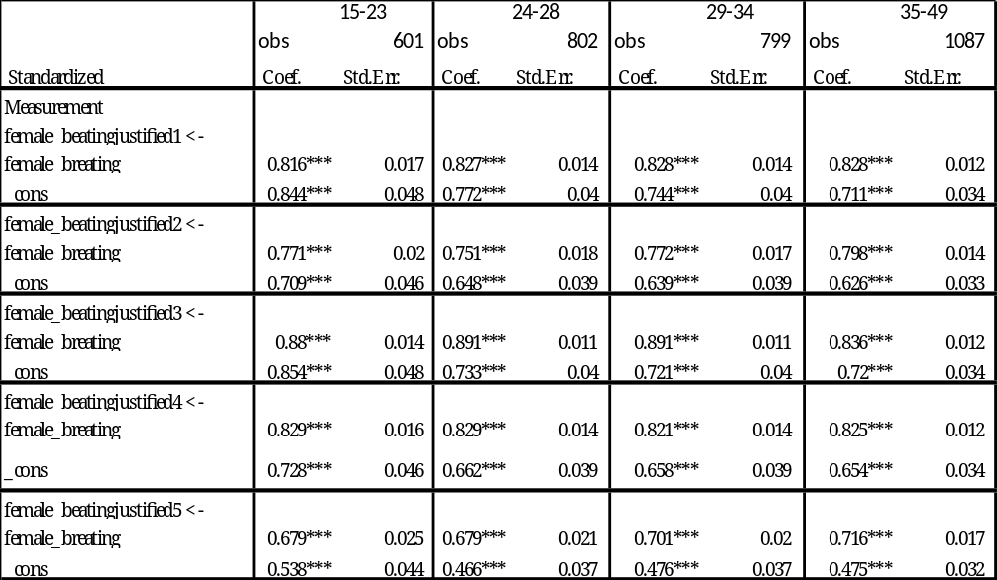
There is no difference, by woman’s age, in the relationship of any component variable of beating justified with its latent variable. Therefore we can say that on average the latent variable of beating justified has similar components of the observed variables. We may have thought that, as a woman gets older she may have a different view, on what constitutes a justified beating, but such differences are not in evidence here.
Table 5: Age wise analysis of violence
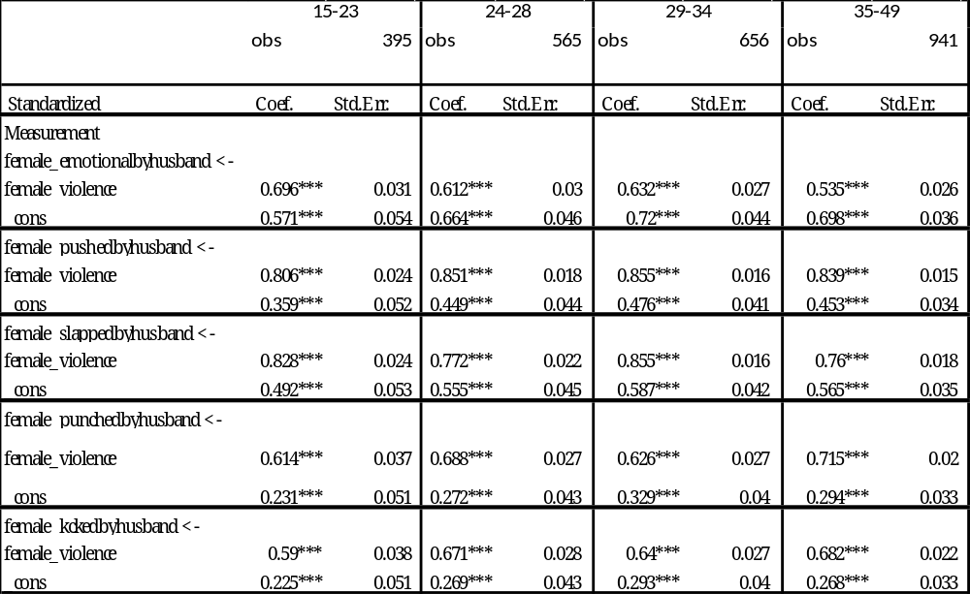
There is little difference, based on a woman’s age, in the relationship of any component variable of violence with the latent variable of violence. Therefore, we can say that on average the latent variable of violence has similar components of the observed variables. Although we can observe that the cofactor of emotional violence decreases somewhat as the age of female increases. It can be theoretically said that younger women are either more subject to or more sensitive to the hurtful remarks made by their husbands.
Table 6: Age wise analysis of decision making power
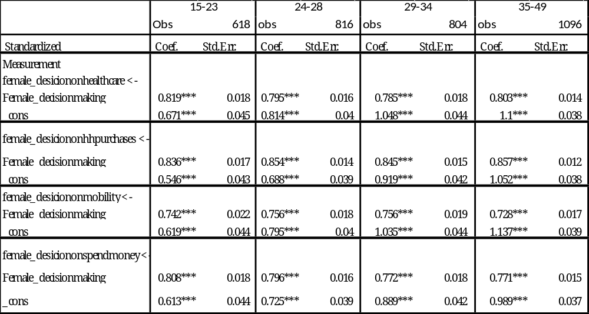
There is no difference, by woman’s age, in the relationship of any component variable of decision making with the latent variable of decision making. Therefore we can say that on average the latent variable of decision making has similar components of the observed variables.

We will begin the analysis by evaluating the latent variables (derived from different survey questions) and study their correlation with the other latent variables. The correlations are important as a measure of the interdependence of two latent variables. For example, we will see if men’s beliefs that that a beating is justified is correlated with the beliefs of women that a beating is justified. Similarly, we will see if the wife belief’s that beating her is justified is correlated with the violence she actually experiences.
The research first estimates the correlation between the different variables
- Female_beatingjustified and Male_beatingjustified
- Female_beatingjustifed and female_violence
- Female_beatingjustified and female_decision
Correlations between latent variables (full sample):
Figure 4
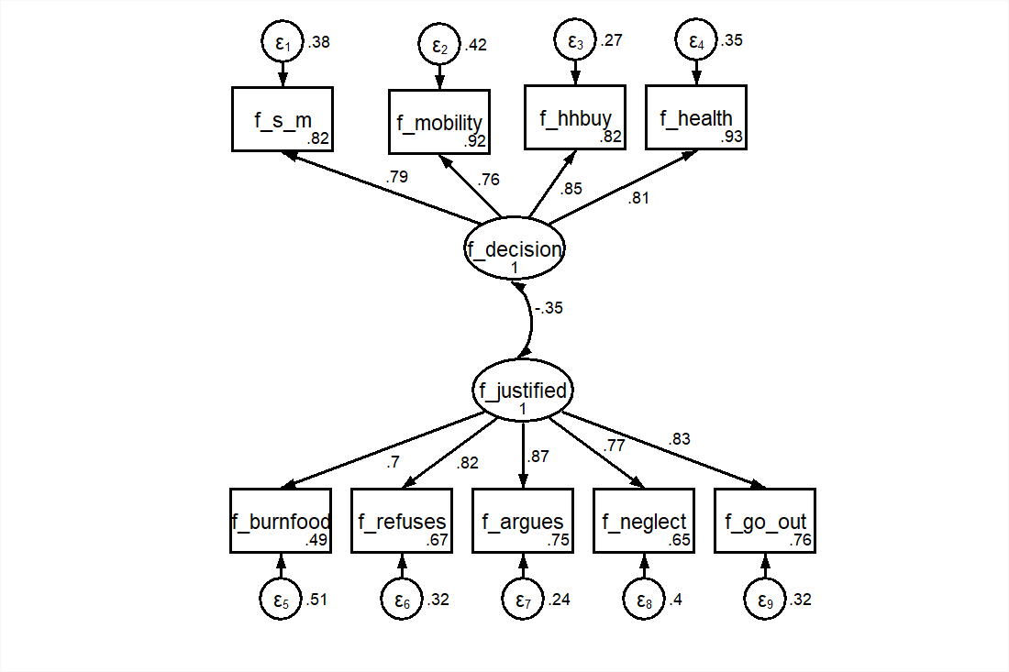
Figure 4 shows a negative correlation between women’s decision-making and women’s beliefs about a beating being justified. This shows that when a woman believes that it is justified for her husband to beat her, she also has less power in decision making.
Figure 5:
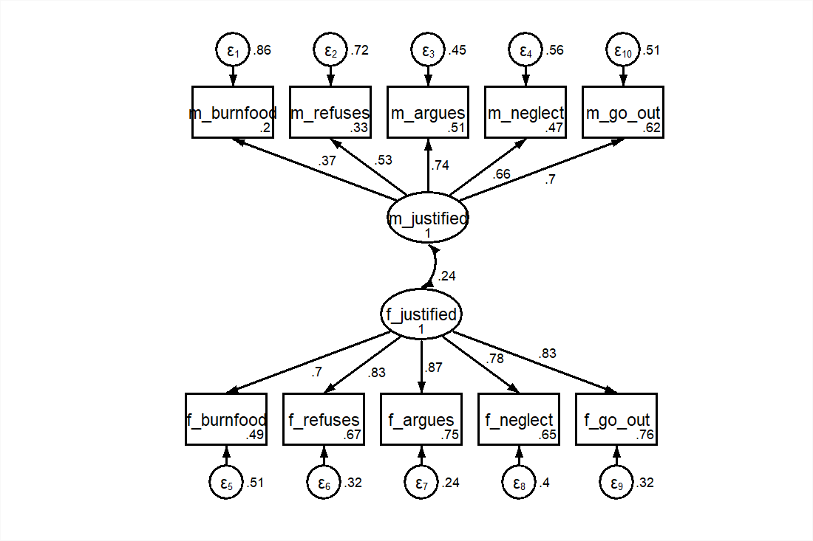
Figure 5 shows that the latent variables of Male_justified and female_justified are positively correlated. This means that if a husband has a belief that it is justified for him to beat his wife, a wife would hold a similar belief. Similarly if the man does not believe that beating the woman is justified, the woman would also not say that beating her is justified.

Figure 6
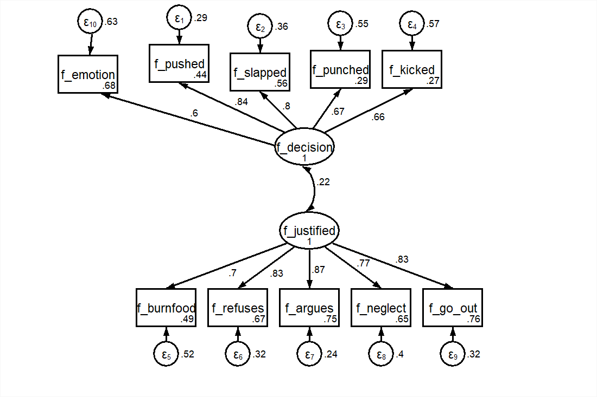
Figure 6 shows that there is also a positive correlation between a woman’s belief that a beating is justified and domestic violence as experienced by women. In other words, women who have views that beating is justified are more likely to face violence from her husband.

Mediating Effect
The mediating effect looks at the possible channels through which the independent variable (women’s empowerment) can affect the dependent variable (total children born), and the how this bi-variate relationship diminishes when a mediator is added. The independent variables measuring women’s empowerment are i) decision making index and ii) beating justified.
Model 1a:
Bivariate effects
Child
Decision
-0.12

Model 1b:
Child
0.061
Beat
Model 1a shows the bivariate effect between Decision and child while model 1b shows the bivariate effect of beat on child. Both of these were estimated using SEM of figure 1. This is used to estimate β₁ for all models.

In these models the mediating variables are i) contraceptive use, ii) work after marriage and iii) family planning awareness. The mediating effects overall show that with an increase in women’s empowerment there is a decrease in total children born.

Contraceptive Use

Model 2A
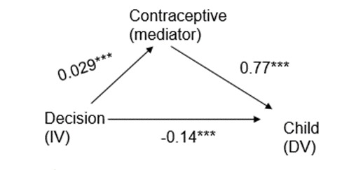
$$Indirect effect = 0.029 * 0.769 = 0.022$$
$$Direct effect = -0.14$$
$$Total Effect: Indirect effect + Direct Effect = (-0.029)(-0.77) ─ 0.14 = 0.02233 ─ 0.14$$
$$Total Effect: -0.1176$$

Model 2A shows that the independent variable (decision making) has a negative impact on number of children born directly, but surprisingly, a positive indirect effect. The total effect (direct + indirect) is equivalent in magnitude to the bivariate effect, because the model has been summarized within the bivariate coefficient. The direct effect demonstrates that, with an increase in decision making power for a woman, there is a reduction in the number of children being born. The indirect effect, such that decision making power increases the usage of fertility-reducing contraception, is in line with respect to the literature (Ezeanolue et al., 2015). But the other half of the indirect effect (contraceptives increases total children born is an anomaly. This can also be due to the inverse effect.
Another reason that the indirect effect of decision on total child born is that the woman wants to have a child so that she can have respect and honor in the family. For example a woman herself wants to have more children so she can be accepted in the society and in her in laws. A similar study, (Eickelman 1993), also showed that in Oman, the perception of status and prestige of women were linked towards their reproductive roles Therefore the researcher thinks that, in this regard, many women are willing to have children to save their marriages, have higher status while having higher control over the house.
Model 2B
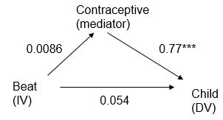
$$Indirect effect = 0.0086 * 0.77 =0.00622$$
$$Direct effect = 0.054$$
$$Total Effect: Indirect effect + Direct Effect = 0.00622 + 0.054$$
$$Total Effect: 0.0606$$

Model 2B is not statistically significant but it shows that with an increase in the belief that a beating is justified, there is a higher number of children born. This result is supported by the literature. The indirect effect is contradictory to the literature, but is also insignificant. The total effect equals the bivariate effect and therefore the model has been properly mediated. The model is not statistically significant. Bairagi (2001) showed that in Bangladesh the contraceptive use rose, but the total children born remained stagnant at 3.3 births per women with an increased abortion rate.

Worked After Marriage

Model 3A

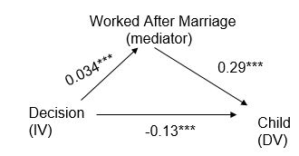
$$Indirect effect = 0.034 * 0.29 = 0.00986$$
$$Direct effect = -0.13$$
$$Total Effect: Indirect effect + Direct Effect = (0)(0.038) ─ 0.13 = 0.00986 ─ 0.13$$
$$Total Effect: -0.12014$$

Model 3A is significant and shows that with higher decision making power, a women is more likely to work after marriage. Somewhat surprisingly, the model also tells us that there are more children born to a woman if she works after marriage. This is a major anomaly but it can due to social and peer pressures, a further study is needed and no literature can explain this. One of the reasons that comes to mind is that after successful time working, the man or his parents may pressurize the woman to have children but the exact reason is unsure and therefore no comments can be made. Another reason may be that the contract term of work of women may be short and women would quit work soon after. The study by Sivasankaran (2014) showed that longer duration of employment translates into reductions in the children born. This study have no implications about the durations of employment that the women does. Adams (2016) quotes that interviews involving women in China and Hong Kong believe that having a child makes the family complete and moves her to the next stage of life that provides happiness and brings care and support in old age. Adams (2016) can also be attributed for this anomaly that women want to retire and move to the next stage so that she can be settled and have her children take care of her.
Model 3B
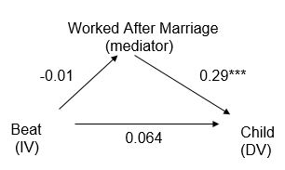
$$Indirect effect = -0.01 * 0.29 = -0.0029$$
$$Direct effect = 0.064$$
$$Total Effect: Indirect effect + Direct Effect = -0.0029 + 0.064 =$$
$$Total Effect: 0.061$$
Model 3B shows that the both the direct effect and the indirect effect is insignificant whereas the impact of mediator on DV is significant. But using the SEM techniques, there cannot be much said on this relationship. This is due to the reason that the bivariate effect of the independent variable of Beat is insignificant.
There is a positive effect of worked after marriage on children born. Bernhardt (1993) suggests that in modern and industrialized societies, there is a negative relation between working and children born. Bernhardt (1993) later adds that the casual relationship is not clear between the two. When a child is born, the women temporary leaves work but as the child gets older the women may get back to work. Stycos; Weller (1967) discovers that there did not appear to be any difference between the fertility rates of the women in labor force of Turkey. Doo-Sub (1986) analyzed that the working women in Korea had higher children born as compared to women who never worked before. Paper (2014) showed that in India working women had delayed marriages and had lower children born.

Moderating Effect

Accounting for the effects of moderation uses the technique of ANOVA and has been implemented using the “oneway” command in Stata. Here, the dependent variable is total children born while the independent variable is female attitudes towards domestic violence. Here the dependent variable is considered a (roughly) continuous variable whereas the independent variable is a categorical variable with two groups: Group 1 consists of women who have attitude that domestic violence is not justified for all five questions of the survey while group 2 consists of women who at the minimum said yes to one to the questions regarding domestic violence in the survey.
For all tables the T statistics would be determine by:
$$H_{o }: µ_{1} ≤ µ_{2}$$
$$H_{o }: µ_{1}> µ_{2}$$
Where:
X₁ is the mean of children born to women with higher empowerment.
X₂ is the mean of children born to women with lower empowerment.
n₁ is the number of women with high empowerment.
n₂ is the number of women with low empowerment.

H_{o} will be rejected if and only if $t> t_{α}$
The T stats will be calculated by the following formula:
$$t= \frac{X_{2}- X_{1}}{\sqrt{\left(\frac{\left(n_{1}-1\right){S_{1}}^{2}+\left(n_{2}-1\right){S_{2}}^{2}}{n_{1}+n_{2}-2}\right)\left(\frac{1}{n_{1}}+ \frac{1}{n_{2}}\right)}}$$

Where $t_{α}=1.645 for 95\% confidence \& t_{α}=2.327 for 99\% confidence.$

Table 1
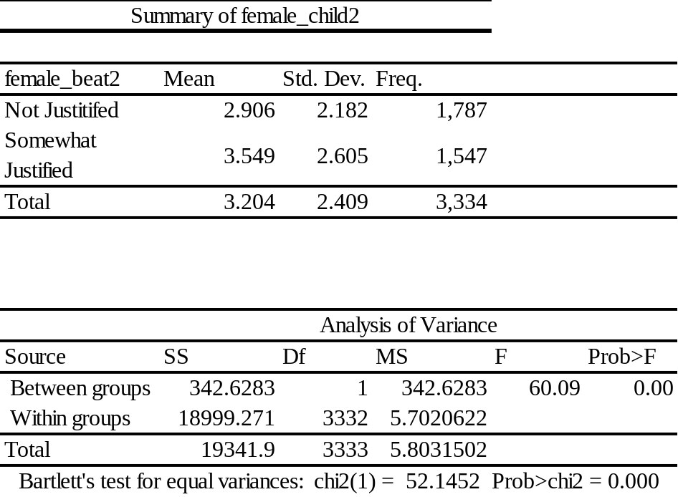

Table 1 shows that out of the full sample of 3334 women, 53.5 percent hold the belief that it is not justified for the husband to beat her wife in any of the circumstances considered by the survey. The means show that women who believe that wife beating is at least sometimes justified on average have a greater number of children as compared to the women who believe that beatings are not justified. These results are highly significant as the results have a high F and low p values. Therefore, we can conclude that women’s empowerment exhibits a strong negative relationship with total children born.
T Statistics:
$$t= \frac{X_{2}- X_{1}}{\sqrt{(\frac{\left(n_{1}-1\right){S_{1}}^{2}+(n_{2}-1){S_{2}}^{2}}{n_{1}+n_{2}-2})(\frac{1}{n_{1}}+ \frac{1}{n_{2}})}}$$

$$t= \frac{3.549 - 2.906}{\sqrt{(\frac{\left(1547-1\right){2.605}^{2}+(1787-1){2.182}^{2}}{1547+1787-2})(\frac{1}{1547}+ \frac{1}{1787})}}$$

$$t= \frac{0.643}{\sqrt{(\frac{\left(1547-1\right)(6.786025)+(1787-1)4.761124}{3332})(0.00064641241+ 0.00055959709)}}$$
$$t= \frac{0.643}{\sqrt{(\frac{10491.194+8503.367}{3332})(0.00064641241+ 0.00055959709)}}$$
$$t= \frac{0.643}{\sqrt{5.7(0.0012060095)}}$$
$$t= \frac{0.643}{\sqrt{0.00687425415}}$$
$$t= \frac{0.643}{0.0829}$$
$$Tstats = 7.756$$

The T-statistic is greater than T-critical value of 1.645 (95% confidence) and also greater than 2.327 (99% confidence).
The next tables show a group-wise analysis by wealth, region and education. Similar results are seen and therefore it can be concluded that women’s empowerment exhibits a negative relationship with the total number of children born given the moderating effects.

By Region
Table 2A
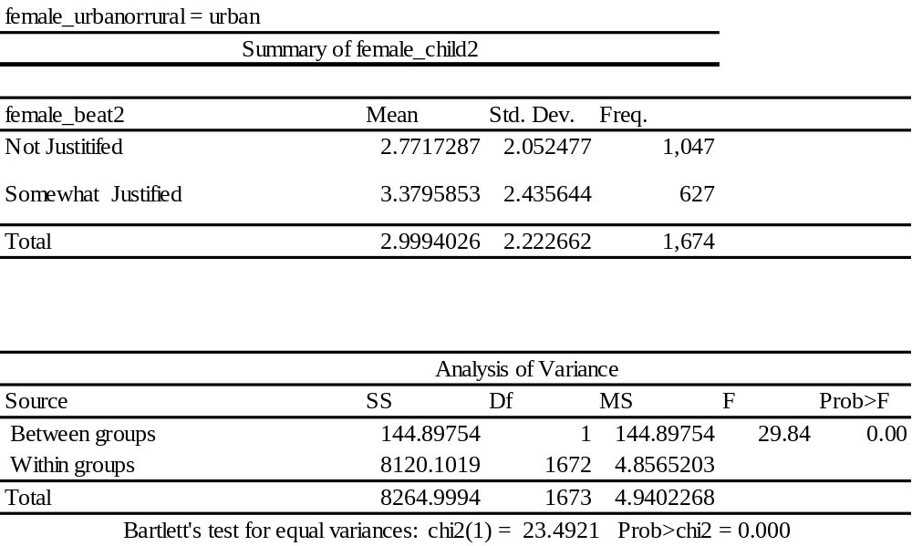
Table 2A shows that there are 1,674 women in the urban areas according to the sample statistics. A majority of the sample (63%) believe that it is not justified for her husband to beat her. The difference between two groups in 0.6 children per women. The model is statistically significant with probability> chi-squared = 0.00.
$$t= \frac{X_{2}- X_{1}}{\sqrt{(\frac{\left(n_{1}-1\right){S_{1}}^{2}+(n_{2}-1){S_{2}}^{2}}{n_{1}+n_{2}-2})(\frac{1}{n_{1}}+ \frac{1}{n_{2}})}}$$

$$t= \frac{3.38 - 2.77}{\sqrt{(\frac{\left(627-1\right){2.43}^{2}+(1047-1){2.05}^{2}}{627+1047-2})(\frac{1}{627}+ \frac{1}{1047})}}$$

$$t= \frac{0.61}{\sqrt{(\frac{3693.4+4395.815}{1672})(0.00255)}}$$
$$t= \frac{0.61}{\sqrt{(4.838)(0.00255)}}$$
$$t= \frac{0.61}{\sqrt{0.0123}}$$
$$t= \frac{0.61}{0.1109}$$
$$T_{stats}= 5.5$$
The T-statistic is greater than T-critical value of 1.645 (95% confidence) and also greater than 2.327 (99% confidence).
Table 2B
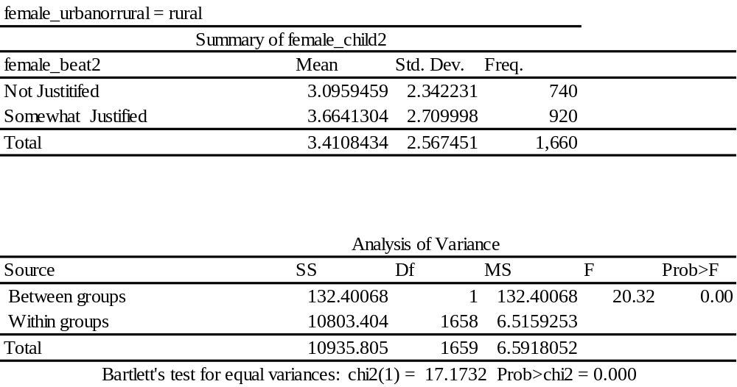
Table 2B shows the women belonging to rural regions. In the above analysis it is observed that if a woman believes that it is justified for her husband to beat her, she tends to have a higher number of children (3.66 children born per women). Whereas the women who believe that a beating is not justified tend to have a comparatively lower number of children. The results are significant with probability>chi-squared =0.

Interestingly even though the urban women have a lower number of children on average for both groups, the mean difference in number of children between the two groups (justified vs. not justified) across both sub-samples is about the same for rural and urban women (about 0.5 children).
$$t= \frac{X_{2}- X_{1}}{\sqrt{(\frac{\left(n_{1}-1\right){S_{1}}^{2}+(n_{2}-1){S_{2}}^{2}}{n_{1}+n_{2}-2})(\frac{1}{n_{1}}+ \frac{1}{n_{2}})}}$$
$$t= \frac{3.66 - 3.09}{\sqrt{(\frac{\left(920-1\right){2.7}^{2}+(740-1){2.342}^{2}}{920+740-2})(\frac{1}{920}+ \frac{1}{740})}}$$
$$t= \frac{0.63}{\sqrt{(\frac{\left(919\right)(7.29)+(739)(5.3485)}{1658})(0.00243)}}$$
$$t= \frac{0.63}{\sqrt{(\frac{6699.51+3952.54}{1658})(0.00243)}}$$
$$t= \frac{0.63}{\sqrt{(\frac{10652.05}{1658})(0.00243)}}$$
$$t= \frac{0.63}{\sqrt{(6.424)(0.00243)}}$$
$$t= \frac{0.63}{\sqrt{0.0156}}$$
$$t= \frac{0.63}{0.1248}$$
$$T_{stats}= 5.04$$
The T-statistic is greater than T-critical value of 1.645 (95% confidence) and also greater than 2.327 (99% confidence).
There is a difference between the two averages of rural women as compared to the urbanized women. This result is also supported by White et al (2005) who quoted that migration from rural to urban resulting in women having lesser children as compared to the rural areas but more children as compared to the urban areas.

By Wealth

Table 3A
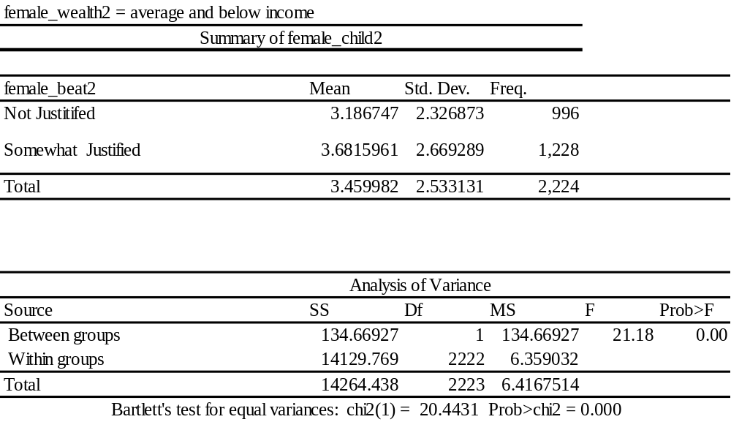

Table 3B
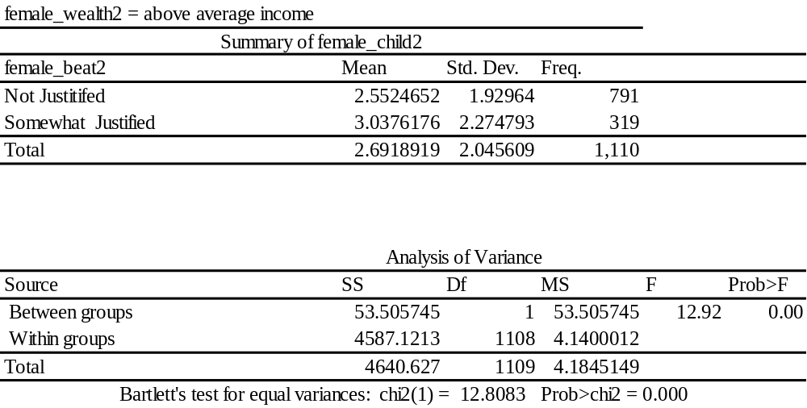
Table 3A and Table 3B consider the sub-samples with respect to wealth indices. The above table also shows that with an increase in wealth, there is a lower number of children born. These results are also statistically significant and this result also consistent with the earlier results that with a decrease in women’s empowerment, that is a women believes that wife beating is justified, would result in a slightly higher number of children. The results also show that women in rural areas on average have a higher number of children as compared to women in urban areas. This is also proved by (Penn, 2003; Aarssen, 2005; Hilgeman & Butts, 2009) that with higher wealth women receive better childcare facilities and better financial independence that reduce the number of children born per women
$$t= \frac{X_{2}- X_{1}}{\sqrt{(\frac{\left(n_{1}-1\right){S_{1}}^{2}+(n_{2}-1){S_{2}}^{2}}{n_{1}+n_{2}-2})(\frac{1}{n_{1}}+ \frac{1}{n_{2}})}}$$
$$t= \frac{3.68 - 3.18}{\sqrt{(\frac{\left(1228-1\right){2.66}^{2}+(996-1){2.33}^{2}}{1228+996-2})(\frac{1}{1228}+ \frac{1}{996})}}$$
$$t= \frac{0.5}{\sqrt{(\frac{\left(1227\right)(7.0756)+(996-1)(5.4289)}{1228+996-2})(\frac{1}{1228}+ \frac{1}{996})}}$$

$$t= \frac{0.5}{\sqrt{(\frac{8681.76+5401.755}{2222})(0.00181)}}$$
$$t= \frac{0.5}{\sqrt{(6.338)*(0.00181)}}$$
$$t= \frac{0.5}{\sqrt{0.01147}}$$
$$t= \frac{0.5}{0.1070}$$
$$T_{stats}= 4.673$$
The T-statistics is greater than T-critical value of 1.645 (95% confidence) and also greater than 2.327 (99% confidence).
For Table 3b
$$t= \frac{X_{2}- X_{1}}{\sqrt{(\frac{\left(n_{1}-1\right){S_{1}}^{2}+(n_{2}-1){S_{2}}^{2}}{n_{1}+n_{2}-2})(\frac{1}{n_{1}}+ \frac{1}{n_{2}})}}$$
$$t= \frac{3.03 - 2.55}{\sqrt{(\frac{\left(319-1\right){2.27}^{2}+(791-1){1.93}^{2}}{319 +791-2})(\frac{1}{319}+ \frac{1}{719})}}$$

$$t= \frac{0.48}{\sqrt{(\frac{\left(318\right)(5.1529)+(790)(3.7249)}{1109})(0.0045)}}$$
$$t= \frac{0.48}{\sqrt{(\frac{1638.62+2942.67}{1109})(0.0045)}}$$
$$t= \frac{0.48}{\sqrt{(4.131)(0.0045)}}$$
$$t= \frac{0.48}{\sqrt{0.018}}$$
$$t= \frac{0.48}{0.134}$$
$${ T}_{stats}= 3.58$$
The T-statistic is greater than the T-critical value of 1.645 (95% confidence) and also greater than 2.327 (99% confidence).
An interesting article on the similar topic on Ghana by White et al (2008) proved the similar point that the urban women on average had 11% lower number of children. These authors agree that the effects of urbanization is strong and evident. The results from this paper are also close: from 3.18 to 2.55 (20% reduction for urban women) for those who believe beating is justified. Whereas a 18% reduction (from 3.68 to 3.03) for women with higher empowerment.

By Education
Table 4A
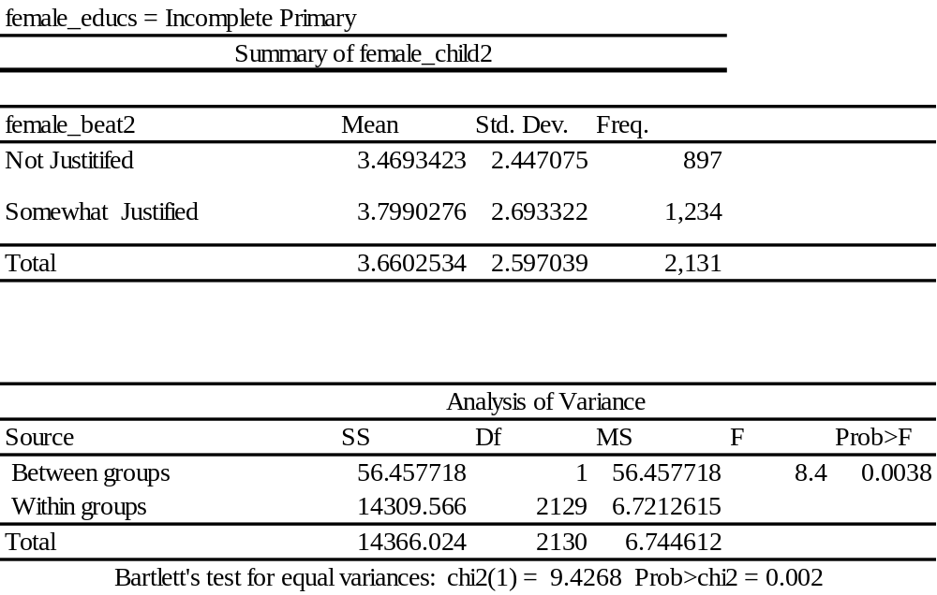
Table 4A shows sub samples with respect to education. The table shows that in the sample there are 2,131 women who are not primary pass, and of those 1,234 (58%) believe that it is justified for her husband to beat her. The women on average have 3.8 children, whereas the women who believe that wife beating is not justified have an average of 3.46. Ruthbah (2019) also approves that with lower women’s autonomy, there will be higher number of children born on average. The F statistics show significance, indicating a negative relationship.
$$t= \frac{X_{2}- X_{1}}{\sqrt{(\frac{\left(n_{1}-1\right){S_{1}}^{2}+(n_{2}-1){S_{2}}^{2}}{n_{1}+n_{2}-2})(\frac{1}{n_{1}}+ \frac{1}{n_{2}})}}$$
$$t= \frac{3.8 - 3.47}{\sqrt{(\frac{\left(1234-1\right){2.69}^{2}+(897-1){2.44}^{2}}{1234+897-2})(\frac{1}{1234}+ \frac{1}{897})}}$$
$$t= \frac{0.33}{\sqrt{(\frac{\left(1233\right)(7.2361)+\left(896\right)5.9536}{2129})(0.00192)}}$$
$$t= \frac{0.33}{\sqrt{(\frac{8922.11+5334.42}{2129})(0.00192)}}$$
$$t= \frac{0.33}{\sqrt{0.0128}}$$
$$t= \frac{0.33}{0.113}$$
$$T_{stats}= 2.92$$
The T-statistics is greater than the T-critical value of 1.645 (95% confidence) and also greater than 2.327 (99% confidence).
Table 4B
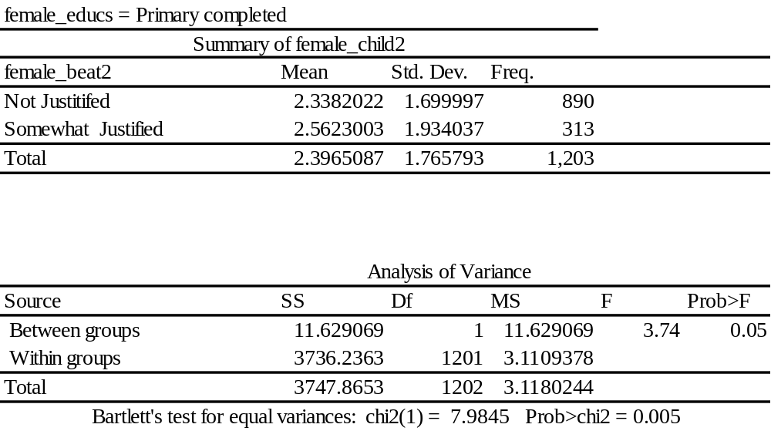

Table 4B shows that for the women who completed primary schooling, 890 women (74%) of women have the belief that beating her is not justified. This group of post-primary educated women have a lower average number of children and also shows that with increased intolerance towards domestic violence there is a lower number of children born. It is also visible in accordance with Keats (2018) that an increase in education will increase the empowerment of women as we can see more women in group 1 in the second table as opposed to the group 1 of the first table.
$$t= \frac{X_{2}- X_{1}}{\sqrt{(\frac{\left(n_{1}-1\right){S_{1}}^{2}+(n_{2}-1){S_{2}}^{2}}{n_{1}+n_{2}-2})(\frac{1}{n_{1}}+ \frac{1}{n_{2}})}}$$

$$t= \frac{2.56 - 2.34}{\sqrt{(\frac{\left(313-1\right){1.93}^{2}+(890-1){1.7}^{2}}{313+890-2})(\frac{1}{313}+ \frac{1}{890})}}$$

$$t= \frac{0.22}{\sqrt{(\frac{\left(312\right)3.725+\left(889\right)2.89}{1201})(0.0043)}}$$
$$t= \frac{0.22}{\sqrt{(\frac{1162.2+2569.21}{1201})(0.0043)}}$$
$$t= \frac{0.22}{\sqrt{(3.1)(0.0043)}}$$
$$t= \frac{0.22}{\sqrt{0.0133}}$$
$$t= \frac{0.22}{0.115}$$
$$T_{stats}= 1.91$$
The T-statistic is greater than the T-critical value of 1.645 (95% confidence) and also greater than 2.327 (99% confidence).
Given tables 4A and 4B, there is an important highlight that with higher education, the mean number of children born fall in both groups. This finding is similar to that if Mason (1986_ that showed that with increase in women’s education lowered the children born.

Limitations
One of the biggest limitations in this research is that the data is cross-sectional and the researcher has a single data point for each woman. As a result, for younger women we know her current level of empowerment but we do not yet know what her eventual number of children at the end of her childbearing years will be, and for mature women we know the number of children she has had but we only know her current level of empowerment but not her empowerment when she began bearing children. In other words, we are unable to capture, using this data, how empowerment changes for a woman over the course of her childbearing years.
Secondly, the way that empowerment is measured, using a series of yes/no questions, tends to lack the nuance one would like to capture when measuring a complex constructs like empowerment and attitudes toward domestic violence. The varying levels of intensity and diversity of experiences are difficult to capture with the survey instruments available, which tend to capture incidents of domestic abuse through discrete rather than continuous measurement.
Lastly there were limited variables and other variables such as culture, customs, and norms cannot be evaluated. With the given data there is not much information on the early life of married women. Variables that could capture intergenerational effects, such as the education of the woman’s parents, her father’s income, number of siblings, and other aspects of her life trajectory prior to marriage are missing from the data. These may cause omitted variable bias through unobserved factors that affect both empowerment and fertility.

Conclusion
This thesis has analyzed the impact of women's empowerment on total children born. The empowerment variables included decision making and beliefs about domestic abuse beating justified. There is a significant mediating effect of contraceptives use and women working after marriage.
The mediating analysis shows that the variables of contraceptives and worked after marriage are somewhat mediated from empowerment to the number of children using the attribute of decision making. However when the research switches the empowerment variable to a belief that beatings are justified, the models lose their significance and show that attitudes toward domestic violence do not affect the number of children born. After incorporating the mediating variables, the magnitude of the independent variable falls, indicating that the effects of decision making power on mediating variables is mixed (there was a positive effect for working after marriage but a negative one for contraceptive use).
The moderating analysis proves the hypothesis that with more decision making (on health), higher education, and greater wealth, there is a lower number of children born on average to women, especially in urban areas. The moderating effect models also proved that women who justify beatings on average have more children born in all respective sub-groups as compared to a more empowered woman in the same sub-group, regardless of location, wealth, or eduction. The T-statistics show that a greater number of children are born to women with less empowerment, as all were significant at 95% confidence interval.

References

- Aarssen, L. W. (2005). Why is fertility lower in wealthier countries? The role of relaxed fertility‐selection. Population and Development Review, 31(1), 113-126.
- Adams, J. (2016). Why do women want children? The case of Hong Kong, China: A lowest-low fertility context. Marriage & Family Review, 52(7), 632-653.
- Anand Singh, K., & Krishna, K. V. S. M. (1994). Agricultural entrepreneurship: the concept and evidence. The Journal of Entrepreneurship, 3(1), 97-111.
- Ainsworth, M., Beegle, K., & Nyamete, A. (1996). The impact of women's schooling on fertility and contraceptive use: A study of fourteen sub-Saharan African countries. The World Bank Economic Review, 10(1), 85-122.
- Al-Riyami, A. A., & Afifi, M. (2003). Determinants of women's fertility in Oman. Saudi medical journal, 24(7), 748-753.
- Amin, V., & Behrman, J. R. (2014). Do more-schooled women have fewer children and delay childbearing? Evidence from a sample of US twins. Journal of Population Economics, 27(1), 1-31.
- Amin, R., & Becker, S. (1998). NGO-promoted microcredit programs and women's empowerment in rural Bangladesh: quantitative and qualitative evidence. The journal of developing areas, 32(2), 221-236.
- Bairagi, R. (2001). Effects of sex preference on contraceptive use, abortion and fertility in Matlab, Bangladesh. International Family Planning Perspectives, 137-143.
- Basu, K. (2006). Gender and say: A model of household behaviour with endogenously determined balance of power. The Economic Journal, 116(511), 558-580.
- Ballon, P. (2018). A structural equation model of female empowerment. The Journal of Development Studies, 54(8), 1303-1320.
- Bbaale, E., & Mpuga, P. (2011). Female education, contraceptive use, and fertility: evidence from Uganda. Consilience, (6), 20-47.
- Becker, G. S., & Barro, R. J. (1988). A reformulation of the economic theory of fertility. The quarterly journal of economics, 103(1), 1-25.
- Becker, H. S. (1960). Notes on the concept of commitment. American journal of Sociology, 66(1), 32-40.
- Becker, G. S., Murphy, K. M., & Tamura, R. (1990). Human capital, fertility, and economic growth. Journal of political economy, 98(5, Part 2), S12-S37.
- Ben-Porath, Y. (1973). Labor-force participation rates and the supply of labor. Journal of Political economy, 81(3), 697-704.
- Ben-Porath, Y. (1973). Labor-force participation rates and the supply of labor. Journal of Political economy, 81(3), 697-704.
- Cleland, J., Bernstein, S., Ezeh, A., Faundes, A., Glasier, A., & Innis, J. (2006). Family planning: the unfinished agenda. The lancet, 368(9549), 1810-1827.
- Deza, M. (2019). Graduated driver licensing and teen fertility. Economics & Human Biology, 35, 51-62.
- Becker, G. S., & Lewis, H. G. (1973). On the Interaction between the Quantity and Quality of Children. Journal of political Economy, 81(2, Part 2), S279-S288.
- Clark, G., & Cummins, N. (2009). Urbanization, mortality, and fertility in Malthusian England. American Economic Review, 99(2), 242-47.
- Do, M., & Kurimoto, N. (2012). Women's empowerment and choice of contraceptive methods in selected African countries. International perspectives on sexual and reproductive health, 23-33.
- Doo-Sub, K. (1986). Working experience of married woman and fertility in Korea. Bulletin of the Population and Development Studies Center, 19-30
- Doepke, M., & Tertilt, M. (2018, May). Women's empowerment, the gender gap in desired fertility, and fertility outcomes in developing countries. In AEA Papers and Proceedings (Vol. 108, pp. 358-62).
- Eickelman, C. (1993). Fertility and social change in Oman: Women's perspectives. Middle East Journal, 47(4), 652-666.
- Ehrlich, I., & Lui, F. T. (1991). Intergenerational trade, longevity, and economic growth. Journal of political Economy, 99(5), 1029-1059.
- Eliot, T. D. (1924). The Relations between Adam Smith and Benjamin Franklin before 1776. Political Science Quarterly, 39(1), 67-96.
- Emerson, P. M., & Souza, A. P. (2007). Child labor, school attendance, and intrahousehold gender bias in Brazil. The World Bank Economic Review, 21(2), 301-316.
- EVA M. BERNHARDT, Fertility and Employment, European Sociological Review, Volume 9, Issue 1, May 1993, Pages 25–42
- Exline, J. J., Yali, A. M., & Sanderson, W. C. (2000). Guilt, discord, and alienation: The role of religious strain in depression and suicidality. Journal of clinical psychology, 56(12), 1481-1496.
- Ezeanolue, E. E., Iwelunmor, J., Asaolu, I., Obiefune, M. C., Ezeanolue, C. O., Osuji, A., ... & Ehiri, J. E. (2015). Impact of male partner’s awareness and support for contraceptives on female intent to use contraceptives in southeast Nigeria. BMC public health, 15(1), 1-6.
- Fanti, L., & Manfredi, P. (2003). The Solow's model with endogenous population: A neoclassical growth cycle model. Journal of Economic Development, 28(2), 103-116.
- Fong, V. L. (2002). China's one‐child policy and the empowerment of urban daughters. American anthropologist, 104(4), 1098-1109.
- Gee, R. E., Mitra, N., Wan, F., Chavkin, D. E., & Long, J. A. (2009). Power over parity: intimate partner violence and issues of fertility control. American journal of obstetrics and gynecology, 201(2), 148-e1.
- Goody, J., & Goody, J. R. (1976). Production and reproduction: a comparative study of the domestic domain (No. 17). Cambridge University Press.
- Guilkey, D. K., & Riphahn, R. T. (1998). The determinants of child mortality in the Philippines: estimation of a structural model. Journal of development economics, 56(2), 281-305.
- Handa, S. (1996). Maternal education and child attainment in Jamaica: Testing the bargaining power hypothesis. Oxford Bulletin of Economics and Statistics, 58(1), 119-137.
- Heckert, J., Olney, D. K., & Ruel, M. T. (2019). Is women's empowerment a pathway to improving child nutrition outcomes in a nutrition-sensitive agriculture program?: Evidence from a randomized controlled trial in Burkina Faso. Social Science & Medicine, 233, 93-102.
- Hilgeman, C., & Butts, C. T. (2009). Women’s employment and fertility: A welfare regime paradox. Social Science Research, 38(1), 103-117.
- Gardner, S. K. (2008). Fitting the mold of graduate school: A qualitative study of socialization in doctoral education. Innovative Higher Education, 33(2), 125-138.Deza (2019)
- Hyoung, C. (1997). Fertility control, reproductive rights, and women's empowerment in Korea. Asian Journal of Women's Studies, 3(1), 103-132
- Islam, M. M. (2018). The changing pattern and determinants of declining consanguinity in Jordan during 1990–2012. Annals of human biology, 45(2), 140-147.
- J. Mayone Stycos, Robert H. Weller; Female working roles and fertility. Demography 1 March 1967; 4 (1): 210–217
- Jacobson, P. C. (1993). Analysis of factors affecting growth of northern pike in Minnesota. Minnesota Department of Natural Resources, Division of Fish and Wildlife, Section of Fisheries.
- Kato, H., Sato, S., Yoneyama, M., Yamamoto, M., Uematsu, S., Matsui, K., ... & Akira, S. (2005). Cell type-specific involvement of RIG-I in antiviral response. Immunity, 23(1), 19-28.
- Keats, A. (2018). Women's schooling, fertility, and child health outcomes: Evidence from Uganda's free primary education program. Journal of Development Economics, 135, 142-159.
- Kolk, M. (2019). Weak support for a U-shaped pattern between societal gender equality and fertility when comparing societies across time. Demographic Research, 40, 27-48.
- Kolk, M., & Barclay, K. (2019). Cognitive ability and fertility among Swedish men born 1951–1967: evidence from military conscription registers. Proceedings of the Royal Society B, 286(1902), 20190359.
- Krishnakumar, J., & Ballon, P. (2008). Estimating basic capabilities: A structural equation model applied to Bolivia. World Development, 36(6), 992-1010.
- Kritz, M. M., & Makinwa-Adebusoye, P. (1999, September). Determinants of women's decision-making authority in Nigeria: the ethnic dimension. In Sociological Forum (Vol. 14, No. 3, pp. 399-424). Kluwer Academic Publishers-Plenum Publishers.
- Lam, D., & Duryea, S. (1999). Effects of schooling on fertility, labor supply, and investments in children, with evidence from Brazil. Journal of Human Resources, 160-192
- Larsen, U., & Hollos, M. (2003). Women's empowerment and fertility decline among the Pare of Kilimanjaro region, Northern Tanzania. Social Science & Medicine, 57(6), 1099-1115.
- Liu, J., & Liu, T. (2018). Two-child policy, gender income and fertility choice in China. International Review of Economics & Finance.
- Liu, P., Xu, L., Wang, Y., Zhang, Y., Du, Y., Sun, Y., & Wang, Z. (2016). Association between perinatal outcomes and maternal pre‐pregnancy body mass index. Obesity Reviews, 17(11), 1091-1102.
- MacQuarrie, K. L., & Edmeades, J. (2015). Whose fertility preferences Matter? Women, husbands, in-laws, and abortion in Madhya Pradesh, India. Population Research and Policy Review, 34(4), 615-639.
- Mahmud, S., Shah, N. M., & Becker, S. (2012). Measurement of women’s empowerment in rural Bangladesh. World development, 40(3), 610-619.
- Maia, J., Almeida, L., Falcao, A., Soares, E., Mota, F., Potgieter, M. A., ... & Soares-da-Silva, P. (2008). Effect of renal impairment on the pharmacokinetics of eslicarbazepine acetate. International journal of clinical pharmacology and therapeutics, 46(3), 119.
- Malhotra, A., Schuler, S. R., & Boender, C. (2002, June). Measuring women’s empowerment as a variable in international development. In background paper prepared for the World Bank Workshop on Poverty and Gender: New Perspectives (Vol. 28).
- Malthus, T. R. (1803). An essay on the principle of population: or, A view of its past and present effects on human happiness. Johnson.
- McCarthy, R., Jungheim, E. S., Fay, J. C., Bates, K., Herzog, E. D., & England, S. K. (2019). Riding the rhythm of melatonin through pregnancy to deliver on time. Frontiers in endocrinology, 10, 616.
- McElwee, G., & Al‐Riyami, R. (2003). Women entrepreneurs in Oman: some barriers to success. Career Development International.
- Miller, G., & Babiarz, K. S. FAMILY PLANNING PROGRAM EFFECTS: A REVIEW OF EVIDENCE FROM MICRODATA.
- Murphy, K. M., Simon, C., & Tamura, R. (2008). Fertility decline, baby boom, and economic growth. Journal of Human Capital, 2(3), 262-302.
- Nalwadda, G., Mirembe, F., Byamugisha, J., & Faxelid, E. (2010). Persistent high fertility in Uganda: young people recount obstacles and enabling factors to use of contraceptives. BMC public health, 10(1), 1-13.
- Noble, R. (2005). Which career first?: Women don't want it all, but they may want children. BMJ, 331(7520), 846–846. https://doi.org/10.1136/BMJ.331.7520.846-B
- Ogawa, N., & Mason, A. (1986). An economic analysis of recent fertility in Japan: an application of the Butz-Ward model. The Journal of Population Studies, 9, 5-15.
- Orrefice, S., & Bercea, B. (2007). Quality of available mates, education and intra-household bargaining power. Fondazione Eni Enrico Mattei Working Papers no. 103.
- Pan, J. N., & Yang, Y. J. (2020). The impact of economic uncertainty on the decision of fertility: Evidence from Taiwan. The North American Journal of Economics and Finance, 54, 101090.
- Ruthbah, U. (2020). Does lower fertility empower women? Evidence from rural Bangladesh. Economics & Human Biology, 36, 100813.
- Sackey, H. A. (2005). Female labour force participation in Ghana: The effects of education.
- Samarakoon, S., & Parinduri, R. A. (2015). Does education empower women? Evidence from Indonesia. World Development, 66, 428-442.
- Samuelson, P. A. (1975). Optimum social security in a life-cycle growth model. International economic review, 539-544.
- Sanderson, S. K., & Dubrow, J. (2000). Fertility decline in the modern world and in the original demographic transition: Testing three theories with cross-national data. Population and Environment, 21(6), 511-537.
- Sathar, Z. A., & Kazi, S. (1990). Women, work and reproduction in Karachi. International Family Planning Perspectives, 66-80.
- Sathar, Z. A., & Kazi, S. (2000). Women's autonomy in the context of rural Pakistan. The Pakistan Development Review, 89-110.
- Schuler, S. R., & Hashemi, S. M. (1994). Credit programs, women's empowerment, and contraceptive use in rural Bangladesh. Studies in family planning, 65-76.
- Schultz, R. T. (2005). Developmental deficits in social perception in autism: the role of the amygdala and fusiform face area. International Journal of Developmental Neuroscience, 23(2-3), 125-141.
- Schultz, T. P. (1993). Investments in the schooling and health of women and men: quantities and returns. Journal of human resources, 694-734.
- Schultz, T. W. (1973). The value of children: an economic perspective. Journal of Political Economy, 81(2, Part 2), S2-S13.
- Sivasankaran, Anitha. "Work and Women’s Marriage, Fertility, and Empowerment: Evidence from Textile Mill Employment in India." Job Market Paper, Harvard University 61 (2014).
- Skidelsky, R. (1992). John Maynard Keynes: the economist as saviour, 1920-1937 (Vol. 2). London: Macmillan.
- Skirbekk, V. (2008). Fertility trends by social status. Demographic research, 18, 145-180.
- Smeland, S., Bielack, S. S., Whelan, J., Bernstein, M., Hogendoorn, P., Krailo, M. D., ... & Marina, N. (2019). Survival and prognosis with osteosarcoma: outcomes in more than 2000 patients in the EURAMOS-1 (European and American Osteosarcoma Study) cohort. european Journal of Cancer, 109, 36-50.
- Solanke, B. L. (2015). Marriage age, fertility behavior, and women’s empowerment in Nigeria. Sage Open, 5(4), 2158244015617989.
- Steele, F., Amin, S., & Naved, R. T. (1998). The impact of an integrated micro-credit programme on women's empowerment and fertility behavior in rural Bangladesh.
- Strulik, H., & Vollmer, S. (2013). Long-run trends of human aging and longevity. Journal of Population Economics, 26(4), 1303-1323.
- Strulik, H., & Sikandar, S. (2002). Tracing the income fertility nexus: Nonparametric estimates for a panel of countries. Economics Bulletin, 15(5), 1-9.
- Tadesse, F., & Headey, D. (2010). Urbanization and fertility rates in Ethiopia. Ethiopian Journal of Economics, 19(2), 35-72.
- TFAILY, R. (2004). Do women with higher autonomy have lower fertility? Evidence from Malaysia, the Philippines, and Thailand. Genus, 7-32.
- THOMPSON, W. O., Thompson, P. K., BRAILEY, A. G., & COHEN, A. C. (1930). Prolonged treatment of exophthalmic goiter by iodine alone. Archives of Internal Medicine, 45(4), 481-502.
- Tripathi, A., & Mishra, A. (2011, September). Cloud computing security considerations. In 2011 IEEE International Conference on Signal Processing, Communications and Computing (ICSPCC) (pp. 1-5). IEEE.
- United Nations Population Fund. (1994). Population and Development Strategies (No. 19). United Nations Population Fund.
- Upadhyay, U. D., & Karasek, D. (2012). Women's empowerment and ideal family size: an examination of DHS empowerment measures in Sub-Saharan Africa. International perspectives on sexual and reproductive health, 78-89.
- Upadhyay, U. D., Gipson, J. D., Withers, M., Lewis, S., Ciaraldi, E. J., Fraser, A., ... & Prata, N. (2014). Women's empowerment and fertility: a review of the literature. Social science & medicine, 115, 111-120.
- Van de Kaa, D. J. (1987). Europe's second demographic transition. Population bulletin, 42(1), 1-59.
- Van den Broeck, G., & Maertens, M. (2015). Female employment reduces fertility in rural Senegal. PloS one, 10(3), e0122086.
- Vavrus, F., & Larsen, U. (2003). Girls’ education and fertility transitions: an analysis of recent trends in Tanzania and Uganda. Economic development and cultural change, 51(4), 945-975.
- Wang, J., Sun, Y., Zhang, W., Thomas, I., Duan, S., & Shi, Y. (2016). Large-scale online multitask learning and decision making for flexible manufacturing. IEEE Transactions on Industrial Informatics, 12(6), 2139-2147.
- Wang, Q., & Sun, X. (2016). The role of socio-political and economic factors in fertility decline: a cross-country analysis. World development, 87, 360-370.
- Wang, Y., Lin, X., Liu, T., Chen, H., Chen, S., Jiang, Z., ... & Liu, M. (2018). Wood‐Derived Hierarchically Porous Electrodes for High‐Performance All‐Solid‐State Supercapacitors. Advanced Functional Materials, 28(52), 1806207.
- Werding, M. (2014). Children are costly, but raising them may pay: The economic approach to fertility. Demographic Research, 30, 253-276.
- White, M. J., Tagoe, E., Stiff, C., Adazu, K., & Smith, D. J. (2005). Urbanization and the fertility transition in Ghana. Population Research and Policy Review, 24(1), 59-83.
- Yoshizawa, M., Tamura, M., & Fujita, M. (2006). Diels-Alder in aqueous molecular hosts: unusual regioselectivity and efficient catalysis. Science, 312(5771), 251-254.

Appendix

The model questionnaires can be found at:
For Women questionnaire: https://dhsprogram.com/pubs/pdf/DHSQ8/DHS8_Womans_QRE_EN_10Dec2021_DHSQ8.pdf
For Men questionnaire:
https://dhsprogram.com/pubs/pdf/DHSQ8/DHS8_Mans_QRE_EN_12Dec2021_DHSQ8.pdf
The specific Pakistan questionnaire can be found as an Appendix to the 2017-18 Pakistan Demographic and Health Survey report at:
https://dhsprogram.com/pubs/pdf/FR354/FR354.pdf

Figures A1:
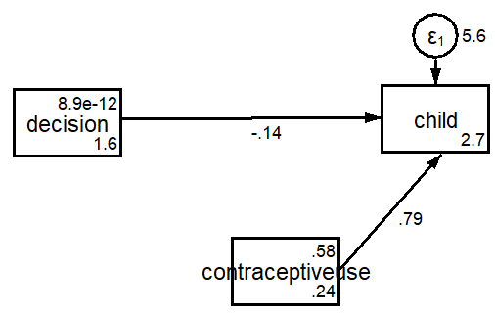
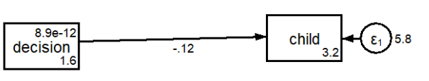
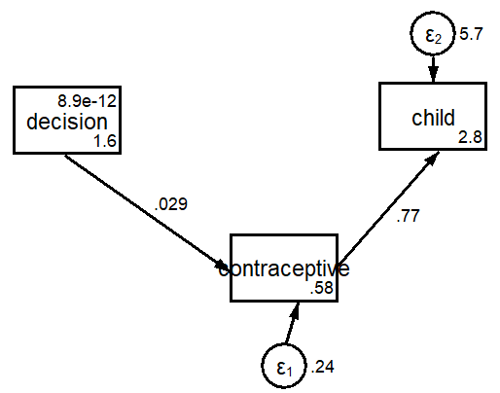
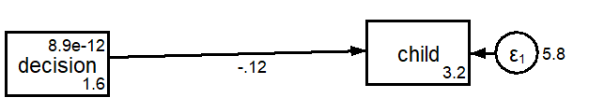
Figures A2:
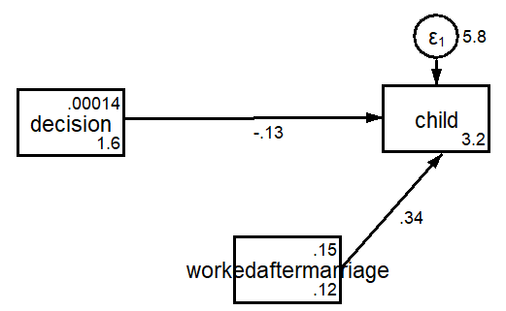

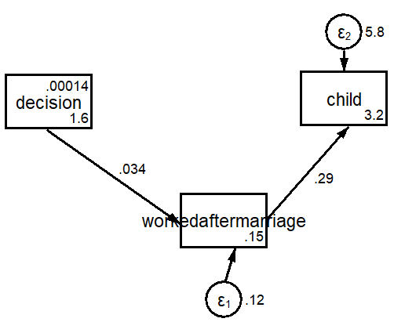

Figures B1:
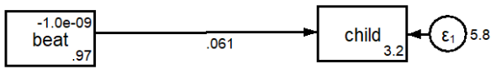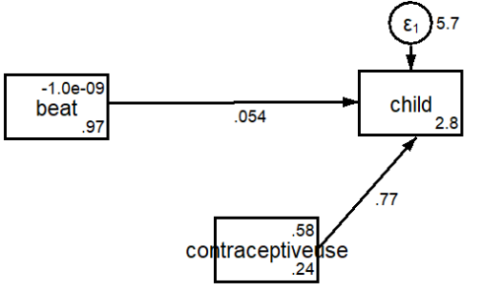
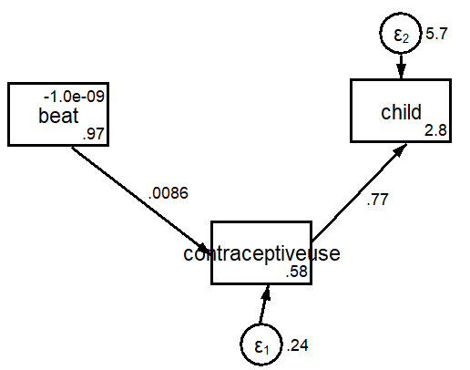

Figure B2:
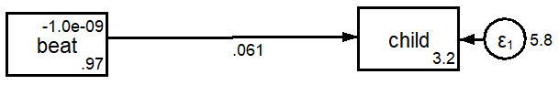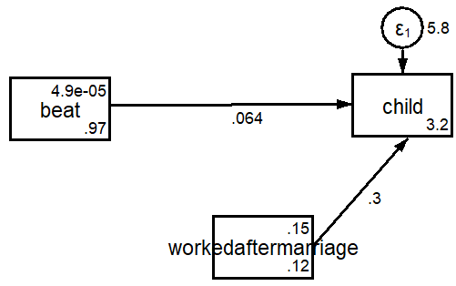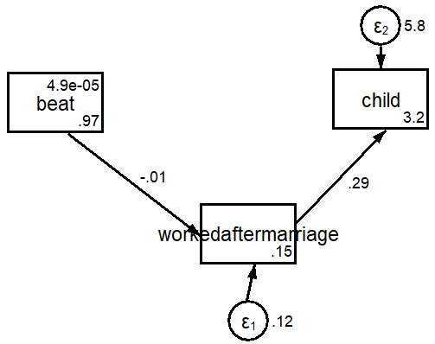

Maternal mortality rate is defined as an incident of a mother dying within 42 days of giving birth.
Source: https://www.unicef.org/pakistan/stories/improving-sanitation-pakistans-rural-villages
Mobility: freedom to visit friends or relatives
Factor loadings are defined as the correlation between the observed and latent variables.
Five questions were asked to both male and female in regard of beating wife Q1) Beating justified if wife goes out without telling husband. Q2) Beating justified if wife neglects children. Q3) Beating justified if wife argues with husband. Q4) Beating justified if wife refuses to have sex with husband. Q5) Beating justified if wife burns food. These are all dummy variables with 1 if beating is justified and 0 otherwise.
Four questions were asked in this regard and if wife had a say in the decision she was given authority Q1) Person who decides on health care. Q2) Person who usually decides on major household purchases Q3) Person who decides on visits to family or relatives Q4) Person who decides what to do with the money that the husband earns. These are dummy variables are 1 if the wife as a say and 0 otherwise.
Five questions were asked in this regard Q1) Slapped by husband Q2) Pushed by husband Q3) Punched by husband Q4) Kicked by husband Q5) Experienced emotionally violence by husband These dummy variables are 1 if yes and 0 otherwise
These tables show the factor loadings between the observed variable and latent variable. Factor loadings are correlations between the observed variable and the latent variable. Tables (1-3) is full sample while (4-6) are sum samples according to different attributes
This table show the factor loadings of the empowerment factor of beating justified of different age groups
This table show the factor loadings of the empowerment factor of violence of different age groups
This table show the factor loadings of the empowerment factor of decision making factor of different age groups.
Circumstances where the female believes that it is justified for her husband to beat her
Circumstances where the male believes it is justified to beat her wife.
Questions asking about the violence faced by the wife
Questions asked about the decision making power given to the wife

