THE DIFFERING GROWTH PATHS IN REDUCING GENDER INEQUALITIES BETWEEN BANGLADESH AND PAKISTAN: THE ROLE OF FEMALE LABOUR FORCE PARTICIPATION.



Maryam Khalid
Lahore School of Economics

Thesis submitted to the Lahore School of Economics
in partial fulfillment of the requirements for the degree of
MPhil in Development Studies
[2018]

Supervised by: Dr. Fareeha Zafar
Co- Supervised by: Dr. Ahmed Nawaz

ABSTRACT
Persistent gender inequalities hinder economic development and in this context the role of FLFP cannot be undermine. The purpose of the study is to focus on gender inequality in Pakistan and Bangladesh as both countries share similar cultural and socio-economic background. Gender related indices such as gender inequality index and global gender gap index indicate that Bangladesh is doing exceptionally well as compared to Pakistan. The study examines the impact of independent variable including ready-made garments export, agricultural credit, contraceptive usage, fertility rate, education, and income inequality on female labour force participation. The study covers for the period 1984-2014 for the two countries. Different statistical techniques were applied to test the impact of independent variables on Female Labour Force Participation. Results showed that RMG has a positive and a highly significant relationship with FLFP in the short and long run for Bangladesh whereas in Pakistan it has a negative relationship with FLFP. The fertility rate and GINI have a negative relationship with FLFP for both countries and it is significant. Agricultural credit has also contributed to the FLFP in both countries, but the impact is more for Pakistan compared to Bangladesh. Contraceptive usage has a positive relationship in Bangladesh in both long run and short run, whereas for Pakistan the contraceptive usage has a positive and significant relationship in the short run but in the long run it becomes insignificant. Overall, education has a positive relationship with FLFP for both countries. We propose certain policy implications based on the findings.

Acknowledgements

I would like to express my utmost gratitude to my thesis supervisor, Dr. Fareeha Zafar, without whose direction this would not have been possible.
A special thanks to Dr. Ahmed Nawaz for patiently assisting me with my Empirical research. I am indebted to him for his relentless mentoring and assistance.
I would also like to thank Dr. Rashid Amjad for making available every possible resource we could have needed during our coursework and the duration of our thesis. His knowledge and experience has been a source of constant guidance for us all.
Last but not the least I would like to pay my gratitude to my family and friends for their patience, support and encouragement.

Table of contents
Acknowledgements 3
LIST OF TABLES 6
LIST OF FIGURES 7
ABBREVIATIONS 8
1 Introduction 9
Outline of the study 15
2 Literature Review 16
3 Research Methodology 26
3.1 Research Gap 26
3.2 Objective of the Study 26
3.3 Research Question 27
3.4 Hypothesis of the study 27
3.5 Methodology 28
3.6 Econometric Model 29
3.7 Unit Root Tests 31
3.8 Augmented Dickey Fuller (ADF) (1981) Test 31
3.9 Phillips and Perron (1988) Test 32
3.10 Testing for Cointegration 33
3.10.1 Autoregressive-Distributed Lag Model (ARDL) 33
3.10.2 Error Correction Model (ECM) 34
4 Descriptive Analysis 35
5 Empirical Analysis and Discussion 44
5.1 Descriptive statistics and Correlation Analyses 44
5.2 Unit Root Testing 47
5.3 Lag-Length Criteria 47
5.4 Augmented Dickey-Fuller Unit Root Test 48
5.5 Auto-Regressive Distributed Lag (ARDL) Model 51
5.6 Short and Long Run Analysis 52
5.6.1 Ready- made Garments 55
5.6.2 Fertility Rate 56
5.6.3 Education 57
5.6.4 Agricultural credit 58
5.6.5 Contraceptive Usage 59
5.6.6 GINI 59
5.7 CUSUM RECURSIVE TEST 61
6 Conclusion and policy implications 63
6.1 Policy Implications 65
7 Bibliography 68
8 Appendices 72

LIST OF TABLES

Table 1.1A Global Gender Gap Index Ranking between Pakistan and Bangladesh …….13
Table 1.1B Labour Force Participation (female to male ratio) …………………………….14
Table 1.1C Gender Inequality Index, 2010-2013…………………………………………...14
Table 3.5 A Sources of Data………………………………………………………………...28
Table 5.1A Summary statistics (Pakistan)…………………………………………………. 45
5.1B Correlation Analysis (Pakistan)……………………………………………………….45
Table 5.1C Summary statistics (Bangladesh)……………………………………………….46
Table 5.1D Correlation Analysis (Bangladesh)……………………………………………..46
Table 5.3A Augmented Dickey-Fuller Unit Root Test (Pakistan)………………………….47
Table 5.3B Augmented Dickey-Fuller Unit Root Test (Bangladesh)……………………....48
Table 5.4A VAR Lag Order Selection Criteria Pakistan…………………………………....49
Table 5.4B VAR Lag Order Selection Criteria Bangladesh………………………………...50
Table 5.5A ARDL bounds testing to cointegration Bangladesh…………………………51
Table 5.5B ARDL bounds testing to cointegration Pakistan…………………………….52
Table 5.6A Error correction model for short run (Pakistan)………………………………...53
Table 5.6B Error correction model for short run results (Bangladesh) ……………………..53
Table 5.6C Long Run Estimates (PAKISTAN)……………………………………………..54
Table 5.6D Long Run Estimates (BANGLADESH) ……………………………………….54

LIST OF FIGURES
Figure 1: Female Labour Force Participation………………………………………………....35
Figure 2: RMG exports as a percentage of total exports……………………………………....36
Figure 3: Fertility Rate per women ……………………………………………………………37
Figure 4: Contraceptive Usage ………………………………………………………………...38
Figure 5: Gross enrollment rate primary (females)……………….............................................49
Figure 6: Gross enrollment secondary (females) ………………………………………………40
Figure 7: Gross enrollment rate tertiary (females)……………………………………………..41
Figure 8: GINI………………………………………………………………………………….42
Figure 9: Agricultural credit disbursement as a percentage of total domestic credit ………….43
Figure 5.7A CUSUM Recursive Test (Bangladesh)………………..............................……….61
Figure 5.7B CUSUM Recursive Test (Pakistan)………………………………………….…...62
Figure 5.7C CUSUM of Squares Recursive Test (Bangladesh)………………….............……62
Figure 5.7D CUSUM of Squares Recursive Test (Pakistan)………………………………..…63

ABBREVIATIONS

Abbreviations | Explanation
PAK | Pakistan
BGD | Bangladesh
FLFP | Female Labour Force Participation
RMG | Ready-made garments
ACDDC | Agricultural credit as a percentage of domestic credit
GEP | Gross enrollment primary
GES | Gross enrollment secondary
GET | Gross enrollment tertiary
FR | Fertility rate
CU | Contraceptive usage
PRGMEA | Pakistan Readymade Garments Manufacturers Exporters Association
BGMEA | Bangladesh Garment Manufacturer and Exporters Association

Introduction

Women face many challenges because of prevailing inequalities in a society, which result in discrimination in access to resources. Very few reach the top level of management of companies or as members of parliament or as ministers. Equal access to opportunities can improve living standards and reduce poverty.
Gender equality itself is an important development goal and to accomplish this goal it is essential that women should be integrated into the labour market as their involvement in the workforce will lead to macroeconomic and social development. Women make up more than half of the world’s population but their contrubution to the measured economic activity, growth and well- being is far below their potential with serious macroeconomic consequences. Despite the progress towards gender equality in recent years, labour markets all over the world are divded along gender lines. (Woytek, et al., 2013)
Most of the studies suggest that among many other variables, lower rates of FLFP is instumental in increasing gender equality. Due to gender inequality especially in the labour market it does effect GDP of a country. According to Teignier & Cuberes (2014) gender inequality creates an average income loss of 38 per cent in the long run especially in the Middle East and North Africa region followed by South Asia and Latin Amercia with long run income losses of 25 per cent and 17.3 per cent respectively. Moreover raising female employment levels to male levels would have a direct impact on the GDP to the extent of, for example, five per cent in the United States, nine per cent in Japan, 12 per cent in United Arab Emirates and 34 percent in Egypt. As women invest a large proportion of their income in the education of their children their employment will lead to better living standards of their children in the future. Political and cultural constraints faced by women result in their inability to join the workforce, thus providing them extra support with will result in economic and social benfits. It has been estimated that 865 million women worldwide have the potential to contribute more fully to their national economies, of this 812 million live in emerging and developing nations. (Aguirre, Hoteit, Rupp, & Sabbagh, 2012)
Women’s partcipation increases economic growth but still women face hurdles in partcipating in the work force. Women drop out from the work force following chilbirth and career track position creates barriers for them entering into the workforce. Therefore, they try to keep themselves away from the laboour market. (Steinberg & Nakane, 2012). When women join the workforce and other income generating activities their economic position improves and this strengthens their status within the household (Sen, 2001; Agarwal, 2002.)
Research shows that when the number of infants and children per female is small, female partcipation in the labour force increases. Bangladesh is doing better in the fertily rate due to their proper implementation of policies and programmes. Increased access of lady health workers in the rural areas, better family planning programs including non clinical methods such as oral pills and condoms that have led to a decrease in the fertilty rate (Bloom & Hossain, 2014).
In Pakistan women are not encouraged to work as the industries are male dominant, as a result most of the women are confined to their homes. Studies have shown that there has been a loss of potential productivity, this also has some important implications as working women are more likely to play a role in household decision making compared with non-working women in the same villages or even in the same familes. The main reason that women are not able to join the workforce is because of their limited physical mobilty outside the home and this is mainly because of the social, cultural and religious norms, safety and crime, and the quality of available transport services (Field & Vyborny, 2016).

Moreover, higher education levels also help in increasing the FLFP . Bangladesh has one of the the largest primary education systems in the world with an estimated 18 million primary school aged children. Enrollment rates have increased with the help of NGOs and gender gaps have reduced in the primary enrollment rate. Between 1985-2001 national enrollment rates doubled , as did the number of primary schools (Chismaya, DeJaeghere, Kendall, & Khan, 2012).
Microfinance has helped Bangladesh in improving its FLFP. In Bangladesh, microfinance is successful and it has helped women a great deal in setting up their own small businesses and improving standard of living. Women’s participation has also increased in poultry and livestock and in a variety of non- farm activites, thanks mainly to the spread of microcredit ( Rahman & Islam, 2013).Microcredit has helped women in educating their children and along with it has also had other positive effects such as increased land ownership, improved sanitation, increase in savings and other areas related to women’s empowerment (Mamun, 2013).
Ready-made garment industry has opened opportunities for women. Mostly women are employed in the ready- made garment sector because of the nature of the work as it does not require any technical education so that even unskilled labour can be employed. Almost 80 to 85 per cent women are employed in this sector whereas in the manufacturing sector males are still dominant. RMG exports have contributed to the economy of Bangladesh in the last two decades (Khatiwada, 2014).
In Pakistan there has been an increase in FLFP but still it is far behind Bangladesh. This is because of the lack of skill, education and training beside socio-cultural norms (Isran & Isran, 2013).
Discouragement of women in the labour force also leads to an increase in child labour as Ray (2000) shows that children’s overall share of household earning was only slightly less than of that of women. Therefore because of the socio-cultural restrictions against women working outside the home, housholds in Pakistan rely more on child labour especially that of boys, a finding suggests that an increase in female labour force partcipation might decrease child labour . Reliance on child labour is also a reason for the higher number of children as they are considerd an investment that will help them financially when they get old and is the main reason for preference of sons as compared to daughters.
Another important factor is that women do not feel safe in public transport which restricts them to their houses, even if the work environment is safe but the travelling to work creates a lot of exposure that violates norms (Ali, 2012). A survey carried out in Karachi of women who travelled regularly, 85 per cent of them said that they had been harrassed on public transport in the past year. Most of the harrassment was perperated by male passengers but about a quarter of women also reported being harrassed by vehicle drivers or conductors. In addtion to this, social tabbos do not allow women to ride bicycles or motorbikes which make them dependent on male members of the family (Asian Development Bank, 2014).
Pakistan and Bangladesh both are developing countries having similar socio-cultural background. But in recent years Bangladesh is doing much better than Pakistan in human development. Pakistan being economically better than Bangladesh but still it is not able to make progress in this context. This raises some serious questions regarding the performance of the government, if the country is unable to improve its human development indicators even though they are economically better. This means that there has been inappropriate utilization of resources. In 2016, Pakistan was ranked in the lower human development category whereas Bangladesh was in the middle human development category. Pakistan was ranked at 147 out of 188 countries whereas Bangladesh was ranked at 139. If a country is not properly investing its resources in its people it makes the situation of women even worse, as already women are at a disadvantage. In the gender equality related indices, we can see that Bangladesh is doing far better than Pakistan. Bangladesh has made remarkable progress in women’s empowerment and in 2015 on Global Gender Gap index they were ranked at 64 out of 145 countries whereas Pakistan was ranked at 144 unfortunately the second last. Almost same is the case with the Gender Inequality Index which ranks Bangladesh at 111 out of 188 countries and Pakistan at 121 (Human development Report, 2016).
Table 1.1A Global Gender Gap Index Ranking between Pakistan and Bangladesh
 | 2006 | 2007 | 2008 | 2009 | 2010 | 2011 | 2012 | 2013 | 2014 | 2015
BGD | 91 | 100 | 90 | 93 | 82 | 69 | 86 | 75 | 68 | 64
PAK | 112 | 126 | 127 | 132 | 132 | 133 | 134 | 135 | 141 | 144
Source: Global Gender Gap Reports
In table 1.1A we can see that there is a huge difference between Pakistan and Bangladesh ranking in global gender gap index. Global gender gap index takes into account four thematic dimensions which are economic participation and opportunity, educational attainment, health and survival and lastly political participation. Over the time the difference has increased between Pakistan and Bangladesh with the latter doing far better.
1.1B Labour Force Participation (female to male ratio)
 | 2006 | 2007 | 2008 | 2009 | 2010 | 2011 | 2012 | 2013 | 2014 | 2015
BGD | 0.61 | 0.63 | 0.63 | 0.69 | 0.73 | 0.73 | 0.73 | 0.69 | 0.70 | 0.70
PAK | 0.39 | 0.39 | 0.40 | 0.26 | 0.26 | 0.26 | 0.26 | 0.27 | 0.30 | 0.30
Source: Global Gender Gap Reports
The study is focusing on the female labour force participation and the aim is to see which determinants are the ones which drive changes in the FLFP between Pakistan and Bangladesh. In the above table 1.1B we can see the female to male ratio. Value equal to 1 indicates equality and value equal to 0 indicates inequality. Bangladesh value is near to 1 which means that there less gender inequality compared to Pakistan whose value is near to 0. So, women in Pakistan face more discrimination in terms of labour compared to Bangladesh
Table 1.1C Gender Inequality Index,2010-2013
Country | 2010 | 2013
Pakistan | 0.721 | 0.563
Bangladesh | 0.734 | 0.529
Source: Human Development report 2010 and 2014

Both countries have also improved their position in the Gender Inequality Index (GII). The value has decreased for both countries, but Bangladesh GII value is closer to zero as compared to Pakistan. This indicates that there is less gender inequality in Bangladesh in terms of education, health and labour force participation.
As already stated, Bangladesh has outdone Pakistan in some of the main variables such as RMG sector, Bangladesh RMG exports are ten times more than those of Pakistan and in this industry mostly women are employed. With the help of the extensive literature review we select some variables that contribute to FLFP significantly for instance, fertility rate, contraceptives usage, education, agricultural credit, readymade garment exports and lastly income inequality. The research will investigate these empirically to prove whether these variables have contributed to FLFP or not for both countries.

Outline of the study

The study is organized as follows: The introduction is followed by a review of literature that includes various studies related to determinants of female labour force participation. Chapter three discusses the data and methodology. In chapter four a descriptive analysis of the selected variables has been presented and chapter five discusses the empirical analysis. The final chapter presents conclusions and policy implications.

Literature Review

The literature on female labour force participation can be viewed both in terms of theoretical predictions and empirical findings. Women’s participation in the labour force varies across countries, reflecting differences in economic development, fertility rates, education levels, social norms, access to childcare and other supportive services. The relationship between these variables and female labour force is complex. Focusing on these issues is essential as female labour force participation is a driver of growth and thus participation rates indicate a country’s potential to grow more rapidly. It is also important especially in developing countries as in these countries women’s labour force participation is a coping mechanism in response to economic shocks that hit the household. The relationship between evolving socio-economic and demographic factors and how women participate in the world is multifaceted.
Chandra ( 2015) states that gender gaps directly impact the income inequality, higher gaps in labour force participation between men and women will lead to more income inequality between sexes. Secondly, mostly women are working in the informal sector in which earnings are low which widens the gender gaps and thirdly inequality of opportunities such as in health, education which are strongly related to income inequality. The results show that income inequality is strongly related with gender gaps in all the countries. If there is an increase in gender inequality, then there is an increase in the net income inequality of 10 points. In advanced countries where the gender gaps in education and economic opportunities has been closed, income inequality arises mainly through gender gaps in labour force participation. Whereas in developing countries, gender gaps in education and health result in more income inequality. The evidence shows that greater women participation in the labour market will lead to more growth and development and lower income inequality.
Gonzales, Chandra, Kochhar, Newiak, & Zeinullayev (2015) find in their study that gender inequality is strongly related with income inequality and if there is a decrease in gender gaps in the labour force partcipation then it will decrease income inequality as well. Their finding shows that an increase in particularly the propoprtion of households with working women on average decrease income inequality by 1 GINI point. And if they are working full time then there is a decrease of 2 GINI point. Moreover, there is a postive relationship between fertility rate and income inequality. If fertilty rate is increasing then the income inequality is also increasing because as women will also have children she will have less time for full time work which will eventually result in more income inequality.
Hakura, Hussain, Newiak, Thakoor & Yang ( 2016) state that greater finacial openness is associated with higher income inequality as there will be more foreign direct investment which will be destined for high skill labour and for capital intensive sectors, which also lowers the income share of unskilled labour force and exacerbates income inequality. Similarly techonlogical progress will effect income inequality especially for the bottom 10 percent whose income will decrease as a result of their not being highly skilled.
Harkness (2010) states that there is is inverse relationship between female employment and income inequality The results confirmed that raising female employment and reducing employment inequality between men and women would have a substantial postive impact on the household income inequality and a far larger impact on reducing gender wage gap. For example, if all non –employed women join labour force then it will reduce inequality by 3 percent in Norway and 16 per cent in Italy. Moreover closing gender gap without raising female employment would only have a small effect on inequality in all the countries. Therefore it is important that women should be included in the workforce so that they can also contribute in the growth of the country.
Kapsos (2008) finds that women’s earnings are 21 percent lower than mens of which pure gender wage gap was 15.9 per cent in Bangladesh . This means that because of the gender wage gap women are at disadvantage as they get less income than males which creates more income inequality.
Verick ( 2014) investigated particularly whether the women who are working may be driven, on the one hand, by poverty and on the other, by their increasing educational level and the opportunities to work that are made available in a more modern economy. The results confirmed that education plays a critical role in determining the nature of employment taken up by women. Education raises the reservation wage (lowest wage at which a person would accept a particular job) and changes the preferences of jobseekers. For example, one study of women in Indonesia estimates that, compared with having a junior secondary education, having a college education increases the probability of working in a regular job by 25.6 per cent and having a higher secondary education increases it by 10.3 per cent. Women with at most a primary school education were less likely to be regularly employed.
Health & Jayachandaran (2016) in their study state that female labour force participation and education is interrelated. Most of the studies support the fact that when education level increases the FLFP also increases. It can work in two ways for instance, increases in education motivate women to participate in the labour force or improved labour market opportunities motivate women to participate in the labour force. The results show the trends in developing countries since the last 30 years that rising female education level does increase the FLFP. However, along with that economic conditions also play an important role such as policies to take legal steps in decreasing discrimination against women in the labour force and a reduction in the time spent in home production and childcare which would allow women to have more time that can be allocated to work. Both education and FLFP delay the decision to have children and lead to healthier children in the long run.
Chismaya, DeJaeghere, Kendall, & Khan (2012) focus on the contribution of Education For All (EFA) frameworks in helping countries to develop appropriate goals, strategies and targets for example Bangladesh adopted a free primary education policy in 1990 - a core component of the EFA policy framework - with commitment by international organizations to provide funding to support countries achieve their targets. Bangladesh has one of the largest primary education systems in the world, with an estimated 18 million primary school-aged children. Enrolment rates have increased with the help of NGOs and gender gaps in primary enrollment rates have been reduced. Between 1985 and 2001, national enrollment rates doubled, as did the number of primary schools.
A study by UNESCO (2010) stressed that Pakistan has been allocating insufficient financial resources for education. Although, Pakistan has repeatedly committed to raise its education budget up to four percent of the GDP, but on average it’s spending has remained around two percent of the GDP during the last 20 years. Increasing expenditure is essential for Pakistan as it will help the education department provide facilities to schools, establish new schools and especially open schools for girls in rural areas. The low education budget is a major factor that is creating difficulties for children from rural areas to attend school as these are located far away from their homes which causes problems for parents in sending their children especially girls to school. The food incentive offered by the World Food Programme in underdeveloped districts and payment of stipend by government has led to an improvement in the enrolment and retention of girls in schools. Moreover because of cultural norms in many parts of Pakistan, it is preferred that girls remain at home and even if they have leave home they need permission from the family and are usually accompanied by another member of the family. These measures are taken for the safety of women as in Pakistan women face harassment in the public sphere. Because of these cultural and social norms, the movement of girls in society is limited which is a hurdle in their gaining education whereas boys face no such restrictions. The enrolment of girls drops off sharply with each 500 meters increase in distance from the closest school and this ‘distance penalty’ accounts for 60 percent of the gender gap in enrolments.
Salik & Zhiyong (2014), state that opportunities for female higher education have always been neglected in Pakistan. In recent years there has been an improvement in the attainment of higher education among all the social classes. However, the persistence of poverty is a constraint for females to continue to higher levels of education. There are several barriers in continuing education that include financial constraints together with social and cultural norms and values.
Khan, Akhtar, Mehmood, & Muhmood (2013) state that data shows Pakistan is not doing well in any of the human development indicators especially skill development. More than half of the population is of women who are unable to contribute in the labour market. Although in recent years their participation in the labour market has increased, however, it has not made any improvement in their economic well-being. This is mainly because of the low levels of education, low skill development and lack of vocational training especially on part of women workers.

Ejaz (2007) verifies the findings of the previous study that education is the major determinant of women’s participation in the labour force by utilizing PSLM (Pakistan Social and Living Standard Measurement Survey 2004-05) data. But in the case of Bangladesh with lower literacy rates compared to Pakistan its FLFP is highest in South Asia which suggests that there might be some other reasons that affect the decision of females to work. This study identifies major determinants of FLFP with reference to rural and urban areas. Results suggest that age, educational attainment and marital status have significant and positive effects on FLFP and women belonging to the nuclear family having access to vehicles are more likely to work; whereas, a large number of children and the availability of home appliances reduces the probability of FLFP, implying that reducing the child care burden on females and facilitating educational attainment would lead to a higher labor force participation rate for females in Pakistan.
Hafeez & Ahmed (2002) investigated various factors affecting the decision of educated married women to participate in the labour force in Punjab. Better educated women are more likely to participate in the labour market. Females living in large and joint families are more employed as compared to the women belonging to small and nuclear families. Financial background also determines women’s choice to work. Low income and few financial assets put economic pressure on women to work. Economic factors rather than socio-economic factors substantially influence women labor force participation decision.
A study by Toor and Parveen (2004) highlights that socioeconomic background plays an important role in increasing the enrollment rate especially for girls, if a mother is educated then there are more chances that her daughter will also gain education. Moreover, making schools available and reducing the travel distance to school will improve the enrollment rate, similarly household income has a direct relationship with the enrollment rate. Most importantly on the government side it is essential to invest in creating human capital.
Rahman & Islam (2013) investigate the trends, drivers and barriers of female labour force participation in Bangladesh. Overall, in South Asia, female participation ranges from around 20 percent in Pakistan to almost 80 per cent in Nepal which can be explained by differences in social and economic factors. Women in Nepal are less constrained by social norms, though they work mostly in subsistence agriculture which is driven more by poverty than by choice. Bangladesh is one the few countries in South Asia that has experienced a rapid increase in women’s participation in employment due to growth in readymade industry and a rise in livestock rearing due to microcredit. The results confirmed that because of an increase in export-oriented goods opportunities for women were increased especially in the RMG sector in Bangladesh. Micro finance also supported women in the rural areas as they were able to set up their own small businesses. However, as women are mostly working in RMG sector employment opportunities for them are limited. Moreover, challenges relating to the level of and gender differential in wages, and other aspects of compliance with labour standards, e.g., working hours, safety and health in the work place, freedom of association and collective bargaining remain. Exports play an important role in the economy of a country as they open and create opportunities for the people of the country. For instance, in Bangladesh the readymade garment sector exports are substantial which create job opportunities for its people and as a result most of the women are employed in this sector. The main attraction for women in this sector is the flexible work hours which allows them to join the workforce.
Bridges, Lawson, & Begum (2011) find that in Bangladesh a higher proportion of women who are poorer join the labour force compared to non poor. Poorer women are more able to parctipate in the lower paid employment whereas non poor self employed, and lastly being married has negative effect on FLFP because of the long working hours. These findings are consistent with the findings of the Klasen and Pieters ( 2012) who found out that women with lower education are usually enagaged in the low paid wage employment.
According to Khatiwada (2014) the 1975 World Conference on women in Mexico was a landmark in identifying gender equality issues. Among the least developed countries Bangladesh has always been active in addressing gender inequalities. Bangladesh has the eighth lowest gender gap in terms of political empowerment in the world. This is partially because it had a female head of state for longer than any other country in the world. In addition, the proportion of seats held by women in the national parliament doubled from 10 per cent in 1990 to 20 percent in 2011. The participation of women in the political system has had a positive impact on the family structure. It has helped in changing the traditional view of son preference. Research shows that as women are participating more in politics the issues women face such as violence on women are reducing. The participation rate of women in the ready-made garment (RMG) sector has increased so that nearly 80 to 85 percent of women are working in this sector whereas in the manufacturing sector males are still dominant. RMG exports have contributed to the economy of Bangladesh in the last two decades. In addition, Bangladesh has experienced significant improvements in women’s health over the past three decades. Women’s life expectancy, for example, increased from 54.3 years in 1980 to 69.3 years in 2010, one of the largest increases in the region.
Kamaran, Tasneem,Parveen, Zaidi (2015) indicate the factors responsible for low contraception usage in Pakistan. Firstly, it is because no family planning services are provided in some areas such as in the rural areas of Balocahistan and Khyber Pakhtunkhwa. Secondly, due to financial contraints people are unable to bear the transport cost and contraceptive cost. Mostly contraceptives are provided free in the public hosiptals but the distance is too far from the residentional areas. Thirdly, there is lack of information about family planning services which results in low levels of utilization. However, some progress has been made as there is greater interaction between couples on the issue of family planning and use of contraceptive methods which indicates that the influence of the extended family is declining. Simlarly, the influence of religious scholors has also reduced but continues to be a barrier in some remote areas. According to Parveen a lady health worker in Balochistan while women are willing to use contraceptives due to limited supply they are unable to do so. Health workers are supplied with contraceptives only twice a year. Farhan Ali who works as a dispensor in the Rural Health Center in Sibi states: “ due to the dangerous location no doctor works here, lady health workers are appointed but due to the secuity threat they don’t want to work. So that’s why we are unable to provide services to the women.” These are some of the factors which the government should look at so that they can improve the health status of women.
There is an interesting study carried out by Priebe (2010) where he explores the relationship between fertility rate and female labour force partcipation. His study on Indonesia showed that there are more chances of women joining the labour force after the third child. It was focused on the low income households and the author argues that it is the expense which is associated with having a third child that drives women to join the labour market.
Moreover, Radhakrishnan (2010) argues that women exit formal employment and enter informal employment when they have children. This suggests that childcare constraints are a bind for some women, at least at the margin of what type of work to perform, and that informal employment is relatively more attractive to mothers, perhaps due to additional flexibility.
Aboohamidi & Chidmi (2013) in their study use the main determinants found in the previous literature to examine their effects on labor force participation in four different countries including three MENA (Middle East and North Africa) countries (Egypt, Morocco and Turkey) and Pakistan. All are Muslim majority countries with similar FLFP rates despite different socio-economic environments. Pakistan is included in the study because it shares similar low FLFP rates. The results show that literacy and urbanization rates have a positive and significant effect on female labor participation; variables such as fertility rate and per capita GDP have a negative and significant effect on female labor participation; and finally, female education enrollment and trade openness do not have a significant effect on FLFP.

Research Methodology

Research Gap

The literature reviewed shows that most of the studies have been conducted using variables such as the relationship between fertility rate and FLFP, education and FLFP, RMG exports and FLFP or microcredit and FLFP separately for both countries. There is hardly any study that has taken all these determinants of FLFP together and carried out a comparison between Pakistan and Bangladesh. Therefore, it has been considered useful to test these variables empirically using appropriate integration techniques such as ARDL bounds testing approach, to analyze which determinants have had the greatest impact on FLFP, and what Pakistan can learn from Bangladesh to improve its FLFP.

Objective of the Study

- Overall research objective is to determine the role of FLFP in reducing gender inequalities in Bangladesh and Pakistan.
To achieve the above objective, specific objectives are:
- To empirically investigate the determinants (fertility rates, ready-made garment exports, contraceptive usage, education levels, inequalities and agricultural credit) which have been instrumental in affecting FLFP in Bangladesh and Pakistan.
- Based on the findings, to suggest appropriate policies to reduce gender inequalities.

Research Question

What drives variations in FLFP between Pakistan and Bangladesh?
.

Hypothesis of the study

H_{0:} Fertility rates have a significant impact on FLFP in Bangladesh and Pakistan.
H_{1:} Fertility rates not have a significant impact on FLFP in Bangladesh and Pakistan.
H_{0:} Education has a significant impact on FLFP in Bangladesh and Pakistan.
H_{1:} Education not have a significant impact on FLFP in Bangladesh and Pakistan.
H_{0:} Ready- made garments export has a significant impact on FLFP in Bangladesh and Pakistan.
H_{1:} Ready-made garment export not have a significant impact on FLFP in Bangladesh and Pakistan.
H_{0:} Contraceptive usage has a significant impact on FLFP.
H_{1:} Contraceptive usage not have a significant impact on FLFP.
H_{0:} Agricultural Credit has a significant impact in FLFP.
H_{1:} Agricultural Credit not have a significant impact on FLFP.
H_{0:} GINI have a significant impact on FLFP.
H_{1:} GINI does not have a significant impact on FLFP.

Methodology

The data set consists of 30 years’ data for Pakistan and Bangladesh covering from the period 1984-2014. Female labour force participation (FLFP) ($lnFLFP$) is taken as dependent variable and fertility rate ($lnFR)$contraceptive usage ($lnCU$), ready-made garment exports as a percentage of total exports ($lnRMG),$gross enrollment rate primary females (lnGEP), gross enrollment secondary females ( lnGES), gross enrollment tertiary females (lnGET), GINI (lnGINI) for income inequality and agriculture credit as a percentage of domestic credit (lnACCDC) are taken as independent variables.
Data for FLFP, fertility rate, contraceptive usage, gross enrollment primary females, gross enrollment rate secondary females, and gross enrollment rate tertiary females have been taken from World Development Indicators. Whereas, data for ready- made garment export Bangladesh is taken is from Bangladesh garment manufacturers and Exporters Association (BGMEA) and Pakistan’s taken from Pakistan readymade garments Manufacturers and Exporters Association (PRGMEA), ACCDC data of Pakistan is taken from Statistical supplement of Economic Survey Pakistan and Bangladesh data taken from Bangladesh Economic Review.
Table 3.5A: Sources of Data
Variables | Description, Data Availability, and Sources of Data
FLFP | Female Labour Force Participation  Description: Labour force, Female ( % of total labour force)  Source: Data is taken from World Development Bank.  Availability: 1984 – 2014
$$FR$$ | Fertility Rate  Description: Total births per women  Source: Data is taken from World Development Indicator  Availability: 1984 – 2014
$$CU$$ | Contraceptive Usage  Description: Contraceptive prevalence any methods (% of women ages 15-49)  Source: Data for the variable is taken from WDI 2015.  Availability: 1972 – 2015
$$GINI$$ | GINI  Description: Income Inequality measure  Source: Data is taken from World Development Indicator  Availability: 1984 – 2014
ACDDC  Pakistan | Agricultural credit disbursement as a % of Domestic credit  Description: Agricultural credit as a % of domestic credit  Source: Statistical supplement of Economic Survey Pakistan  Availability: 1984-2014
ACDDC  Bangladesh | Agricultural credit disbursement as a % of Domestic credit  Description: Agricultural credit as a % of domestic credit  Source: Bangladesh Economic Review  Availability: 1984-2014
$RMG$ Pakistan | Readymade Garment  Description: Ready Made Garment as a % of Total Exports  Source: Pakistan readymade garments Manufacturers and Exporters Association (PRGMEA)  Availability : 1984-2014
RMG  Bangladesh | Readymade Garment  Description: Ready Made Garment as a % of Total Exports  Source: Bangladesh garment manufacturers and Exporters Association (BGMEA)  Availability: 1984-2014
Education at all levels (GEP, GES,GET) | Gross enrollment primary, secondary and tertiary of females  Description: Gross enrollment primary, secondary, tertiary of females in percentage.  Source : World Development Indicators  Availability: 1984-2014

Econometric Model

There are a few studies in the literature linking the FLFP to economic growth in the context of Pakistan and Bangladesh. But there is hardly any study which investigates the determinants of FLFP in time series analysis. In the backdrop of the model of this study the literature has been extensively being reviewed based on which the possible determinants of change in FLFP have been identified accordingly. Therefore, those variables in the underline model have been selected which have derived the maximum variations in FLFP for Pakistan and Bangladesh from the last 30 years. Hence our model is;
$FLFP=f\left( FR, CU, RMG, GEP,GES ,GET,GINI,ACCDC\right)$ (1)
Where,
FLFP = Female labour force participation (percentage of total labour force)
FR= Fertility rate
CR = Contraceptive usage
RMG = Ready- made garment
GEP = Gross enrollment rate primary
GES = Gross enrollment rate Secondary
GET= Gross enrollment rate tertiary
GINI= Income Inequality Measure
ACDDC= Agricultural credit disbarments as a percentage of domestic credit
After taking the natural logarithm of this model,
$lnFLPP =α_{0}+α_{1}lnFR+ α_{2}lnCR+ α_{3}lnRMG+ α_{4}lnGEP+ α_{5}lnGES+a_{6}lnGET+a_{7}lnGINI+a_{8}lnACDDC$ $+ ε_{t} (2)$
Where $ln$ is natural logarithm and $ε_{t}$ is error term of the model. The base model is given in equation (2). These equations have been expanded further for estimations.
In this study, auto regressive distributed lag (ARDL) model has been applied to find the long-run and short-run co-integration in the model separately. Female Labour Force Participation ($lnFLFP$) is dependent variable and fertility rate ($lnFR),$ contraceptive usage$(lnCR),$ ready–made garment exports $(lnRMG),$ gross enrollment rate primary females $(lnGEP),$ gross enrollment rate secondary females $(lnGES)$, gross enrollment rate tertiary females $\left(lnGET\right),$Income Inequality $(lnGINI)$ and agricultural credit disbursement $(lnACDDC)$ are the independent variables. This econometric technique has been used due to its different benefits. ARDL test has the capacity to capture the effect structural break in the series. The other benefit of ARDL is, it is applicable on mix order of co-integration (Stationary at me (0) or me (1)). Other cointegration test cannot be applied on this mix-order cointegration situation.
To find the maximum order of integration Augmented Dickey Fuller (ADF) (1981) unit root tests are used to find the stationary level of the variables. Optimal lag selection is one of the important steps in estimating the equation. ARDL bounds testing estimates the cointegration but after finding the cointegration causality test has been used.

Unit Root Tests

When data is based on time, there is important to find the stationary level of the variables. The concept of unit root testing is first given by the Granger and Newbold (1974). They have the stochastic trends in the data and also reported that if this problem will exist in the data the results will lead to spurious regression. So, it is very important to find the stationary level of the data for better forecasting. Dickey and Fuller (1979, 1981) have developed first formal unit root test for finding the stationary level of variables and then Phillips and Perron (1988) have developed powerful non-parametric unit root test. This study has used two-unit root tests for the confirmation of results.

Augmented Dickey Fuller (ADF) (1981) Test

To examine the stationary level of the variables Dickey and Fuller (1981) have made a unit root test known as augmented dickey fuller unit root test. The benefit of this test is, it can be used for long data set. Simple auto-regression model as follows:
$y_{t}= {σy}_{t-1}+x_{t}^{'}ϑ+μ_{t}$ (3)
Where $t$ is time period, $y$ is dependent variable, $σ$ is parameter of dependent variable, $μ$ is error term, and $x$ is independent variable. There are three types of stationary properties of variables, constant, trend, and constant and trend. The equations are as follows respectively:
${∆x}_{t}=γ_{0}+ {ϑx}_{t-1}+γ_{1}{∆x}_{t-1}+γ_{2}{∆x}_{t-2}+…+γ_{p}{∆x}_{t-p}+γ_{t}$ (Constant) (4)
${∆x}_{t}=τ+ {ϑx}_{t-1}+γ_{1}{∆x}_{t-1}+γ_{2}{∆x}_{t-2}+…+γ_{p}{∆x}_{t-p}+γ_{t}$ (Trend) (5)
${∆x}_{t}=γ_{0}+τ+ {ϑx}_{t-1}+γ_{1}{∆x}_{t-1}+γ_{2}{∆x}_{t-2}+…+γ_{p}{∆x}_{t-p}+γ_{t}$ (Constant and Trend) (6)
Where p is the augmented lag, which is determined by Akaike Information Criterion (AIC). In equation (4) $γ_{0}$ is the constant term in the model. $τ$ is the time trend in the model and $γ_{0}+τ$ is when both constant and trend exists in the model. The null hypothesis of ADF unit root test is
$$H_{0}: ϑ>0.10$$
And alternative hypothesis is
$H_{1}: ϑ<0$.10
$H_{0}$ is null hypothesis, which means that if our critical value is greater than 0.10 (prob.) value of table, then we may accept null hypothesis which is series has a unit root. The alternative hypothesis $H_{1}$ is that if our critical value less than 0.10 then we may reject null hypothesis, may accept alternative hypothesis which is series does not has a unit root.
ADF was the widely used unit root test but it does not have strong power. Due to this problem, it sometimes misleads the results. Therefore, Phillips and Perron (1988) have modified ADF test and developed new unit root test named as Phillips and Perron Non-parametric unit root test.

Phillips and Perron (1988) Test

Phillips and Perron (1988) developed many unit root tests but PP non-parametric unit test became popular due to its feasibility and reliability of results. This test is different from ADF in manners of parameters. PP is non-parametric test which means that this unit root test can deal with the problem of Heteroscedasticity and serial correlation in the errors. PP test equation as follows:
$∆y_{t}= β^{'}D_{t}+{πy}_{t-1}+υ_{t}$ (7)
Where $υ_{t}$ is hetroskedasticity and I (0)? This is new in PP test which accommodates the problem of serial correlation and hetroskedasticity. PP equations with variance parameters are as follows:
$ξ^{2}= \lim_{T→∞}{T^{-1}}\sum_{t=1}^{T}{E[u_{t}^{2}]}$ (8)
$φ^{2}=\lim_{T→∞}\sum_{t=1}^{T}{E[T^{-1}S_{T}^{2}]}$ (9)
Where $S_{T}^{2}$ is sample. $ξ^{2}$is sample variance of least square residual $u_{t}^{2}$ and long-run variance estimate is $φ^{2}$. Hypothesis are same in PP as in ADF. PP test is robust to general form of heteroscedasticity in error term (Phillips and Perron, 1988).

Testing for Cointegration

Autoregressive-Distributed Lag Model (ARDL)

To find the long run relationship between independent and dependent variables, we will apply ARDL bounds testing which was developed by Pesaran et al. (2001). ARDL bounds testing can apply on mix order of cointegration in series but not do not incorporate those series which are stationary at I (2). This approach gives best results in case of structural break in the series. Unrestricted error correction model (UECM) equations are given below including short and long run relations;
$$∆{lnFLFP}_{{}_{t}}= α_{1}+α_{T}T+α_{FLFP}{lnFLFP}_{{}_{t-i}}+α_{FR}{lnFR}_{t-i}+α_{CU}{lnCU}_{t-i}+α_{RMG}{lnRMG}_{t-i}+α_{EDU}{lnEDU}_{t-i}+α_{GINI}{lnGINI}_{t-i}+α_{ACDDC}{lnACDDC}_{t-i}+\sum_{q=1}^{p}{α_{i}{∆FLFP}_{2_{t-i}}}+ \sum_{r=0}^{q}{α_{j}{∆lnFR}_{t-i}}+ \sum_{s=0}^{r}{α_{k}∆{lnCU}_{t-i}}+\sum_{t=0}^{s}{α_{l}{∆lnRMG}_{t-i}}+\sum_{u=0}^{t}{α_{m}{∆lnEDU}_{t-i}}+\sum_{v=0}^{u}{α_{n}∆{lnGINI}_{t-i}}+\sum_{w=0}^{V}{α_{n}∆{lnACDDC}_{t-i}}+θECT+μ_{t} (2)$$

Error Correction Model (ECM)
$${∆lnFLFP}_{t}= α_{1}+α_{T}T+\sum_{q=1}^{p}{α_{i}{∆lnFLFP}_{t-i}}+ \sum_{r=0}^{q}{α_{j}{∆lnFR}_{t-i}}+ \sum_{s=0}^{r}{α_{k}∆{lnCU}_{t-i}}+\sum_{t=0}^{s}{α_{l}{∆lnRMG}_{t-i}}+\sum_{u=0}^{t}{α_{m}{∆lnEDU}_{t-i}}+\sum_{v=0}^{u}{α_{n}∆{lnGINI}_{t-i}}+\sum_{w=0}^{V}{α_{n}∆{lnACDDC}_{t-i}}+θECT+μ_{t} (2)$$

Where $t$ is time period in residual $μ$, $∆$ is difference operator, $α$ is the coefficient of the variable and $ECT$ is error correction term which shows the speed of adjustment from short run to long run towards equilibrium. To find the optimal lag length, Akaike information criterion (AIC) will be used. F-test will be used to check the cointegration with the help of Wald test. Pesaran et al. (2001) have computed two critical bounds to check the long-run cointegration. These bounds are lower critical bounds and upper critical bounds. These bounds are used to compare the value of F-statistics of Wald test. If the value will greater than UCB then there will exist long-run relations and if the value will less than LCB then there will be no long-run cointegration in the model and if the value will occur somewhere between UCB and LCB then the results will be inconclusive.

Descriptive Analysis

This chapter focuses on the trends of the variables over the years 1984-2014. Dependent variable followed by independent variables.

Figure 1: Female Labour Force Participation (as % of total labour force)
Source: World Development Indicators

Female Labour Force Participation for Bangladesh has always been more than Pakistan. In the recent years Pakistan has improved its FLFP. In 2014 it was 22.26 per cent but still it was less than Bangladesh. In Bangladesh most of the women are working in the readymade garment sector, due to an increase in their exports of readymade garments as a result many factories were established. Compared to Pakistan, Bangladesh readymade garment sector is more established and due to the women friendly working environment more women are able to enter into the garment sector whereas in Pakistan the readymade garment is not that much established our exports are far less than Bangladesh and even in the garment sector mostly men are employed.

Figure 2: RMG exports as a percentage of total exports
Source: World Development Indicators

It shows the percentage of readymade garment exports as a percentage of total exports of the country. We can clearly see that Bangladesh exports are much higher than Pakistan. It’s almost ten times better than Pakistan. In 2014 it was near to 90 Percent whereas Pakistan’s readymade garments export was hardly 10 percent. And mainly most of the women are employed in the readymade garments sector which leads to higher percentage of female labour force participation in Bangladesh. Bangladesh exports have risen from 3.81 percent to 90 per cent over the thirty years, whereas Pakistan exports rose from 7.13 per cent to 8.85 per cent. Which is really low compared to Bangladesh.

Figure 3: Fertility Rate per women
Source: World Development Indicators

Both countries have shown improvement in the fertility rate, but the improvement is more for the Bangladesh as in 2014 it was 2.175 per women whereas for Pakistan it was 3.62 per women. But both countries tried to control the fertility rate with the help of programmes such as lady health workers which created awareness among the community that it’s important to have less children so that you can brought them up properly and it will help in raising the standard of living of the family along with that women and children health will also be maintained. The involvement of the religious scholars with the community also helped in creating awareness among the people that few children are better for the family.

Figure 4: Contraceptive Usage
Source: World Development Indicators

The Contraceptive usage (CU) for both countries have increased over the years which helped in reducing in fertility rate. As we can see that in 1984 it was only 8.48 for Pakistan and 19.1 for Bangladesh but over time it has increased in 2014 it was 39.6 whereas for Bangladesh it was 62.4. Compared to Bangladesh, Pakistan CU is still low it is half of Bangladesh CU value. In Bangladesh there is stability and an increasing trend whereas is Pakistan there are more fluctuations but recently there is an increasing trend which depicts that contraceptive usage has increased over the last thirty years.

Figure 5: Gross enrollment rate primary (females)
Source: World Development Indictors

In gross enrollment rate primary both countries have improved it. In 1984 it was 35.90 per cent for Pakistan and 57. 7 per cent for Bangladesh. In the recent years the value has increased to 95 per cent for Pakistan whereas for Bangladesh it is 148 percent which is far better than Pakistan. Bangladesh is doing exceptional in achieving in universal primary education by providing free and compulsory education. It is one the country who has completed its Millennium Development Goal of universal primary education.

Figure 6: Gross enrollment secondary (females)
Source: World Development Indicators

In the Gross enrollment rate secondary both countries almost had the same value, with time Bangladesh made drastic progress whereas Pakistan also did better but it was gradually. In comparison with Pakistan, Bangladesh GES is higher it is almost 70 per cent whereas Pakistan’s is 34 per cent. Which is almost half of Bangladesh.

Figure 7: Gross enrollment rate tertiary (females)
Source: World Development Indicators

In gross enrollment tertiary Pakistan and Bangladesh values are almost same. The trend shows fluctuations in some years Pakistan is doing better and in other years Bangladesh is doing better. In 1993 to 2002 Pakistan’s value was decreasing whereas Bangladesh value was increasing in this period and after that both countries were improving. In 2014 both countries had almost 15 per cent.

Figure 8: GINI
Source: World Development Indicators

The GINI ratio shows income inequality in the country we can see that in Bangladesh the income inequality was low in 1984 whereas Pakistan income inequality was high but with the passage of time Pakistan tried to reduce its income inequality in 2014 it was 30.90 percent whereas for Bangladesh it was 33.48 which is higher than the previous years and higher than Pakistan.

Figure 9: Agricultural credit disbursement as a percentage of total domestic credit
Source: Bangladesh economic review and Pakistan statistical supplement of Economic Survey of Pakistan

The above figure shows Agricultural credit disbursement as a percentage of domestic credit (ACDDC). In the initial years both countries had almost the same percentage but over the time in between 1993 to 1999 Bangladesh was doing far better than Pakistan in the agricultural credit whereas in these years Pakistan ACDDC was decreasing but in the recent years Pakistan has shown a lot of improvement and it has improved its ACDDC. Whereas Bangladesh ACDDC is decreasing in the recent years. In both countries there were a lot of fluctuations it was not stable.

Empirical Analysis and Discussion
This chapter aims to discuss the findings and results of the study. Time series econometric techniques have been used in this study. Starting from descriptive statistics to short run and long run analysis. Data is starting from 1984 – 2014. Results have been discussed briefly below:

Descriptive statistics and Correlation Analyses
Descriptive statistics describes the coefficients and their summary briefly. Descriptive statistics includes measures of central tendency and measure of variability. Descriptive statistics shows the skewness of the data. It also describes the normality of data.
Table 5.1A and 5.1B below represents descriptive statistics of Pakistan and Bangladesh for all the variables. It shows that the measure of central tendency and measures of dispersion in addition to this it also depicts the skewness and the normality of the data.

Ideally the value for skewness and kurtosis should lie between -2 to +2. Which shows that the all the variables are normal skewed to origin. Whereas Correlation depicts the strength of relationship between two variables and its values ranges between -1 to +1 where the values near to -1 shows the negative correlation between the variables on the other hand variables near to+1 shows the positive relationship between the variables. If the values lie near to 0 then it maybe signals a weak correlation between the variables.

Table 5.1A Summary statistics (Pakistan)

 | FLFP | FR | CU | RMG | GEP | GES | GET | GINI | ACDDC
Mean | 15.8 | 4.92 | 21.68 | 7.87 | 60.88 | 22.5 | 4.09 | 31.55 | .035
Median | 14.76 | 4.73 | 22.3 | 7.62 | 54.94 | 23.12 | 2.26 | 31.37 | .033
Maximum | 22.25 | 6.44 | 39.6 | 9.7 | 95.9 | 35.9 | 13.57 | 33.76 | .055
Minimum | 11.28 | 3.62 | 8.46 | 6.58 | 35.9 | 9.6 | .87 | 28.67 | .018
Std.Dev. | 3.66 | 1.011 | 8.80 | .77 | 20.33 | 7.91 | 3.67 | 1.4 | .0097
Skewness | .56 | .288 | -.019 | .52 | .320 | -.14 | 1.21 | .030 | .36
Kurtosis | 1.88 | 1.55 | 1.88 | 2.4 | 1.52 | 1.8 | 3.2 | 1.8 | 2.33

Criteria for skewness and Kurtosis is that the value should be between -2 to 2 therefore all the variables meet the criteria of skewness. Whereas for the kurtosis all the values lie between -2 to 2 except RMG, ACDDC and GET.

5.1B Correlation Analysis (Pakistan)

 | RMG | FR | CU | GEP | GES | GET | GINI | ACDDC | FLFP
RMG | 1.000
FR | -0.1089 | 1.000
CU | 0.3301 | -0.9355* | 1.000
GEP | -0.0685 | -0.9507* | 0.8993* | 1.000
GES | 0.0907 | -0.9863* | 0.9379* | 0.9583* | 1.000
GET | -0.1843 | -0.7946* | 0.7800* | 0.9126* | 0.8490* | 1.000
GINI | 0.0769 | 0.6324 | -0.5356* | -0.5922* | -0.6698* | -0.4446* | 1.000
ACDDC | -0.3548 | -0.6126* | 0.5242 | 0.7643* | 0.5922* | 0.6671* | -0.2241 | 1.000
FFLP | -0.1412 | -0.9048* | 0.8495* | 0.9733* | 0.9336 | 0.9510* | -0.5494* | 0.7426* | 1.000
Source: Self- constructed with the use of the data
*signifies significance level at 5%

The correlation matrix shows the correlation between two variables that how negatively or positively they are correlated to each other. RMG has negative relationship with FLFP but it is not significant. The fertility rate and GINI have a negative relationship with FLFP and it is significant as well. The other variables for instance CU, GEP, GET and ACDDC have a positive relationship with FLFP and are significant.

Table 5.1C Summary statistics (Bangladesh)
 | FLFP | FR | CU | RMG | GEP | GES | GET | GINI | ACDDC
Mean | 39.18 | 3.48 | 48.577 | 61.11129 | 75.21 | 37.90 | 5.06 | 30.99 | 0.33
Median | 39.385 | 3.27 | 52.6 | 74.15 | 69.4 | 46.29 | 3.57 | 32.43 | 0.32
Maximum | 40.441 | 5.698 | 62.4 | 81.13 | 148.15 | 69.49 | 15.01 | 33.5 | .054
Minimum | 37.524 | 2.18 | 19.1 | 3.89 | 27.94 | 11.5 | 1.1 | 25.94 | .025
Std.Dev. | .8854 | 1.07 | 11.69 | 22.4962 | 32.03 | 18.28 | 4.11 | 2.7 | .007
Skewness | -.363 | .58 | -1.02 | -1.25 | .47868 | -.1863 | 1.06 | -.87 | 1.18
Kurtosis | 1.82 | 2.16 | 3.29 | 3.26 | 2.365 | 1.711 | 2.8 | 2.00 | 4.08

Criteria for skewness and Kurtosis is that the value should be between -2 to 2 therefore all the variables meet the criteria of skewness. Whereas for the kurtosis the values should lie between -2 to 2 the values of GEP, RMG, ACDDC, GET, FR and CU don’t meet the criteria they are above 2 only FLFP, GES and GINI meets the criteria of Kurtosis.

Table 5.1D Correlation Analysis (Bangladesh)
 | RMG | CU | GEP | GES | GET | GINI | ACDDC | FLFP
RMG | 1.000
CU | 0.9544* | 1.000
GEP | 0.4765* | 0.6519* | 1.000
GES | 0.8892* | 0.9093* | 0.7590* | 1.000
GET | 0.6196* | 0.6950* | 0.8924* | 0.8562* | 1.000
GINI | 0.9439* | 0.8953* | 0.4489* | 0.8960* | 0.5935* | 1.000
ACDDC | 0.3782* | 0.2223 | -0.3454 | -0.1316 | 0.2075 | 0.4476* | 1.000
FLFP | -0.3522 | -0.2303 | 0.3404 | -0.1480 | 0.3733* | -0.4415* | -0.6272* | 1.0000
Source: Self constructed with the use of data
- Signifies significance level at 5%

In Bangladesh RMG, CU, GES are negatively correlated with FLFP but they are not significant. GINI and ACDDC are also negatively correlated with FLFP and they are significant at 5 per cent. GEP,GET are positively correlated with FLFP but are insignificant.

Unit Root Testing

First step in testing the variables is to check the stationary level of the variables. It is also important for the further specification tests. There are many unit root tests available in the literature like ADF, GADF, KPS, PP, etc. In this study, augmented dickey-fuller test is use.

Lag-Length Criteria

Optimal lag is the most important step in time series estimations and also for forecasting. There are several lag length criterions like AIC, SC, HQ, LogL, LR, and FPE. Every criterion has different method and range. In this study, AIC is followed and according to AIC the optimal lag length of the model is 2 (-58.75104*) in case of Pakistan and for Bangladesh the lag length of the model is 2(1.756145*). Now, this study will use this optimal lag length for other econometric estimations.

Table 5.3A VAR Lag Order Selection Criteria
Pakistan
Lag | LogL | LR | FPE | AIC | SC | HQ
0 | 494.3872 | NA | 2.34e-26 | -33.47498 | -33.05065 | -33.34208
1 | 757.7849 | 345.1417 | 1.05e-31 | -46.05413 | -41.81080 | -44.72517
2 | 1022.890 | 182.8312* | 2.52e-36* | -58.75104* | -50.68871* | -56.22602*
* indicates lag order selected by the criterion
LR: sequential modified LR test statistic (each test at 5% level)
FPE: Final prediction error
AIC: Akaike information criterion
SC: Schwarz information criterion
HQ: Hannan-Quinn information criterion

Table 5.3B VAR Lag Order Selection Criteria
Bangladesh

Lag | LogL | LR | FPE | AIC | SC | HQ
0 | -259.5596 | NA | 0.227290 | 18.38342 | 18.71346 | 18.48678
1 | -27.20873 | 336.5082 | 8.12e-07 | 5.738533 | 8.378828 | 6.565441
2 | 79.53590 | 103.0638* | 2.96e-08* | 1.756145* | 6.706699* | 3.306597*
* indicates lag order selected by the criterion
LR: sequential modified LR test statistic (each test at 5% level)
FPE: Final prediction error
AIC: Akaike information criterion
SC: Schwarz information criterion
HQ: Hannan-Quinn information criterion

Augmented Dickey-Fuller Unit Root Test

In this study we have applied augmented dickey- fuller unit root test table shows the stationary level of the variables of Pakistan. Table 5.4A shows that all variables are stationary at 1st difference except GINI. lnAcddc, lnCU, lnFLFP, lnFR, lnGEP, lnGES, lnGET. lnRMG all are stationary at 1st difference and are significant at 1 percent except lnFR which is significant at 5 percent.

Table 5.4 A ADF Unit test ( Pakistan)
Variables | ADF Test  t-statistics value |  | Stationary
 | Level | 1st Diff
$$lnACDDC$$ | -1.3084  (0.6125) | -5.0651  (0.0003) | I(1)
$$lnCU$$ | -1.3496  (0.5931) | -6.3250  (0.0000) | I(1)
$$lnFFLP$$ | -0.0848  (0.9424) | -5.4678  (0.0001) | I(1)
$$lnFR$$ | -1.3116  (0.6098) | -4.0087  (0.0225) | I(1)
$$lnGEP$$ | -1.8585  (0.6506) | -5.0528  (0.0017) | I(1)
$$lnGES$$ | -1.4397  (0.8260) | -4.3841  (0.0084) | I(1)
$$lnGET$$ | -1.8035  (0.6769) | -4.4938  (0.0065) | I(1)
$$lnGINI$$ | -3.3906  (0.0715) | -5.8793  (0.0000) | I(0)
$$lnRMG$$ | -2.7523  (0.2245) | -6.7682  (0.0000) | I(1)

*, **, *** signifies at 10 percent, 5 percent and 1 percent respectively

Table 5.4 B ADF unit test ( Bangladesh)
Variables | ADF Test  t-statistics value |  | Stationary
 | Level | 1st Diff
$$lnACDDC$$ | -2.5901  (0.1061) | -5.8566  (0.0000) | I(1)
$$lnCU$$ | -3.4872  (0.0155) | -3.8489  (0.0066) | I(0)
$$lnFFLP$$ | -1.7858  (0.3797) | -2.0638  (0.0393) | I(1)
$$lnFR$$ | -5.0835  (0.0003) | -6.6198  (0.0000) | I(0)
$$lnGEP$$ | 0.6580  (0.9890) | -4.8477  (0.0005) | I(1)
$$lnGES$$ | -0.1768  (0.9309) | -2.9136  (0.0560) | I(1)
$$lnGET$$ | 0.1789  (0.9967) | -4.4448  (0.0073) | I(1)
$$lnGINI$$ | -2.0421  (0.5548) | -2.9068  (0.0568) | I(1)
$$lnRMG$$ | -4.8048  (0.0006) | -4.4278  (0.0016) | I(0)

*, **, *** signifies at 10 percent, 5 percent and 1 percent respectively

Table 5.4B shows that stationary level of all the variables of Bangladesh. ACDDC, FLFP, GEP, GES, GET, GINI are stationary at 1st difference except CU, FR and RMG. lnACDDC, lnFLFP, lnGEP, lnGES, lnGET, lnGINI are all stationary at 1st difference and are significant at 1 percent except FLFP, ACDDC, GEP and GET they all are significant at 5 percent.

Auto-Regressive Distributed Lag (ARDL) Model

Unit root tests have suggested to use ARDL model for checking the long-run cointegration in the model. ARDL model for cointegration has been applied because variables have mix order of integration. The benefit of using ARDL model is that it gives best results in case of structural break present in the series. Upper critical bound (UB) and lower critical bounds (LB) developed by Narayan (2005) to compare the value of F-statistics. If calculated valued is greater than upper bound then we may say that there exists long-run cointegration in the model and if calculated value is less than lower critical bound, then we may say that there is no cointegration in the model but if calculated value is between upper bounds and lower bounds then we may say that results are inconclusive.

Table 5.5A ARDL bounds testing to cointegration Bangladesh
ARDL bounds testing to cointegration |  |  |  |  |  | Diagnostic tests
Estimated Model | Optimal Lag Length | F-Statistics | 1 percent |  |  | $χ^{2}$ Serial | $χ^{2}$ BPG Hetro | $χ^{2}$ RESET
Estimated Model | Optimal Lag Length | F-Statistics | LB | UB
$$F_{FLFp}(FLFP/FR,CU,RMG,GEP,GINI,ACDDC)$$ | 4,2,4,4,3,3 | 7.000 | 4.29 | 5.61 |  | 0.1896 | 0.7536 | 0.4571

Table 5.5B ARDL bounds testing to cointegration Pakistan
ARDL bounds testing to cointegration |  |  |  |  |  | Diagnostic tests
Estimated Model | Optimal Lag Length | F-Statistics | 1 percent |  |  | $χ^{2}$ Serial | $χ^{2}$ BPG Hetro | $χ^{2}$ RESET
Estimated Model | Optimal Lag Length | F-Statistics | LB | UB
$$F_{FLFp}(FLFP/FR,CU,RMG,GEP,GINI,ACDDC)$$ | 2,3,3,1,2,2,3 | 6 | 3.74 | 5.06 |  | 0.3591 | 0.9305 | 0.1530

Table 5.5A and 5.5B are showing the results of ARDL model. FLFP is dependent variable and FR, CU, RMG, GINI, ACDDC, GEP are independent variables. Calculated F-statistics for Pakistan is 6 and for Bangladesh it is 7 which is greater than upper critical bound at 1 percent level of significance. This shows that there exists long-run cointegration in the model. The stability of this is further confirmed by diagnostic tests. Serial correlation test is showing that there is no serial correlation in the model. Heteroscedasticity test is showing that variance of the model is constant over the time and mean is zero. Ramsey RESET test is confirming that there are no specification errors in the model.
After confirming the long-run cointegration in the model this study has investigated the short-run and long-run impacts of RMG, ACDDC, CU, FR, GEP on female labour force participation.

Short and Long Run Analysis

Error correction model (ECM) shows the speed of adjustment of between dependent variable (FLFP) and independent variables (fertility rate, contraceptive usage, ready- made garment export as a percentage of total exports, gross enrollment rate primary girls, income inequality, agricultural credit as a percentage of total credit) from short run to long run equilibrium. The sign of ECM should be negative and statistically significant. ECM shows the short-run results of the model. The results are bifurcated at three education levels; primary, secondary and tertiary. Table 5.6A and 5.6B shows the short run results whereas tables 5.6C and 5.6D shows the long term results of both countries at primary level. The secondary and tertiary level results are in the Appendix.
Table 5.6A Error correction model for short run (Pakistan)
Dependent variable = $∆$FLFP
 | Coefficient | Std. Error | t- statistic | Prob.
$$∆lnRMG$$ | -0.257049 | 0.124224 | -2.069246 | 0.0629*
$$∆lnACDDC$$ | 0.155310 | 0.074321 | 2.089723 | 0.0607*
$$∆lnCU$$ | 0.147014 | 0.056000 | 2.625239 | 0.0236*
$$∆lnFR$$ | -0.352432 | 0.605922 | -2.232023 | 0.0474**
$∆lnGEP$(Primary) | 0.163990 | 0.575317 | 2.005392 | 0.0697*
$$∆lnGINI$$ | -0.452932 | 0.096333 | -4.701705 | 0.0006***
ECM_{t-1} | -0.503754 | 0.127218 | -3.959773 | 0.0022*

*, **, *** signifies significant level at 10 percent, 5 percent. 1 percent respectively

Table 5.6B Error correction model for short run results (Bangladesh)
Dependent variable = $∆$FLFP
 | Coefficient | Std. Error | t- statistic | Prob.
$$∆lnRMG$$ | 0.057637 | 0.016225 | 3.552397 | 0.0062***
$$∆lnACDDC$$ | -2.374307 | 3.422498 | -0/693735 | 0.5054
$$∆lnCU$$ | 0.023828 | 0.015091 | 1.578943 | 0.0988*
$$∆lnFR$$ | -0.647737 | 0.600107 | 2.745738 | 0.0226**
$∆lnGEP$ (primary) | 0.012563 | 0.003310 | 3.796110 | 0.0042***
$$∆lnGINI$$ | -0.766077 | 0.126260 | -6.067477 | 0.0002***
ECM_{t-1} | -0.228002 | 0.109168 | -2.088536 | 0.0663*
*, **, *** signifies significant level at 10 percent, 5 percent. 1 percent respectively

Table 5.6C Long Run Estimates (PAKISTAN)
Dependent variable = $lnFLFP$
 | Coefficient | Std. Error | t- statistic | Prob.
$$C$$ | 0.012971 | 2.469170 | 3.245208 | 0.0078***
$$lnFR$$ | -0.208568 | 1.234565 | -3.084948 | 0.0104**
$lnGEP$ (Primary) | 0.372728 | 0.669685 | 2.049812 | 0.0650*
$$lnCU$$ | -0.147696 | 0.187489 | -0.787759 | 0.4475
$$lnGINI$$ | -0.899113 | 0.275288 | -3.266081 | 0.0075***
lnRMG | -0.510268 | 0.232665 | -2.193139 | 0.0507*
lnACDDC | 0.459907 | 1.135651 | 3.3930376 | 0.0060***
*, **, *** signifies significant level at 10 percent, 5 percent. 1 percent respectively

Table 5.6D Long Run Estimates (BANGLADESH)
Dependent variable = $lnFLFP$
 | Coefficient | Std. Error | t- statistic | Prob.
$$C$$ | 0.339647 | 24.551139 | 1.950654 | 0.0966*
$$lnFR$$ | -0.226856 | 3.210438 | -2.251050 | 0.0509*
$lnGEP$ (primary) | 0.080133 | 0.054824 | 2.461628 | 0.0779*
$$lnCU$$ | -0.104508 | 0.089488 | 1.167834 | 0.2729
$$lnGINI$$ | -0.289117 | 0.819736 | -2.792506 | 0.0210**
lnRMG | 0.555582 | 0.183780 | 3.023078 | 0.0210**
lnACDDC | 0.413541 | 16.383137 | 1.935626 | 0.0908*
*, **, *** signifies significant level at 10 percent, 5 percent. 1 percent respectively

Ready- made Garments

The results confirm that RMG has a positive relationship with FLFP in Bangladesh in both short and long run. When the coefficient of RMG exports rises then the FLFP also rises, and the relationship remains same for all the education levels and it is highly significant. It shows that in Bangladesh the ready-made garment industry is female oriented, and more females are employed in this sector. One of the main reasons is that it attracts unskilled workforce so the women who have not acquired any education or skills they can also join it. Moreover, as the female labour is easily available and it is cheap so mostly they are employed. Additionally, government also supports this sector heavily by providing for instance duty drawback facilities, creation of export processing zone, cash assistance, zero tariff on machinery output and etc. (Rahman & Siddiqui ,2015). These factors have helped the sector to grow and as the sector grows it encourages women to join the workforce. On the contrary, Pakistan’s RMG exports has a negative relationship which FLFP which means that when the coefficient of RMG exports increases then FLFP decreases and it is significant in short run and long run at only the primary level. Whereas at the secondary and tertiary level both for short run and long run the relationship remains negative but it is insignificant. It shows that in Pakistan this industry is still male oriented, and females are not encouraged to join the workforce. Another reason could be that women don’t feel safe working in the factories this could be because of the mobility barriers which they face. According to Women, Peace and Security Index (2017) Pakistan ranks highest in the discriminatory norms which is 73 percent compared to Bangladesh which ranks at 57 percent. Similarly, Bangladesh got the highest percentage (80 %) in women’s perception of community safety. As a result, women feel safer in Bangladesh compared to Pakistan which allows them to join the workforce. Our results are consistent with the findings of (Kabeer & Mahmud,2003; Ahmed,2004; Bhattacharya, Rahman, & Raihan ,2002; Hasan, et al., 2016; Rahman & Siddiqui, 2015;Rock ,2003; Hossain & Moon ,2014; Senate,2013)

Fertility Rate

In both countries the coefficient of fertility rate shows the negative relationship with the FLFP in both short run and long run at the primary level and it is highly significant. For Bangladesh at all levels the relationship remains the same and it is highly significant for both short run and long run. Whereas for Pakistan in the long run the relationship is negative, and it is significant at the secondary and tertiary level, but in the short run it becomes insignificant for secondary and tertiary level. For instance, the establishment of unit health centers especially near to the villages have contributed in lowering fertility rate in both countries. However, in Bangladesh the impact is more because of higher employment opportunities for women. Particularly, the RMG sector is more established then Pakistan, therefore, FLFP is more likely in the RMG sector in Bangladesh which has resulted reducing fertility rate. As women have more employment opportunities so it drives opportunity cost on high fertility, rather than staying at home and taking care of house chores they have the opportunity to work which will help them in improving their standard of living. Studies of Engelhardt & Prskawetz, 2002; Aboohamidi & Chidmi, 2013; Lee & Chung, 2008; Mira & Ahn, 2002; Siegel, 2012; Bloom, Canning, Fink, & Finlay, 2007; Galor & Weil, 1993; Canning & Schultz, 2012;Mishra & Smyth, 2010; Brewster & Rindfuss, 2000) are aligned with our results, showing us that even a small change in fertility rate could make a large impact on FLFP.

Education

In both countries education has contributed significantly in both short run and long run, it has a positive relationship with FLFP. When the coefficient of education increases then the FLFP also increases. In Bangladesh in all three levels the results remain the same for both short run and long run. Whereas for Pakistan at the tertiary level it becomes insignificant in the short run. Our results confirm that the education is one of the main factor which determines FLFP and a small change in the coefficient of education brings a substantial change in the FLFP. It supports the theory that gaining education is important for females as a result it gives them more employment opportunities. Government should try to encourage females to gain education, but this could only be done by eliminating the barriers which makes difficult for women to gain education. One of the main barrier is the financial constraint. As parents are not financially stable that they can send their children to school especially daughters. As there is a notion that rather than spending money on daughter education it is better that she should stay at home or work and contribute to the household income, because eventually she will be get married so there is no use of wasting money on her. This conception needs to be addressed so that females can gain education. Similarly, there should be proper physical infrastructure with quality education. In Pakistan most of the public schools do not have adequate physical infrastructure so that mostly students are studying outdoor they have no proper facilities. As studies have found in several developing countries, women’s education needs to expand beyond middle school (junior secondary) for their participation in the labor force to increase, especially if they are to work in better jobs. At higher levels of education, potential earnings act as a pull factor, helping overcome economic and social constraints. Additionally, the social norms and mobility also create barriers for women, as they cannot move freely, they face harassment in the local transport, and while walking which limits their mobility. To remove these barriers it is essential that government and society work collectively so that they can put an end to misconceptions and encourage women to gain education. Our results are aligned with a number of other studies (Babalola & Akor, 2013; Bhalla & Kaur, 2011; King & Hill, 2010; Kuenning & Amin, 2001; Social sector developments, 2004; Hossain & Tisdell, 2005; Verna et al, 2011)

Agricultural credit

In Pakistan, agricultural credit has gone a long way in both the short run and long run at all educational levels. The coefficient of agricultural credit has a positive relationship with FLFP which indicates that when agricultural credit increases the FLFP also significantly increases; except at tertiary level, in the long run, where it becomes insignificant. Whereas, more or less similar evidence has been found for Bangladesh, for the long run, both at primary and tertiary level, agricultural credit has contributed to the FLFP. However, the short run effects of agricultural credit for Bangladesh remain insignificant at primary and secondary level. But in the long run, unlike Pakistan, agricultural credit at the tertiary level contributes to FLFP. This may suggest that at tertiary level, Bangladeshi women have more opportunities to participate in the labour force through utilizing agricultural credit. Additionally, one policy which helped in improving women’s participation is the provision of microcredit. Rahman & Islam, (2013) find that women’s participation has also increased in poultry and livestock and in a variety of rural non-farm activities, thanks mainly to the spread of microcredit. Bangladesh was the pioneer of microcredit and many women were and still are benefitting from it. Microcredit has helped women to participate in economic activities. In both countries the agriculture sector is dominating the sector wise distribution of microcredit and there are more rural borrowers than urban borrowers. In Pakistan it is still on a small scale compared to Bangladesh but still many women are benefitting from it. Our results are consistent with the findings of the earlier studies (Mamun, 2013; Loro, 2013; Razia & Ghazala, 2011).

Contraceptive Usage

In contraceptive usage (CU) both countries have made progress but the impact is more in Bangladesh relative to Pakistan. Interestinlgy, in Pakistan the empirical evidence suggests that more CU leads to FLFP in short run at secondary and tertiary level. However, in the long run its impact becomes more insignificant at all educational levels. Whereas for Bangladesh increase in education leads to more contraceptive usage as as result there is an increase in FLFP. This evidence may suggest that the norms and behaviour related to fertility decisions are relatively less conventional in Bangladesh relative to Pakistan. Men’s involvement in family planning programmes and policies are important in increasing the CU as most of the women especially in a society like Pakistan do not have the choice of decision making so they need their husband’s consent. Our results confirm that an increase in CU leads to an increase in FLFP. Our results are consistent with earlier studies (Irani, Speizer, & Fotso, 2014; Schaner & Das, 2016; Jayachandaran, 2015; Islam, et al, 2016).

GINI

The analysis has been controlled for the effects of inequalities taking the GINI as a proxy. The evidence shows that for short run and long run at all educational levels the relationship between the GINI and FLFP is align with the theory. Which suggests that lower levels of inequalities tend towards high FLFP. In this aspect relative to Pakistan, Bangladesh has come a long way. The land reforms, more equal opportunities for female employment, access to microcredit etc. However, in Pakistan’s case the significant relationship between GINI and FLFP holds only at primary level for both short run and long run. Surprisingly, for secondary and tertiary level the coefficient of inequality becomes positive. This evidence may be related to the fact that relative to Bangladesh, Pakistan has more unequal society in terms of gender. Where opportunities to the higher level of education are limited to females but at the same time women who attain those higher levels of education have more chances of becoming part of the labour force (King & Hill ,2010; Kuenning & Amin, 2001; Harkness, 2010; Gonzales, Chandra, Kochhar, Newiak, & Zeinullayev, 2015).
Finally, the error correction term (ECT) is negative for both countries and it is statistically significant at 10 percent for Bangladesh and for Pakistan it is statistically significant at 1 percent. ECT shows that the speed of adjustment of the variables from short-run to long-run is 50 percent in a year for Pakistan and 22 percent for Bangladesh. This study has also applied some diagnostic tests to check the stability of the model. $χ^{2} LM$ Checks the serial correlation in the series and if the probability value of LM serial correlation is greater than 0.10 then there is no serial correlation in the series. Probability value is 0.1896 for Bangladesh and 0.3591for Pakistan, which means that there is no serial correlation in the series. $χ^{2}ARCH$ Checks the problem of heteroscedasticity in the model. It shows that whether the variance of the error term is constant over the time and mean of error term is zero or not. If the probability value is greater than 0.10, then we may say that the variance of error term is constant, and mean is zero. In this model, calculated probability value for Pakistan is 0.9305 and for Bangladesh is 0.7536, which means that there is no problem of heteroscedasticity in the error term.

CUSUM RECURSIVE TEST

Two recursive tests have been applied to check the stability of the model, CUSUM and CUSUM of Square.

Figure 5.7A CUSUM Recursive Test (Bangladesh)
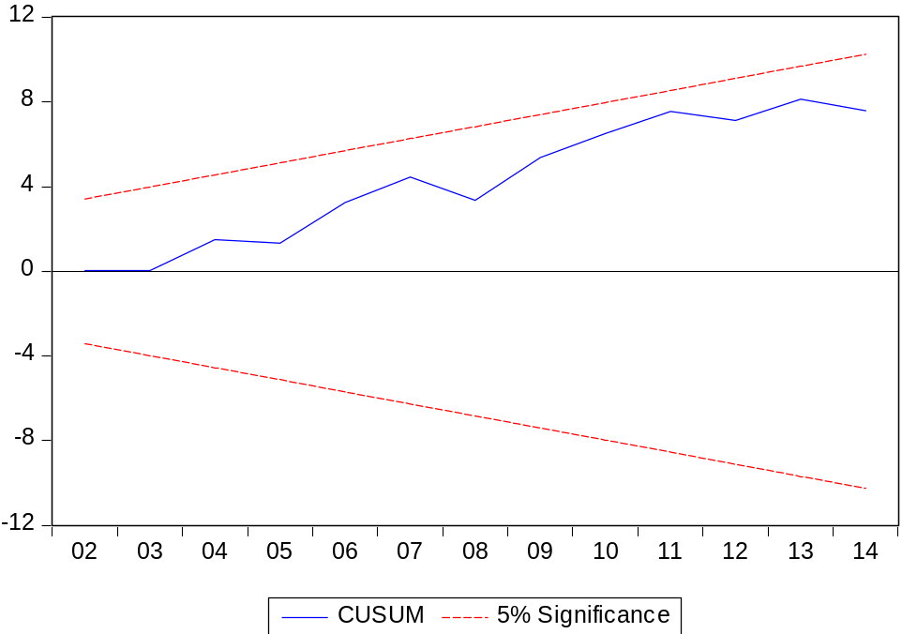

Figure 5.7B CUSUM Recursive Test (Pakistan)
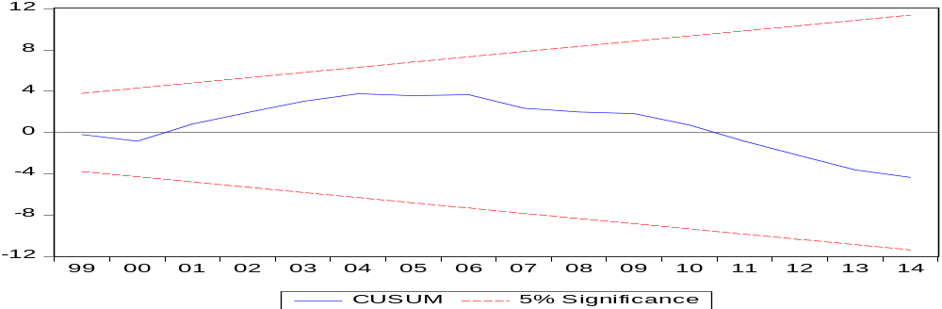

Figure 5.7C CUSUM of Squares Recursive Test (Bangladesh)
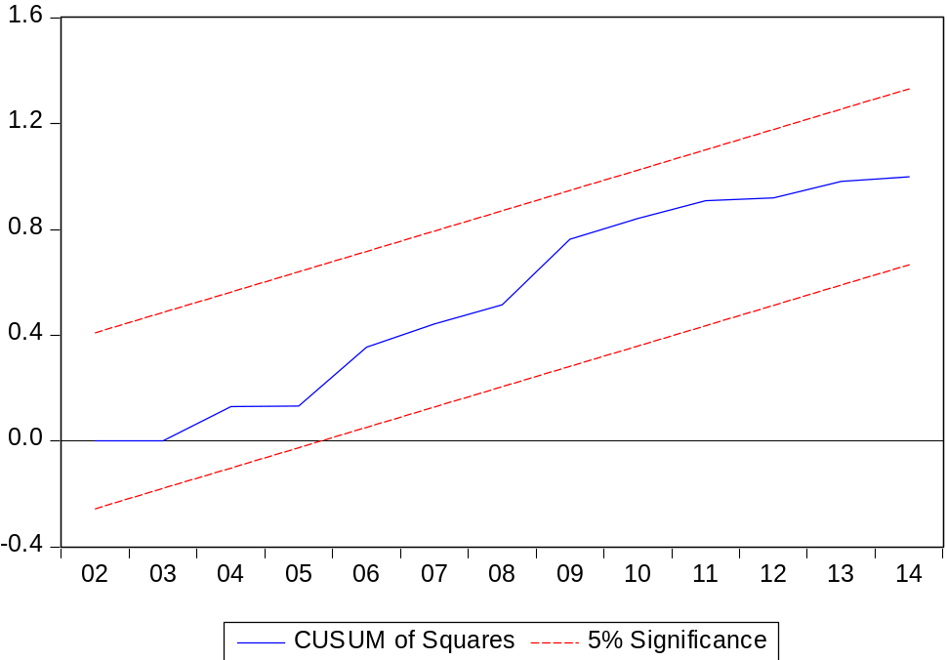

Figure 5.7D CUSUM of Squares Recursive Test (Pakistan)
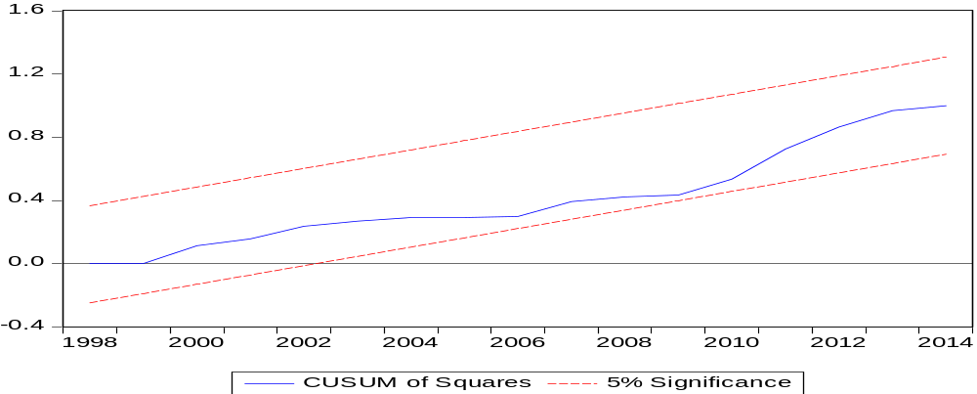
All of the above figures are are showing the reliability tests. In figure 5.7A and 5.7B there is 4 percent level of significance. If the blue line is between these upper and lower bound, then the model is reliable. In figures 5.7C and 5.7D, line is between the blue line, at 4 percent level of significance bounds which confirms the reliability of the long-run model.

Conclusion and policy implications

This study has been conducted in the backdrop of differing growth paths towards reducing gender inequalities between Pakistan and Bangladesh. To this extent, after extensive review of the existing literature, higher participation rates of female labor force in Bangladesh was found to be instrumental in driving these variations in gender inequalities. Therefore, the objective of this study was to investigate empirically the determinants of female labour force participation, which have caused significant changes in FLFP between the two countriesThe impact of the dependent variable (female labour force participation) with independent variables (fertility rate, contraceptive usage, agricultural credit, education levels (primary, secondary & tertiary), RMG and inequalities (GINI) have been studied and a causal linkage has been found between the variables. ADF and PP unit root tests have been applied to find the stationary level of the variables and unit root tests have found the mix order of cointegration. ARDL bounds testing have applied for cointegration of the series for short and long run and all the analysis are bifurcated in to three education levels (gross enrollment primary, gross enrollment secondary, gross enrollment tertiary).
Overall, the results confirm that the fertility rate has a negative relationship with FLFP in both countries for short run and long run for all educational levels. It is one of the strong determinants of FLFP, when fertility rate decreases then the FLFP increases. Particularly in Bangladesh, the relationship remains negative and highly significant at all educational levels, whereas in Pakistan it becomes insignificant for short run at secondary and tertiary level but for long run it is significant.
Furthermore, the readymade garments have contributed to the FLFP in Bangladesh. The relationship remains positive for short run and long run at all educational levels. It depicts, that RMG has played a significant role in the FLFP of Bangladesh. On the contrary, in Pakistan the relationship is negative at all educational levels but is only significant at primary level whereas at other educational level it becomes insignificant. The results confirm that in Pakistan readymade garment sector is still male dominated, women are not encouraged in this sector.
Moreover, the education has a positive relationship with FLFP in both countries for both short run and long run. Education has contributed to FLFP and it is highly significant. Even if there is a small percentage change in the coefficient of education then the FLFP increases by a larger extent.
Interestingly, agricultural credit has contributed to FLFP particularly in Pakistan. The relationship remains positive for both short run and long run at all educational levels except at tertiary level for long run. This shows that in Pakistan the agriculture credit helps in increasing the FLFP. However in Bangladesh the relationship remains negative for short run at primary and secondary levels but in the long run it becomes positive and highly significant for both primary and tertiary levels.
Additionally, contraceptive usage has a positive relationship and significant in Bangladesh for both short run and long run at primary and tertiary level, at the secondary level it becomes negative, but it is insignificant. On the other hand, in Pakistan the relationship is negative at all educational levels for long run and not significant whereas in short run it is positive and significant at secondary and tertiary level, but at the primary level it is negative.
Lastly, the GINI has a negative relationship with FLFP in Bangladesh for both short run and long run at all educational levels and it is significant as well. It goes with the theory that when inequality decreases then the women get more chances in joining the workforce which results in higher FLFP. However, in Pakistan, the relationship is negative and significant for short run at primary and secondary level but at tertiary level it becomes positive, whereas in the long run the relationship is positive for secondary and tertiary level but at the primary level it is negative. It shows that relative to Bangladesh in Pakistan there are more inequalities.

Policy Implications

Based on the results we have proposed some policies that may help Pakistan in improving the FLFP. Firstly, the readymade exports show that an increase in exports will decrease the FLFP which means that this industry is still male dominated. Therefore to attract female labour it’s important that women friendly working environment should be provided and secondly public transport should be safe enough that women can travel as in Pakistan the women are harassed in the public transport and this create barrier for them. The government should give more rebate on exports currently it’s 6 per cent, therefore if there would be an increase in rebate it will encourage more exports. Additionally, the cultural taboos and the perception on the role of working women is more modern compared to Pakistan which is more traditional. Similarly, the energy crisis which Pakistan faces, due to that many industries have faced losses and they have shifted to Bangladesh as they provide concession on energy and, most importantly their wage rate is $ 80 which is low relative to Pakistan which is $ 150. Due to the cheap labour most of the international companies favor Bangladesh. In this respect, Pakistan needs to increase their exports in this sector as it will create more opportunities for women. They should also provide concessions on energy, increase the percentage of rebate on exports and focus on the finished goods as it will favor women. Additionally, the labour laws need to be female friendly, so that more females can join the workforce.
For fertility rate, based on the results more needed to be done in Pakistan so that they have a meaningful impact on increasing FLFP. More employment opportunities should be created to increase female labour force participation because still decrease in fertility rate has not gone a long way in increasing the FLFP especially in short run.
Higher level of education is more significant in increasing FLFP relative to lower levels of education. Government should make more effort on increasing secondary and primary education which constitutes of large population of female labour force. The results clearly show that in terms of employment they more conducive for higher education. More effort is needed for increasing primary and secondary education, as it will lead to an increase in FLFP.
Based on the findings, in the long run contraceptive usage has not contributed to FLFP though in short run it has a negative relationship at primary level. More awareness needs to be created with the involvement of the community and the religious scholars. This can be created through various channels for instance advertisements on TV, radio and advocacy at the grass root level so that people are more aware about the benefits of having less children. More importantly not only women should be targeted, men should be targeted as well. Since most of the reproductive decision-making power is in the hand of husband it is essential to create awareness among them as well. In this aspect, Bangladesh has done remarkably well with the help of community and religious scholars.
Agricultural credit has contributed in the FLFP in Pakistan more can be done as in the long run the relationship becomes insignificant. As mostly women who have gained primary and secondary education have taken loans so for women who have gained tertiary level education they have not benefitted much from agricultural credit. More can be done to create opportunities among the women with higher level of education so that they can also be benefit from it.
Finally, income inequality needs to be reduced as it will help in reducing the gender gap. At the tertiary level it becomes positive which means that the income gap is increasing and due to that few women are benefitting. For instance, we can see that in Pakistan there is huge gap between classes the rich is becoming richer and the poor are becoming poorer. As a result, those who achieve tertiary level of education they are contributing more to the FLFP. Government should try to make efforts to reduce inequalities at primary and secondary level access to education so that more women can become part of the labour force.
The present study has few limitations. Due to data unavailability this study uses overall exports of ready-made garments as a proxy for the development of RMG Sector. Future line of inquiry could look into gender inequalities in the employment of this sector if data permits. Further, the usual suspects of omitted variable bias is also there which warrants inclusion of more variables which affects the FLFP could be added in the future research. Due to data limitations we have restricted our study to thirty years. Nonetheless, this study is an initial step in understanding the determinants of FLFP in Pakistan and Bangladesh and it will help in improving the FLFP in Pakistan if we focus on the determinants which contribute the most.

Bibliography

Aboohamidi, A., & Chidmi, B. (2013). Female Labor Force Participation in Pakistan and Some MENA Countries.
Agarwal, B. (2002). Bargaining and legal change: towards gender equality in India’s inheritance laws. Sussex: Institute of Development Studies Brighton.
Aguirre , D., Hoteit, L., Rupp , C., & Sabbagh, K. (2012). Empowering the third billion women and the world of work . Booz & Company .
Ahmed, F. E. (2004). The rise of Bangladesh garment industry: globalization ,women workers and voice . NWSA, 34-45.
Ali, K. A. (2012). Women, Work and Public Spaces: Conflict and Coexistence in Karachi’s Poor Neighborhoods. International Journal of Urban and Regional Research., 585-605.
Bhattacharya, D., Rahman, M., & Raihan, D. (2002). Contirbution of the RMG sector to the Bangladesh economy. Center for Policy dialogue.
Bloom, E., & Hossain, M. (2014). Project Performance Assessment Report. World Bank.
Bridges, S., Lawson, D., & Begum, S. (2011). Labour Market Outcomes in Bangladesh: The Role of Poverty and Gender Norms. European Journal of Development Research, 459-487.
Chandra, S. J. (2015, october 27). why gender and income inequality are linked . Retrieved from world economic forum : https://www.weforum.org/agenda/2015/10/why-gender-and-income-inequality-are-linked/
Chismaya, G., DeJaeghere, J., Kendall, N., & Khan, M. A. (2012). Gender and Education for All: Progress and Problems in acheiving gender equity. International Journal Of Educational development.
Ejaz, I., Shaikh, B. T., & Rizvi, N. (2011). NGOs and government partnership for health systems strengthening: A qualitative study presenting viewpoints of government, NGOs and donors in Pakistan. BMC Health Services Research .
Ejaz, M. (2007). Determinant of Female Labour Force Participation in Pakistan An Emperical Analysis of PSLM (2004-05) Micro Data. The Lahore Journal of Economics.
Ejaz, M. (2011). The determinants of female labour force partcipation in Pakistan: An instrumental variable approach. Lahore School Of Economics .
Engelhardt, H., & Prskawetz, A. (2002). On the changing correlation between fertility rate and female employment over space and time. Max Planck Institute for Demographic Research .
Field, E., & Vyborny, K. (2016). Policy brief on Female labour force partcipation in Pakistan. Mandaluyong: Asian Development Bank.
Fuller, W. A., & Dickey, D. (1981). Likelihood Ratio Statistics for Autoregressive Time Series with a Unit Root. Econometrica: Journal of the Econometric Society.
(2015). Global gender gap report . World Economic Forum.
Gonzales, C., Chandra, S. J., Kochhar, K., Newiak, M., & Zeinullayev, T. (2015). Catalyst for change: Empowering women and and Tackling income inequality . IMF.
Hafeez, A., & Ahmed, E. (2002). Factors determining the labor force participation decision of educated married women in a district of Punjab .
Hakura, D., Hussain, M., Newiak, M., Thakoor, V., & Yang , F. (2016). Inequality, Gender Gaps and Economic Growth:Comparative Evidence for Sub-Saharan Africa . International Monetary Fund.
Harkness, S. (2010). The contribution of women's employment and earnings to household income inequality : a cross country analysis. Center for Analysis of Social Policy and Department of Social and Policy Studies, University of Bath.
Hasan, K., Mia, M., Ashaduzzaman, Rahman, M., Ahmed Ullah, A., & Ullah, M. (2016). Role of Textile and Clothing Industries in the Growth and Development of Trade & Business Strategies of Bangladesh in the Global Economy. International Journal of Textile Science, 39-48.
Health, R., & Jayachandaran, J. (2016). The Causes and Consequences of Increased Female Education and Labor Force Participation in developing countries. New York: Oxford university press.
(2016). Human development Report. UNDP.
Irani, L., Speizer, I. S., & Fotso, J. C. (2014). Relationship characteristics and contraceptive usage among couples in Kenya. International persepective on sexual and reporductive health, 11-20.
Islam, A. Z., Mondal, N. I., Khatun, L., Rahman, M., Islam, R., Mostafa, G., & Hoque, N. (2016). Prevalence and Determinants of Contraceptive use among Employed and Unemployed Women in Bangladesh. International journal of MDH and AIDS, 92-102.
Isran, S., & Isran, M. A. (2013). Low female labour force partcipation: causes and consequences. Pakistan Journal of Social Sciences , 163-178.
Jayachandaran, S. (2015). The roots of gender inequalities in developing countries . Annual review of economics .
Kabeer, N., & Mahmud, S. (2004). Rags,Riches and Women Workers: Export oreinted garment manufacturing in Bangladesh. In N. Kabeer, & S. Mahmud, Chains of Fortune: Linking women producers and workers with global markets (pp. 133-164). london: commonwealth secretariat.
Kamaran, I., Tasneem, Z., Parveen, T., & Zaidi, Y. Z. (2015). Investigation the low patterns of modern contraceptive use in Pakistan. Population Council.
Kapsos, S. (2008). The gender wage gap in Bangladesh. International Labour Organization.
Khan, m., Akhtar, S., mehmood, H. z., & Muhmood, K. (2013). Analysing Skills, Education and Wages in Faisalabad: Implications for Labour Market . Procedia Economics and Finance 5 , 423-432.
Khatiwada, S. (2014). A Quiet Revolution: Women In Bangladesh. Retrieved from International Labour Organization: http://www.ilo.org/global/about-the-ilo/newsroom/news/
Klasen, S., & Pieters, J. (2013). What Explains the Stagnation of Female. Bonn: IZA.
Lee, N., & Chung, J.-S. (2008). Interrelation between fertility and female labour force in Korea. The Journal Of Applied Business Research .
Mamun, M. z. (2013). Impact of Microcredit on Rural Livelihood: A Case Study in Bangladesh. Social Science Review, the Dhaka University Studies,Part-D, Vol. 30, No. 2, 179-197.
Mira, P., & Ahn, N. (2002). A note on the changing relationship between fertility and female rates in developed countries. Journal of the Population Economics, 667-682.
Mishra, V., & Smyth, R. (2010). Female labor force participation and total fertility rates in the OECD: New evidence from panel cointegration and Granger causality testing. Journal of economics and business, 48-64.
Newbold, P., & Granger, C. (1974). Spurious regressions in econometrics. Journal of econometrics.
Organization, U. N. (2010). Why Gender Equality in Basic Education in Pakistan? Islamabad: UNESCO.
Perron, P., & Phillips, P. C. (1988). Testing for a unit root in time series regression. Biometrika, 335-346.
Priebe, J. (2010). Child Costs and the Causal Effect of Fertility on Female Labor Supply: An Investigation 1993–2008. Courant Research Centre – Poverty, Equity and Growth Discussion papers.
Radhakrishnan, U. (2010). A Dynamic Structural Model of Contraceptive Use and Employment Sector. US Census Bureau Center for Economic Studies Paper No. CES-WP-10-28.
Rahman, D., & Siddiqui, S. A. (2015). Female RMG worker: Economic Contribution in Bangladesh. International Journal of Scientific and Research Publications.
Rahman, R. I., & Islam, R. (2013). Female labour force participation in Bangladesh : trends,drivers, and barriers. International Labour Organization.
(2014). Rapid Assessment of Sexual Harassment in Public Transport and Connected Spaces in Karachi. Manila. Asian Development Bank.
Ray, R. (2000). Child Labor, Child Schooling, and Their Interaction with Adult Labor: Empirical Evidence for Peru and Pakistan. World Economic Bank Review, 347-67.
Razia, B., & Ghazala, Y. (2011). CONTRIBUTION OF PAKISTANI WOMEN IN AGRICULTURE:PRODUCTIVITY AND CONSTRAINTS. Sarhad journal of agricultural.
Salik, M., & Zhiyong, Z. (2014). Gender Discrimination and Inequalities in Higher Education:A case study of Rural Areas of Pakistan. Academic Research International.
Schaner, S., & Das, S. (2016). Female Labour force partcipation in Asia: Indonesia country study. Asian Development Bank.
Sen, A. (2001). The many faces of Gender Inequality . The new republic , 35-38.
Siegel, C. (2012). Female employment and fertility -The effects of rising female wages. The London School OF Economics and Politcial Science.
(2004). Social sector developments . Economics Survey Pakistan .
Steinberg, C., & Nakane, M. (2012). Can women save Japan? International Monetary Fund.
Teignier , M., & Cuberes , D. (2014). Aggregate Costs of Gender Gaps in the Labor Market: A Quantitative Estimate. Ub Economics working papers .
Toor, I. A., & Parveen, R. (2004). Factors Influencing Girls’ Primary Enrolment in Pakistan.
Verick, S. (2014, september ). Female Labour force partcipation in developing countries . Retrieved from I Z A world of labour evidence based policy making : wol.iza.org
(2001). World Development Report 2000/2001:Attacking Poverty. New York: Oxford University Press.
Woytek, K. E., Newiak, M., Kochhar, K., Fabrizio, S., Kpodar, K., Wingender, P., . . . Schwartz , G. (2013). women, work and the economy: macroeconomic gains from gender equality. International monetary fund.

Appendices

Table 8.0A Error Correction Model for Pakistan at Secondary level
Dependent Variable: ∆FLFP
 | Coefficient | Std. Error | t- statistic | Prob.
$$∆lnRMG$$ | -0.054500 | 0.101317 | -0.537914 | 0.6024***
$$∆lnACDDC$$ | 0.000445 | 0.083092 | 0.005355 | 0.0958***
$$∆lnCU$$ | 0.141970 | 0.064908 | 2.187263 | 0.0536***
$$∆lnFR$$ | 0.341312 | 1.260932 | 0.270682 | 0.7921
$∆lnGES$ (secondary) | 0.408929 | 0.211398 | 1.934402 | 0.0818***
$$∆lnGINI$$ | -0.284677 | 0.097727 | -2.912980 | 0.0155**
ECM_{t-1} | -0.561021 | 0.141811 | -3.956126 | 0.0027*
***,**,* signifies 10 percent, 5 per cent and 1 per cent respectively

Table 8.0B Error Correction Model for Bangladesh at Secondary level
Dependent Variable: ∆FLFP
 | Coefficient | Std. Error | t- statistic | Prob.
$$∆lnRMG$$ | 0.060226 | 0.018546 | 3.247380 | 0.0100*
$$∆lnACDDC$$ | -0.451123 | 3.395814 | -0.132847 | 0.8972
$$∆lnCU$$ | 0.001003 | 0.014205 | -0.774597 | 0.4584
$$∆lnFR$$ | -0.393164 | 0.489553 | -2.845786 | 0.0192**
$∆lnGES$ (Secondary) | 0.041059 | 0.018757 | 2.188965 | 0.0563***
$$∆lnGINI$$ | -0.740288 | 0.224783 | -3.293349 | 0.0093*
ECM_{t-1} | -0.798685 | 0.174267 | -4.53102 | 0.0013*
***,**,* signifies 10 percent, 5 per cent and 1 per cent respectively

Table 8.0C Error Correction Model for Pakistan at Tertiary level
Dependent Variable: ∆FLFP
 | Coefficient | Std. Error | t- statistic | Prob.
$$∆lnRMG$$ | -0.681033 | 0.109058 | -6.244669 | 0.0001*
$$∆lnACDDC$$ | 0.073748 | 0.034345 | 2.147293 | 0.0573*
$$∆lnCU$$ | 0.106197 | 0.037237 | 2.851907 | 0.0172**
$$∆lnFR$$ | -0.021715 | 0.353480 | -0.061432 | 0.9522
$∆lnGET$ (Tertiary) | 0.012402 | 0.033584 | 0.369292 | 0.7196
$$∆lnGINI$$ | 0.085827 | 0.046039 | 1.864233 | 0.0919***
ECM_{t-1} | -0.681033 | 0.109058 | -6.244669 | 0.0001*
***,**,* signifies 10 percent, 5 per cent and 1 per cent respectively

Table 8.0D Error Correction Model for Bangladesh at Tertiary level
Dependent Variable: ∆FLFP
 | Coefficient | Std. Error | t- statistic | Prob.
$$∆lnRMG$$ | 0.055600 | 0.019184 | 2.898292 | 0.0339**
$$∆lnACDDC$$ | 0.346750 | 6.306853 | 2.750460 | 0.0403**
$$∆lnCU$$ | 0.065851 | 0.018619 | 3.536683 | 0.0166**
$$∆lnFR$$ | -0.680009 | 0.746588 | -2.250250 | 0.0743***
$∆lnGET$ (Tertiary) | 0.144126 | 0.063487 | 2.270150 | 0.0724***
$$∆lnGINI$$ | -0.912380 | 0.333330 | -2.737165 | 0.0409**
ECM_{t-1} | -0.542469 | 0.443151 | -3.480682 | 0.0176
***,**,* signifies 10 percent, 5 per cent and 1 per cent respectively

Table 8.0E Long Run Estimates (BANGLADESH Secondary Level)
Dependent variable = $lnFLFP$
 | Coefficient | Std. Error | t- statistic | Prob.
$$C$$ | 0.396569 | 4.802705 | 3.118019 | 0.0000
$$lnFR$$ | -0.892138 | 0.485619 | -2.955566 | 0.0002*
$lnGES$(secondary) | 0.051408 | 0.016700 | 3.078405 | 0.0132**
$$lnCU$$ | -0.013777 | 0.016907 | -0.814853 | 0.4362
$$lnGINI$$ | -0.249797 | 0.112984 | -2.210900 | 0.0544***
lnRMG | 0.222553 | 0.014678 | 2.162842 | 0.0000*
lnACDDC | -0.564832 | 4.285559 | -0.131799 | 0.8980
***,**,* signifies 10 percent, 5 per cent and 1 per cent respectively

Table 8.0F Long Run Estimates (Pakistan)
Dependent variable = $lnFLFP$
 | Coefficient | Std. Error | t- statistic | Prob.
$$C$$ | 0.792199 | 1.317181 | 3.638224 | 0.0046
$$lnFR$$ | -0.748130 | 0.946510 | -2.903434 | 0.0157**
$lnGES($Secondary) | 0.420387 | 0.352494 | 2.192609 | 0.0606***
$$lnCU$$ | -0.387167 | 0.299450 | -1.292927 | 0.2251
$$lnGINI$$ | 0.507427 | 0.189167 | 2.682432 | 0.0230**
lnRMG | -0.097144 | 0.166660 | -0.582887 | 0.5729
lnACDDC | 0.229329 | 0.117837 | 1.946148 | 0.0803***
***,**,* signifies 10 percent, 5 per cent and 1 per cent respectively

Table 8.0G Long Run Estimates (BANGLADESH)
Dependent variable = $lnFLFP$
 | Coefficient | Std. Error | t- statistic | Prob.
$$C$$ | 0.840821 | 3.970671 | 3.285621 | 0.0001
$$lnFR$$ | -0.241529 | 0.579750 | -3.866371 | 0.0118**
$lnGET$ (tertiary) | 0.093438 | 0.025839 | 3.616181 | 0.0153**
$$lnCU$$ | 0.042692 | 0.009043 | 4.720785 | 0.0052*
$$lnGINI$$ | -0.416562 | 0.100708 | -4.136342 | 0.0090*
lnRMG | 0.180157 | 0.021323 | 2.448966 | 0.0004*
lnACDDC | 0.246090 | 3.795404 | 2.963081 | 0.0314**
***,**,* signifies 10 percent, 5 per cent and 1 per cent respectively

Table 8.0H Long Run Estimates (Pakistan)
Dependent variable = $lnFLFP$
 | Coefficient | Std. Error | t- statistic | Prob.
$$C$$ | 2.024271 | 0.310068 | 6.528482 | 0.0001
$$lnFR$$ | -0.937075 | 0.245336 | -3.819560 | 0.0034*
$lnGET$(Tertiary) | 0.122810 | 0.032561 | 3.771710 | 0.0037*
$$lnCU$$ | -0.106294 | 0.099858 | -1.064445 | 0.9884
$$lnGINI$$ | 0.126025 | 0.062849 | 2.005191 | 0.0728**
lnRMG | -0.015152 | 0.085157 | -0.177927 | 0.8623
lnACDDC | 0.000699 | 0.046908 | 0.014895 | 0.9884
***,**,* signifies 10 percent, 5 per cent and 1 per cent respectively

Cusum Recursive Test
Figure 8.1 A Bangladesh ( Secondary Level)
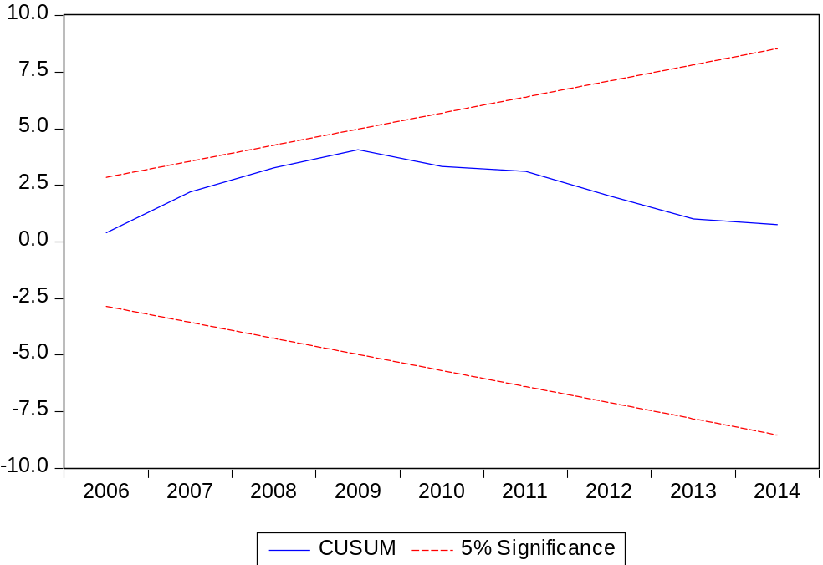
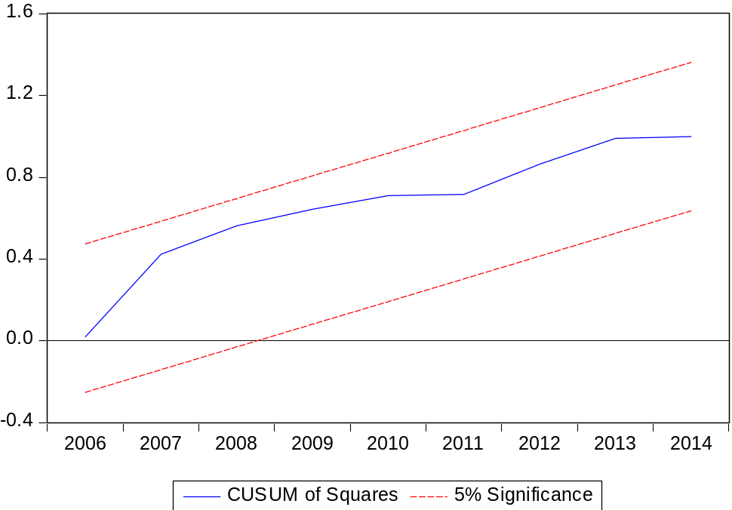

Figure 8.1B Bangladesh (Tertiary Level)
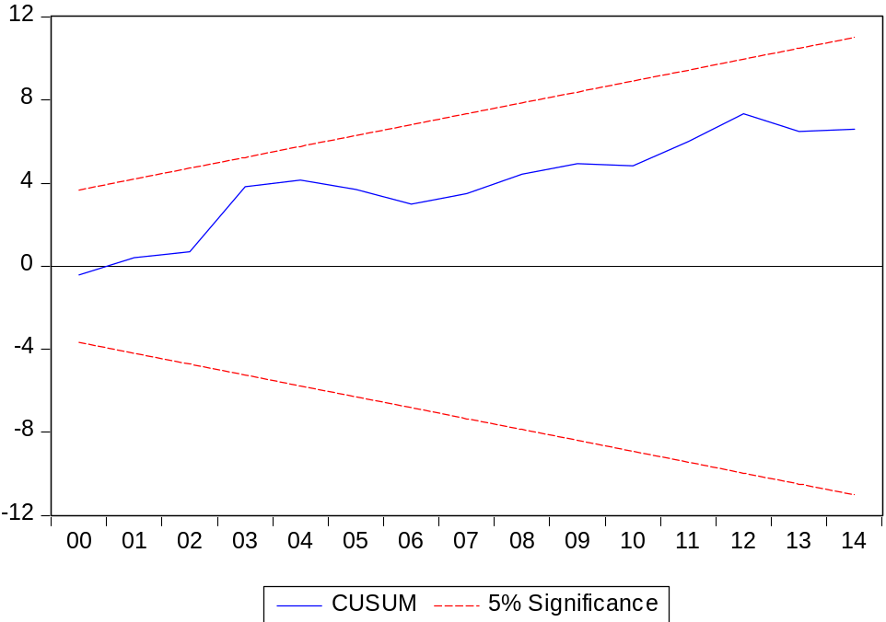
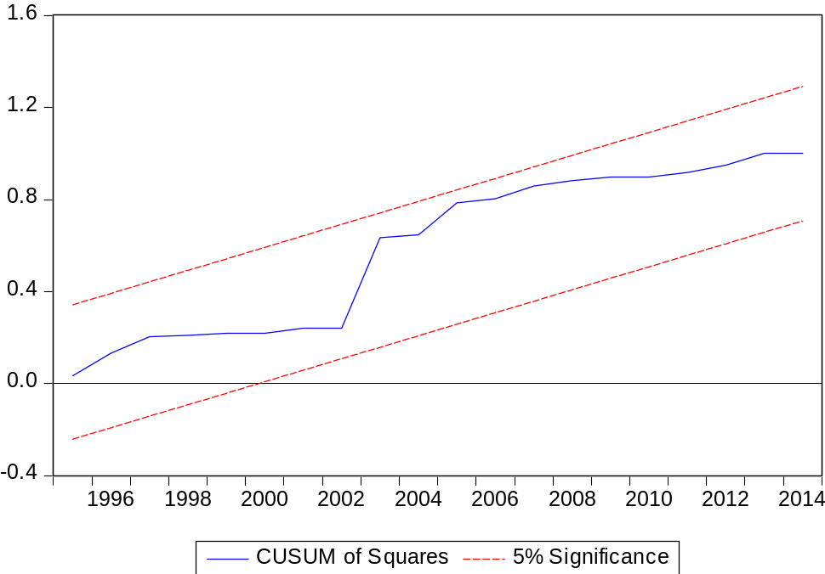

Figure 8.1C Pakistan (Secondary Level)
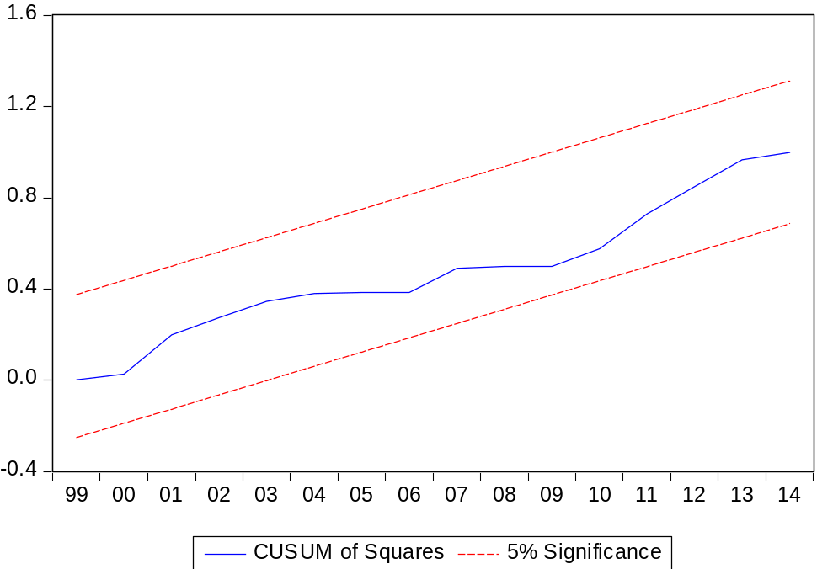

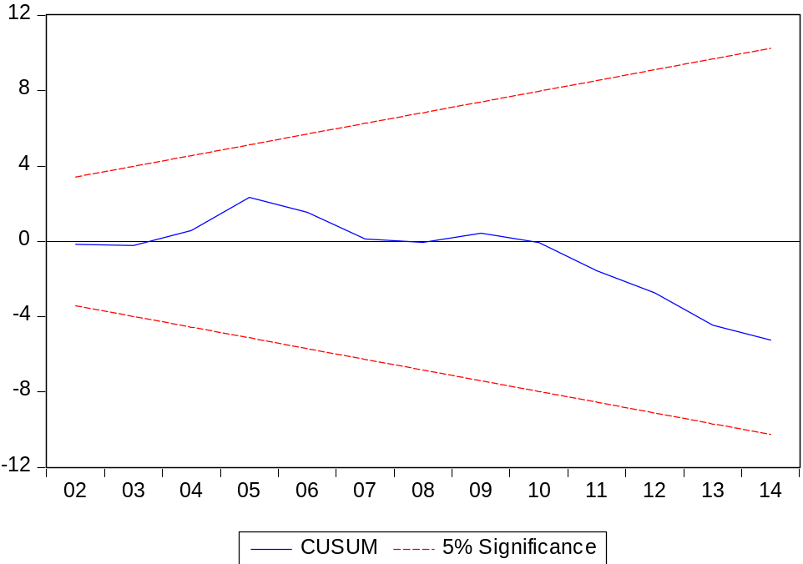

Figure 8.1D Pakistan (Tertiary Level)
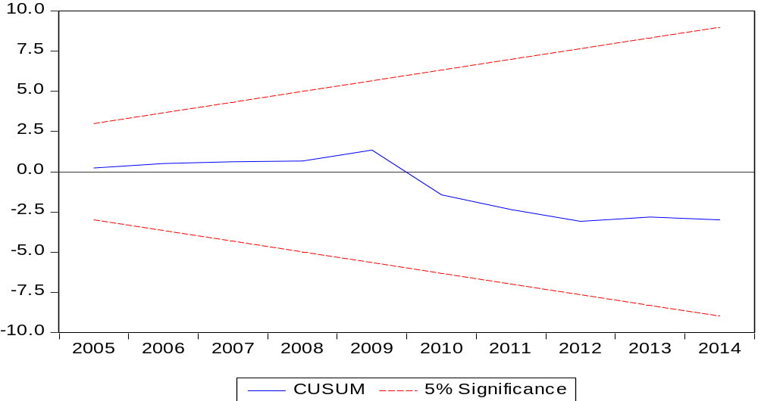
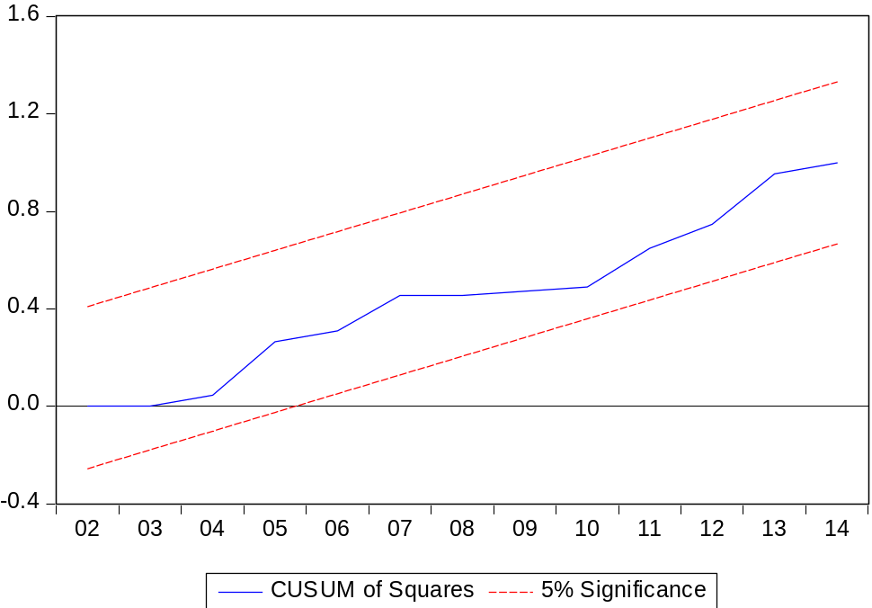

(World Development Report 2000/2001:Attacking Poverty, 2001)
(Ejaz, Shaikh, & Rizvi, 2011)
(Human development Report, 2016)
(Human development Report, 2016)
(Global gender gap report , 2015).
(Global gender gap report , 2015).
Authors’ calculation using the data from BGMEA and PREGMA

