INSTITUTIONS AND EXPORTS OF FIRMS: A CROSS COUNTRY ANALYSIS

By

Maryium Nazif

Thesis submitted to the Lahore School of Economics
in partial fulfillment of the requirements for the degree of
MPhil Economics
2019

Supervised by: Dr Shaheen Naseer

Abstract
Institutional perceptions in the country influence export propensity of firms based on standard theories. This study using a sample of 11,970 firms across three countries Pakistan, India and Bangladesh investigates the relationship between institutions and export propensity of firms. The study develops a moderation model to investigate the mechanism linking institution and export. Empirical analysis makes use of three main category of variables, namely the variable of interest (export propensity), institutional variables (corruption, political instability and informal sector) and moderating variable (innovation). The results show that institutional characteristics have an effect on the export propensity of firms however these effects are not uniform across the three countries. Innovation moderates the relationship between the institutional variables and export propensity of firms, though they are not similar for the three countries and not for all institutional variables.

1. Introduction
A voluminous body of literature on economic growth subscribes to the idea that exports are an engine of economic growth (Bhagwati, 1978; Krueger, 1978). Empirical research has confirmed the view that exports contribute to economic growth by enabling countries to produce according to their comparative and competitive advantage thus raising productivity and overall economic growth.
There are two different schools of thought regarding the relationship between exports and economic growth when we discuss developing countries. First is the neoclassical school of thought, which propagates that good export performance can enhance economic growth in the developing countries through increasing specialization, greater market size leading to greater economies of scale, being able to afford greater capacity utilization and new technology. The neoclassical school presents a positive image of the relationship between exports and economic growth, but in contrast, the neo-Marxist school of thought is skeptical about the trade between developing and developed nations as it results in the exploitation of the developing nations (Ram, 1987). Even though in theory, there are different thoughts about the relationship between exports and economic growth but empirically, a study using a sample of seventy-three countries depicts that export expansion can lead to greater economic growth (Kavoussi, 1984).
We cognize that better export performance can lead to greater economic growth in developing countries but there are different determinants that affect export performance in the developing countries. Firstly, the relationship between firm size (economies of scale) and export performance is an inverted U-shape, which implies that economies of scale can only help firms up to a certain point in entering foreign markets, which is quite understandable as large firms have strong domestic market share; hence they are less inclined to export. Foreign ownership is positively related to the export propensity of firms. Younger firms are likely to export earlier than older firms. In supplier dominated firms, more skilled labor is positively related to a firm’s export performance while R&D is positively related to the firm’s export intensity only for mature firms (Dijk, 2002). Moreover it is seen that many different factors influence the export performance of firms, for instance, the firm size, the ownership, age, etc.
The aim of this study is to determine the relationship and intensity of the relationship between institutional quality and export performance of the firms. Institutions are a significant part of the Country’s framework moreover its affect is not limited to the daily workings of the government. Everything is affected in some way or another by the institutions or institutional characteristics of the country. Economy is also impacted and determined by the nature of the institutions a country has.
It is understandable that institutions and exports are absolutely vital for the country’s economy but it would be intriguing to witness how they interact with each other and this is precisely what this paper intends to investigate. This paper studies how the institutional characteristics such as corruption, political instability, etc. which are identified by the firms as an obstacle, affect their export propensity.
Moreover through the use of the moderating variable, innovation, looking at these institutional characteristics relationship with export performance of firms.
The rest of this paper is organized as follows: Section 2 discusses relevant literature, Section 3 presents the general comparison of exports of the three countries, Section 4 presents a conceptual framework linking exports and institutions, Section 5 describes the empirical methodology used, Section 6 discusses the results of the study and Section 7 presents the conclusion of the paper.

2. Literature Review

2.1 Pakistan
There is extensive literature on Pakistan explaining the relationship between exports and economic growth but there is ambiguity regarding the direction of causality. A study using rich time series data of 43 years (1960-2003) for Pakistan concluded that growth in exports leads to output growth but the converse in not true (Shirazi & Manap, 2004). Contradictory literature is also present where a study investigating the causal relationship between exports and GDP using data from 1975 to 2010 finds that there is unidirectional causality that is in short and long run output growth causes export growth (Abbas, 2012).
Several problems exist in the export sector of Pakistan. One of the biggest problems in the export sector of Pakistan is the lack of product diversification. A study investigating the structural change in exports of Pakistan using the data from 1972-2012 concluded that the export base of Pakistan is still fairly traditional with the least traditional industries accounting for less than ten percent of the total exports in 2012 (Ahmed & Hamid, 2014). This non diversification of exports have resulted in Pakistan exporting low value added exports like agricultural products which have a significant negative effect on the economic growth (Faridi, 2012). There is also literature on how to tackle different problems concerning the export sector of Pakistan. A study presented a comprehensive set of policies by analyzing different Asian countries who have been successful in increasing their exports. The set of policies outlined in the paper are focusing on sectors in which the country already possesses expertise while gradually developing new export sectors, transitioning from low value added to higher value added exports, having a mix of policies rather than having a single policy to boost exports, integrating education and training with the industrial policy to develop skilled workforce needed for the production of higher value added exports and credit policies to enhance technological up gradation (Chaudhry & Andaman, 2014).
The relationship of institutions and economic growth has also been investigated by studies in Pakistan. There is evidence that the causality is unidirectional and only exists in the long run that is the institutional quality affects the economic growth of a country in the long run (Siddiqui & Ahmed, 2009). There are also studies looking at the institutional characteristics in Pakistan and its impact on economic growth. Corruption is very evident in Pakistan as it ranks 117 out of 180 countries in the corruption perceptions index 2018 by Transparency International. Study using time series data from 1987-2009 concluded that corruption obstructs economic growth in Pakistan (Farooq et al., 2013).
As seen from our analysis of literature above on Pakistan that there is literature present on the relationship of exports and economic growth, problems and solutions of Pakistan’s export sector and the relationship between institutions and economic growth. This paper aims at filling the gap in literature that exists because not much work is done on the relationship between institutions and exports/export propensity of firms in Pakistan. A study investigates how the quality of institutions affect the relationship between trade and economic growth (Chaudhry, 2011) but does not empirically test the relationship and does not look at the direct relationship between institutions and exports/export propensity of firms.

2.2 India
Literature on exports and economic growth in case of India presents the same problem of ambiguity in terms of the direction of causality. A study by using the Granger causality test concluded that there is a unidirectional relationship between real GDP and exports but only in the long run and causality runs from GDP to exports (Mishra, 2011). Study done on India using two measures of GDP, GDP including and excluding exports also failed to prove that exports granger cause GDP (Sharma & Panagiotidis, 2005). There are many papers which negate the Export Led Growth hypothesis, some of which are mentioned above but there are also studies done which support the ELG hypothesis. A study using the augmented production function finds that in India, growth in exports had a significant impact on economic growth mainly in the 1980s (Nidugala, 2000).
There is a study similar to this paper done on India which finds that emerging economy firms are more likely to export if they perceive greater informal competition and high political instability (Krammer et al., 2018). This paper does not only investigate the relationship between institutions and export propensity of firms but also investigates how innovation affect the relationship between institutions and export propensity of firms.

2.3 Bangladesh
In case of Bangladesh there is evidence of a unidirectional long run relationship between exports and economic growth where the causality runs from exports to economic growth (Mamun & Nath, 2005). Another study on Bangladesh also validates the export led growth hypothesis using a two sector growth model and finding out that export growth through its positive impact on total factor productivity increases the GDP growth significantly (Begum & Shamsuddin, 1998).
There are papers on Bangladesh which investigate the relationship between institutions and economic growth like in case of Bangladesh there exists a positive relationship between corruption and economic growth (Paul, 2010).The gap in literature for Bangladesh exists in terms of investigating the relationship between institutions and export/export propensity of firms which is the objective of this paper.

2.4 Institutions
There are instances where the institutional imperfections actually lead to greater number of exports by a firm for example, if there is political instability in a country then the firms operating in that country would look for alternate profitable markets to sell their products (Guillaumont et al., 1999) meaning they would rely more on exports and less on the sales in the domestic market. There are studies that indicate that corruption is perceived as extra favorable among companies that: do no longer face great competition, are especially large, and are new (Sharma & Dhiman, 2014) . The evidence indicates that corruption and political instability obstacle will increase the probability that a company enters the foreign marketplace (Kapri, 2018). Kapri shows that for a one-unit growth in corruption, there is a 7 percentage factors growth inside the possibility of exporting. Also, for a one-unit increase within the political instability, the model anticipates 32.2 percent points increase in the chance of exporting. Furthermore, Kapri finds that the impact of political instability on firm’s export decision decreases if the extent of corruption is excessive. For that reason, the estimation results conclude that corruption and political instability boom the company’s chance of getting into the foreign marketplace and the impact of corruption decreases when the extent of political instability is high.
Institutional imperfections leading to greater exports is not always the case as we can see in literature that corruption is a major impediment in the way of economic development of nations ( (Chadee & Roxas, 2013); (Wang & You, 2012)). The evidence is also there which indicates that government reforms (institutions) have positive impact on firm’s performance and also on its exports (Nguyen, Le, & Bryant, 2013). Institutions that protect property rights that is informal sector in economy are vital to monetary boom and to investment that effects the firm performance of exports (Knack & Keefer, 1995). A sustainable economic growth leads to increase in exports and for sustainable growth the institution quality matters for the country (Majeed et al., 2006). There are also studies which shows that institutional quality is important for new and small firms for its export performance as compare to large and established firms (LiPuma et al, 2013).

2.5 Innovation
Institution and export performance of the firms are related but to see its relationship the factor of innovation is important. Exporting firms have access to knowledge not available locally which might improve their internal learning process thus forming the basis of innovation (Cabral et al., 2015). Innovation have positive effects in terms of enhancing firm performance in manufacturing industries (Gunday et al., 2011), which helps in improving manufacturing industries and with it countries export of manufacturing products increases. India’s decreasing export performance growth in the manufacturing sector is due to an exceptionally aggressive worldwide financial system dynamics primarily based on technology‐concentrated opposition; export promoting rules which includes tax vacations and allowing duty‐loose imports for export‐ orientated corporations can be effective in enhancing export performance (Francis, 2015). This shows technology (innovation) and tax vacations (institution like political stability) are important for the exports of the manufacturing sector. Innovation can help in introduction of new products in or in diversifying commodities used for trade, which can promote export growth at the extensive margin ( (Krugman, 1979); (Grossman & Helpman, 1989) ). Innovation itself is very import for the export growth of the country and with it if good quality institutions are there in the country, it can lead to high growth in its exports.

3. General Comparison of Exports of Pakistan, India and Bangladesh
In this section the paper compares the export sectors of Pakistan, India and Bangladesh by looking at the composition of their exports, major trading partners, problems in their export sector, future prospects for their exports and statistical/graphical comparison.

3.1 Composition of Exports

The above table shows that major exports of Pakistan are cotton manufactures, which account for almost 56.7 percent of Pakistan’s total export. The other two major exports are leather items and rice which cumulatively with cotton manufactures makes up 69.2 percent of total exports of Pakistan. This shows that Pakistan’s export composition mostly consists of primary products or less sophisticated goods because of which exports of Pakistan are lagging. High value added products are not exported by Pakistan translating to less export revenue and consequently the high value of imported specialized goods, culminates current account deficit.

The above table shows the amount of total exports of Bangladesh for the years 2011-16 disaggregated on the basis of primary and manufactured commodities. We can see that manufactured exports make up more than 95% of the total exports of Bangladesh in 2015-16 but we need to be very careful in analyzing this table because on the basis of this, one can deduce that Bangladesh actually exports more specialized or sophisticated goods but, that is not true. Knitwear and woven garments make up more than 85% of the total manufactured commodities exported in 2015-16, so it is quite obvious that Bangladesh also does not export very high value added goods but this statistic shows the dominance of textile sector in the export sector of Bangladesh.

Breakdown of total exports of India (2016)

The above figure shows the breakdown of India’s total exports by main commodity groups for the year 2016. We can see that manufactured commodities make up 70.5% of the total exports of India in 2016 followed by fuel and mining products and agricultural products. If we further investigate, we see that India’s two largest exports are refined petroleum (10.3%) followed by diamonds (9.1%) (O.E.C). Even though the exports of India are not so specialized, but they are more valuable, which is why India is the 17th largest exporter in the world. Pakistan, on the other hand is the 68th largest exporter (OEC) and despite the similarities in exports of Bangladesh with Pakistan, its rank is much better, as Bangladesh is the 54th largest exporter in the world (OEC).

3.2 Major Trading Partners
Pakistan

The above table shows the major export destinations/partners of Pakistan for the years 2015-18. The top destination for the exports of Pakistan is USA as 16% of the total exports of Pakistan are exported to the United States. The other major export partners of Pakistan are China, Afghanistan, United Kingdom and Germany, to each of which Pakistan exports more than 5% of its total exports. Even though the US is the leading export partner of Pakistan but the situation might change with the completion of China Pakistan Economic Corridor (CPEC) as China might overtake USA in terms of the top destination for Pakistan’s Exports.
Bangladesh

Source: WTO
The figure above shows the breakdown of Bangladesh’s total exports by main destination for the year 2015. It shows that the top destination for Bangladesh’s exports is European Union, as 24.5 % of the total exports were exported to the European Union in the year 2015. The second major export partner of Bangladesh is the United States which accounts for 19.3% of the total exports for the year 2015. So in terms of the major trading partners, Pakistan and Bangladesh are somewhat similar with US being one of the top export destination but on the other hand Bangladesh only exports about 2.3% of their exports to China which is almost 3 times less in terms of the percentage of exports that are exported to China by Pakistan, the reason for which can be the relationship of each country with China.
India

Source: WTO
The above figure depicts the breakdown of the total exports of India by main destination for the year 2017. The biggest export partner or destination for the exports of India is European Union, where 17.4% of the total exports of India are exported while the United States comes in at 2nd place as 16.1% of India’s exports are exported to United States. However it is evident that in terms of Individual countries, United States would be the top destination for the Indian Exports which is quite understandable looking at the close relationship between these two countries.

3.3 Problems in their Export Sector
Pakistan
Pakistan faces a number of problems that affect their exports, for instance, terrorism, low GDP growth, energy crises, narrow industrial base, etc. Other than these there are some other factors that affect the exports of Pakistan:
There is a high cost of doing business in Pakistan, which results in Pakistan’s exports to be uncompetitive in the global market. The reasons for this high cost of doing business are cost of utilities, raw material and finance cost, lack of skilled labor, lack of technology, poor infrastructure and unavailability of supporting institutions. The table below shows that in year 2014 Pakistan was charging higher electricity tariff than other countries in the region.
Electricity Tariff of Pakistan and other Regional Countries
Source: International Energy Agency

Another problem with Pakistani exports is competitiveness, which can be seen in the table below that shows Pakistan is the worst in terms of its rank in the Index of Competitiveness when compared its other regional competitors.
Index of Competitiveness
There is very low level of sophisticated goods in the exports of Pakistan. Pakistan’s main exports are textile, whereas if we see the figure below it is clear that the world’s exports consist of mainly sophisticated goods like non pharmaceutical chemicals, automotive products, etc.
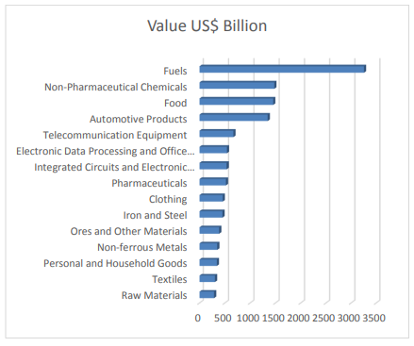

Pakistan’s exports also have a problem in terms of market access, even though it enjoys GSP plus status with European Union and GSP facility was also provided by US in 2015 but still, Pakistan needs to sign more free trade/ preferential treatment agreements with other countries. CPEC can provide a real boost to Pakistan’s export as more trade agreements are being signed with China and apart from this; other countries are also interested in using this route subsequently resulting in further agreements.
There is a mammoth problem of poor infrastructure in Pakistan, as its road network ranks 72nd in 132 countries in terms of quality of roads network and 60th in 132 countries when it comes to railroad infrastructure.
In the meanwhile, Pakistan’s government is also unsupportive and does not facilitate trade as it ranks 116th in 132 countries in terms of Global Enabling Trade Index 2012. As the table depicts, because of the lengthy procedure and document requirements it takes more days for an item to be exported as compared to other countries.
Efficiency of Export Performance
Other than these above mentioned complications, there is noncompliance with international quality standards, law and order situation, unskilled labor, etc. (Study on Reasons of Decline in Exports of Pakistan, 2015).

Bangladesh
Bangladesh’s export sector also faces various hindrances. One of the major problems is the political instability, which affects the law and order situation in the country which in turn affects the country’s exports. Secondly, there is the electricity shortage, which leads to a loss of 12.3 percent of sales according to a World Bank report, and this figure is much higher as compared to Pakistan and India, where the loss is of 5.4 percent and 5.5 percent of sales respectively. There is also very low use of labor in Bangladesh’s economy even though it can take advantage in the labor intensive industries, as there is a high number of working age population that are unemployed. Related to the last point that there should be more labor intensive industries, however to enhance production and exports, it is obligatory for the labor to attain skills which will subsequently be useful in achieving the target. Lastly, another point related to labor is that due to noncompliance of labor safety standards, Bangladesh can lose their exports as well as their reputation in the international market (Kathuria & Malouche, 2016).
India
India has similar problems as Pakistan and Bangladesh, as mentioned earlier there is electricity shortage issue which results in the loss of 5.5 percent of sales (Kathuria & Malouche, 2016). In addition, there is a huge issue of ease of doing business where India ranks below Pakistan and Bangladesh as indicated by the figure below:
Ease of Doing Business
Even though India performs better in the competitiveness Index than Pakistan and Bangladesh however, it still falls behind as compared to other regional competitors, as it can be seen in the table of Index of competitiveness in the subsection of the problems of export sector of Pakistan. Electricity Tariff rates in India are also high as compared to other regional countries, except for Pakistan, which is evident in the table depicting Electricity Tariff of Pakistan and other Regional Countries in the subsection of the problems of export sector of Pakistan (Study on Reasons of Decline in Exports of Pakistan, 2015).
It has been identified that all the three countries are facing problems in their export sectors, which if rectified, may help boost the exports, consequently help enhance their global market share and competitiveness in the international market.

3.4 Policy measures for Increased Export Performance
Pakistan
There are a number of policy measures that are required to increase total exports of Pakistan and help its global market competitiveness.
Firstly, there should be a diversification of goods and markets, as mentioned earlier, more than 50 percent of the total exports of Pakistan comes from textile which needs to be reformed and more sophisticated goods must be supplemented in Pakistan’s export product mix. In addition, Pakistan needs to explore new markets for their products and should keep their focus on dynamic economies like China and India.
There should be a higher share of advance technology products in the exports of Pakistan. For Pakistan to achieve this, it needs to promote Small Medium Enterprises (SMEs) which have proven to be beneficial in the case of East Asian countries. Furthermore SMEs can provide a base to promote high technology exports in the future but to achieve this; there should be relaxation of constraints that act as a hindrance in the development of these firms. Limited access to credit, higher cost of accessing information, etc. chiefly constitute these barriers.
Agro based products can also help increase export growth in the medium term in Pakistan. With the natural climate, land and irrigation facilities available, Pakistan has a comparative advantage in producing these products. Pakistan needs to focus on quality control of these products and develop marketing infrastructure, which will ultimately result in these products making meaningful impact in total exports.
There should also be a policy framework that is supportive, there is evidence of supportive economic policies resulting high export oriented growth in Asia. To accomplish this, there is a need for trade policy that is outward oriented, similarly exchange rate policy that is competitive and measures taken to ensure macroeconomic stability.
Lastly, Pakistan needs to enhance its export competitiveness. For this, there is a need to develop skills of their labor force, reduction in the cost of doing business through rationalizing administrative regulations, improving the legal system and eliminating delays in tax related refunds, investing in infrastructure and facilitating trade (Ahmed et al., 2010).
Bangladesh
Bangladesh has provided different objectives and policies in their export policy of 2015 to 2018 to enhance their export performance. They want to liberalize the trade regime to be consistent with the World Trade Organization’s requirements and gradually increasing their export earnings to 60 billion US dollars by the year 2021.The policy hints, that they want to diversify export products and markets by investing in the provision infrastructure, enhancing services sector in exports including ICT, facilitating easy availability of raw materials and moreover, branding their products. The focal point of this policy is to encourage foreign direct investment in export oriented industries to enhance their export performance, hence enabling the economy to export quality products at a competitive price, meanwhile assisting firms to acquire skilled workforce.
All of these policies can really help Bangladesh achieve greater export growth as these policies are very much related to discussion before on the problems that are being faced by the export sector of Bangladesh. Interpretation of this policy report hints, that Bangladesh is really anxious about their export performance and enhancing their export performance is one of their top priorities (Export Policy 2015 - 2018).
India
India’s Foreign Trade Policy (FTP) 2015-20 outlays the ways in which the exports can be increased, conjointly enabling employment generation and higher value addition in India. If we study this report, India seems to be very concerned about the ease of doing business in their country, so their main focus is to facilitate trade and enable ease of doing business, in addition implementing 24 hours of paperless working. To counter costly materials import, measures to encourage the procurement of capital goods from local manufacturers are laid out. Furthermore specific business units in different schemes are to enjoy Fast Track clearance facility, using duty free equipment for training purposes and allowing them to set up near the port from where their product would be exported. India also put forward a roadmap to boost exports of Defense and higher technology items. India is already paving its way for the augmentation of its E-Commerce market and in this policy, it depicts that they want to further increase exports of different products such as books, toys, handloom products, customized fashion garments and leather footwear.

3.5 Statistical/Graphical Comparison of their Exports
In this section, the paper takes advantage of the World Bank data to compare the difference in total exports of the three countries (Pakistan, Bangladesh and India). We have used two simple indicators to compare these three countries, first being the total export of goods and services over the years which would give an idea about their performance over the years as well as the difference between them and secondly, we have used growth rate of total exports of goods and services which would also give us an idea about their historical performance and may indicate whether there is a chance that these countries might overtake or catch up.
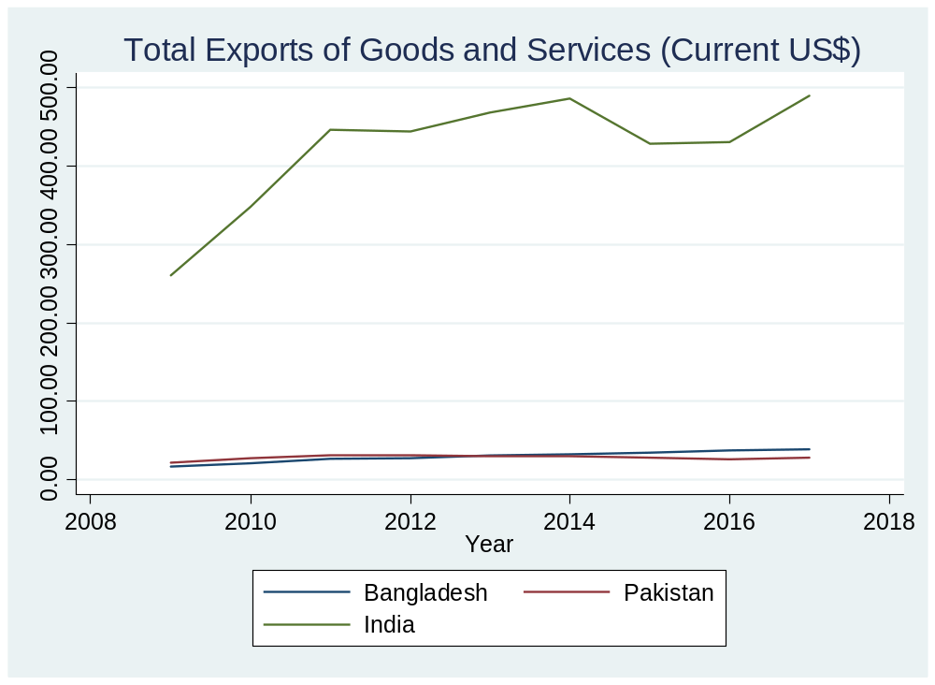
The above graph shows the total exports of goods and services for the years 2009 to 2017 for Pakistan, India and Bangladesh. The graph is not so visually appealing because of the difference in the level of exports. India’s exports for the year 2017 were 489.40 billion $ whereas for Pakistan and Bangladesh it were 28.89 and 39.16 billion $ respectively. Even though the graph is not that engaging, nonetheless it gives some insights about the total exports of these countries. One insight being, that there is a huge difference in terms of the value of the total exports of goods and services between India and the other two, in addition, each of these three countries have enjoyed export growth, as the level of exports that they have at present is higher than what they had in 2009. So we get an idea about how far up the value chain India is in terms of the exports, which is understandable when we compare the relative sizes of these countries as well as the differences in their resources.
To better comprehend graphically the situation of the total exports we look at the graph below which includes only the total exports of Pakistan and Bangladesh for the years 2009 to 2017.
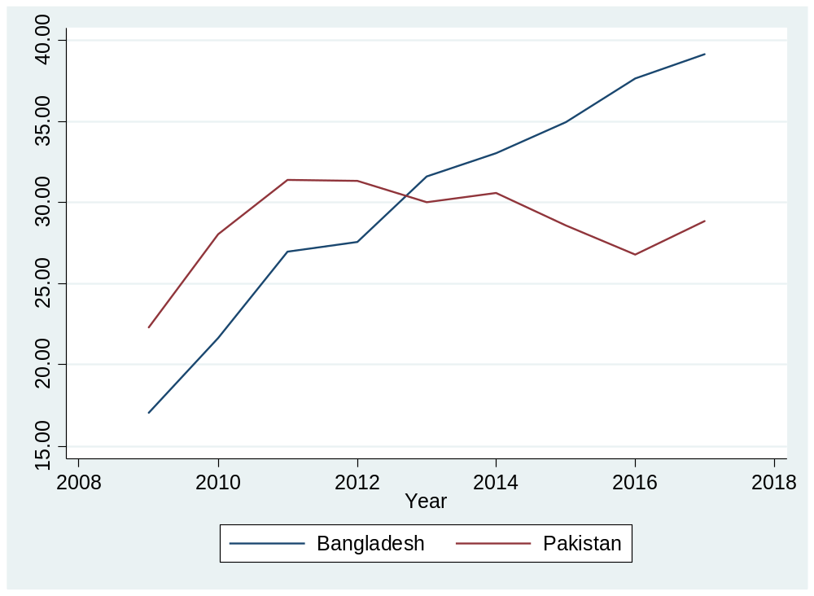
In the above graph we can see that the total exports for Bangladesh have an upward trend meaning, from 2009 to 2017, it has been on a constant rise whereas, in Pakistan’s case, there has been a decline after 2011 and even still in 2017, it is below in value as compared to the exports Pakistan had in 2010. Even though Pakistan exports were decreasing after 2011, exports have again picked up the momentum in 2016. We have seen that exports for all three countries have increased from the year 2007 to 2017 but it would be interesting to look at the annual growth rate of exports during these years which can be seen in the graph below.
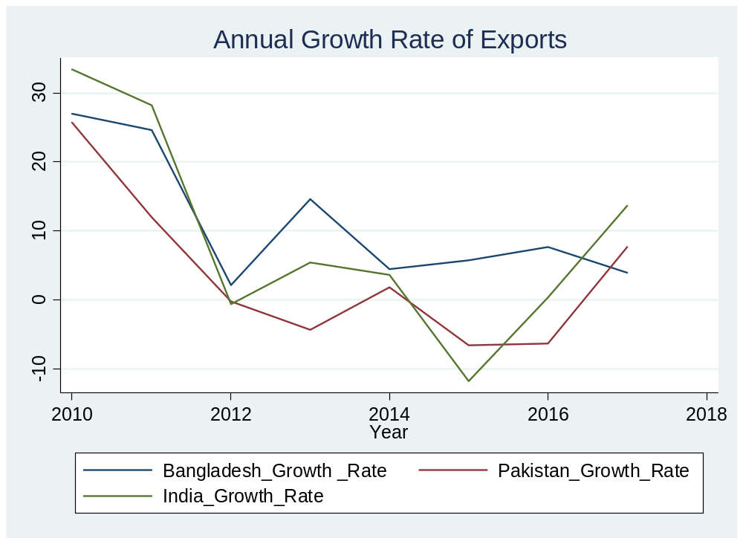

From the graph above we can clearly see that the annual growth rate of exports has shown a downward trend for all the three countries, it does not mean that they experienced a reduction in their exports but rather means that their exports did not grow as quickly as it was growing before. Also there is some degree of correlation between the growth rates of these three countries which could be because of being in the same region or because of having almost same trading partners or maybe because of facing similar problems when we talk about their export sectors. Bangladesh’s annual export growth rate has never been negative for the years 2010 to 2017, while for Pakistan it has been negative multiple times and for India, a couple of times. The annual growth rate of exports for the year 2017 is highest for India, followed by Pakistan and then Bangladesh. One interesting inference that can be drawn from the graph is that if the trend continues as it is there from the year 2016 to 2017 then India and Pakistan will enjoy a huge increase in their total exports while Bangladesh will have increase in exports but at a slower rate or might see a decrease in their exports. Also if we see the trend line only for the two years 2016-17 we can see that India and Pakistan’s trend line is almost parallel which infers, that even though Pakistan might enjoy an increase in their total exports but the gap between India and Pakistan’s exports would remain same because India’s exports would be increasing on almost the same rate which means that Pakistan might be able to catch up to Bangladesh owing to their downward trend in 2016-17 time frame but would not be possible for either Pakistan or Bangladesh to catch up to India.

4. Exports and Institutions: A Conceptual Framework
To illustrate the role of institutions in the determination of exports, we utilize a simple production framework based on the notion of a production set. Consider a small open economy which takes international prices as given. Suppose the economy produces a composite exportable good $y>0$ by using a vector of inputs $\left(h, z\right)∈R ×R^{n}$ where $h>0$ denotes human capital and $z≫0$ is a vector of $n$ inputs. The production of the composite exportable can be defined as:
$y≤f\left(h, z\right)$ (1)
According to equation (1), given production technology, $f(.)$, the output of exportable depends on human capital and other inputs. It is assumed that human capital exerts a positive influence on the production of exportable by allowing better use of technology and skills to produce according to the world market requirements. The production of exportable may or may not be technically efficient and whether production is maximized for any combination of inputs in the production set so that the production is technically efficient depends on institutionally quality. To formally incorporate the role of institutional quality, let $θ>0$ measure the quality of institutions with higher $θ$ denoting better institutional quality. It is assumed that for a given level of inputs, the higher the institutional quality the higher will be the productivity of the economy and the higher output of the exportable will be realized. This can be captured as:
$y=max⁡\{y∈R_{++}:y=θ.f\left(h, z\right)$} (2)
From equation (2), it is clear that the higher the value of $θ$, the higher the output of the exportable will be realized, and in the ideal case of a highly efficient institutional and regulatory framework, output of exportable will be at the technology frontier. Better institutional quality allows the economy to deploy its resources efficiently and maximize production. This simple framework shows how institutional quality can influence exports of the economy. To augment the production technology and include the role of other control variables such as (firm age and firm size), equation (2) can be modified as follows:
$y=max⁡\{y:y=θ.f\left(h, z;x\right)$} (3)
Where $x∈R^{l}≫0$ is a vector of control variables that affect the production/supply of exportables but do not directly influence the production technology. The precise relationship between exports, institutional quality and other control variables is an empirical issue which is dealt with in the next section.

5. Empirical Methodology

In this study we are using a new methodology which has recently got popularity in exports research. Checked the relationship between export performance with cluster resources with moderating variable technological intensity (Prim et al., 2016). We have seen that the moderating framework is new and is being used in the exports research recently but why to use moderators. Moderators represent the appropriate conditions that validate/invalidate the investigated relationships (Yeoh and Jeong, 1995)..
The data for this research is collated from the World Bank’s Enterprise Surveys of firms. In this paper, we make use of several variables which can be divided into three main categories, namely the variable of interest (export propensity), institutional variables (corruption, political instability and informal sector) and moderating variable (innovation). The descriptive statistics are there for these variables at the end of this section which show that the three countries are quite different in terms of which institutional characteristic are the biggest obstacle for them as well as in other variables like innovation.
The institutional variables (political instability, corruption and informal sector) in this study are based on the perceptions of the owners and senior managers of the firms operating in these three countries. These variables represent that are they an obstacle for these firms or not (dummies) and does not represent objective values of these institutional variables that might be calculated on a regional/country level (e.g. the ICRG index of corruption). As mentioned, these are based on the perceptions of the owners and top managers of the firms so it is quite plausible that the actual situation of these institutional characteristics might be very different than how the owners or managers perceive them to be.
For this study to fulfill its aim of finding the answer of the questions mentioned before, two different regressions have been run. First being how political instability, corruption and informal sectors affect export intensity of the firm. Secondly, how these factors interacted with innovation (moderating factor) affects the export intensity of the firm.
The specification for the first regression is as follows:
$$X_{i}\left({Export Propensity}_{i}\right)=a_{0}+a_{1}{Political Instability}_{ij}+a_{2}{Corruption}_{ij}+a_{3}{Informal Sector}_{ij}+δ_{i}Y_{ij}+ε_{ij}$$
Export propensity is a dummy variable which is 1 for a firm if it has some percentage of its sales as either direct or indirect exports and otherwise zero. Political instability is a dummy variable which takes a value of 1 if the firm feels that political instability is an obstacle for them otherwise 0. Corruption is a dummy variable which is equal to 1 if the firm feels that corruption is an obstacle for them otherwise 0. Informal sector is also a dummy variable which is equal to 1 if the firm feels that the practices of its competitors in the informal sector are an obstacle for them otherwise 0. Y is the vector of controls including: firm size, firm age and size of the locality in which the firm operates.
Specification of the second regression:
$$X_{i}\left({Export Propensity}_{i}\right)=a_{0}+a_{1}{Political Instability}_{ij}+a_{2}{Corruption}_{ij}+a_{3}{Informal Sector}_{ij}+a_{4}{Innovation}_{ij}+a_{5}{Political Instability}_{ij}{Innovation}_{ij}+a_{6}{Corruption}_{ij}{Innovation}_{ij}+a_{7}{Informal Sector}_{ij}{Innovation}_{ij}+δ_{i}Y_{ij}+ε_{ij}$$
Innovation variable is a dummy variable which takes on a value of 1 if the firm has introduced new or significantly improved products/services or has introduced new or significantly improved processes in the last three years and 0 otherwise. So this innovation variable takes into account both the product as well as process innovation.
The above regression specification is for the moderating variable which is innovation in this case; the idea is that how political instability, corruption and informal sector interacted with innovation affects the export propensity of a firm. The main purpose is to see that innovation moderates the relationship of these variables with export propensity or not.
Descriptive Statistics
 | Pakistan |  |  | India |  |  | Bangladesh
 | Mean | SD | Obs. | Mean | SD | Obs. | Mean | SD | Obs.
Variable of Interest
Export Propensity | 0.19 | 0.39 | 1148 | 0.16 | 0.36 | 9281 | 0.25 | 0.43 | 1442
Institutional Variables
Political Instability | 0.77 | 0.42 | 1191 | 0.57 | 0.49 | 9259 | 0.97 | 0.16 | 1441
Corruption | 0.82 | 0.39 | 1216 | 0.86 | 0.35 | 9264 | 0.87 | 0.34 | 1437
Informal Sector | 0.68 | 0.47 | 1198 | 0.58 | 0.49 | 9081 | 0.53 | 0.50 | 1437
Moderating Variable
Innovation | 0.35 | 0.48 | 1246 | 0.60 | 0.49 | 9275 | 0.52 | 0.50 | 1442
Controls
Firm Age | 22.55 | 13.74 | 1125 | 19.60 | 14.29 | 9260 | 20.98 | 13.69 | 1437
Firm Size | 155.8 | 730.3 | 1238 | 112.8 | 352.1 | 9275 | 218.2 | 652.4 | 1442

6. Results

Pakistan
Table 1: Relationship between Institutional variables and Export Propensity (Pakistan)

 | OLS | OLS | Probit | Probit
VARIABLES | Export Propensity | Export Propensity | Export Propensity | Export Propensity
Political Instability | 0.0315 | 0.0463 | 0.149 | 0.193
 | (0.0314) | (0.0324) | (0.124) | (0.138)
Corruption | 0.177*** | 0.171*** | 0.945*** | 0.948***
 | (0.0326) | (0.0330) | (0.172) | (0.183)
Informal Sector | 0.0148 | 0.0285 | 0.0574 | 0.180
 | (0.0279) | (0.0286) | (0.106) | (0.117)
Controls | No | Yes | No | Yes
Observations | 1,074 | 995 | 1,074 | 995
Standard errors in parentheses
*** p<0.01, ** p<0.05, * p<0.1
Note: Export propensity is a dummy variable which is 1 for a firm if it has some percentage of its sales as either direct or indirect exports and otherwise zero. Controls include Firm Age, Firm Size which is proxied by the total full time employees and Size of the locality in which the firm operates.

In the case of Pakistan, all of the institutional variables are insignificant except the corruption variable which is significant across all the specifications. The sign on the corruption variable is positive which means that the more a firm feels that corruption is an obstacle, the firm would be more likely to export. One would expect the sign should be negative but the positive sign is also justified in the sense that if the incidence of corruption is high in your home country, the firm would look for alternate markets for its products where the firm would not be facing the corruption at least in the selling of their products.
Table 2: Moderating Effect of Innovation on the Relationship between Institutional variables and Export Propensity (Pakistan)
 | OLS | OLS | Probit | Probit
VARIABLES | Export Propensity | Export Propensity | Export Propensity | Export Propensity
Political Instability | 0.0137 | 0.0331 | 0.0815 | 0.192
 | (0.0359) | (0.0377) | (0.152) | (0.172)
Corruption | 0.144*** | 0.148*** | 0.922*** | 0.920***
 | (0.0360) | (0.0369) | (0.208) | (0.219)
Informal Sector | 0.00808 | 0.0261 | 0.0358 | 0.167
 | (0.0339) | (0.0353) | (0.140) | (0.155)
Innovation | 0.0585 | 0.0524 | 0.556 | 0.483
 | (0.0888) | (0.0900) | (0.415) | (0.448)
Political Instability x Innovation | 0.00608 | 0.0102 | 0.00157 | -0.114
 | (0.0734) | (0.0750) | (0.274) | (0.297)
Corruption x Innovation | 0.0452 | 0.0232 | -0.197 | -0.122
 | (0.0861) | (0.0870) | (0.390) | (0.412)
Informal Sector x Innovation | 0.0201 | 0.00513 | 0.0509 | 0.0250
 | (0.0588) | (0.0603) | (0.218) | (0.236)
Controls | No | Yes | No | Yes
Observations | 1,073 | 994 | 1,073 | 994
Standard errors in parentheses
*** p<0.01, ** p<0.05, * p<0.1
Note: Export propensity is a dummy variable which is 1 for a firm if it has some percentage of its sales as either direct or indirect exports and otherwise zero. Controls include Firm Age, Firm Size which is proxy by the total full time employees and Size of the locality in which the firm operates.

From table 2, we can see that in case of Pakistan innovation does not play a moderating role when it comes to the relationship between institutional variables and export propensity. Another important result is that innovation is not significant in any of the specifications which is quite unexpected but the variable that I am using is based on the fact that if the firm has introduced a new or significantly improved products/services or processes in the last three years but it does not take into account that if that product/service or process is new in the market as well or more specifically new in the market that the firm is exporting to. Also we can say that the firms in Pakistan are innovating but they are very far away from the technological frontier as Pakistan ranks 105th out of 129 countries in the Global Innovation Index (Global Innovation Index 2019).

India
Table 3: Relationship between Institutional variables and Export Propensity (India)
 | OLS | OLS | Probit | Probit
VARIABLES | Export Propensity | Export Propensity | Export Propensity | Export Propensity
Political Instability | 0.0451*** | 0.0411*** | 0.191*** | 0.184***
 | (0.00838) | (0.00820) | (0.0354) | (0.0362)
Corruption | -0.00575 | 0.0145 | -0.0251 | 0.0639
 | (0.0119) | (0.0118) | (0.0507) | (0.0526)
Informal Sector | -0.0325*** | -0.0287*** | -0.135*** | -0.107***
 | (0.00786) | (0.00770) | (0.0326) | (0.0334)
Controls | No | Yes | No | Yes
Observations | 9,053 | 9,028 | 9,053 | 9,028
Standard errors in parentheses
*** p<0.01, ** p<0.05, * p<0.1
Note: Export propensity is a dummy variable which is 1 for a firm if it has some percentage of its sales as either direct or indirect exports and otherwise zero. Controls include Firm Age, Firm Size which is proxied by the total full time employees and Size of the locality in which the firm operates.

Table 3 shows that in the case of India, corruption is an insignificant institutional variable in relation to the export propensity but political instability and informal sector are both significant. Political instability and informal sector have opposite signs, political instability is positive meaning that if a firm feels that political instability to be an obstacle then the firm is more likely to export which makes sense as the firm’s local sales would get affected due to the political instability so it would look for foreign markets to sell their products and on the other hand if we see informal sector has a negative sign which means that if the firm feels that practices of the informal sector to be an obstacle then the firm would be less likely to export.
Table 4: Moderating Effect of Innovation on the Relationship between Institutional variables and Export Propensity (India)
 | OLS | OLS | Probit | Probit
VARIABLES | Export Propensity | Export Propensity | Export Propensity | Export Propensity
Political Instability | 0.0434*** | 0.0386*** | 0.235*** | 0.234***
 | (0.0129) | (0.0127) | (0.0602) | (0.0616)
Corruption | -0.0124 | 0.0104 | -0.0706 | 0.0355
 | (0.0171) | (0.0168) | (0.0798) | (0.0830)
Informal Sector | -0.0193 | -0.0179 | -0.107* | -0.0838
 | (0.0124) | (0.0122) | (0.0574) | (0.0589)
Innovation | 0.0940*** | 0.0871*** | 0.399*** | 0.405***
 | (0.0225) | (0.0220) | (0.0976) | (0.101)
Political Instability x Innovation | -0.0253 | -0.0211 | -0.168** | -0.167**
 | (0.0172) | (0.0168) | (0.0753) | (0.0770)
Corruption x Innovation | 0.0159 | 0.0107 | 0.0838 | 0.0557
 | (0.0238) | (0.0233) | (0.104) | (0.107)
Informal Sector x Innovation | -0.0256 | -0.0212 | -0.0567 | -0.0479
 | (0.0160) | (0.0157) | (0.0700) | (0.0717)
Controls | No | Yes | No | Yes
Observations | 9,047 | 9,022 | 9,047 | 9,022
Standard errors in parentheses
*** p<0.01, ** p<0.05, * p<0.1
Note: Export propensity is a dummy variable which is 1 for a firm if it has some percentage of its sales as either direct or indirect exports and otherwise zero. Controls include Firm Age, Firm Size which is proxy by the total full time employees and Size of the locality in which the firm operates.

In the table above we can clearly see that innovation has a positive effect on export propensity meaning that more a firm innovates then the firm would be more likely to export. If we look at the moderating effect of innovation, there is no moderating effect of innovation except in the case of political instability which can be seen by the significance of the interaction between political instability and innovation in the third and fourth column (probit results) of table 4. We can see that the sign of this interaction term is negative but the sign of political instability is positive so we can say that innovation moderates the relationship between political instability and export propensity. The negative sign of the interaction term between political instability and innovation means that if an innovating firm feels political instability to be an obstacle then that firm would be less likely to export.

Bangladesh
Table 5: Relationship between Institutional variables and Export Propensity (Bangladesh)
 | OLS | OLS | Probit | Probit
VARIABLES | Export Propensity | Export Propensity | Export Propensity | Export Propensity
Political Instability | 0.0605 | 0.0679 | 0.222 | 0.220
 | (0.0724) | (0.0679) | (0.250) | (0.283)
Corruption | 0.0969*** | 0.0687** | 0.326*** | 0.238*
 | (0.0340) | (0.0317) | (0.115) | (0.125)
Informal Sector | -0.171*** | -0.131*** | -0.542*** | -0.428***
 | (0.0227) | (0.0214) | (0.0739) | (0.0809)
Controls | No | Yes | No | Yes
Observations | 1,433 | 1,428 | 1,433 | 1,428
Standard errors in parentheses
*** p<0.01, ** p<0.05, * p<0.1
Note: Export propensity is a dummy variable which is 1 for a firm if it has some percentage of its sales as either direct or indirect exports and otherwise zero. Controls include Firm Age, Firm Size which is proxied by the total full time employees and Size of the locality in which the firm operates.

In the case of Bangladesh, table 5 shows that political instability is not a significant institutional variable when it comes to its relationship with export propensity. On the other hand, corruption and informal sector both are significant but with opposite signs. Corruption has a positive sign which means that if a firm feels corruption to be an obstacle then the firm would be more likely to export. Informal sector on the other hand has a negative sign which means that if a firm feels that practices of the informal sector to be an obstacle then the firm would be less likely to export.
Table 6: Moderating Effect of Innovation on the Relationship between Institutional variables and Export Propensity (Bangladesh)
 | OLS | OLS | Probit | Probit
VARIABLES | Export Propensity | Export Propensity | Export Propensity | Export Propensity
Political Instability | 0.139 | 0.140 | 0.761 | 0.784
 | (0.0986) | (0.0953) | (0.490) | (0.535)
Corruption | -0.0120 | -0.0132 | -0.0350 | -0.0592
 | (0.0430) | (0.0405) | (0.151) | (0.159)
Informal Sector | -0.0944*** | -0.0924*** | -0.391*** | -0.359***
 | (0.0324) | (0.0308) | (0.120) | (0.127)
Innovation | 0.250* | 0.151 | 1.023* | 0.740
 | (0.141) | (0.135) | (0.594) | (0.660)
Political Instability x Innovation | -0.132 | -0.128 | -0.764 | -0.886
 | (0.141) | (0.135) | (0.587) | (0.648)
Corruption x Innovation | 0.159** | 0.144** | 0.516** | 0.576**
 | (0.0692) | (0.0654) | (0.244) | (0.269)
Informal Sector x Innovation | -0.162*** | -0.0859** | -0.325** | -0.147
 | (0.0447) | (0.0425) | (0.155) | (0.165)
Controls | No | Yes | No | Yes
Observations | 1,433 | 1,428 | 1,433 | 1,428
Standard errors in parentheses
*** p<0.01, ** p<0.05, * p<0.1
Note: Export propensity is a dummy variable which is 1 for a firm if it has some percentage of its sales as either direct or indirect exports and otherwise zero. Controls include Firm Age, Firm Size which is proxy by the total full time employees and Size of the locality in which the firm operates.
Table 6 shows us the moderating effect of innovation on the relationship between institutional variables and export propensity. We can see that innovation moderates the relationship of corruption and informal sector with export propensity. Even though it moderates the relationship of both corruption and informal sector but the moderation is quite different in both cases as we can see that corruption coefficient is lower in magnitude in table 5 as compared to the magnitude of corruption’s interaction with innovation in table 6 whereas in the case of informal sector the coefficient is more negative in table 5 than the magnitude of the coefficient of interaction between informal sector and innovation in table 6. Also, another interesting factor here is that the moderation only makes the relationship stronger or weaker in this case but does not change the sign of the relationship. So the positive and significant interaction term of corruption and innovation means that if an innovating firm would feel that corruption is an obstacle then the firm would be more likely to export whereas in the case of the interaction between informal sector and innovation, if an innovating firm feels that practices of informal sector to be an obstacle then the firm would be less likely to export.

Table 7: Summary of Regression Results
Dependent Variable: Export Propensity | Pakistan | India | Bangladesh
Political Instability | No Relationship | Positive | No Relationship
Corruption | Positive | No Relationship | Positive
Informal Sector | No Relationship | Negative | Negative
Political Instability x Innovation | No Relationship | Positive | No Relationship
Corruption x Innovation | No Relationship | No Relationship | Positive
Informal Sector x Innovation | No Relationship | No Relationship | Negative

Table 7 provides a summary of the regression results. An interesting observation that we can see from the table above is that for all the three countries, the relationship of different variables with export propensity either does not exist but if it does for any two countries then the sign of the relationship is the same for both the countries.
In case of Pakistan, all of the institutional variables are insignificant except the corruption variable with a positive sign whereas in the case of India, corruption is not significant but the other two institutional variables are significant. Political Instability is significant with a positive sign and informal sector as well but with a negative sign for India. Bangladesh regression results have similarities with Pakistan, as corruption variable is significant for Bangladesh as well with positive sign and with India as informal sector variable is significant with a negative sign. So we can see that all the three institutional variables that are in question in this study might not be significant for all but if they are significant, then the signs are consistent. The only exception is political instability, which is only significant in the case of India whereas the other two institutional variables are significant for two countries.
If we look at the regression results of the other part of the study, which is the role of innovation in moderating the relationship between institutional variables and export propensity, then it is only there in the case of India where the sign does not change but the magnitude is lower. Pakistan is the only country in our analysis where the moderating effect of innovation does not exist in terms of the relationship between institutional variables and export propensity. Bangladesh is the other unique case in our analysis where the moderating role of innovation does not only exist for one institutional variable’s relationship with export propensity but exists for two, corruption and informal sector’s relationship with export propensity.
These summary of regression results actually give insights about which institutional flaws are the most critical for these countries like in the case of Bangladesh and Pakistan, corruption is important but not in the case of India, where political instability is more important which is not true for the other two countries. Another important insight we acquire from our results is, that these institutional flaws actually lead countries to explore other markets and export more but this is not true only in the case when the firm feels practices of the informal sector to be an obstacle.

7. Conclusion

Using the World Bank enterprise data on Pakistan, India and Bangladesh, this study established that there are different institutional variables that matter when it comes to the export performance of the firms working in these countries, furthermore innovation in some cases acts as a moderating variable when it comes to the relationship between institutional variables and export propensity.
The main two hypotheses that we explore in this study are, that whether institutional characteristics affect the export propensity of firms in these countries and does innovation act as a moderating variable in the relationship between the institutional variables and export propensity.
An interesting finding of this study is that even though there are different institutional variables that came out to be significant in these countries, but there is a consistency in the signs of these significant variables. Corruption is significant in the cases of Pakistan and Bangladesh and in both the cases, it had a positive sign. Informal sector is significant in the case of India as well as Bangladesh and the sign of informal sector is also consistent across both the countries (negative).
In Pakistan’s case, there is no moderating effect of innovation, a probable reason that there may be innovating firms in Pakistan but they are still behind other players in the global market as mentioned earlier that Pakistan ranks 105th among 129 countries in global innovation index (Global Innovation Index). There are moderating effects of innovation in the cases of India and Bangladesh. For India, innovation moderated the relationship between political instability and export propensity as innovation made the relationship negative which was positive before. For Bangladesh, innovation did not change the sign of the relationship but changed the magnitude as it made the relation of corruption and export propensity stronger and on the other hand made the relationship between informal sector and export propensity weaker.
The results of this study are also consistent with the literature as there is a study that establishes that firms in emerging economies would be more likely to export if there is high incidence of political instability and corruption in their home country (Krammer et al., 2018). Also informal competition is detrimental to the whole economic environment and if the cost of compliance is high then formal firms would lose head to head in competition with informal players because of the cost advantage (González & Lamanna, 2007).
Furthermore this study could be improved if there is a big panel that could estimate changes overtime as the world bank enterprise survey is done for each country in a particular year and there might be some factors of that particular year that might have changed the results like the data for Pakistan is from 2013 which was the year of election and new government came into power. Also it would have been interesting if we had the data for all the three countries from the same year.

Bibliography
Abbas, S. (2012). Causality between Exports and Economic Growth: Investigating Suitable Trade Policy for Pakistan. Eurasian Journal of Business and Economics, 91-98.
AHMAD, M. T. (2006). Determinants of Exports in Developing Countries . The Pakistan Development Review.
Ahmed, H., & Hamid, N. (2014). Patterns of Export Diversification: Evidence from Pakistan. The Lahore Journal of Economics, 307-326.
Ahmed, H., Mahmud, M., Hamid, N., & Talal-Ur-Rahim. (2010). A Strategy for Reversing Pakistan's Dismal Export Peformance. CREB Policy Paper.
Baron, R. M., & Kenny, D. A. (1986). The moderator–mediator variable distinction in social psychological research: Conceptual, strategic, and statistical considerations. Journal of personality and social psychology, 1173.
Begum, S., & Shamsuddin, A. F. (1998). Exports and economic growth in Bangladesh. The Journal of Development Studies, 89-114.
Cabral, J. E., Coelho, A. F., Coelho, F. J., & Costa, M. D. (2015). Capabilities, innovation, and overall performance in Brazilian export firms. RAM. Revista de Administração Mackenzie, 76-108.
Chadee, D., & Roxas, B. (2013). Institutional environment, innovation capacity and firm performance in Russia . Critical perspectives on international business, 19-39.
Chaudhry, A. (2011). Tariffs, Trade and Economic Growth in a Model with Institutional Quality. The Lahore Journal of Economics, 31-54.
Chaudhry, A., & Andaman, G. (2014). The Need for a Coordinated Industrial Strategy to Boost Pakistani Exports: Lessons from Asia. The Lahore Journal of Economics, 177-206.
Commerce, M. o. (2015). Export Policy 2015 - 2018. Government of People's Republic of Bangladesh.
Commerce, M. o. (2015). Study on Reasons of Decline in Exports of Pakistan. Government of Pakistan.
Dhiman, R. &. (2014). Study of Post Reform Period of Indian Exports: A Review. Review of Business Technology and Research. (RBTR) ISSN 1941-9414.
Dijk, M. v. (2002). The Determinants of Export Performance in Developing Countries: The Case of Indonesian Manufacturing. Eindhoven Centre for Innovation Studies Working Paper,.
Faridi, M. Z. (2012). Contribution of agricultural exports to economic growth in Pakistan. Pakistan Journal of Commerce and Social Sciences, 133-146.
Farooq, A., Shahbaz, M., Arouri, M., & Teulon, F. (2013). Does corruption impede economic growth in Pakistan? Economic Modelling, 622-633.
Francis, S. (2015). India’s Manufacturing Sector Export Performance: A Focus on Missing Domestic Inter-sectoral Linkages. Institute for Studies in Industrial Development.
González, A. S., & Lamanna, F. (2007). Who Fears Competition from Informal Firms? An Evidence from Latin America. Policy Research Working Paper (World Bank).
Grossman, G. M., & Helpman, E. (1989). Product development and international trade. Journal of political economy, 1261-1283.
Guillaumont, P., Jeanneney, S. G., & Brun, J.-F. (1999). How Instability Lowers African Growth. Journal of African Economies, 87-107.
Gunday, G., Ulusoy, G., Kilic, K., & Alpkan, L. (2011). Effects of innovation types on firm performance. International Journal of Production Economics, 662-676.
Joseph A. LiPuma, S. L. (2013). The effect of institutional quality on firm export performance in emerging economies: a contingency model of firm age and size. Small Business Economics.
Kapri, K. (2018). Corruption, Political Instability and Firm-Level Export Decisions.
Kathuria, S., & Malouche, M. M. (2016). Toward New Sources of Competitiveness in Bangladesh. World Bank Group.
Keefer, S. K. (1995). Institutions and Economic Performance:Cross-Country Tests Using AlternativeInstitutional Indicators. MPRA.
Knack, S., & Keefer, P. (1995). Institutions and economic performance: cross‐country tests using alternative institutional measures. Economics & Politics , 207-227.
Krammer, S. M., Strange, R., & Lashitew, A. (2018). The export performance of emerging economy firms: The influence of firm capabilities and institutional environments. International Business Review , 218-230.
Krugman, P. (1979). A model of innovation, technology transfer, and the world distribution of income. Journal of political economy, 253-266.
LiPuma, J. A., Newbert, S. L., & Doh, J. P. (2013). The effect of institutional quality on firm export performance in emerging economies: a contingency model of firm age and size. Small Business Economics, 817-841.
M.Kavoussi, R. (1984). Export expansion and economic growth: Further empirical evidence. Journal of Development Economics, 241-250.
Majeed, M. T., Ahmad, E., & Khawaja, M. I. (2006). Determinants of Exports in Developing Countries. The Pakistan Development Review, 1265-1276.
Mamun, K. A., & Nath, H. K. (2005). Export-led growth in Bangladesh: a time series analysis. Applied Economics Letters, 361-364.
Mishra, P. K. (2011). The dynamics of relationship between exports and economic growth in India. International Journal of Economic Sciences and Applied Research, 53-70.
Nguyen, T. V., Le, N. T., & Bryant, S. E. (2013). Sub-national institutions, firm strategies, and firm performance: A multilevel study of private manufacturing firms in Vietnam. Journal of World Business, 68-76.
Nidugala, G. K. (2000). Exports and economic growth in India: an empirical investigation. Indian Economic Journal, 67.
Paul, B. P. (2010). Does corruption foster growth in Bangladesh? International Journal of Development Issues, 246-262.
Prim, A. L., Amal, M., & Carvalho, L. (2016). Regional Cluster, Innovation and Export Performance: An Empirical Study. BAR - Brazilian Administration Review.
Ram, R. (1987). Exports and Economic Growth in Developing Countries: Evidence from Time-Series and Cross-Section Data. Economic Development and Cultural Change, 51-72.
Sharma, A., & Panagiotidis, T. (2005). An Analysis of Exports and Growth in India: Cointegration and Causality Evidence (1971–2001). Review of Development Economics, 232-258.
Sharma, M., & Dhiman, R. (2014). Study of Post Reform Period of Indian Exports: A Review. Review of Business Technology and Research. Review of Business Technology and Research, 836-841.
Shirazi, N. S., & Manap, T. A. (2004). Exports and Economic Growth Nexus: the Case of Pakistan. The Pakistan Development Review, 563-581.
Siddiqui, D. A., & Ahmed, Q. M. (2009). The Causal Relationship between Institutions and Economic Growth: An Empirical Investigation for Pakistan Economy.
Thang V. Nguyen, N. T. (2013). Sub-national institutions, firm strategies, and firm performance: A multilevel study of private manufacturing firms in Vietnam. Journal of World Business.
Wang, Y., & You, J. (2012). Corruption and firm growth: Evidence from China. China Economic Review, 415-433.

Appendix: Regressions with Controls

Table 1: Relationship between Institutional variables and Export Propensity (Pakistan)

 | OLS | Probit
VARIABLES | Export Propensity | Export Propensity
Political Instability | 0.0463 | 0.193
 | (0.0324) | (0.138)
Corruption | 0.171*** | 0.948***
 | (0.0330) | (0.183)
Informal Sector | 0.0285 | 0.180
 | (0.0286) | (0.117)
Firm Age | 0.00319*** | 0.00955***
 | (0.000889) | (0.00340)
Firm Size | 0.000106*** | 0.000830***
 | (1.54e-05) | (0.000129)
Size of Locality | -0.00235 | -0.0589
 | (0.0664) | (0.0609)
Constant | -0.145** | -2.477***
 | (0.0607) | (0.277)
Observations | 995 | 995
Standard errors in parentheses
*** p<0.01, ** p<0.05, * p<0.1

Table 2: Moderating Effect of Innovation on the Relationship between Institutional variables and Export Propensity (Pakistan)
 |  |  | OLS |  |  | Probit
VARIABLES |  |  | Export Propensity |  |  | Export Propensity
Political Instability |  |  | 0.0331 |  |  | 0.192
 |  |  | (0.0377) |  |  | (0.172)
Corruption |  |  | 0.148*** |  |  | 0.920***
 |  |  | (0.0369) |  |  | (0.219)
Informal Sector |  |  | 0.0261 |  |  | 0.167
 |  |  | (0.0353) |  |  | (0.155)
Innovation |  |  | 0.0524 |  |  | 0.483
 |  |  | (0.0900) |  |  | (0.448)
Political Instability x Innovation |  |  | 0.0102 |  |  | -0.114
 |  |  | (0.0750) |  |  | (0.297)
Corruption x Innovation |  |  | 0.0232 |  |  | -0.122
 |  |  | (0.0870) |  |  | (0.412)
Informal Sector x Innovation |  |  | 0.00513 |  |  | 0.0250
 |  |  | (0.0603) |  |  | (0.236)
Firm Age |  |  | 0.00269*** |  |  | 0.00795**
 |  |  | (0.000902) |  |  | (0.00348)
Firm Size |  |  | 0.000102*** |  |  | 0.000796***
 |  |  | (1.54e-05) |  |  | (0.000127)
Size of Locality |  |  | -0.0275* |  |  | -0.0776
 |  |  | (0.0160) |  |  | (0.0615)
Constant |  |  | -0.144** |  |  | -2.569***
 |  |  | (0.0643) |  |  | (0.313)
Observations |  |  | 994 |  |  | 994
Standard errors in parentheses
*** p<0.01, ** p<0.05, * p<0.1

Table 3: Relationship between Institutional variables and Export Propensity (India)

 | OLS | Probit
VARIABLES | Export Propensity | Export Propensity
Political Instability | 0.0411*** | 0.184***
 | (0.00820) | (0.0362)
Corruption | 0.0145 | 0.0639
 | (0.0118) | (0.0526)
Informal Sector | -0.0287*** | -0.107***
 | (0.00770) | (0.0334)
Firm Age | 0.00248*** | 0.00964***
 | (0.000265) | (0.00108)
Firm Size | 0.000178*** | 0.000661***
 | (1.06e-05) | (4.64e-05)
Size of Locality | 0.0234*** | 0.105***
 | (0.00413) | (0.0185)
Constant | -0.00166 | -1.722***
 | (0.0181) | (0.0826)
Observations | 9,028 | 9,028
Standard errors in parentheses
*** p<0.01, ** p<0.05, * p<0.1

Table 4: Moderating Effect of Innovation on the Relationship between Institutional variables and Export Propensity (India)
 | OLS | Probit
VARIABLES | Export Propensity | Export Propensity
Political Instability | 0.0386*** | 0.234***
 | (0.0127) | (0.0616)
Corruption | 0.0104 | 0.0355
 | (0.0168) | (0.0830)
Informal Sector | -0.0179 | -0.0838
 | (0.0122) | (0.0589)
Innovation | 0.0871*** | 0.405***
 | (0.0220) | (0.101)
Political Instability x Innovation | -0.0211 | -0.167**
 | (0.0168) | (0.0770)
Corruption x Innovation | 0.0107 | 0.0557
 | (0.0233) | (0.107)
Informal Sector x Innovation | -0.0212 | -0.0479
 | (0.0157) | (0.0717)
Firm Age | 0.00248*** | 0.00963***
 | (0.000264) | (0.00109)
Firm Size | 0.000172*** | 0.000636***
 | (1.06e-05) | (4.64e-05)
Size of Locality | 0.0242*** | 0.113***
 | (0.00412) | (0.0188)
Constant | -0.0463** | -1.965***
 | (0.0216) | (0.105)
Observations | 9,022 | 9,022
Standard errors in parentheses
*** p<0.01, ** p<0.05, * p<0.1

Table 5: Relationship between Institutional variables and Export Propensity (Bangladesh)

 | OLS | Probit
VARIABLES | Export Propensity | Export Propensity
Political Instability | 0.0679 | 0.220
 | (0.0679) | (0.283)
Corruption | 0.0687** | 0.238*
 | (0.0317) | (0.125)
Informal Sector | -0.131*** | -0.428***
 | (0.0214) | (0.0809)
Firm Age | -0.000138 | -0.00166
 | (0.000765) | (0.00291)
Firm Size | 0.000225*** | 0.00131***
 | (1.63e-05) | (0.000111)
Size of Locality | 0.0873*** | 0.331***
 | (0.0144) | (0.0637)
Constant | -0.163* | -2.336***
 | (0.0861) | (0.375)
Observations | 1,428 | 1,428
Standard errors in parentheses
*** p<0.01, ** p<0.05, * p<0.1

Table 6: Moderating Effect of Innovation on the Relationship between Institutional variables and Export Propensity (Bangladesh)
 | OLS | Probit
VARIABLES | Export Propensty | Export Propensty
Political Instability | 0.140 | 0.784
 | (0.0953) | (0.535)
Corruption | -0.0132 | -0.0592
 | (0.0405) | (0.159)
Informal Sector | -0.0924*** | -0.359***
 | (0.0308) | (0.127)
Innovation | 0.151 | 0.740
 | (0.135) | (0.660)
Political Instability x Innovation | -0.128 | -0.886
 | (0.135) | (0.648)
Corruption x Innovation | 0.144** | 0.576**
 | (0.0654) | (0.269)
Informal Sector x Innovation | -0.0859** | -0.147
 | (0.0425) | (0.165)
Firm Age | -0.000195 | -0.00178
 | (0.000758) | (0.00294)
Firm Size | 0.000207*** | 0.00123***
 | (1.64e-05) | (0.000112)
Size of Locality | 0.0752*** | 0.304***
 | (0.0145) | (0.0653)
Constant | -0.191* | -2.730***
 | (0.108) | (0.589)
Observations | 1,428 | 1,428
Standard errors in parentheses
*** p<0.01, ** p<0.05, * p<0.1

Regression with controls are there in Appendix 1
Regression with controls are there in Appendix 1
Regression with controls are there in Appendix 1
Regression with controls are there in Appendix 1
Regression with controls are there in Appendix 1
Regression with controls are there in Appendix 1

