EVALUATION OF SOIL ORGANIC CARBON AND NUTRIENT STATUS OF THE HIGH ALTITUDE PASTURE, PAMIR SHIMSHAL IN HUNZA, PAKISTAN

By

Saida Begum

This thesis is submitted to the Lahore School of Economics in partial fulfilment of the requirements for the degree of MPhil Environmental Science and Policy
2016-2018

Roll No: 16M03008

[15435]


Supervised by: Prof. Dr. Muhammad Nawaz Chaudhry (FPAS)

Co-supervisor: Dr Akram Qazi (Chief Scientist Soil Fertility Research Institute Thokar Niaz Baig, Lahore)

ABSTRACT

This present study was conducted to evaluate soil organic carbon and soil fertility status from high altitude pasture of Shimshal, Hunza Pakistan. Stratified random sampling method was used to collect soil samples from three different zones classified as zone 1 (peat land), zone 2 (vegetative land) and zone3 (barren land). Sixty four (64) surface soil (0 to12cm depth) samples were examined for Soil organic carbon (SOC) and requisite soil fertility parameters such as soil texture, pH, Electrical conductivity dSm⁻¹ (EC), organic matter (OM) and macro nutrients which include available Phosphorus (P), extractable Potassium (K) and micro nutrients, Copper (Cu), Zinc (Zn), Manganese (Mn), Iron (Fe) and Boron (Br) by standard cited procedures. Descriptive statistic was used to analyze the findings. Soil chemical properties revealed that, the soil was sandy loam (70%), silt loam (16%) and silt clay (14%) and moderately alkaline (7.19-8.18) in nature. The EC of the soils was slightly saline (1.48-2.34 dSm⁻¹). Organic matter was medium in 81% samples .The organic carbon content was low to medium (81 % soil samples showed satisfactory and 19% was low).AB-DTPA AP (mgkg⁻¹) was low to satisfactory (83% was satisfactory and 17% was low). AB-DTPA Ex K (mgkg⁻¹) was satisfactory to adequate, 84% was satisfactory, 6 % was low and 9% was adequate. Fe (mgkg⁻¹) was high. Cu (mgkg⁻¹) was low to medium, 36% of the soil samples showed low, 47% medium and 16% adequate. Mn (mgkg⁻¹) was high, where 19% samples have low, 25% have medium and 56% have high level of Mn. Zn (mgkg⁻¹) was low, 62% samples have low, 20% medium and 17% high. While Br was marginal in the soil. That is 34% of the samples fall in safe, 39% were in marginal and 27% were in unsafe class.
Hence, it is concluded that high altitude pasture, Pamir of Shimshal valley has capacity to store huge amount of organic carbon with proper grazing management. The fertility status revealed that nutrients are in good amount except zinc.

DEDICATION

This work is dedicated to my husband, Ibadat Ali for his concern, prayers, patience and love. Without his decision and support I would have never been able to complete this thesis and degree.

ACKNOWLEDGEMENT
I express my sincere gratitude to all organizations and individuals who helped indirectly and directly during the course of this research. I would like to express my heartfelt thanks to my supervisor Prof. Dr. Muhammad Nawaz Chaudhry for his guidance, supervision and support. I am highly obliged and thankful to Dr Mahjabeen Abadi and Dr Aman for their help, suggestions and support. I want to address my deepest thanks to Dr Mahjabeen and her family as always standing behind me. I also would like to address my sincere thanks to Dr Akram Qazi Director of Agriculture Department Lahore. The Laboratory officers and technicians of Soil and Water testing laboratory Thokar Niaz Baig, Agriculture Department, Government of the Punjab, Lahore for providing me entirely conceivable facility in every aspect during the laboratory work. My special appreciation goes to Mr Naveed for his kind support during laboratory analysis. Apart from that, I want to express my gratitude to WWF, Lahore for helping me in developing the GIS maps. I would wish to specify my deepest recognitions to my beloved father and nephew Shahbaz Ali Shah for their unconstrained support in site selection, sample collection and transporting to laboratory. My husband, Ibadat Ali deserves distinctive gratitude for his continuous support, care and encouragement, the strength he gave me to avail this degree and completion of thesis. Specifically, he carried the responsibilities of household and looking after Emma our 2 years old daughter with patience and endurance. I would offer my thanks to the professors and fellow friends at LSE, for their significant commitments and support during this study. Essentially, Kinza Qazi my friend and fellow deserves special thanks for her consideration in Lahore. She is the person who sympathetically shared thoughts, at whatever point required.

Content

Abstract……………………………………………………………………………………………………………………………… iii
Dedication……………………………………………………………………………………………………………………………іv
Acknowledgement………………………………………………………………………………………………………….……vі
Chapter 1. Introduction………………………………………………………………………………………………….……1

1.1Background of the study………………………………………………………………………………………………….4

1.2 Problem statement and justification…………………………………………………………………………….…6

1.3 Hypothesis…..............................................................................................................7
1.4 Research question…………………………………………………………………………………………………….…….7
1.5 Objectives………………………………………………………………………………………………………………….……8
Chapter 2: Literature Review……………………………………………………………………………………………...17
Chapter 3: Material and method…………………………………………………………………………………………18
3.1 Site description……………………………………………………………………………………………………………..18
3.1.1. Location……………………………………………………………………………………………………………………18
3.1.2. Climate……………………………………………………………………………………………………………………..19
3.1.3. Geology…………………………………………………………………………………………………………………….19
3.1.4. Population and household…………………………………………………………………………………..……19
3.1.5. Biodiversity……………………………………………………………………………………………………………….20
3.1.6. Livestock keeping………………………………………………………………………………………………………21
3.2. Soil sampling design…………………………………………………………………………………………………….22
3.3. Soil sampling………………………………………………………………………………………………………………..23
3.3.1. Soil parameters and measurement methods…………………………………………………………….25
3.4. Soil laboratory analysis…………………………………………………………………………………………………26
3.4.1. Sample preparation…………………………………………………………………………………………………..26
3.5. Chemicals and reagents……………………………………………………………………………………………….27
3.6. Instruments………………………………………………………………………………………………………………….27
3.7. Soil parameter analysis………………………………………………………………………………………………..28
3.7.1. Determination of soil texture……………………………………………………………………………………28

3.7.2. Soil pH determination……………………………………………………………………………………………….29
3.7.3. Determination of soil electrical conductivity……………………………………………………………..30
3.7.4. Determination of soil organic matter and organic carbon…………………………………………30
3.7.5. Determination of Available Phosphorus in soil………………………………………………………….31
3.7.6. Determination of soil extractable potassium…………………………………………………………….32
3.7.7. Determination of micronutrients………………………………………………………………………………33
3.7.8. Determination of soil Boron………………………………………………………………………………………34
3.8. Scoring method…………………………………………………………………………………………………………...34
3.9. Statistical analysis………………………………………………………………………………………………………..36
Chapter 4: Results and discussion……………………………………………………………………………………….37
4.1. Soil physiochemical properties…………………………………………………………………………………….37
4.1.1. Soil texture……………………………………………………………………………………………………………….38
4.1.2. Soil pH………………………………………………………………………………………………………………………38
4.1.3. Electrical conductivity…………………………………………………………………………………………..…..40
4.2. Soil macro-nutrients availability……………………………………………………………………………..……42
4.2.1. Soil organic matter and organic carbon…………………………………………………………………....42
4.2.2. AB-DTPA- Available Phosphorus………………………………………………………………………………..44
4.2.3. AB-DTPA Exchangeable Potassium…………………………………………………………………………...45
4.3. Soil DTPA-Extractable (Zn, Cu, Mn, and Fe) content of the soil…………………………………….47
4.3.1. DTPA-extractable Fe………………………………………………………………………………………………….48
4.3.2. DTPA-extractable Zu………………………………………………………………………………………………….49
4.3.3. DTPA- extractable Cu…………………………………………………………………………………………………50
4.3.4. DTPA-extractable Mn………………………………………………………………………………………………..50
4.3.5. Soil Boron………………………………………………………………………………………………………………….51
Chapter: 5 conclusion………………………………………………………………………………………………………….54
Chapter 6. Recommendation and limitation………………………………………………………………………..55

Appendix A………………………………………………………………………………………………………………………….64
Appendix B………………………………………………………………………………………………………………………….67
Appendix C………………………………………………………………………………………………………………………….70

Lists of Tables

- Soil parameters and measurement methods……………………………….....26
- Criteria used for categorisation of soil samples for different class of texture………………………………………………………………………..35
- Categorisation of the soil samples for different classes of pH and Ec……………….............................................................................................35
- Standards used for categorisation of soil samples for different classes of essential nutrients………………………………………………………….....35
- Criteria used to classify soil samples for Boron……………………………..36

List of Figures

- Analysis of soil texture……………………………………………………....38
- Percentage distribution of soil samples according to low, medium, high and very high categories for pH in different zones of High Altitude pasture…….40
- Zone wise range and values for soil EC and pH in soils of high altitude pasture, Pamir………………………………………………………………..40
- Percentage distribution of soil samples according to NS, SS and MS categories for electrical conductivity in different zones……………………. 41
- Percentage distribution of soil samples according to low, medium and high categories for organic matter in different zones ……………………….……44
- Percentage distribution of soil samples according to low, medium and high categories for AB-DTPA-Available Phosphorus in different zones………....45
- Percentage distribution of soil samples according to low, medium and high categories for Ex Potassium in different zones .……………………………..46
- Zone wise range and mean values for available macronutrient and SOM in soils ……………………………………………………………………..…...47
- Zone wise range and mean values for available micronutrients in soils ….....47
- Percentage distribution of soil samples according to low, medium and high categories of available micronutrients in different zones…………………....48
- Percentage distribution of soil samples according to low, medium and high categories for available Boron in different zones …………………………...52
- Zone wise range and mean values for available Boron in soils ……………..52

List of Illustrations

Fig 1. Organic carbon pool in soil…………………………………..…….…13

Fig 2. Grazing of animals in pasture…………………………………………18

Fig 3. Map of the study area......................................................................…..22

Fig 4. Sketch map for planning of soil sampling…….....................................23

Fig 5. GIS map of study site…………………………………....……………24
Fig 6. Equipment used during field work………………………………….....25
Fig 7. Soil texture………………………………………………………….…26
Fig 8. GIS map of highest and lowest mean value of soil parameters……….53

List of symbols

OM Organic Matter
CO₂ Carbon dioxide
SOC Soil Organic Carbon
OC Organic Carbon
GHGs Greenhouse gases
C Carbon
SOM Soil Organic Matter
GB Gilgit-Baltistan
ha hectares
Kg kilogram
FAO Food and Agriculture Organization
SIC Soil Inorganic Carbon
Ec Electrical Conductivity
asl above sea level
SNT Shimshal Nature Trust
GPS Global Positioning System
GIS Geographic Information System
Fig Figure
Ppm parts per million
DI Deionised
IUCN International Union for Nature Conservation

CHAPTER 1. INTRODUCTION

Background of the study

Soil is an important sink and reservoir for carbon (Eswaran. et al, 1993; Lal & Kimble, 1998). According to the estimation of Lal et al (2004) world’s soil can retain around 1500 gigatons (Gt) of organic matter (OM) to a profundity of 1m and an extra 900Gt to a profundity of 1-2 m. Soil has a potential to sequester a very large proportion of Carbon Dioxide (CO₂ ) emission (Bell and Lawrence, 2009). According to (Ni, 2002) it is interesting to note that dry lands are a net sink for CO₂. These lands store colossal amount of 241 Pg of organic carbon which is 60 times more than the total CO₂ emissions to the atmosphere every year.
Soil organic carbon is among the soil constituents that has been analyzed the most. In the nineteenth century, physicists as of now were consistently dissecting soil carbon (Schuur et al., 2008). In the beginning, the purpose of these analyses was to examine pedogenesis (reproduction of young larva) as well as to evaluate the productivity of soil, both are thoroughly associated to Organic Carbon (Gregorich et al., 1997). Recently, scientists have started to analyze soil organic carbon (SOC) for an additional reason i.e. to assess the net trade of carbon among air and soil (Dad, 2019). Undoubtedly, organizing stores of SOC had been arranged as a strategy for diminishing the increasing of air carbon dioxide (CO₂) focuses brought about by anthropogenic exercises, for example, consuming of petroleum product and land use change (Lal, 1997 & 2005). Modification of natural ecosystems by human for their agricultural purpose is the main component of disturbance that has the potential to change soil carbon and nitrogen storage (Batjes, 1996).
Uncontrolled greenhouse gases (GHGs) emission, 60% of which is CO₂ is leading to global warming and climate change. World over, it is resulting in damage to agriculture, spread of disease, extreme events as well as desertification. By increasing C sequestration in the soils it is possible to offset such greenhouse gas (GHG) emissions (Schuman et al., 2002). Improving soil quality and increasing soil carbon sequestration can provide improved ecosystem services, which include availability of clean water, enhancement of agricultural yield and increasing biodiversity (Lal, 2004).
Soil carbon sequestration is an offset to greenhouse gas (GHG) emissions, this can be therefore a cost effective and earth agreeable approach to store C (Eswaran et al., 1993). Soil carbon sequestration suggests evacuation of air carbon dioxide by plants and its stockpiling as soil organic carbon (Belyea & Ni, 2004). The methodology is to build SOC density in the soil, improve profundity distribution of SOC and balance out SOC by embodying it inside stable micro-aggregates, so carbon is shielded from microbial cycles or as stubborn carbon with long turnover time (Lal, 2005).
Accordingly, it can likewise improve other ecosystem services formed from soil, for example, clean water supply, agricultural yield and biodiversity by enhancing SOM content and in this way enhancing soil quality (Zia et al., 2006). The substance of soil organic carbon (SOC) shows critical fluctuation both spatially and on a level plane dependent on land use and soil profile. The concentration of SOC diminishes with deepness separated from vegetation, soil surface and types (Farooq et al., 2016).
However, the largest amount of C is stored in temperate and Alpine grassland (Ni, 2002 & Eswaran et al., 1993). The importance of temperate land C storage has been given due attention (Hall et al, 1995 & Batjes, 1996). However, the function of alpine pastures has been less appreciated (Ni, 2002). On the other hand, Lal (2005) argues that indigenous and well managed pastures are among the types of land use that hold most of the carbon in soils. Generally, such land use causes minor soil disturbance, which diminishes the carbon loss from OM and ultimately it allows the fresh plant materials to become part of OM from the grasses (Garcia et al., 2017).
Pakistan has total area of 87.98 million hector (including Kashmir and Gilgit-Baltistan), Out of which 50.88 million ha, i.e. approximately 58 % is rangelands (Bittner et al., 2008). Rangelands provide not only forage for livestock but also offer extensive ecological services. Rangelands are habitat for domestic and wild animals; provide clean water, medicinal plants as well as space for leisure (Khan et al., 2013). They also have an important control over the climate and clean our atmosphere (Afzal et al., 2008). The world’s rangelands with their extensive surface area are regarded as important sinks and reservoirs of Carbon (Beg, 2010).
Some of the land use practices that lead to the deterioration of soil carbon sequestration have been mentioned by some of the writers. (Ledo et al., 2000 & Gao et al., 2007) “Deforestation removes colossal quantity of stored carbon and subsequently decreases Carbon storage in the terrestrial biomass”. Continuing transformation of grasslands as well as forest land into cropland has been historically resulting in huge loss of soil carbon globally (Lal, 1997 & 2004). Concentrated cultivation can also lead to decreased soil C resulting in the net fluxes of C from land to the atmosphere (Pal et al., 2009 & Essington, 2004). Grazing pressure has been increasing in majority of the world’s rangelands that may have the potential to store soil carbon as high as a quarter of the global terrestrial potential to store soil carbon (Gao et al., 2007; Farooq et al., 2016 & Garcia et al., 2017). However, some studies have shown that improper grazing management leads to amplified carbon-emissions into the atmosphere from rangeland ecosystems (Ali et al., 2017; Hussain et al., 2019 & Maharjan, 2010). Therefore, bringing changes in the C pools can mitigate or intensify carbon dioxide (CO₂) in the atmosphere (Schlesinger, 1990). Further, afforestation (Garcia et al., 2017; Addis, 2015 & Moffat, 1997) and exclusion grazing areas are successful restoration practice for the soil’s ability to store carbon and Nitrogen (Gao et al., 2007).
The assessment of soil fertility deals with the availability of essential plant nutrients measurement in addition, the ability of the soil in terms of sustaining continuous supply of these nutrients to crops. The calculation of soil fertility is done by different methods worldwide, however, the common method being in use is soil testing method (Ali et al., 2017). Soil physo chemical analysis and test play essential role in the management of nutrient. Fertility status of a soil is identified through soil tests and on the basis of this information recommendations for nutrient management are suggested.
Nutrient management and crop production vary from soil to soil and depends on their physio-chemical behavior (Parveen et al., 2010). Therefore, soil resources should be managed carefully for sustainable crop production.
Geospatial devices are progressively being utilized by soil researchers to plan soil properties across wide scopes of geographic and geological locales (Kashtanov et al., 2018). Planning is significant for land use arranging, fruitfulness the board, better yields, observing of the supplement status and reasonable agro biological system the executives (Pal et al., 2009).Geospatial tools are increasingly being used by soil scientists to map soil properties across wide ranges of geographic and topographic regions (Kashtanov et al., 2018 & Pal et al., 2019). Mapping is important for land use planning, fertility management, better yields, monitoring of the nutrient status and sustainable agro ecosystem management (Hussain et al., 2019).

Problem Statement and Justification

The ability of carbon sequestration in dry lands differs widely from place to place (Zhao et al., 2019) but remains uncertain because of absence of broad field reviews, and proper measuring techniques (Zhao et al., 2019 & Umrani, 1995). The knowledge about how geographic, biological, climatic and soil factors interrupt soil organic carbon and nutrients in alpine high-altitude environments have been poorly acknowledged (Zhao et al., 2019). Therefore it is censoriously important to study the SOC content and nutrient status in dry lands, to assess the significance of this ecosystem in storing carbon (carbon sequestration) and nutrients these are the main components in the soils associated to climate change (Tilahun, 2007).
Gilgit-Baltistan (GB) has an extensive rangeland area of approximately 0.8 million hectares (ha). According to (Khan et al., 2013) this is 1/3rd of 2.34 million ha of the area of GB. It is important to note that glaciers of GB which are the biggest system of snow and ice outside polar region are under threat (due to glacier melting). One of the best solutions available to use for mitigating the impending disaster is to sequester C in the excellent and large surface rangelands of GB.
Therefore knowledge about the status of soil of GB and specifically high altitude pasture can identify the quality of the land. It can help sequester atmospheric carbon in soils and improve soil productivity. This would help mitigate climate change and improve forage and ultimately food production.
Therefore, this research will open the possibility of not only of carbon sequestration but also the increase in soil fertility, rangeland production and agriculture, thus compensating largely for over grazing and erosion. Furthermore, this research will also provide data about the status of major and micro nutrients, physo chemical properties of soil that would eventually increase the productivity of the pasture in Shimshal Pamir. Furthermore, the findings will help the local community to know the health of the soil and its effect on vegetation of pasture. Ultimately its impact on the grazing animals.
Beside, this study will be a baseline study for future researches because; as far as we know no body has carried out work related to soil in GB rangelands. Though a number of researches have been conducted in Shimshal Pasture (Pamir) by national and international researchers and numerous topics have been covered such as domestic and wildlife conflict, common land and national park, rangeland management and carrying capacity, biodiversity of Pamir and many social aspect of pastoralism. Apparently, no such study has been reported on soil organic carbon and nutrient status of high altitude pastures of GB. However more recently some work has been done on the status of soil carbon of forest (Hussain et al., 2019), and agricultural lands (Ishaq et al., 2015; Ali et al., 2017;Ahmed, 2020 & Huaasin et al., 2020) in different parts of GB. That is why it was important to conduct research on the unexplored topic so my discoveries could assist the community with finding a way to improve bad quality soils, preserve the excellent soils and keep up the efficiency of rangeland. Over the long run the study would assist with getting improvement soil quality and advancement in individual’s financial status.

Hypothesis

High altitude pasture land in Shimshal is good sink for carbon storage due to its high fertility status.
1.4 Research Questions
- How much Carbon is stored in high altitude pasture Pamir, Shimshal?
- How much nutrient is available in the area?
- Which site is more vulnerable in retaining SOC, micronutrient and macronutrients?
  - Objectives of the Study
Main Objective
The main objective of study was to evaluate soil organic carbon, macro and micro nutrient status of high pasture land in Shimshal.
Specific objectives
- To determine soil organic carbon in sampled soil.
- To determine the physiochemical properties of the sampled soil.
- To determine micro nutrient status of the sampled soil.
- To assess the macro nutrient status in the sampled soil.
- To develop spatial distribution map of SOC, macro and micro-nutrients of the area.
- Make recommendations on sustainable pasture management and development.

CHAPTER 2: LITERTURE REVIEW

Gilgit-Baltistan (GB) is blessed with diverse and excellent ecosystems such alpine pastures, forests, peat lands, marshy areas, high-altitude lakes, and agro-ecosystems adjoining high pastures (Khan et al., 2013). These ecosystems supply significant services to almost 1.5 million susceptible people of the mountain (Afzal et al., 2008). Among the divisions of the land use and land cover in GB the most well-known category is that of high-altitude rangelands (Pastures) (Khan et al., 2013). 30 % of the region is high altitude rangelands (Hussain et al., 2015). These rangelands are very important to provide freshwater reserves that feed the Indus River as a main foundation of rivers. Furthermore, it is home for many wild species of flora and fauna (Butz, 1995). Vegetation in the high-altitude pastures is subjected by forbs, grasses medicinal plants, perennial herbs and shrubs for example Juniperus communis, Phleum alpinum, Plantago ovate etc ( Khan et al.,2013).
The high altitude of GB and its climatic conditions are mostly responsible for different texture, mineralogy and soil fertility (Hussain et al., 2019). According to Kreutzmann (2014) the livelihood of mountain dwellers of GB is subsistence agriculture. However livestock herding is the main source that contributes to their household income of 35–40 percent and 11 percent of GDP (Khan et al., 2013). According to (Iturrizga, 1991; Bittner at al., 2008 & Beg, 2010) the high altitude pastures in Himalaya and Karakorum is rapidly degrading because of over grazing, erosion, encroachment and conflict between livestock and wildlife for fodder.
The Shimshali community in GB has exclusive grazing rights to over 2700 square kilometers of territory surrounding the village (Butz, 1996). Within these area the community has three dozen of main pastures; the three huge and productive alpine pastures are Pamir, Ghujerab, and Lupgar (Knudsen, 1992; Butz, 1995). Shimshalis practice their traditional system of grazing and pasture management (Iturrizaga, 1997). Furthermore, more recent studies in the area show that Shimshal Pamir (shaworth ) is overgrazed, If properly managed, this alpine pasture contains fertile earth vegetation that offer the highest value grazing lands with an average carrying capacity of five animal units per hectare (Khan et al., 2013). Well managed pastures have the capacity to hold huge number and diversity of plant and animal species to graze (Gao et al., 2007). Better utilization of pastures is to make the animals healthier so as increase the outcome (Beg, 2010). This would improve the quality of life of mountain people (FAO, 1987). As stated earlier that in arid rangelands the only way to use the area is for livestock grazing (Butz, 1996).
Soil is an important sink and reservoir for Carbon (Eswaran et al, 1993). Soil is the 3rd largest Carbon (C) sink worldwide after ocean and atmosphere (Bell & Lawrence 2009). Soil has potential to sequester a very large proportion of carbon dioxide (CO₂) emission (Bell & Lawrence, 2009). According to (Ni, 2002) it is interesting to note that dry lands are a net sink for CO₂. These lands store colossal amount of 241 Pg (10̄ ¹² kg) of organic carbon which is 60 times more than the total CO₂ emissions to the atmosphere every year. Such land use holds around ten to thirty percent of the world’s carbon stored in soil (Eswaran et al., 1993). The surface soil contains about 1500 pentagram (Pg) of carbon (Eswaran et al., 1993) and further 600 Pg of carbon is stored in the flora (Essington, 2004) .Accumulatively these two forms three times the quantity of carbon available in the atmosphere. When soil carbon is emitted into the atmosphere, it can cause a serious climatic consequences; for example the release of methane (CH₄) from permafrost soils can lead to global warming and climate change (Tilahun, 2007). Because of global warming, previously frozen carbon will defrost and be available for microbial decomposition (Schuur et al., 2008).Thus, any kind of disturbance in the sequestration of carbon in soils and plants have major consequences for atmospheric CO_{2.} Change can either be anthropogenic or natural .Characteristics of the soil are generally formed from the formation process of soil. Which vary according to the characteristic of its geography, physiology, and morphology. Therefore, it is significant to acquire better and improved knowledge about soils both its classification and characterisation. Such information, sequentially, will support in the understanding of nutrient status and response to hostile situations in diverse soil (Zia et al., 2006 & Soltanpour, 1985). Literatures showed that Pakistani soils are mainly formed from alluvium and loess material (Umrani et al., 1995). The soils have high pH, low in OM, calcareous, similarly low in various major nutrients particularly Phosphorus (P) (Parveen et al., 2010).
Lands of GB have severe soil degradation problems. From previous years these problems have increased because of population growth, settlement of people on slopes, overgrazing, unplanned resource use, cutting of forests and depletion of natural environments (Hussain et al., 2020). Consequently soils of the mountainous areas are susceptible to environmental as well as anthropogenic changes. Therefore their management and planning is required. For that purpose soil fertility and organic carbon study is important to enhance agriculture, forest and pasture productivity and sustain agro-ecosystems.
Soil carbon sequestrations means the elimination of carbon dioxide (CO₂) from the atmosphere by vegetation and crops and accumulate it in the form of soil organic carbon (SOC) (Schuur et al., 2008). The soil C sequestration is in fact a successful approach (Lal, 2004). By increasing carbon sequestration in the soils it is possible to offset greenhouse gas (GHG) emissions (Smith, 2002). Improving soil quality and increasing carbon storage can provide improved ecosystem services, which include availability of clean water, enhancement of agriculture yield and increasing biodiversity (Lal, 2004). Soil Carbon sequestration has environmental as well as socio-economic value, environmental viewpoint is the elimination of atmospheric carbon dioxide and the enhancement of soil feature (Batjes, 1996; Henderson et al., 2000 & Adamczy et al., 2020).The later perspective (socioeconomic) importance is to increase the productions and economic value from prospective carbon tradeoff systems (Ingram & Fernandes, 2001).But, in alpine ecosystems the carbon sequestration ability differs widely (Zhao et al., 2016) and remains uncertain because of absence of widespread field studies, and proper measuring techniques (Yang et al., 2008). Additionally the information about how geographic components, soil factors, natural elements, and atmosphere factors influence SOC and nutrients in the dry high altitude ecosystems have been inadequately archived (Zhao et al., 2019). It is in this manner basically essential to contemplate the SOC and nutrient status in alpine dry lands to assess the significance of these ecosystems in sequestrating carbon and supplements which are the critical components in soils identified with the environmental change (Maharjan, 2010 & Ali et al., 2017). Soil organic carbon (SOC) is lively; regularly new carbon is augmented as plant litter while the present SOC is slowly decayed to carbon dioxide by microbes in the soil (Schuur et al., 2008). Essington (2004) describes that, SOC is a form of carbon present in the soil which is formed by biological sources. Further the writer explains that, SOC occurs in three soil pools; the carbon combined in the living biomass, organic remains and soil SOM (Fig 5). Thus these pools contain soil organic carbon. In these pools Carbon is not the only atom. Carbon is one of the essential component of the tissues. SOC is among the soil components that have been studied the most, started with the initial soil examinations. In the 19th century, scientists were already regularly analysing carbon in the soil (Lawes & Gilbert 1885). However recently, scientists are analysing SOC in order to find net conversation of carbon between soil and atmosphere (Ritchie et al., 2007). Certainly, structuring reserves of SOC have been planned a method for reducing the increasing of CO₂ concentration in the atmosphere, produced through human accomplishments for example land use change and burning of fossil fuel etc. (Lal, 2004). Differences in temperature, precipitation and snowfall of an area affects the accumulation and decomposition of SOM (Jobbagy, 2000).
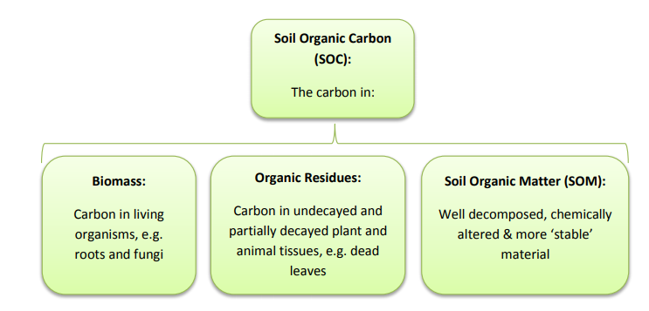
Fig 1. Organic carbon pools in soil (Essington, 2004).
Literature show that, forest is the largest C sequestration source on the earth. According to FAO report (1987) forest soil can sequester 1240pg of C. The distribution of SOC in forest also varies with altitude, biomass, climate and type of trees (Lal. 2005; Ali et al., 2017& Hussain et al., 2020). The SOC concentration in forest soils may vary from zero percent in young soil and as much as 50 percent in wetland soil (Trettein & Jurgensen.,2003).According to (Ali et al.,2017) findings, the amount of OM was higher in forest and pastures than agricultural plot in Bagrot valley, Gilgit.
Accordingly, Peat land is another main source of carbon sequestration. It has been stated that between the depths from half (1/2) a meter to 20, the layers of peat store above 50% of C (Hawken, 2016). However, this unique ecosystem covers only 3% of the world’s land (Belyea & Ni. 2004). It is interesting to note that after ocean, wetland is the second largest sink for carbon (Hawken, 2016). Peat lands have plants to absorb C through photosynthesis and acidic water to create anaerobic conditions that keep C from emitting into the atmosphere. Yet, the flip side of peat land disturbance is, it can be the chimney of GHGs because it holds above 10% C than other ecosystems.
Moreover, grazing lands are also very important ecosystems. As described by (Eswaran et al., 1993) these lands holds 10 to 30 percent of the world’s SOC. These are huge reservoir of soil C due to their higher C density as well as the large land area it covers (Sahuman et al., 2002). Batjes (1999) estimated that near 1-m depth of grazing lands the soil can accumulate around 470 to550 pentagram (Pg) of soil inorganic carbon (SIC) and 306 to 330 Pg SOC. According to Gao et al (2007) overgrazing, salinisation and acidification have contributed in the degradation of huge areas of worlds grasslands. Soil erosion can also eﬀect soil C distribution in grazing lands however it usually doesn’t contribute to soil C emission. Land degradation and desertification are spreading in Alpine grassland ecosystems due to overgrazing, often resulting in increased CO₂ emissions (Zou et al., 2015). The above mentioned reasons of land degradation has been described by (Henderson, 2000; Khan, 2003; Khan et al, 2013 & Hussain et al., 2019) in GB. Grazing land soils can sequester significant amount of C, it can further be increased through appropriate management and care (Smith, 2002 & Khan et al., 2013).
Micronutrients are essential for maintaining soil health and similarly increasing productivity of crops (Zia et al., 2006). Shortage of micronutrients during the last 3 decades has grown up in both, magnitude and extent. The micronutrients in soil is essential to recognised for both grass and legume pasture plants. The well-known micronutrient are manganese (Mn), boron (B), iron (Fe), copper (Cu) and zinc (Zn) (Brennan et al., 2020). These elements are important for plants except boron (B), it is essential for animals (Parveen et al., 2010). Micronutrients in the soil are very essential and plays vital role in the growth of plants. Regardless of being requisite in minor amounts. Shortage of these nutrients may result catastrophe for vegetation while in excess amount this may cause other health threats. Some literatures have proposed rang of micronutrients which has created the base of extraction methods (Ritchie et al., 2007). Main causes of soil micronutrients availability are organic forms within humus and inorganic forms from parent material, however insufficiency or harmfulness can be usually credited to the parent material formed from (Sillanpaa, 1982).The features which have vital role in the regulation of micronutrients are pH of soil, organic matter, oxidation state, microorganisms and steadiness of chelates (Zia et al., 2006 & Rattan et al., 2009). The concentration of organic micronutrient raises along with the stockpile of soil organic matter, while the availability of these nutrients decrease with decrease in SOM storage (Joy et al., 2015).
Boron (B) is an important micronutrient element necessary for cell division and plant growth. It is exists in sedimentary, metamorphic and igneous rocks in minor amount.
The role of B in soils is in soil fertility and plant nutrition (Sadiq, 1986). Availability of Boron decreases with increasing soil pH. When soil pH increase the adsorption of B onto clay soil also increase and Al and Fe hydroxyl surfaces, especially at high soil pH (Ritchie et al., 2007). Boron deficiency is common in calcareous, sandy, light textured, acidic and low OM soils for plants grown in arid, semiarid and heavy rainfall areas (Amer at al., 2015 & Qazi et al., 2009).
Because of alkaline and calcareous nature, Pakistan’s soils are more susceptible to zinc deficiency (Parveen et al., 2010). Zinc solubility is extremely dependent on soil pH and decreases with rise in pH (Farooq et al., 2016).
Fertility status of a soil is utmost significant sign of soil productivity. It includes complex procedures, such as alteration of nutrients between inorganic and organic forms (Ni, 2002). Additionally, fertility status of soil is affected by various nutrient contents, such as SOC, phosphorous (P), nitrogen (N), exchangeable Potassium (K). Plus pH of the soil that affects plant physiological processes (Zia et al., 2006). However, among the factors (SOM) has direct effect on the physical and chemical properties of soil. As SOM provisions SOC which is the foremost source of energy for the microorganisms to carry out their biotic functions (Dad, 1919) .Some publications have reported that soil fertility parameters such as pH, cation exchange capacity (CEC), soil organic matter (SOM), electrical conductivity, available phosphorus, extractable potassium and nitrogen have shown significant variations across mountainous soils (Jobbagy, 2000).
Spatial analysis is widely in use to collect information in land use sector.it plays very essential role for site-specific nutrient management (Hussain et al., 2020). Studies have showed that soil scientists are using Geospatial tools and techniques increasingly to record soil properties and characteristics across extensive ranges of topographic and geographic areas. Mapping is vital because it helps in better crop yields, better planning for land use, controlling fertility also management of sustainable agro ecosystem (Bashir et al., 2018). Above all this technique helps in the monitoring and evaluation of soil health (Hussain et al., 2020). Moreover, we get information regarding the availability of nutrients and its possible management, through the use of required fertilizer. Thus it is very helpful for farmers to get knowledge about their land and get more crop yields (Bashir et al., 2018 & Hussain et al., 2020).

CHAPTER: 3 MATERIAL AND METHODS

  - Site Description
    - Location
This research was carried out in Shimshal-Pamir lake, locally called Shuwert .The total area of (catchment) around the lake is 32km² at an altitude of 4,755 meter above sea level (asl).It is located at the extreme north of Pakistan, beginning exact from Shimshal valley, the study area spreads around 50 km into the mountainous valley alongside with the southern boundary of Xinjiang, China and northwest of Shimshal valley (Khan et al., 2013). It covers an area of 4,455.06 sq km (Butz, 1996).
Pamir is the community owned grazing area, summer pasture for sheep, goats and yaks and winter pasture for yaks.

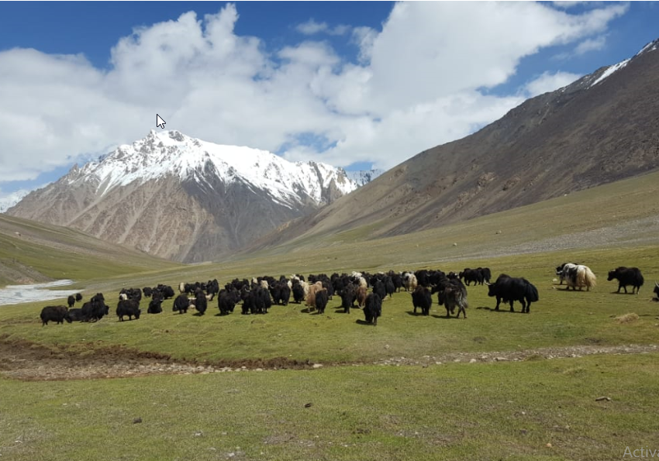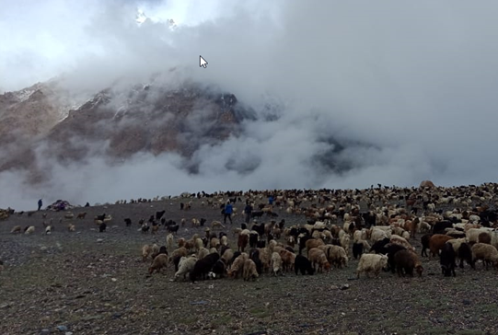
Fig 2. Shuwert Pasture
Topography of the area offers different ecological obstacles, such as fast running and freezing water, huge snow covered mountains and glaciers with unusually severe climatic situations existing for nine months annually (Khan et al., 2013). This restricts any kind of cultivation practices in the area.

3.1.2 Climate
The study area has a climate described as cold with mild summers and extremely cold winters. Maximum air temperature during summer is 25ºC in July and minimum of 5ºC in October while lowest winter temperature is -15 ºC during January and February with mean annual precipitation of around 112 mm. Approximately, the area gets 12 mm of rainfall per month. Western monsoon stays afar, it rarely cross the great mountains of Karakoram Range (IUCN, 2003).

    - Geology
Utmost the geology is sedimentary, colluvial, debris depositional surfaces. Sloppy mountain landscapes with slightly steep to very steep (Butz, 1996). Ammonites (saligram) and fossilised molluscs are the key fossils found in Mesozoic sedimentary rocks in the area (Iturrizaga, 19197).
    - Population and household
Shimshal village consists of four main hamlets (Aminabad, Farmanabad, Central Shimshal and Khazirabad). Shimshal has 3000 individual and 250 households. Historically Shimshali community has been dependent on subsistence mode of production, which consists of cultivation of cereal crops on irrigated terraces (Butz, 1993). Recently after road completion potato cultivation has been stated in the village. Herding numerous numbers of goats, sheep and yaks on extensive area of high altitude pastures (Butz, 1995 &1996).

    - Biodiversity
According to (Khan et al., 2013) the Shimshal Pamir lakes (Shuwert) comes under the category of extreme alpine zone which lack any kid of woody vegetation. However some prostrate shrubs like Potentilla dryadenthoides and Sibbaldia tetrandra grows in thinly dispersed way. A study conducted by (Khan et al., 2013) shows that 58 plant species commonly grasses have grown in the area. Additionally, the writer has documented 48 species of birds, big mammals have 5 species, 8 small mammals and four reptilian species.
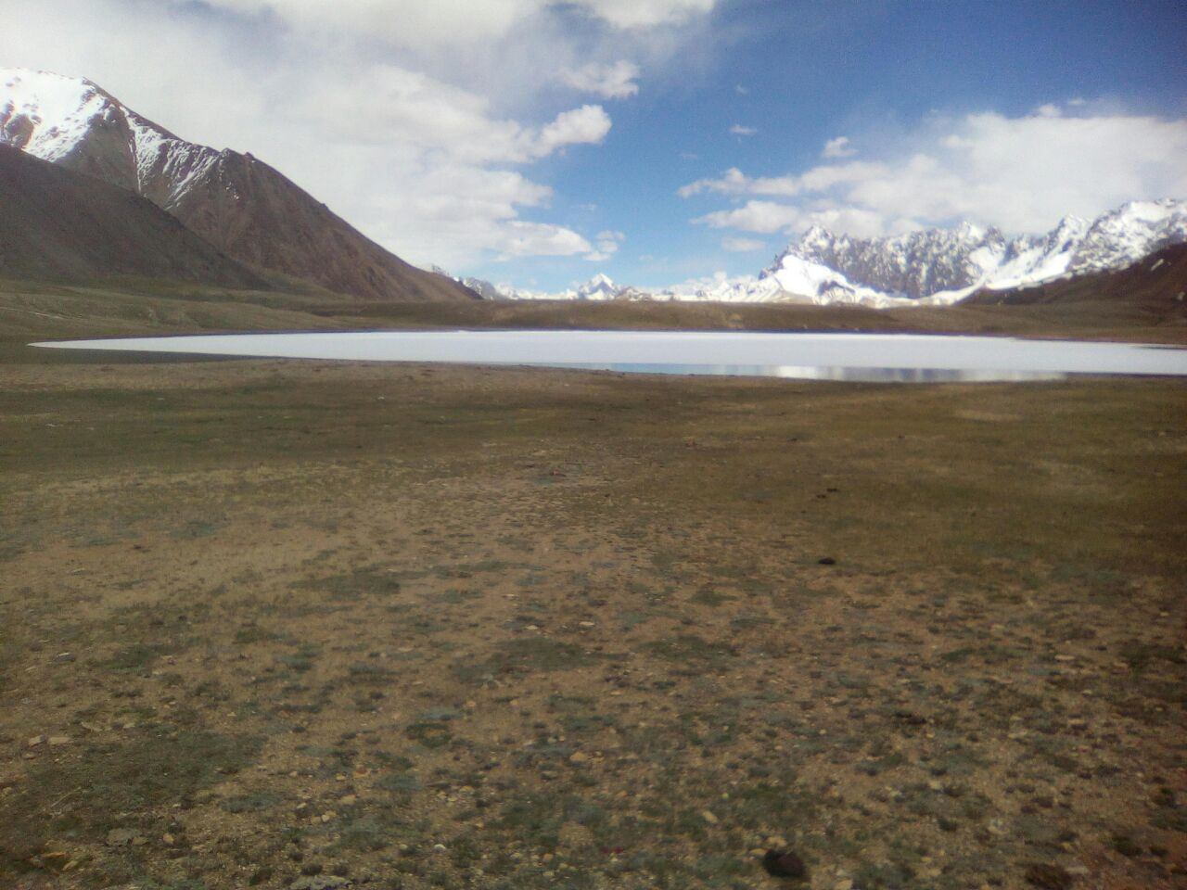
Fig 3: view of Shimshal Pamir lakes (Shuwert) in June 2018.
Moreover, a number of wildlife species are also found in the area, such as Blue sheep (Pseudois nayaur), Brown Bear (Ursus arctos), Snow Leopard (Uncia uncia), Marco Polo Sheep (Ovis ammon polii), also Tibetan Wild Ass (Equus kiang). Similarly it is habitat for a number of birds and waterfowls for nesting and staging. main avifauna species are Northern Shoveler (Anas clypeata), Grey Heron (Ardea cinerea), Mallard (Anas platyrhynchos), Common Teal (Anas crecca), Northern Pintail (Anas acuta),Marbled Teal (Marmaronetta angustirostris) and Coot (Fulica atra) (SNT,1998).

3.1.6 Livestock keeping
Livestock-keeping in Shimshal has remained an important source of income for most households up to the present day. Shimshali pastoral practices are divided into two different sections i.e winter and summer shepherds. For the five summer months women are responsible and in charge of sheep, goats and yaks in pastures (Shuijerab and Shuwert). They take over from the male winter shepherds by May, when the small livestock are transferred (kuh) from Shimshal village to Shuijerab (4,350 m) at the foot of shimshal Pass (4,726 m). The joint herds are pastured in the shimshal Pamir until October 20, when the winter shepherds take over the yak while sheep and goats return to the village. The yak herds are kept outside the village all year long. A study conducted by Khan et al (2013) on the productivity of pasture, reveals that the area is over grazed due to unplanned grazing and management.

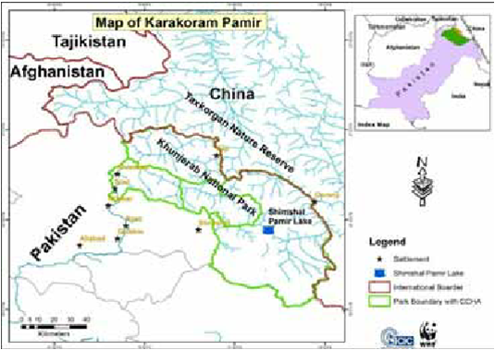
Fig 4: location map of the study area (Khan et al., 2013).

  - Soil Sampling design
Before going to the sampling site a sketch was prepared for planning the sampling and selection of the three main zones i.e. Peat land, vegetative land and barren land (Fig. 3). Z1, Z2 and Z3 respectively. 1m ×1m size of plots were selected for sampling, which has considered to be standard size for the study of pasture land soils (Maharjan, 2010). Stratified random sampling method was used for the study.
The starting point was selected randomly along GPS reading at the edge of lake and was considered as zero point. The elevation was 4722 meter above sea level (asl). N 36 º26’28.7 E 075 º40’58.7. After selecting the center point, sampling zones, Z1, Z2, and Z3 were selected in relation to the zero point. The zones are representative of the whole pasture land (Shuwert) because there are these 3 types of soil.
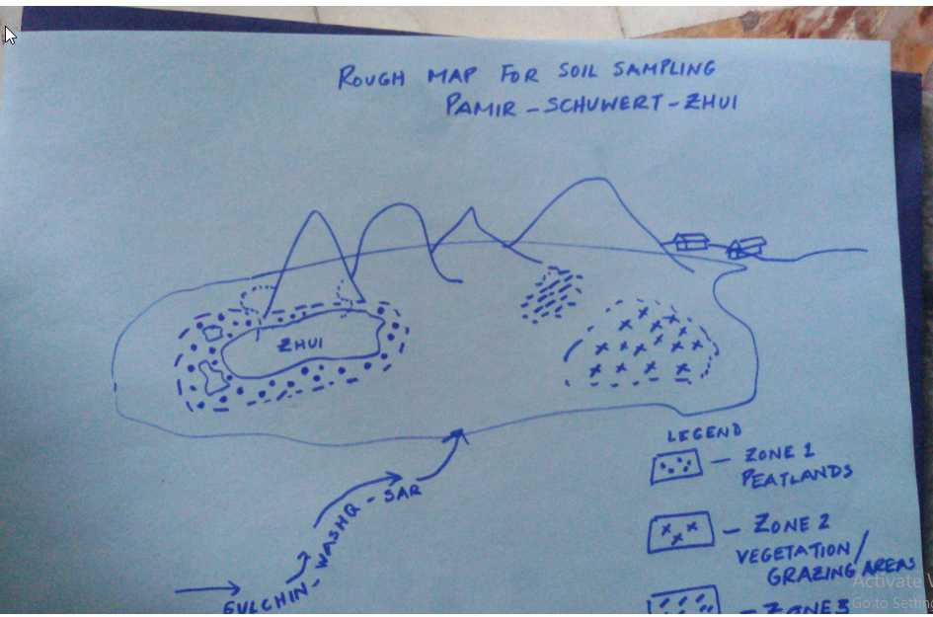
Figure 5: Sketch for planning soil sampling site

  - Soil Sampling
Stratified random sampling method, proposed by (Singh et al, 1982) was adopted for the study. Total 32 grids were selected randomly having the size of 1m ×1m, this size of the plots was standard size for the purpose of pasturelands soil study (Maharjan, 2010). For this purpose a square grid was prepared by using plastic pipes in order to make the sampling more appropriate. (Fig 6). Soil samples were collected from two different soil depths 0-6 inches and 6-12 inches in each grid. Therefore the square grid was randomly thrown to the identified zones. Five soil samples were taken from each sampling plot and profile from the same depth. Samples were combined together and comprehensively mixed to acquire one composite sample. The composite samples were then air dried for one day at the site to minimise oxidation of soil carbon. The dead grasses, manures and gravels were removed from the sample during sampling. 1/2kg composite soil sample was taken in air tight plastic bags. Each bag was labeled with grid number and Global Positioning System (GPS) reading (Fig 6). All sampling points were recorded by a handy GPS. Total 64 composite soil samples were collected. 4 samples from z1, 37 from Z2 and 26 from Z3 and transported to the lab for analysis of physico-chemical characteristics and the identification of organic carbon content and nutrients status.
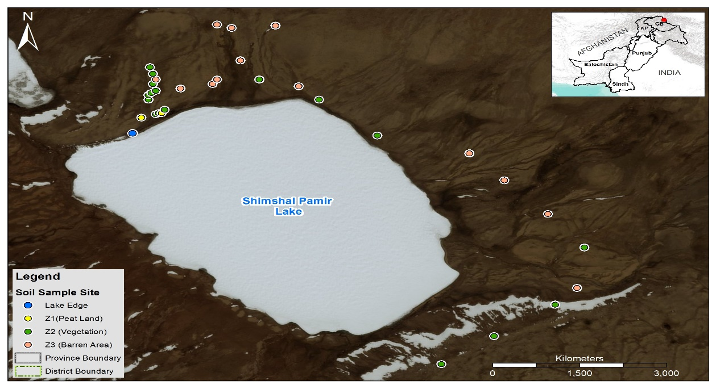
Figure 6: GIS map of sampling site.

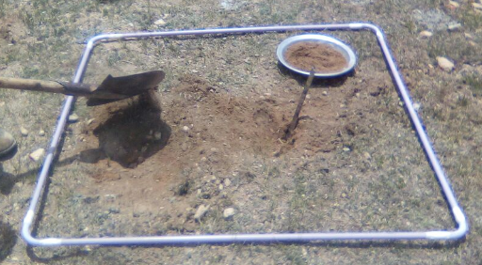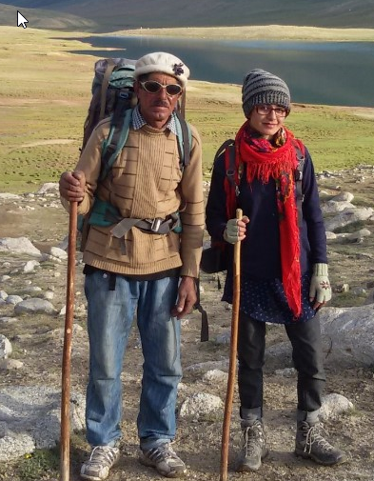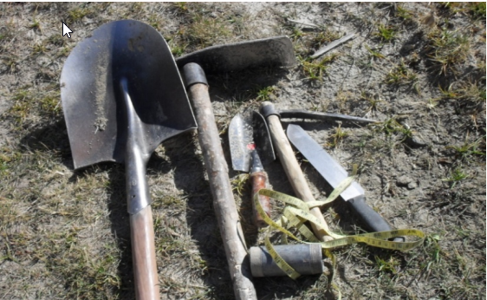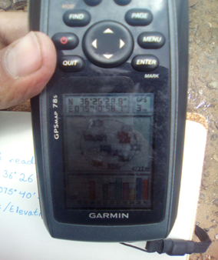
Fig7: Equipment used during field work

3.3.1 Soil parameters and measurement methods
In order to evaluate soil carbon content and nutrient status of different zones, different soil properties were analysed as shown in Table 1.

Table 1: soil parameters and measurement methods
Soil parameters | Methods
Texture (%) | Hydrometer method (Bouyoucos, 1962; Izaurrat et al., 2001)
pH | pH meter in water suspension (Malik et al.,1984)
Electrical conductivity (dSm⁻¹) | Electrical conductivity method (Malik et al., 1984)
Soil organic matter (mgkg⁻¹) | Chromic acid hot oxidation method (Walkely & Black, 1934)
Soil available phosphorus (mgkg⁻¹) | Flame Photometer method (Olsen’s et al., 1982)
Soil extractable potassium (mgkg⁻¹) | Sodium bicarbonate extraction and Colorimetry (Olsen & Sommer, 1982)
Micronutrients ( Zn, Ur, Fe, Mn) (mgkg⁻¹) | DTPA extracts by Atomic Absorption Spectroscopy (Lindsay & Norvell, 1978; Qazi et al., 2009).
Boron (ppm) | Azomethine H method (Bingham, 1982). Hot water suspension (Bergerand, 1939).

  - Soil laboratory analysis
The physiochemical analysis of soil samples were carried out at the laboratory of Soil and water testing laboratory, Thokar Niaz Baig, Department of Agriculture, Government of Punjab. During lab analysis it was make sure to follow the standard procedures.
3.4.1 Sample Preparation
Soil samples were prepared by quartering technique .All the composite samples were air dried for one week. 2.0 mm sieve was used to pass soil through it, therefore to remove big particles of grass, stone and wood and were stored in zipped plastic bags for further analysis.
  - Chemicals and reagents
Standard buffer solutions with pH 4.0, 7.0 and 9.2, deionized water, Potassium Chloride Solution (KCl), 0.01 N Potassium Dichromate Solution (K₂Cr₂O₇), 1N Concentrated Sulfuric Acid (H₂SO₄),Concentrated Orthophosphoric Acid (H₃PO₄), 0.5 M of Ferrous Ammonium Sulfate Solution [(NH₄) 2SO₄.FeSO₄.6H₂O], Diphenylamine Indicator (C₆H₅)₂NH, 0.5 M of Sodium bicarbonate solution (NaHCO₃), 4 % of Sodium haxametaphosphate Amyl Alkohol, 1N Ammonium Acetate Solution (NH₄OAc), Hydrochloric acid (HCl), Triethanolamine (TEA), Buffer Solution, Activated Charcoal (Boron - free), Azomethine-H Solution (C ₁₇H₁₂NNaO₈S₂) were prepared.

  - Instruments
Plastic beaker, spatula, pH meter, conductivity meter, glass beakers, suction pump, magnetic stirrer, stirring bar glassware, pipettes for the dispensation and preparation of reagents, burette i.e. titration apparatus, spectrophotometer, laboratory glassware, volumetric flasks, pipettes funnels, extraction bottles, hydrometer, 1000 ml of graduated cylinder, thermometer, 500 ml of beaker, stop watch, wash bottle, flame photometer along equipment, 3000 rmp centrifuge, test tubes, automatic shaker, atomic absorption spectrophotometer (AAS), 50 ml of Erlenmeyer flasks and spectrophotometer.

  - Soil parameter analysis
    - Determination of soil texture
Hydrometer method was used for the analysis of soil texture (Izaurral et al., 2001).
Procedure
The air dried samples was crushed with mortar-pestle and passed through 2 mm sieve. A 50 gm sieved sample was taken in 1000 ml beaker and soaked for 3-6 hours by adding purified water 200ml and 50 ml of 10% solution of sodiumnhexa-metaphosphate ( NaPO₃)₆. This sample was shaken for 5-10 minutes with electric shaker. The contents of the shaker were poured into 1000 ml standard cylinder and distilled water was added up to 1000 ml volume. This soil suspension was shaken with a plunger. Hydrometer readings in the duly shaked soil suspensions were taken between 40-50 seconds after shaking for concentration of silt and clay. Similarly 2 hours readings were also taken for concentration of clay only. After each reading, temperature of the soil suspension was recorded. The zero error of hydrometer was also determined by taking reading in distilled water at the same temperature. Prior to that, blank solution was also prepared by adding 50 ml of 10% solution of sodium-hexa-metaphosphate in distilled water to the volume 980 ml.
Thus the percentage of silt, clay and sand content was analysed by Concentrations of silt plus clay and that of clay only were determined from the corrected hydrometer reading taken after 40 seconds and two hours, respectively. The concentration of sand was determined by deducting concentration of silt plus clay from known concentration of soil sample which was 50 gm/l in the instant case. From the percentages the contents of clay, sand and silt of each soil sample, relevant classes of soil was determined using the standard soil classification triangle.
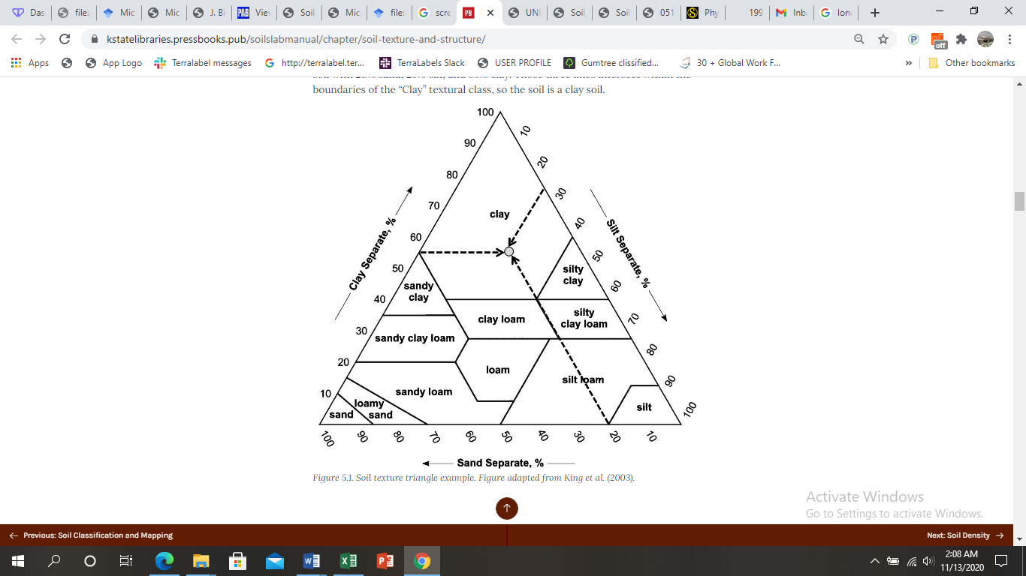
Source: (King et al., 2004)

    - Soil pH determination
Soil pH was determined with an enso Direct 100 pH meter in water suspension as described by (Malik et al., 1984).
Procedure
10g of air-dried soil sample transferred in nine different beakers with size 100 mL. Later 50 mL purified water was added and the soil water sludge 1:5 ratio was prepared. The sludge was allowed to settle down and then pH meter was adjusted with buffer solutions of pH (4.0, 7.0 and 9.0), (methods proposed by (FAO, 2008). Finally the pH meter (Elmentro CPI-501, Poland) was placed into the prepared slurry and the pH was recorded.
    - Determination of soil electrical conductivity (dS m⁻¹)
Electrical conductivity meter used by (Malik et al., 1984) was used for the determination of soil electrical conductivity.
Procedure
10g dried sample was taken in beakers. 50 ml distilled water was added in the ratio of 1:5 in the beaker. The mixtures were agitated 30minutes with the help of glass rod, then it was left for an hour without any disturbance. When all the soil partials were settled down then the EC value was measured by electrical conductivity meter (ELMEIRON, EC-60, China) into the supernatant solution and readings were recorded.

    - Determination of soil organic matter and organic carbon
Soil organic matter of the samples was analysed by Walkey and Black method (Walkely & Black, 1934).
Procedure
The soil organic matter of the samples was analysed by Walkey and Black method (Walkely & Black, 1934). Used by (Malik et al., 1984). 1g of air dried soil sample was taken in nine Erlenmeyer flask (50 mL), then 20 ml conc. Sulphuric acid (H₂SO₄) and 10 ml of potassium dichromate (K₂Cr₂O₇) was added with the help of measuring cylinder. Then the mixture was shaked for thirty minutes. Formerly, 10 ml orthophosphoric acid (H₃PO₄), 100 ml purified water, and 1ml diphenylamine (C₁₂H₁₁N) indicators were added .This mixture of solution was titrated against 0.5 N ferrous ammonium sulphate [(NH₄)₂Fe(SO₄)₂H₂O₆] until the color of the solution changed from blue-violet to green.in the beginning the blank titration was also performed without soil. Formulas shown below were used for the calculation.
OC % = N× (VB−Vs) ×0.39×mcf
S
N= Normality of FeSO₄
VB= volume of 0.5 N ferrous sulphate needed to neutralize 10 mL 1 N
K ₂Cr ₂O ₇, i.e. blank reading in ml
VS=Volume of 0.5N FeSO₄ required for titration of soil sample (mL)
S= weight of air dried soil samples (g)
0.39=3x10- 3 x100% 1.31 where, 3 is equivalent weight of C. It is supposed that
just 78% of the OM is oxidised and a portion of 100/78= 1.28
Organic matter (OM) (%) = Organic carbon (OC) (%) x 1.72
Thus, 1.72 is an average content of C in soil organic matter = 57%.

    - Determination of available Phosphorus in soil (mgkg⁻¹)
The soil available phosphorus (P) was analysed by a method adopted by (Olsen’s et al., 1982).
Procedure
2.5gm air dried soil sample was taken in 150mL of glass conical flask. Then 0.3gm of phosphorus free activated charcoal was added.50mL reagent, NaHCO₃ was added, the mixture was shaken manually for twenty minutes. Then 5mL of the content was filtered on Whatman No. 42 filter paper in 25mLvolumtric flask immediately. 4mL ascorbic acid and ammonium molybadate solution was added and shaked and kept for 30 minutes. Then phosphorus extract was analysed with spectrophotometer-21 at of wavelength 880nm.

    - Determination of oil extractable Potassium (mgkg⁻¹)
Ammonium Acetate Solution (NH₄OAc) was prepared as reagent, 55 ml of conc. acetic acid (CH₃COOH) solution was added into 800 ml of deionized water, then the solution of 60 ml conc. ammonium hydroxide (NH₄OH) was added and had well mixed, then that solution was kept to get cool. pH of the solution was attuned at 7.0 while adding extra CH₃COOH and brought to volume of 1 L with deionized water. Subsequently, standard stock solution was prepared by dissolved 1.9 gram dried KCl into deionized water and brought it to the volume of 1L. The mixture contained 1000 parts per million (ppm) K. Stock solutions were used to prepare a numbers of standard solutions in 100-mL numbered flasks by adding ammonium acetate solution (1 N). Such solutions were comprised of 20, 40, 60, 80, 100 and 150 ppm K correspondingly. Extraction was carried out by, adding 5 g dried soil into a 200-mL flask. Added 30 mL 1 N NH₄OAc solution, ratio 1:5. The mixture was then kept for Shaking for 25 to 30 minutes on a counter shaker at 300 rpm. The solution was filtered using on whatman No 1 filter paper to remove remaining soil particles and stand the remains to the volume 40-mL with 1 N NH₄O solution. Measurement was carried out by flame photometer at 767-nm wavelength.

    - Determination of Micronutrients
The micronutrients under study copper (Cu), Iron (Fe), Zinc (Zn) and manganese (Mn) were analyzed through DTPA (Diethylene triaminepentaacetic acid) test method (Lindsay & Norvell., 1978) on atomic absorption spectrophotometer.

DTPA Extraction solution for soil
0.01 Molar calcium chloride (CaCl₂), 0.1 Molar TEA and 0.005 M DTPA were fixed to at pH 7.3. Then 268.5 grams of TEA and 35.5 grams of DTPA and 130ml of distilled water were added to prepare 18Lof solution, the solution was stirred till it dissolved because DTPA shows slow solubility in water. Then 26 grams of CaCl₂.2H₂O were added to 10L of demineralised water free from micronutrients. DTPA/TEA mixture was then added and brought to 17 L with demineralised water. During this process the pH was 7.3 used conc. Hydrochloric acid (HCl) and brought to 18 L. Stock Standards were kept 1,000ppm for each micronutrients.
Standard solution concentration range were Mn 0-10ppm, Fe 0 -10ppm, Zn, 0 - 5 and Cu, 0 -2 ppm.10g of the sampled soil was taken without losing against the side of the cylinder. 10 gram of soil was added to a 50 mL Erlenmeyer flask, care was taken to remove all the soil from the flask. Then 20 ml of the extracting solution i.e. (1:2 soil-to solution ratio) was added to every flasks and shaked at 160 rpm for two 60 minutes. Whatman No.42 filter paper was used the filtration of mixture. Atomic absorption spectrophotometer (AAS 700, Perkin Elmer, USA) was used for taking the readings.

    - Determination of Soil Boron
Azomethine-H method was used for the determination of boron (Bingham, 1982). And hot-water procedure was used (Bergerand, 1939).
Procedure
240 gram of ammonium acetate (NH₄OAC) and 10 gram of EDTA disodium (ethylene diamine tetraacetic acid) was added into 300ml of DI water to set up the buffer solution. 125 mL glacial acetic acid (CH₃COOH) was added continuously and blended well. Azomethine-H Solution (C₁₇H₁₂NNa O₈S₂) prepared while Dissolved 1gram L-ascorbic acid, 90 ml DI water and afterward added 0.44gram Azomethine-H, and blended well. Besides, standard stock arrangement was set up by dissolved 0.112 gram of boric acid (H₃BO₃) in deionized water to 1-L volume. This mixture contained 15 ppm Boron (Stock Solution). Then standard solution was prepared by the stock solution. Then 4 mL buffer solution, 4 ml Azomethine-H solution was added and well mixed. The standard curve was arranged by using a Pipette 3 ml of every standard (0.5 – 3.5 ppm), and proceed just like for the samples. Also made blank with 2 ml DI water, and continued as for the sample. Spectrophotometer (420-nm) was used to take the readings of the absorbance of standard, blank and samples after thirty minutes.

  - Scoring method
The Criteria used for the classification of soil parameters for different classes of texture, salinity, major and micro nutrients are given in table 1, 2, 3, 4 and 5

Table 2. Criteria used for categorization of soil samples for different classes of texture
Saturation % | Texture
2- 20 | sand
21- 30 | Sandy loam
31 - 45 | loam
46 - 65 | silt
66 – 100 | Clay

Source: (Malik et al., 1984)
Table No 3. Categorization of the soil samples for different classes of Soil pH and EC
Status | Soil pH Status EC (dSm⁻¹ )
Very High | >8.5 Normal < 4.0
High | 7.0- 8.5 Saline ≥ 4.0
Medium | 5.5 – 7.0 Saline Sodic ≥ 4.0
Low | < 5.5 Sodic < 4.0
Source (Ashri 1998; Landon 1991 & Malik et al., 1984)
Table No 4. Standards used to categorise soil samples for different classes of essential soil nutrients
Status | OM % | Available Phosphorus(mgkg⁻¹ ) | Exchangeable Potassium (mgkg⁻¹)
Poor | < 0.60 | < 7 | < 90
Satisfactory | 0.61 – 1.25 | 7 - 14 | 90 - 180
Adequate | 1.26- 2.50 | > 14 | > 180
Source: (Baize, 1993; Malik et al., 1984 & Motsara, 2002).

Table No 5. Criteria used to categorize soil samples for Boron
Status | Boron (ppm)
Safe /Normal | < 0.7
Marginal/ Middle | 0.7 – 1.5
Unsafe / High | > 1.5

Source: (Deshmuk, 2012)

  - Statistical analysis
Descriptive statistic was used to represent the data. Standard deviation, arithmetic means, and coefficient of variation was done for the comparisons of various soil parameters.
The average values given in the results session are different from each other because these are instrumental values calibrated against standards.

CHAPTER 4: RESULTS AND DISCUSSION

Soil Physiochemical Properties

Soil texture

Soil texture is important to study because it is basic to many other soil properties. It can indicate the cation exchange capacity, aeration, content of organic matter and capacity of holding water .it is additionally important as it controls the holding and remove of supplements in soil-plant environment.
The saturation percentage for the soil texture was done in view of the categorisation of soil texture proposed by (Malik et al., 1984) shown in table 2.
The saturation percentage ranged for peat land (Z1) in table 6 reflects range from 38 to 40 with a mean value (39.5%). Vegetative land (Z2) ranged from 20 to 50 with mean value (37.65%), similarly Z3 i.e. barren land ranged from 30 to 45 with mean value (40%). Whereas, the highest mean value is 40 and lowest mean value is 37.65 of vegetative land. However, out of 64 soil samples, 6 % soil samples from Z1 were of medium or satisfactory texture, following this Z2 41% samples were satisfactory textured and 9% lies in the high class. Z3 shows the same trend i.e. 23% of the samples were in the same texture. Therefore data reveals that 70% soils of the area fall under the category of medium texture (sandy loam) however 16% soils are light textured i.e. (silt clay) soil. Whereas another 14% soils of the site are high textured soil that is (clay) (Table 6).According to (Malik et al., 1984) sandy loam soils are appropriate for farming of entirely crops whereas the light soils (silt clay) have lesser capacity to hold water which can be increased by the addition farmyard fertilizer to increase it water holding capacity. Soil physical condition plays role in holding water and nutrients (Ali et al, 2017). Baber et al (2004) stated that the texture of the soils of Gilgit varies from silt clay to silt loam, common texture classes identified were, (35%) silt loam, subsequently (30%) sandy loam, (7.5%) loamy sand, (20%) loam, (25%) silt clay and (5%) silt clay loam. while Ishaq et al (2015) described that the soil texture of Shiskat village Silt and Gulmit soil showed Silt loam texture. In the present study the mean textual class of high altitude pasture, Pamir fall into sandy loam (70%), silt clay (14%) and clay (14%).

Table 6. Analysis of soil texture
 |  |  |  |  | Zone wise %
Name of area | L | M | H | Total | L | M | H
Z1 | 0 | 4 | 0 | 4 | 00 | 100 | 00
Z2 | 6 | 26 | 2 | 34 | 18 | 76 | 8
Z3 | 4 | 15 | 7 | 26 | 15 | 58 | 27
Total | 10 | 45 | 9 | 64
Percentage | 16 | 70 | 14 | 100

4.1.2 Soil pH
Soil pH is the measurement of hydrogen ion activity in the soil solution. It shows the acidic and basic nature of soils. It is also the major element in plant growth system. As an important soil chemical indicator it defines the soil health, availability of nutrients in the soil, physical condition and biotic activity of soil (Deshmukh, 2012).
Classification of soil pH proposed by Ashri (1989) and Landon (1991) shown in table 2. In the view of this classification, In Z1 pH values ranged from 7.6 to 8.4 with mean value (8.00), whereas the Z2 ranged 7.7 to 8.9 with mean value (8.18) and Z3 ranged from 6.9 –to 8.8 mean value (7.91) respectively., as shown in (table7) out of 64 soil samples 6% samples were in medium category, the largest number 89% were in high category classification and the remaining 9% were in group of very high (table 8). Thus 89% indicates that the soils of high altitude pasture, Pamir is alkaline in nature. The narrow range of soil pH variation in the area needs further investigation to understand its reason. Although, it very well may be credited to the high buffering capacity of soil and lack of carbonate in the capacity extract (Rasayan, 2012). Soil has alkaline nature that may be due to alkaline nature of parent materials, high level of evapotranspiration and low-rainfall (Hussain et al., 2007). The finding is similar to Maharjan (2010); Rashid et al (2008); Parveen et al (2010) and Obaid et al (2010) .Further Kausar et al (2016) stated that such soils are good for cultivation except pH greater than 8.2. it is interesting to note that, there is a slight difference in finding of this study with the pervious writers of GB such as ishaq et al (2015); Ishaq et al (2014); Ahmed (2020); Babar et al (2004) and Parveen et al (2008), they studied soils from GB Pakistan including Gilgit, Hunza and Skardu. The pH ranged between 7.2 and 7.5. Such difference may be because these writers have studied cultivated lands while samples collected for the present study were from high altitude pasture land (4722m above sea level).

Table 7. Percentage distribution of soil samples according to low, medium, high and very high categories for pH in different zones of high altitude pasture.
Sampling area | L | M | H | VH | Total | Zone wise percentage
Sampling area | <5.5 | 5.5-7.0 | 7.0-8.5 | >8.5 | Total | L | M | H | VH
Z1 | 0 | 0 | 4 | 0 | 4 | 00 | 00 | 100 | 00
Z2 | 0 | 0 | 30 | 4 | 34 | 00 | 00 | 88 | 12
Z3 | 0 | 1 | 23 | 2 | 26 | 00 | 4 | 88 | 8
Total | 0 | 1 | 57 | 6 | 64
Percentage | 00 | 6 | 89 | 9

Table 8. Zone wise mean value and range values for soil pH and Ec of High altitude pasture, Pamir

Name of zones | Soil pH | EC(dSm⁻¹ ⁾
Z1 | 7.6-8.4 (8) | 1.3-1.7 (1.48)
Z2 | 7.7-8.9(8.18) | 1.2-8.1(2.35)
Z3 | 6.9-8.8(7.91) | 0.5-4.8(1.89)

Note: Values in parenthesis shows mean value
EC= Electrical conductivity

    - Electrical conductivity
Cooke (1982) described that electrical conductivity (EC) of the soil is the measure of salinity through the soluble salt concentrations in the soil. Furthermore, in order to overcome certain uncertainties in the measurement of dissolved salts, EC measurement would be the faster and adequately precise for maximum purposes (Dahnke & Whitney, 1988).
The analysed data for soil electrical conductivity in (table 8 and 9) revealed that, accumulate percentage of the area falls in the category of saline i.e.52 %, while 36% are in non-saline and the remaining 23% come under moderately saline. Furthermore, the zone wise percentage reveals that Z1, Z2 and Z3 has almost 50% non-saline and 50% slightly saline soil (table 8). Regarding ranges of EC, mean values of zones were 1.48, 2.35 and 1.89 dSm⁻¹ respectively. Thus the soils in the three zones of Pamir were mostly non-saline to slightly saline. Low EC in majority of the soil samples in the area indicates low electrolyte concentration.
In 1999 to 2000 the fertility and physiochemical characteristic of Gilgit soil was studied by (Khan et al., 2004). As stated by them the EC they found was diverse from 0.06 to 0.5 dS/m. while in Gulmit and Shishkat the electrical conductivity was 78.2 us/cm and 2.44 us/cm (Ishaq et al., 2015). Furthermore in the present study there is far great difference in electrical conductivity 1.48, 2.35 and 1.89 dSm^{-1.} This finding is similar to Qureshi et al (2007) and Parveen et al (2010). They described that such soil contains low soluble salts and has not salinity risks. Also Hernandez et al (1993) described that the drainage water is categorised by its alkalinity, which allows decrease in the solubility of heavy metals.
Table 9. Percentage distribution of soil samples according to NS, SS and MS categories for electrical conductivity (dSm⁻¹) in different zones of high altitude pasture, Pamir

Zones | NS | SS | MS |  | Zone wise percentage
Zones | 1-1.4 | 1.5 -2.8 | 2.9 -5.7 | Total | 0.0 - 1.4 | 1.5 - 2.8 | 2.9 - 5.7
Z1 | 2 | 2 | 0 | 4 | 50 | 50 | 00
Z2 | 11 | 19 | 4 | 34 | 32 | 56 | 12
Z3 | 11 | 12 | 3 | 26 | 42 | 46 | 27
Total | 24 | 33 | 7 | 64
Percentage | 36 | 52 | 23

Where, Non saline=NS, slightly saline=SS and moderately saline=MS.

  - Soil macro nutrients availability

4.2.1 Soil organic matter and organic carbon

Organic matter of soil plays vital part in nutrient supply, providing nutrients, water as well as appropriate physical environment to the plants. Correspondingly it supports to hold soil fertility through enhance soil structure, maintenance of inorganic nutrients and increase water carrying capacity (Ali et al., 2017 & Ahmed, 2020). Inherently, Pakistani soils are low in organic matter i.e. (<1.0%) (Amer et al., 2015).
Baize (1993) classified organic carbon contents as, very low < 0.60%, low 0.60 – 1.25% and medium 1.26 – 2.50%. On the basis of these classes and on an average mean of soil samples, the analysed data is presented in (Table 10and 11). The status of organic carbon content of soils of High altitude pasture, Pamir was medium. The soils of Z1 (peat land) retain the highest mean value of organic carbon and organic matter (0.55% and 0.96%) and it is followed by Z3 (barren land) with mean percentage (0.53 and 0.91) , Z2 i.e. vegetative land showed the lowest mean percentage value for SOC and OM (0.49 and 0.89) . it is interesting to note that, Soil organic matter in each zone has higher value than organic carbon it contains, this may be due to the harsh climate , alkalinity and more compacted soil structure, that reduce the microbial decomposition of OM.
Thus soils in this study contain low to medium organic carbon content. The result suggests that medium level of SOM in the mountainous soils as compared to other agricultural soils such as , Ishaq et al (2015); Babar et al (2004); Parveen et al (2010); & Ahmed (2020) will be helpful in improving soil physical and chemical properties, soil aggregation and reducing nutrient losses.
SOC in the area is relatively high as compared to the findings of the above writers of GB, which might be due to the availability of high biomass. However, this cannot be considered as the sole factor that effect SOC sequestration. Additional reasons include temperature, because area with low temperature results in higher SOC sequestration. In high-altitude areas, the temperature is low due to which microbial activity in the soil delays. As microbial activity reduces, degradation and release of nutrients required for plant growth also became weak. Because of lack of required nutrients, plants cannot use the carbon available in the present soils. However, SOC in the high altitude pasture, Pamir is greater than other regions which could be considered as a sustainable sink for the atmospheric carbon in the absence of forest and woody plants in the area. Similar result was sowed at alpine region of Nepal by (Maharjan, 2010). The slightly less amount of SOC at high altitude pastures could be because of harsh climatic conditions which provide less time for soil formation, limit decomposition of the OM and result in low net primary production (Ali et al., 2017).
Moreover, Ritchie et al (2007) reported that uncultivated land soils hold more organic matter in its surface layers than cultivated soil for years.

Table 10. Percentage distribution of soil samples according to low, medium and high categories for organic matter in different zones of high altitude pasture.
Zone | Poor | satisfactory | Adequate | Total | poor | Satisfactory | Adequate
Z1 | 0 | 4 | 0 | 4 | 00 | 100 | 00
Z2 | 9 | 25 | 0 | 34 | 26 | 74 | 00
Z3 | 3 | 23 | 0 | 26 | 26 | 12 | 88
Total | 12 | 52 | 00
percentage | 19 | 81 | 00

4.2.2 AB-DTPA- Available Phosphorus (mgkg⁻¹)
Phosphorus is considered to be the key factor in agriculture, since soils with limited availability of P reduces the growth of cultivated as well as uncultivated crops (Murphy et al., 1981). In most of the natural ecosystems, such as in grasslands and forests P uptake is reduced by both, low total quantity of the elements and by very low solubility of the limited quantity in the soil present (Brady and Weil, 2002).
Available phosphorus (P) status of soils of high altitude pasture, Pamir was satisfactory. Table (11) shows range and mean values for P. According to the analysed data, the soils of Zone 3 (barren land) own the highest mean value of DTPA- AP (9.17mg/kg) and it was followed by zone 1, peat land (9.2 mg/kg) and then vegetative land (zone 2) with mean value (8.58 mg/kg). It is the lowest mean value in the data. Out of 64 soil samples, 53 samples (83%) were found to be satisfactory, 11 samples (17%) were low (Table 11).
Thus, the result shows that high altitude pasture has significant amount of AP as compared with the previous studies conducted in GB, there is a huge difference. As Isahq et al (2015) showed that soil in Shiskat village contained 2.49 mg kg⁻¹ and Gulmit 2.45 mg kg ⁻¹ .Similarly, the value of AP in Sakardu is (3.47±0.31, 5.63±0.46 and 0.92±44 mg kg⁻¹) (Huaasin et al., 2019). However, this finding is related to (Maharjan, 2010), who found high AP in high altitude region of Nepal at elevation of (3650 and 3850 m). The writer described that; the high availability of P is due to the clay content in the soil. Therefore, the reason of having medium or satisfactory AP is due to less clay content in soil.
Table 11. Percentage distribution of soil samples according to low, medium and high categories for AB-DTPA -Available Phosphorus (mgkg⁻¹⁾ in different zones of high altitude pasture, Pamir

 | Poor | Satisfactory | Adequate |  | Zone wise percentage
Zones | < 7 | 7 -14 | >14 | Total | < 7 | 7- 14 | >14
Z1 | 1 | 3 | 0 | 4 | 25 | 75 | 00
Z2 | 8 | 26 | 0 | 34 | 24 | 76 | 00
Z3 | 2 | 24 | 0 | 26 | 8 | 92
Total | 11 | 53 | 00 | 64
Percentage | 17 | 83 | 00

    - AB-DTPA-Exchangeable potassium
The analysed data of AB-DTPA- exchangeable potassium (mgkg⁻¹) is shown in table (12 and 13). The finding revealed that, the highest mean value of Ex K (134mgkg⁻¹) was found in zone 1 and it was followed by zone 3 with mean value (131.08 mgkg⁻¹) and then Z2 with mean value (128.44 mgkg⁻¹). It is the lowest mean value in the data. Furthermore, according to the data of percentage distribution, out of 64 soil samples, 4 soil samples (6%) were found to be in low category, while 54 soil samples (84%) were under the category of medium or satisfactory and the remaining 6 soil samples( 9%) were in low state (Table 12). The reason behind low content of K may be due to lightly and scattered vegetation observed in the field.
According to (Ishaq et al., 2015) ex K in the two villages of Gojal Hunza, the highest value was observed in Gulmit (87.7 mg kg⁻¹), and in Shiskat it was observed (65.8 mg kg⁻¹). While in the mountainous valley Sakardu, the mean value for ex K ranged from 25.94±0.31, 51.17±0.46 and 22.36±44 mg/kg⁻¹ respectively (Hussain et al., 2019). The current result is far greater than these values, the reason may be elevation, soil type, land practice and usage. Soltanpour (1985) described that change in the distribution of ex K is because of the minerals present, distribution of particles size, level of weathering, cultivation practices, soil development and management and climatic conditions.

Table 12. Percentage distribution of soil samples according to low, medium and high categories for Ex Potassium in different Zones of High Altitude pasture, Pamir
 | Poor | Satisfactory | Adequate |  | Zone wise percentage
Zones | < 90 | 90 -180 | >180 | Total | < 90 | 90- 180 | >180
Z1 | 1 | 2 | 1 | 4 | 25 | 50 | 25
Z2 | 1 | 30 | 3 | 34 | 3 | 88 | 9
Z3 | 2 | 22 | 2 | 26 | 8 | 85 | 8
Total | 4 | 54 | 6 | 64
percentage | 6 | 84 | 9

Table 13. Zone wise range and mean values for available macronutrient and SOM in soils of high altitude pasture, Pamir

Name of Zones | OC (%) | OM (%) | Av P (mg/kg) | Ex K(mg/kg)
Peat land (Z1) | 0.14 – 0.75 (0.55) | 0.7-1.3 (0.96) | 6.8- 10.9 (9.2) | 58 - 210 (134)
Vegetative (Z2) | 0.3 – 0.76 (0.49) | 0.52-1.31 (0.85) | 5.4- 13.3 (8.58) | 85 - 190 (128.44)
Barren (Z3) | 0.3 – 0.74 (0.53) | 0.52-1.28 (0.91) | 5.4 – 10.9 (9.17) | 85 - 186 (131.08)

Note: Values in parenthesis shows mean value
OC =Organic Carbon, OM= Organic Matter, Av P=Available Phosphorus, Ex K=Exchangeable Potassium

  - Soil DTPA-Extractable (Zn, Cu, Mn, and Fe) content of the soil
Analyzed data for the DTPA-extractable micronutrients (Zn, Cu, Mn, and Fe) is shown in (table 14). The zone wise percentage distribution of samples falling in High, medium and low fertility categories for available micronutrients are presented in (table 15).
Table 14. Zone wise range and mean values for available micronutrients in soil of high altitude pasture, Pamir
Name of Zones | Zn (mgkg⁻¹) | Fe (mgkg⁻¹) | Cu (mgkg⁻¹) | Mn(mgkg⁻¹)
Peat land (Z1) | 0.2-0.63 (0.43) | 17.6-21.7 (19.22) | 1.88-2.36 (2.09) | 1.93-5.66 (3.76)
Vegetative (Z2) | 0.11-4.53 (1.58) | 13.5-34.4 (21.29) | 0.27-3.03 (1.85) | 0.15-7.21 (2.68)
Barren (Z3) | 0.27-6.08 (1.87) | 12.9-28.9 (20.12) | 0.72-2.78 (1.67) | 0.66-7.3 (3.25)

Note: Values in parenthesis shows mean value

Table 15.Percentage distribution of soil samples according to low, medium and high categories for available micronutrients in different zones of high altitude pasture, Pamir
Name of zones | Fe |  |  | Cu |  |  | Zn |  |  | Mn
Name of zones | L | M | H | L | M | H | L | M | H | L | M | H
Z1 | 0.0 | 0.0 | 100 | 0.0 | 75 | 25 | 100 | 0.0 | 0.0 | 0.0 | 25 | 75
Z2 | 0.0 | 0.0 | 100 | 32 | 52 | 15 | 59 | 26 | 15 | 26 | 26 | 47
Z3 | 0.0 | 0.0 | 100 | 50 | 35 | 15 | 62 | 15 | 23 | 12 | 23 | 65
Percentage | 0.0 | 0.0 | 100 | 36 | 47 | 16 | 62 | 20 | 17 | 19 | 25 | 56

L=Low, M=Medium, H=High

4.3.1 DTPA-extractable Iron (Fe)
The status of total available iron content of soils of high altitude pasture, Pamir was found high. The soils of Z2 (Vegetative land) retain the highest mean value of DTPA-extractable Fe (21.29mg/kg) followed by Z3 (barren land) (20.12 mg/kg) and Z1 i.e. peat land (19.22 mg/kg) which showed the lowest mean value of DTPA extractable Fe (table 13). All the 64 soil samples (100%) were high in available Fe content (table 15). The mean values of soil Fe at diverse samplings zones were higher than the critical value of 2.5 mgkg⁻¹ as suggested by Soltanpour (1985).
The high Fe concentration in these soils may be because of the existence of minerals like magnetite; moisture due to excess water in soil enhances Fe availability even to the level of toxicity (Farooq et al., 2016). Moreover, aeration problem in soil due to compaction also increases availability of Fe. As mentioned above that, the soil has relatively high amount of phosphorus, which may be another reason of high Fe in the soil. The current study showed far greater value of Fe than those reported previously, by (Khan et al., 2007) in Pakistan while working in semi-arid region. The Fe values of this study were found higher than (Landon et al., 1991) the study reported from central Florida .This variation could be due to diverse climate, topography and altitude in addition to vegetation type and other ecological factors( Ali et al., 2017& Hussain et al., 2019).
4.3.2 DTPA-extractable Zinc (Zn)
The status of total available Zn of soils of the high altitude pasture, Pamir was low. The soil of Zone 3 (barren land) own the highest mean value of DTPA-extractable Zn (1.87 mgkg⁻¹) it is followed by Z2 i.e. vegetative land (1.58 mgkg⁻¹) and peat land (Z 1) with mean value (0.43 mgkg⁻¹). The lowest mean value (0.43 mgkg⁻¹) of DTPA extractable Zn (table 13) was observed in soils of peat land. Out of 64 soil samples, 40 samples (62 %) were found to be low, 13 samples (20%) were medium and the left over 11 samples (17%) were high (table 15). The finding is similar to results observed by (Farooq et al., 2016; Chavda et al., 2011 & Patel et al., 2017). The reason behind low availability of Zn may be due to high pH of the soil and organic soil as stated by (Brennan, 2020). Deficiency of Zn usually occurs with pH greater than 6.0 (Richards, 1968). Whereas the current soil has pH 7.0 to 8.5. Soils especially sand also cause deficiency of Zn as well (Brennam, 2020). The result is similar to Parveen et al (2010), who analysed low Zn level on surface soil of Peshawar, (0.058 mg kg⁻¹ to 4.05 mgkg⁻¹). Zinc deficient soil can simply be cured with Zinc fertilizer such as zinc sulphate most widely used fertilizer.
4.3.3 DTPA-extractable Copper (Cu)
Overall, the available Copper (Cu) status of soils of high altitude pasture, Pamir was medium. The available copper value ranged between (0.37 to 1.78 mg/kg) with mean value (0.86 mg/kg). According to the analysed data in (table 13) the highest mean value of available Cu was found in Z1 (Peat land) soils (2.09 mg/kg) followed by soils of Z3 barren land (1.85 mg/kg) and then Z2, vegetative soil (1.67 mg/kg). Moreover, out of total 64 soil samples 24 samples (36 %) were low, 30 samples (47%) were medium and the 10 samples (16%) were high in available Cu content (Table 15).
    - DTPA-extractable Manganese (Mn)
Overall, the available Manganese (Mn) status of soils of High altitude pasture, Pamir was high. It ranged from 3.74 to 8.44 mgkg⁻¹ with mean value 10.38 mgkg⁻¹. The highest mean value for available Mn was observed in zone 1 which ranged from 1.93 to 5.66 (3.76 mgkg⁻¹).then it was followed by zone 3 with mean value (3.25 mgkg⁻¹) and zone 2 with lowest mean value (2.68mgkg⁻¹) . Table 14 depicts the data. According to the zone wise percentage data in (table 15 ) out of the 64 soil samples 12 soil samples (19%) were found to be low, 16 soil samples (25%) were under the category of medium class and the remaining 36 soil samples (56%) were found to be high. The high value of Mn May be because of less mobility of Mn⁺² in soils, which may have resulted in the buildup of reducible and soluble forms of manganese in the surface soils. (Jastrow et al., 2007), also observed similar results in Gujarat in India. The current result is in line with the findings of (Tilahun, 2007), who also found similar results for the grazing land of Ethiopia.
Sims & Johnson (1991) specified the acute level of available Mn and Fe for the growth of crops i.e. 2.5 to 4.5 mgkg⁻¹ and 1 to 50 mgkg⁻¹ respectively. Consequently, findings of the present study showed that the average mean values of available Fe and Mn were in high range for crop production.
High pH permits Mn adsorption into soil particles, diminishing their accessibility (Farooq et al., 2016). In any case, a few reports have proposed that an overabundance of accessible Mn is created under reduced soil conditions, even at high soil pH esteems (Tilahun, 2007). A lessening climate can be delivered when there is an overabundance of water, applications of organic material or poor drainage (Jastrow et al., 2007 &Tilahun, 2007).
    - Soil Boron (ppm)
Boron is an important trace element. This is present in the soil in the form of Orthoboric acid (H₃BO₃) and its salts. Numerous factors that effects the availability of Br in soil are, its pH, calcium, texture, light, organic matter and moisture (Chavda et al., 2018). Though, Br critically impacts transport and metabolism of carbohydrates in plants. Furthermore, it plays role in development of cell wall and membrane integrity, which affects cell extension, cell division and permeability (Soltanpour, 1985). Boron deficiencies delay the uptake of calcium (Deshmukh, 2012).
The status of available Boron (Br) of soils of High altitude pasture, Pamir was marginal. The soils of Z3 (barren land) retain the highest mean value of Br (1.10 ppm) and it was followed by Z2 (vegetative land) (1.01 ppm) and Z1 i.e. peat land (0.66 ppm) which showed the lowest mean value of Br (table 16). According to the zone wise percentage data in (table 15), among 64 soil samples 22 (34%) soil samples were in safe zone. It was followed by marginal zone in which 25 soil samples (35%) and the remaining 17 (27%) soil samples fall in unsafe zone. Hence, according to the criteria presented by (Deshmuk, 2012) in table 5, it is concluded that soil boron concentration in the area was marginal to high. The barren land has toxic quantities of Br, This might be because of the dry soils, which retard biotic activities in the soil, in addition to mineralization of organically combined Br, and the result is similar to (Deshmuk, 2012). Br in the soil ranged 0.66-1.10 ppm, where highest level of Br were recorded in soils having pH greater than 8.5.
Table 16. Percentage distribution of soil samples according to low, medium and high categories for available Boron in different zones of high altitude pasture, Pamir
 | Safe | Marginal | Unsafe |  | Zone wise percentage
Zone | < 0.7 | 0.7- 1.5 | > 1.5 | Total | < 0.7 | 0.7 – 1.5 | > 1.5
Z1 | 3 | 1 | 0 | 4 | 75 | 25 | 00
Z2 | 12 | 14 | 8 | 34 | 35 | 41 | 24
Z3 | 7 | 10 | 9 | 26 | 27 | 38 | 35
Total | 22 | 25 | 17 | 64
Percentage | 34 | 39 | 27

Table 17. Zone wise range and mean values for available Boron in soils of high altitude pasture, Pamir

Name of zones | Boron (ppm)
Peat land (Z1) | 0.09-1.5(0.66)
Vegetative land (Z2) | 0.11-1.9 (1.01)
Barren land (Z3) | 0.07-1.88 (1.10)

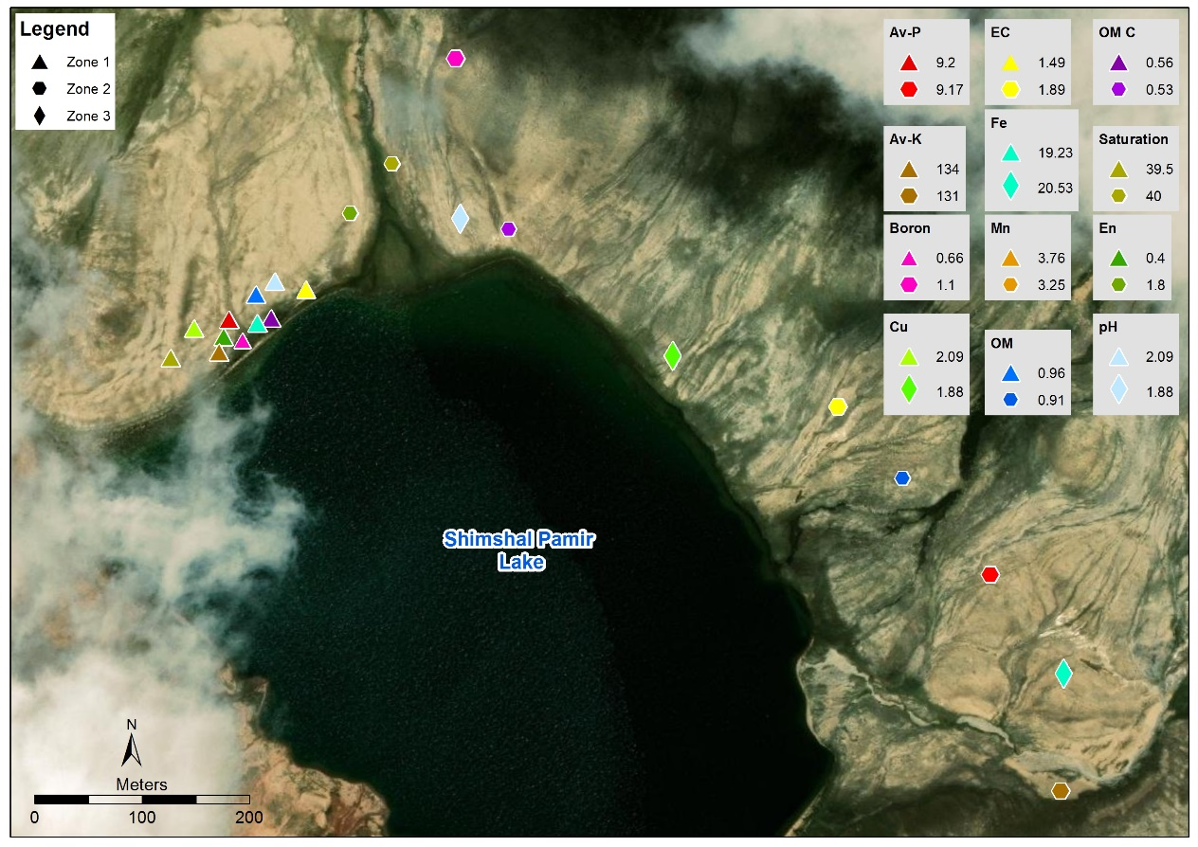
Fig 8: highest and lowest mean value comparison of soil parameters in the study area.

CHAPTER 5. CONCLUSION

The study of evaluation of soil organic carbon and fertility status high altitude pasture, Pamir showed that the soils from study area are sandy loam (70%), silt loam (14%) and silt clay (14%). The soils are moderately alkaline (7.19-8.18) in nature .The EC of the soils is found to be slightly saline (1.48-2.34 dSm⁻¹) .Soils in this study contain low to medium organic carbon content (0.49-0.56%). Available Phosphorus (8.58-9.20 mgkg⁻¹) and Extractable Potassium (128.44-134 mgkg⁻¹) was good in the area. DTPA-extractable Mangnism (Mn) and Iron (Fe) were high in the area .Copper (Cu) was medium and Zinc (Zn) was low. Boron (Br) is marginal and high in the soil.
Zinc deficient soil can simply be cured with Zinc fertilizer such as zinc sulphate most widely used fertilizer.
Considering the nature and land use of the area, it is concluded that a comprehensive soil assessment of the area should be done to develop nutrient management practices for sustainable crop production and proper grazing management should be done. It is additionally essential to secure the soils of the high and dry mountainous environment, especially the high altitude grazing pastures to support the carbon storage.

CHAPTER 6: RECOMMENDATION AND LIMITATION

6.1 Recommendations
- Additional study on ecological and biophysical aspect of high altitude pasture of shimshal should be done.
- To better understand the fertility status of the pasture, nutrient availability in forage must be studied in detail.
- Comprehensive soil survey of the area should be done to develop nutrient management practices for sustainable meadow production.

6.2 Limitations
- Soil has multidimensional capacity, and this investigation did not cover all features of the high altitude pasture soils.

REFERENCE

Aamer, M., Javed, Q., Mustafa, G., & Mahmood, S. (2015). Soil Fertility Management for Sustainable Agriculture: A Case Study of District Bahawalnagar, Pakistan. J. Nat. Sci. Res., 5(19), 2224-3186.
Adamczy k, B., Heinonsalo, J., & Simon, J. (2020). Mechanisms of Carbon Sequestration in Highly Organic Ecosystems–Importance of Chemical Ecology. ChemistryOpen, 9(4), 464.
Addis, W., & Abebaw, A. (2015). Analysis of selected physicochemical parameters of soils used for cultivation of garlic (Allium sativum L.). Science, Technology and Arts Research Journal, 3(4), 29-35.
Afzal, J., Ahmed, M., & Begum, I. (2008). Vision for Development of Rangelands in Pakistan-a policy perspective. Science vision, 14, 53-58.
Ahmed, S. (2020). Soil Fertility Management for Sustained Crop Production in Gilgit-Baltistan the Northern Mountainous Region of Pakistan.
Ali, F., Sadiq, A., Ali, I., Amin, M., & Amir, M. (2014). Effect of applied phosphorus on the availability of micronutrients in alkaline-calcareous soil. Journal of Environment and Earth Science, 4(15), 143-147.
Ali, S., Begum, F., Hayat, R., & Bohannan, B. J. (2017). Variation in soil organic carbon stock in different land uses and altitudes in Bagrot Valley, Northern Karakoram. Acta Agriculturae Scandinavica, Section B—Soil & Plant Science, 67(6), 551-561.
Ashri A (1998). Sesame breeding. Ann Rev Plant Breed 16: 179-228. 19.
Baize, D. (1993). Soil Science and analysis. A guide to current use, John Wiley and sons Ltd, West Sussex. 201 p

Batjes, N. H. (1996). Total carbon and nitrogen in the soils of the world. European journal of soil science, 47(2), 151-163.
Beg, GA (2010) ‘Current status of pastoral systems in Gilgit-Baltistan and Chitral, Pakistan’. In Kretzmann, H; Abdulalishoev, K; Lu, Zhaohui; Richter, J (eds) Pastoralism and rangeland management in mountain areas in the context of climate and global change; Regional workshop in Khorog and Kashgar, 14-21 July 2010. pp214. Deutsche Gesellschaft fur Internationale Zusammenarbeit, Feldafing (Germany)
Belyea, L. R., & Malmer, N. (2004). Carbon sequestration in peat land: patterns and mechanisms of response to climate change. Global Change Biology, 10(7), 1043-1052.
Bittner, C; Paul, D; Methke, D & Wachter, T (2008). Land use in Shigar Valley. Freie University Berlin
Brennan, R. F., Penrose, B., & Bell, R. W. (2020). Micronutrients limiting pasture production in Australia. Crop and Pasture Science, 70(12), 1053-1064.
Butz, D. (1995). Legitimating porter regulation in an indigenous mountain community in northern Pakistan. Environment and Planning D: Society and Space, 13(4), 381-414.

Butz, D. (1996). Sustaining indigenous communities: symbolic and instrumental dimensions of pastoral resource use in Shimshal, northern Pakistan. Canadian Geographer/Le Géographe canadien, 40(1), 36-53.

Chavda, D. B., Jat, J. R., Kumar, S., Malav, J. K., Pavaya, R. P., & Patel, J. K. (2018). Status of DTPA-extractable micronutrients (Fe, Mn, Zn and Cu) in soils of Gandhinagar district of Gujarat. Journal of Pharmacognosy and Phytochemistry, 7(6), 2039-2043.
Dad, J. M. (2019). Organic carbon stocks in mountain grassland soils of northwestern Kashmir Himalaya: spatial distribution and effects of altitude, plant diversity and land use. Carbon Management, 10(2), 149-162.
Dahnke, W. C., & Whitney, D. A. (1988). Measurement of soil salinity. Recommended chemical soil test procedures for the North Central Region, 499, 32-34.
Deshmukh, K. K. (2012). Evaluation of soil fertility status from Sangamner area, Ahmednagar district, Maharashtra, India. Rasayan journal of Chemistry, 5(3), 398-406.
Essington, M. E., (2004). Soil and water chemistry: an integrative approach. CRC Press LCC, Boca Raton, Florida, USA.

Eswaran, H., Van Den Berg, E., & Reich, P. (1993). Organic carbon in soils of the world. Soil science society of America journal, 57(1), 192-194.

FAO (1987) Pakistan’s experience in rangeland rehabilitation and improvement. Food and Agriculture Organization of the United Nations. Rome, pp70
Farooq, M. U., Ahmad, S., Islam, M., & Qamar, I. A. (2016). Assessing the status of carbon pool in two rangeland grasses (Panicum antidotale and Panicum maximum) in Pothwar, region, Pakistan. Pakistan Journal of Agricultural Research, 29(4).
Gao, Y. H., Luo, P., Wu, N., Chen, H., & Wang, G. X. (2007). Grazing intensity impacts on carbon sequestration in an alpine meadow on the eastern Tibetan Plateau. Research Journal of Agriculture and Biological Sciences, 3(6), 642-647.

Garcia-Pausas, J., Romanyà, J., Montané, F., Rios, A. I., Taull, M., Rovira, P., & Casals, P. (2017). Are soil carbon stocks in mountain grasslands compromised by land-use changes? In High Mountain Conservation in a Changing World (pp. 207-230). Springer, Cham.
Hall, D. O., Ojima, D. S., Parton, W. J., & Scurlock, J. M. O. (1995). Response of temperate and tropical grasslands to CO2 and climate change. Journal of Biogeography, 537-547.
Henderson, D.C. (2000). Carbon storage in grazed prairie grasslands of Alberta. MS thesis, University of Alberta, Edmonton, AB, Canada
Hussain, A., Ali, H., Abbas, H., Khan, S. W., Ali, S., Hussain, A., & Ali, S. (2019). Spatial analysis of selected soil parameters in potato growing areas of mountainous region of Gilgit-Baltistan, Pakistan. Pak. J. Bot, 51(2), 623-630.
Hussain, Z., Tahir, M. M., Rahim, N., Khaliq, A., Facho, Z. H., Shafqat, H., & Shaheen, A. (2019). 23. Fertility assessment of mountainous soils of District Skardu, Gilgit-Baltistan, Pakistan. Pure and Applied Biology (PAB), 8(3), 2095-2103.
Ingram JSI & Fernandes ECM (2001).Managing carbon sequestration in soils: Concepts and terminology. Agriculture, Ecosystems & Environment 87: 111-117.
Ishaq, S., Begum, F., Hussain, K., Abbas, Y., Ali, K., Ahmed, S., & Karim, R. (2015). Soil quality assessment in gulmit and shiskat valley of upper hunza, district Hunza Nagar, Gilgit-Baltistan. J Biodiversity Environ Sci, 7, 87-95.
Iturrizaga, L. (1997). The valley of Shimshal–a geographical portrait of a remote high mountain settlement and its pastures with reference to environmental habitat conditions in the North-West Karakorum (Pakistan). GeoJournal, 42(2-3), 303-328.
Jastrow, J. D., Amonette, J. E., & Bailey, V. L. (2007). Mechanisms controlling soil carbon turnover and their potential application for enhancing carbon sequestration. Climatic Change, 80(1-2), 5-23.
Jobbagy EG & Jackson RB (2000). The vertical distribution of soil organic and its relation to climate and vegetation. Ecol Appl 10: 423-426.

Jobbágy, E. G., & Jackson, R. B. (2000). The vertical distribution of soil organic carbon and its relation to climate and vegetation. Ecological applications, 10(2), 423-436.
Johnson, J. M. F., Franzluebbers, A. J., Weyers, S. L., & Reicosky, D. C. (2007). Agricultural opportunities to mitigate greenhouse gas emissions. Environmental pollution, 150(1), 107-124.
Joy, E. J., Broadley, M. R., Young, S. D., Black, C. R., Chilimba, A. D., Ander, E. L., & Watts, M. J. (2015). Soil type influences crop mineral composition in Malawi. Science of the Total Environment, 505, 587-595.
Kashtanov, A. N., Vernyuk, Y. I., Savin, I. Y., Shchepot’ev, V. V., Dokukin, P. A., Sharychev, D. V., & Li, K. A. (2018). Mapping of Rill Erosion of Arable Soils Based on Unmanned Aerial Vehicles Survey. Eurasian Soil Science, 51(4), 479-484.

Khan, M. Z., Khan, B., Awan, S., Khan, G., & Ali, R. (2013). High-altitude rangelands and their interfaces in Gilgit-Baltistan, Pakistan: current status and management strategies. High-Altitude Rangelands and their Interfaces in the Hindu Kush Himalayas, 66.
Kreutzmann, H. (2004). Pastoral practices and their transformation in the North-Western Karakoram. Nomadic Peoples, 8(2), 54-88
Lal, R. (1997). Residue management, conservation tillage and soil restoration for mitigating greenhouse effect by CO2-enrichment. Soil and tillage research, 43(1-2), 81-107.
Lal, R. (2004). Soil carbon sequestration impacts on global climate change and food security. science, 304(5677), 1623-1627.
Lal, R. (2005). Forest soils and carbon sequestration. Forest ecology and management, 220(1-3), 242-258.
Lal, R. (2008). Carbon sequestration. Philosophical Transactions of the Royal Society B: Biological Sciences, 363(1492), 815-830.
Landon JR (1991). Booker tropical soil manual, Hand Book for soil survey and Agricultural land evaluation in Tropics and sub-tropics. Longman. New York
Ledo, A., Smith, P., Zerihun, A., Whitaker, J., Vicente‐Vicente, J. L., Qin, Z., & Kuhnert, M. (2020). Changes in soil organic carbon under perennial crops. Global Change Biology.
Maharjan, M. E. N. U. K. A. (2010). Soil carbon and nutrient status of rangeland in Upper Mustang. Institute of Forestry, Tribhuvan University, Pokhara Google Scholar.
Malik, D. M., Khan, M. A., & Choudhry, T. A. (1984). Analysis manual for soil, water and plants. Directorate of Soil Fertility and Soil Testing, Lahore, Pakistan.
Murphy, L. S., Ellis Jr, R., & Adriano, D. C. (1981). Phosphorus‐micronutrient interaction effects on crop production. Journal of Plant Nutrition, 3(1-4), 593-613.
Nelson, D. W., & Sommers, L. (1983). Total carbon, organic carbon, and organic matter. Methods of soil analysis: Part 2 chemical and microbiological properties, 9, 539-579.
Ni, J. (2002). Carbon storage in grasslands of China. Journal of Arid Environments, 50(2), 205-218.
Olson, K. R. (2013). Soil organic carbon sequestration, storage, retention and loss in US croplands: Issues paper for protocol development. Geoderma, 195, 201-206.
Pal, D. K., Tarafdar, J. C., & Sahoo, A. K. (2009). Analysis of Soil for Soil Survey and Mapping. Soil survey manual. NBSS&LUP Publication, (146).

Parveen, S., Malik, Z., & Nazif, W. (2010). Fertility Status of Vegetable Growing Areas of the Peshawar, Pakistan. Pakistan Journal of Botany 46, 1871- 1880

Qazi, M. A., Akram, M., Ahmad, N., Artiola, J. F., & Tuller, M. (2009). Economical and environmental implications of solid waste compost applications to agricultural fields in Punjab, Pakistan. Waste Management, 29(9), 2437-2445.

Richards, L. A. (1968). Diagnosis and Improvement of Saline and Alkali soils. United State Salinity Laboratory Staff. Agril. Handbook No. 60.

Ritchie, J. C., McCarty, G. W., Venteris, E. R., & Kaspar, T. C. (2007). Soil and soil organic carbon redistribution on the landscape. Geomorphology, 89(1-2), 163-171.
Sadiq M (1986). Proc. Intl Forum Soil Taxonomy and Agro-technology Transfer. 113-118
Schuman, G. E., Janzen, H. H., & Herrick, J. E. (2002). Soil carbon dynamics and potential carbon sequestration by rangelands. Environmental pollution, 116(3), 391-396.
Schuur, E. A. G., Bockheim, J., Canadell, J. G., Euskirchen, E., Field, C. B., Goryachkin, S. V., Hagemann, S., Kuhry, P., Lafleur, P. M., Lee, H., Mazhitova, G., Nelson, F. E., Rinke, A., Romanovsky, V. E., Shiklomanov, N., Tarnocai, C., Venevsky, S, Vogel, J. G & Zimov, S. A., (2008): Vulnerability of Permafrost Carbon to Climate Change: Implications for the Global Carbon Cycle. Bio Science, 58: 701- 714.
Shimsal Nature Trust. 1998. Shimshal Nature Trust (SNT); fifteen year vision & management plan. Available online at: http://www
Sillanpää, M. (1982). Micronutrients and the nutrient status of soils: a global study (Vol. 48). Food & Agriculture Org.
Singh, S., Seed, H. B., & Chan, C. Y. (1982). Undisturbed sampling of saturated sands by freezing. Journal of Geotechnical and Geoenvironmental Engineering, 108(GT2).

Smith, P. (2002). The potential of US grazing lands to sequester carbon and mitigate the greenhouse effect: edited by RF Follett, JM Kimble and R Lal. Lewis Publishers, Boca Raton, 2001. Hardbound, 442 pp. ISBN 1566705541. GBP60.
Soltanpour, P. N. (1985). Use of ammonium bicarbonate DTPA soil test to evaluate elemental availability and toxicity. Communications in Soil Science and Plant Analysis, 16(3), 323-338.
Tegler, B. (2017). “Drawdown: The Most Comprehensive Plan Ever Proposed to Reverse Global Warming" by Paul Hawken, 2016. [Book review]. The Canadian Field-Naturalist, 131(2), 197.
Tilahun, G. (2007). Soil fertility status as influenced by different land uses in Maybar areas of South Wello Zone, North Ethiopia. MS.c Thesis, Haramaya University, Haramaya, Ethiopia. 40p.
Trettin, C. C., & Jurgensen, M. F. (2003). Carbon cycling in wetland forest soils (pp. 311-331). Lewis Publishers, Boca Raton, London, New York, Washington, DC.
Umrani, A. P., English, P. R., & Younie, D. (1995). Rangelands in Pakistan. Asian Livestock.
World Health Organization. (1980). Recommended health-based limits in occupational exposure to heavy metals: report of a WHO study group [meeting held in Geneva from 5 to 11 June 1979]. World Health Organization.

Zhao, Z., Zhang, X., Dong, S., Wu, Y., Liu, S., Su, X., & Tang, L. (2019). Soil organic carbon and total nitrogen stocks in alpine ecosystems of Altun Mountain National Nature Reserve in dry China. Environmental monitoring and assessment, 191(1), 40.
Zia, M. H., Ahmad, R., Khaliq, I., Ahmad, A., & Irshad, M. (2006). Micronutrients status and management in orchards soils: applied aspects. Soil Environ, 25(1), 6-16.

Appendix A

NS= Non Saline, SS= Slightly Saline, MS=moderately saline

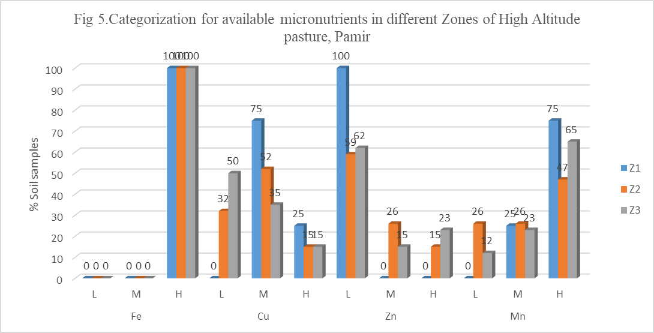

Appendix B

Table 1.Mean value of the soil parameters at sampling area.

Variables | Z1 | Z2 | Z3
Saturation % | 39.50 | 37.65 | 40.00
pH | 8.00 | 8.18 | 7.91
EC dSm⁻¹ | 1.48 | 2.35 | 1.89
Organic Matter % | 0.96 | 0.85 | 0.91
Organic Carbon % | 0.56 | 0.49 | 0.53
Av P (mgkg⁻¹) | 9.20 | 8.58 | 9.17
Av K(mgkg⁻¹) | 134.00 | 128.44 | 131.08
Cu | 2.09 | 1.85 | 1.67
Fe | 19.23 | 21.30 | 20.52
Mn | 3.76 | 2.68 | 3.25
Zn | 0.43 | 1.58 | 1.87
Boron (ppm) | 0.66 | 1.01 | 1.10

Table 2. Maximum, minimum, mean value and standard deviation of soil parameters
in zone,1 (peat land)

Estimation | Range | Mean | SD
Saturation % | 38 - 40 | 39.5 | 01
Soil pH | 7.6 -8.4 | 8.00 | 0.3651
Ec (dSm⁻¹ ) | 1.3 – 1.7 | 1.475 | 0.1708
Organic Matter (%) | 0.7-1.3 | 0.9625 | 0.2551
Organic Carbon | 0.14 – 0.75 | 0.5575 | 0.1482
Av. Phosphorus(mgkg⁻¹ ) | 6.8- 10.9 | 9.2 | 2.0445
Exc Potassium (mgkg⁻¹ ) | 58 - 210 | 134 | 54.179
Fe | 17.6- 21.7 | 19.225 | 1.7914
Mn | 1.93- 5.66 | 3.76 | 1.7076
Zn | 0.2- 0.63 | 0.425 | 0.1994
Cu | 1.88- 2.36 | 2.9025 | 0.2311
Br | 0.09 -1.5 | 0.655 | 0.608

Where, SD = Standard Deviation
Table 3. Maximum, minimum, mean value and standard deviation of soil parameters in zone 2, vegetative land
Estimation | Rang | Mean | S D
Saturation% | 20 – 50 | 37.645 | 6.6873
Soil pH | 7.7 – 8.9 | 8.1824 | 0.2949
Ec | 1.2 – 8.1 | 2.3529 | 1.5894
Organic Matter (%) | 0.52-1.31 | 0.8491 | 0.2614
Organic Carbon | 0.3 – 0.76 | 0.4924 | 0.1527
Avail Phosphorous | 5.4- 13.3 | 8.5765 | 2.1783
Ex Potassium | 85 - 190 | 128.44 | 31.545
Copper (cu) | 0.27- 3.03 | 1.8521 | 0.6527
Zinc (Zn) | 0.11 – 4.53 | 1.5794 | 1.0392
Magnise (Mn) | 0.15- 7.21 | 2.6812 | 1.5154
Iron (Fe) | 13.5- 34.4 | 21.297 | 5.959
Boron (B) | 0.11 -1.9 | 1.0097 | 0.5486

SD = Standard Deviation

Table 4.Maximum, minimum, mean value and standard deviation of soil parameters in zone 3, barren land
Estimation | Rang | Mean | S D
Saturation% | 30 – 54 | 40 | 7.5472
Soil pH | 6.9 – 8.8 | 7.9115 | 0.4457
Ec (dSm⁻¹) | 0.5 – 4.8 | 1.8885 | 0.9245
Organic Matter (%) | 0.52-1.28 | 0.9135 | 0.2434
Organic Carbon (%) | 0.3 – 0.74 | 0.5292 | 0.1414
Avail Phosphorous (mgkg⁻¹ ) | 5.4 – 10.9 | 9.1731 | 1.6732
Ex Potassium(mgkg⁻¹ ) | 85 - 186 | 131.08 | 31.016
Cu | 0.72 – 2.78 | 1.6677 | 0.5926
Zn | 0.27 – 6.08 | 1.8688 | 1.4405
Mn | 0.66 – 7.3 | 3.2515 | 1.5448
Fe | 12.9 – 28.9 | 20.519 | 4.0421
Boron (ppm) | 0.07- -1.88 | 1.0988 | 0.6152

Appendix C

SOIL ANALYSIS REPORT

Sr # | EC | pH | Organic Matter (%) | Organic C (%) | Av.P (ppm) | Ex. K (ppm) | Saturation % | Zn (ppm) | Cu (ppm) | Fe (ppm) | Mn (ppm) | Boron (ppm)
Z2 | 1.7 | 8.2 | 1.21 | 0.70 | 10.9 | 144 | 50 | 0.91 | 1.27 | 19.2 | 1.63 | 1.66
Z2 | 1.8 | 8.4 | 0.73 | 0.42 | 9.5 | 120 | 48 | 1.32 | 2.18 | 15.3 | 1.46 | 0.49
Z2 | 1.4 | 8.5 | 1.13 | 0.66 | 8.2 | 184 | 40 | 0.38 | 1.10 | 16.7 | 1.93 | 1.79
Z2 | 1.4 | 8.4 | 0.80 | 0.47 | 5.4 | 109 | 36 | 0.12 | 1.72 | 17.3 | 2.10 | 1.61
Z2 | 2.2 | 8.3 | 1.15 | 0.67 | 8.2 | 190 | 34 | 4.53 | 2.34 | 23.2 | 4.96 | 0.25
Z2 | 1.9 | 8.1 | 0.66 | 0.38 | 8.2 | 97 | 34 | 0.11 | 2.70 | 15.3 | 3.99 | 1.72
Z1 | 1.7 | 7.6 | 1.30 | 0.75 | 8.2 | 210 | 40 | 0.20 | 1.88 | 18.3 | 2.78 | 1.50
Z1 | 1.3 | 7.8 | 0.82 | 0.48 | 6.8 | 85 | 40 | 0.32 | 1.92 | 17.6 | 1.93 | 0.38
Z1 | 1.5 | 8.2 | 1.01 | 0.59 | 10.9 | 132 | 40 | 0.55 | 2.36 | 19.3 | 5.66 | 0.65
Z1 | 1.4 | 8.4 | 0.72 | 0.41 | 10.9 | 109 | 38 | 0.63 | 2.21 | 21.7 | 4.67 | 0.09
Z2 | 2.6 | 8.0 | 1.24 | 0.72 | 8.2 | 148 | 42 | 1.05 | 1.93 | 22.5 | 2.52 | 0.58
Z2 | 2.8 | 7.8 | 0.77 | 0.45 | 5.4 | 128 | 40 | 1.93 | 2.01 | 27.5 | 2.66 | 0.38
Z2 | 1.6 | 8.1 | 1.15 | 0.67 | 10.9 | 166 | 44 | 3.19 | 2.48 | 32.3 | 0.15 | 0.65
Z2 | 2.0 | 7.9 | 0.70 | 0.41 | 8.2 | 120 | 44 | 2.61 | 3.03 | 26.6 | 1.01 | 1.32
Z2 | 1.4 | 7.9 | 1.31 | 0.76 | 10.9 | 180 | 40 | 1.25 | 1.26 | 13.5 | 3.16 | 1.32
Z2 | 1.3 | 8.1 | 0.89 | 0.52 | 5.4 | 95 | 40 | 2.01 | 1.16 | 17.8 | 2.17 | 0.43
Z2 | 2.7 | 8.4 | 1.03 | 0.60 | 5.4 | 155 | 38 | 0.57 | 1.66 | 14.3 | 4.73 | 0.40
Z2 | 2.5 | 8.2 | 0.75 | 0.43 | 5.4 | 101 | 40 | 0.78 | 2.04 | 21.8 | 2.61 | 1.48
Z2 | 1.4 | 8.2 | 1.13 | 0.66 | 9.5 | 148 | 42 | 1.77 | 2.05 | 16.3 | 4.22 | 1.30
Z2 | 1.3 | 7.9 | 0.57 | 0.33 | 8.2 | 111 | 40 | 1.82 | 1.93 | 29.6 | 2.93 | 0.25
Z3 | 1.6 | 7.8 | 1.15 | 0.67 | 10.9 | 160 | 40 | 4.92 | 1.32 | 17.6 | 3.91 | 0.67
Z3 | 2.1 | 7.8 | 0.82 | 0.48 | 8.2 | 104 | 34 | 3.44 | 1.16 | 12.9 | 2.81 | 1.66
Z2 | 1.5 | 8.0 | 1.03 | 0.60 | 5.4 | 184 | 42 | 4.48 | 1.71 | 21.9 | 4.65 | 1.72
Z2 | 1.3 | 8.4 | 0.66 | 0.38 | 8.2 | 95 | 40 | 3.01 | 2.51 | 15.7 | 3.67 | 1.48
Z2 | 1.2 | 8.3 | 1.01 | 0.59 | 10.9 | 162 | 40 | 1.84 | 2.81 | 31.2 | 7.21 | 1.43
Z2 | 1.3 | 8.1 | 0.52 | 0.30 | 10.9 | 90 | 40 | 2.17 | 2.68 | 26.8 | 2.91 | 1.46
Z3 | 1.4 | 8.0 | 0.57 | 0.33 | 10.9 | 123 | 30 | 1.19 | 1.84 | 17.6 | 4.41 | 1.43
Z3 | 1.3 | 8.2 | 0.85 | 0.49 | 8.2 | 85 | 32 | 1.18 | 1.03 | 18.3 | 3.62 | 1.59
Z3 | 1.4 | 7.8 | 1.27 | 0.73 | 10.9 | 138 | 54 | 1.37 | 1.86 | 23.5 | 5.85 | 0.74
Z3 | 1.5 | 7.7 | 0.66 | 0.38 | 5.4 | 138 | 44 | 2.01 | 2.75 | 14.9 | 3.34 | 1.84
Z3 | 2.7 | 7.1 | 1.15 | 0.67 | 9.5 | 155 | 50 | 1.25 | 1.84 | 18.4 | 5.80 | 1.23
Z3 | 3.7 | 6.9 | 0.77 | 0.45 | 8.2 | 119 | 50 | 2.03 | 1.82 | 23.2 | 2.74 | 0.78
Z2 | 2.7 | 7.7 | 1.31 | 0.76 | 5.4 | 130 | 36 | 1.00 | 0.69 | 14.7 | 3.66 | 0.49
Z2 | 4.3 | 7.8 | 0.57 | 0.33 | 8.2 | 150 | 40 | 1.18 | 2.67 | 19.9 | 1.79 | 1.08
Z3 | 2.9 | 8.1 | 1.15 | 0.67 | 10.9 | 133 | 40 | 2.84 | 1.62 | 18.5 | 7.30 | 1.55
Z3 | 2.3 | 8.0 | 0.77 | 0.45 | 10.9 | 178 | 44 | 2.18 | 2.78 | 20.7 | 2.91 | 1.68
Z3 | 4.8 | 7.2 | 1.03 | 0.60 | 10.9 | 112 | 48 | 0.96 | 2.11 | 26.7 | 5.51 | 1.39
Z3 | 1.4 | 7.5 | 0.72 | 0.41 | 8.2 | 180 | 44 | 1.21 | 2.19 | 21.8 | 3.01 | 0.11
Z3 | 1.1 | 7.5 | 1.12 | 0.65 | 10.9 | 112 | 50 | 0.79 | 1.14 | 28.9 | 1.83 | 1.88
Z3 | 0.5 | 7.5 | 0.80 | 0.47 | 10.9 | 101 | 36 | 0.27 | 1.62 | 17.9 | 2.72 | 1.72
Z3 | 1.4 | 8.0 | 1.28 | 0.74 | 10.9 | 123 | 30 | 0.65 | 1.99 | 14.5 | 4.00 | 1.48
Z3 | 1.3 | 8.2 | 0.85 | 0.49 | 8.2 | 85 | 32 | 0.45 | 1.35 | 21.8 | 3.18 | 0.74
Z3 | 2.5 | 8.7 | 1.15 | 0.67 | 10.9 | 104 | 32 | 0.99 | 1.12 | 21.6 | 0.66 | 0.07
Z3 | 2.2 | 8.5 | 0.57 | 0.33 | 8.2 | 90 | 30 | 1.29 | 1.93 | 17.3 | 1.39 | 1.01
Z2 | 2.1 | 8.7 | 0.57 | 0.33 | 8.2 | 90 | 30 | 0.90 | 1.69 | 34.4 | 5.19 | 0.81
Z2 | 2.4 | 8.9 | 0.57 | 0.33 | 8.2 | 90 | 30 | 1.74 | 2.74 | 28.5 | 3.94 | 1.25
Z2 | 2.1 | 8.8 | 0.57 | 0.33 | 8.2 | 90 | 38 | 1.26 | 1.18 | 14.7 | 2.19 | 0.20
Z2 | 4.8 | 8.3 | 0.54 | 0.31 | 8.2 | 85 | 40 | 1.79 | 2.39 | 16.8 | 1.05 | 0.85
Z3 | 1.8 | 8.1 | 1.04 | 0.60 | 8.2 | 108 | 30 | 0.87 | 2.74 | 23.5 | 2.37 | 1.57
Z3 | 2.1 | 8.8 | 1.04 | 0.60 | 8.2 | 108 | 44 | 2.03 | 1.04 | 27.4 | 1.48 | 1.32
Z3 | 1.3 | 8.0 | 1.15 | 0.67 | 8.2 | 186 | 44 | 6.08 | 0.72 | 21.3 | 3.37 | 1.43
Z3 | 1.5 | 8.0 | 0.72 | 0.41 | 5.4 | 142 | 40 | 4.72 | 1.01 | 17.2 | 2.03 | 0.09
Z3 | 0.7 | 8.1 | 1.27 | 0.73 | 9.5 | 180 | 46 | 1.48 | 1.15 | 26.4 | 3.82 | 1.72
Z3 | 1.2 | 8.2 | 0.66 | 0.38 | 8.2 | 132 | 46 | 1.15 | 2.45 | 21.9 | 2.18 | 0.58
Z2 | 7.4 | 8.2 | 1.18 | 0.68 | 10.9 | 140 | 20 | 1.07 | 1.04 | 14.9 | 2.27 | 0.76
Z2 | 8.1 | 8.5 | 0.52 | 0.30 | 6.8 | 122 | 20 | 1.63 | 1.83 | 16.5 | 1.37 | 0.11
Z3 | 2.5 | 7.9 | 0.67 | 0.39 | 7.9 | 176 | 32 | 1.32 | 1.05 | 20.4 | 2.12 | 0.13
Z3 | 1.9 | 8.1 | 0.52 | 0.30 | 9.8 | 136 | 38 | 1.92 | 1.73 | 19.3 | 2.18 | 0.16
Z2 | 2.0 | 8.4 | 0.66 | 0.38 | 13.1 | 98 | 44 | 1.56 | 1.39 | 26.8 | 1.52 | 0.92
Z2 | 2.4 | 8.0 | 0.94 | 0.54 | 9.2 | 105 | 42 | 1.92 | 1.72 | 25.2 | 2.02 | 1.90
Z2 | 1.9 | 7.8 | 0.72 | 0.41 | 8.7 | 128 | 36 | 0.38 | 1.58 | 19.5 | 1.76 | 1.28
Z2 | 1.4 | 7.8 | 0.52 | 0.30 | 13.3 | 162 | 32 | 1.02 | 1.39 | 21.3 | 1.72 | 1.55
Z2 | 1.8 | 8.1 | 0.94 | 0.54 | 9.8 | 118 | 28 | 1.48 | 1.82 | 18.7 | 0.92 | 1.10
Z2 | 1.3 | 8.0 | 0.82 | 0.48 | 10.1 | 132 | 30 | 0.92 | 0.27 | 27.4 | 1.09 | 0.31

NOTE
Zone 1: Peat land
Zone 2: vegetation
Zone 3: Barren land

.

