

E-GOVERNANCE AND SERVICE DELIVERY IN HEALTH SECTOR IN PUNJAB: APPROACHES, CHALLENGES AND POSSIBILITIES

AMMAR ARSHAD
[19M01001]

Thesis submitted to the Lahore School of Economics
in partial fulfilment of the requirements for the degree of
MPhil in Development Studies
2019 – 2021

[21,382]

Supervisor: Dr Fareeha Zafar
Co-Supervisor: Dr. Ahmad Nawaz

Abstract
The rise of new digital technologies and their rapid expansion is transforming the world as we know it. The federal and provincial governments in Pakistan have been increasingly trying to transition towards modern, e-Governance based, public service delivery in the health sector but they face significant challenges in the materialization of these aims. Despite significantly jacking up public sector spending in the Governance and IT sector, Pakistan ranks 153 out of 193 countries in the United Nations E-Government Development Index. This highlights significant room for improvement in the way these interventions are carried out.
The thesis is an effort towards investigating the role e-Governance has played, to this end, in improving public delivery of services, in the health sector, in Punjab. The Hospital Information Management System (HIMS) intervention in the province of Punjab is discussed as a case study. The user experiences and satisfaction levels are analyzed to identify the overarching themes of the effectiveness and challenges faced by e-governance interventions, seeking to improve the provision of services in health sector, in Punjab. The thesis also puts forward a few recommendations which may help the development planners in designing better e-Governance interventions, in the context of Punjab.

Acknowledgments
I shall forever remain grateful to my supervisor Dr. Fareeha Zafar. Had it not been for her undaunting support, invaluable advice and precious time, this research would not have been possible.
At a stage when I was unable to find the way forward, Dr. Ahmad Nawaz proved to be a life-saver and helped in completing this thesis. I am forever indebted to Dr. Ahmad Nawaz for this kindness.
I would like to thank all those, in Planning and Development Board and Primary and Secondary Healthcare Department who helped me during the course of this research. I would further like to thank all those in Tehsil Headquarter Hospital Raiwind, who answered the questionnaires for this research. Their professional and technical expertise was crucial for answering the research questions and thereby gaining meaningful insights into the e-Governance and service delivery interventions in the health sector.

Table of Contents
Abstract ii
Acknowledgments iii
Table of Contents iv
Abbreviations vii
List of Tables ix
List of Figures x
Chapter 1 - INTRODUCTION 1
1.1. E-Governance in Pakistan 2
1.2. Management of Development Interventions in Punjab 7
1.3. HIMS Intervention in Punjab 10
1.4. Research Objectives 13
1.5. Research Questions 13
1.6. Purpose and Rationale of the Study 13
Chapter 2 - LITERATURE REVIEW 15
2.1. E-Governance 15
2.2. Importance of e-Governance in Health Sector 17
2.3. Literature Related to Hospital Information Management System 19
2.4. Literature Related to E-Governance in Health Sector in Other Countries 23
2.4.1. India 23
2.4.2. Bangladesh 26
2.4.3. Other Countries 28
2.5. Literature Related to E-Governance in Health Sector in Pakistan 31
2.6. Research Gap 35
Chapter 3 - RESEARCH METHODOLOGY 36
3.1. Research Design 36
3.1.1. Convergent Mixed Methods Design 36
3.1.2. Case Study Design 37
3.1.3. Evaluation Framework 38
3.2. Population, Sampling Frame, Sample Size and Sampling Technique 39
3.2.1. Population 39
3.2.2. Sampling Frame 39
3.2.3. Sample Size 39
3.2.4. Sampling Technique 40
3.3. Research Questionnaire Design 40
3.4. Data Collection 42
Chapter 4 - RESULTS AND DISCUSSION 45
4.1. Descriptive Analysis 47
4.1.1. Technological Issues 48
4.1.1.1. Operational Functionality Modelling (OFM) 48
4.1.1.2. Software Complexity (SC) 48
4.1.1.3. Software Shortcomings (SS) 49
4.1.1.4. Lack of Robust Technical Support Mechanism (LTS) 50
4.1.2. Non-Technological Issues 50
4.1.2.1. Communication and Coordination Issues (C&C) 50
4.1.2.2. Data Non-Utilization (DNU) 51
4.1.2.3. Lack of Robust Operations & Maintenance (LROM) 52
4.1.3. User Experiences and Satisfaction Level 52
4.2. Qualitative Analysis 55
4.2.1. Technological Issues 55
4.2.1.1. Operational Functionality Modelling 56
4.2.1.2. Software Complexity 57
4.2.1.3. Software Shortcomings 58
4.2.1.4. Lack of Robust Technical Support Mechanism 60
4.2.2. Non-Technological Issues 61
4.2.2.1. Communication and Coordination Issues 62
4.2.2.2. Negative Attitudes 63
4.2.2.3. Data Non-Utilization 64
4.2.2.4. Lack of Robust Operations and Maintenance 66
4.3. Attainment of Project Objectives 67
Chapter 5 - CONCLUSION AND POLICY RECOMMENDATIONS 69
5.1. Observations and Conclusion 69
5.2. Main Findings and Lessons Learnt from HIMS Intervention 71
5.3. Policy Recommendations 72
5.3.1. Technical Recommendations 72
5.3.2. Non-Technical Recommendations 73
Chapter 6 – LIMITATIONS AND FUTURE LINE OF INQUIRY 75
ANNEXURES 76
Annexure A 76
REFERENCES 81

Abbreviations
ABS – Annual Budget Statement
BPR – Business Process Reengineering
CIS – Clinical Information System
CNIC – Computerized National Identity Card
DGM&E – Directorate General Monitoring & Evaluation
DHQ – District Headquarter Hospital
EGDI – E-Government Development Index
EMR – Electronic Medical Record
ERP – Enterprise Resource Planning
FY – Financial Year
HER – Electronic Health Record
HIT – Health Information Technology
HIMS – Hospital Information Management System
ICT – Information & Communications Technology
IT – Information Technology
LHWs – Lady Health Workers
M&E – Monitoring & Evaluation
MHIS – Mental Health Information System
MO – Medical Officer
MPD&SI – Ministry of Planning, Development & Special Initiatives
NADRA – National Database & Registration Authority
O&M – Operations and Maintenance
OECD – Organization for Economic Cooperation and Development
OPD – Out Patient Department
PITB – Punjab Information Technology Board
P&DB – Planning & Development Board
P&SHD – Primary & Secondary Healthcare Department
SDGs – Sustainable Development Goals
SWOT – Strengths, Weaknesses, Opportunities and Threats
TAM – Technology Acceptance Model
THQ – Tehsil Headquarter Hospital
UN – United Nations
UNDESA - United Nations Department of Economic and Social Affairs
WHO – World Health Organization

List of Tables
Table 1-1: Year-Wise Ranking of Pakistan on E-Government Development Index 6
Table 1-2: Project Documents for Development Intervention 7
Table 1-3: Fora for Approval of Development Projects 8
Table 1-4: Project Objectives of the HIMS Intervention 11
Table 3-1: Question-Respondent Mapping 41
Table 3-2: List of Respondents for Research Questionnaires 43
Table 3-3: Hospital Staff Interviewed in Detail 43
Table 4-1: Major Themes and Sub-Themes 45
Table 4-2: Evaluation Criteria to Sub-Theme Mapping 46
Table 4-3: Survey Questionnaire to Sub-Theme Mapping 47

List of Figures
Figure 1-1: Year-Wise Development Budget for IT Sector 4
Figure 1-2: Year-Wise Non-Development Budget for IT Sector 5
Figure 1-3: Pakistan's Ranking on E-Government Development Index 6
Figure 1-4: Project Management Cycle 10
Figure 2-1: Models of E-Governance 17
Figure 3-1: Convergent Mixed Methods Design 37
Figure 3-2: Evaluation Framework 38
Figure 4-1: Summary Statistics for Operational Functionality Modelling 48
Figure 4-2: Summary Statistics for Software Complexity 48
Figure 4-3: Summary Statistics for Software Shortcomings 49
Figure 4-4: Summary Statistics for Lack of Robust Technical Support Mechanism 50
Figure 4-5: Summary Statistics for Communication and Coordination Issues 50
Figure 4-6: Summary Statistics for Data Non-Utilization 51
Figure 4-7: Summary Statistics for Lack of Robust Operations & Maintenance 52
Figure 4-8: System Improvements Due To HIMS 52
Figure 4-9: Improvements in Productivity & Effectiveness Due To HIMS 53
Figure 4-10: HIMS - User Experiences & Satisfaction Level 54
Figure 4-11: HIMS - Technological Issues 56
Figure 4-12: Availability of Robust Technical Support Mechanism 60
Figure 4-13: HIMS - Non-Technological Issues 62
Figure 4-14: Project Objective Attainment Matrix 67

- INTRODUCTION
The world, as we know it, is being transformed by the gradual rise and rapid expansion of new digital technologies. World Bank (2016) estimates suggest that nearly 40 percent of the world population has access to the Internet, and amongst the poorest 20 percent of the world population, 7 out of 10 have access to the mobile phones. This is a truly remarkable finding, and this high digital availability is a useful tool that governments, across the globe, should use to improve their governance and provision of services. This is where e-Governance comes into play. The term E-governance is defined as “the use of Information and Communication Technologies (ICTs) in the public sector for enabling easier information access, efficient delivery of public services, participatory decision-making, and more accountable and transparent governments” (Sabri, Sabri, & Al-Shargabi, 2012).
E-governance is not tangential to conventional forms of government; rather, it acts as a complement to conventional governance and aims to fill the gaps left by conventional governance. In that way, e-governance helps the governments achieve the objectives of good governance. This is primarily what the government of Punjab aimed to do when it decided to implement Hospital Information Management System (HIMS) in various Tehsil Headquarter Hospitals across Punjab in 2016. HIMS finds basis in Enterprise Resource Planning (ERP) systems which are information systems that aim to integrate the units of an organization and optimize the business processes (Moon, 2007).
Barker and Frolick (2003) contend that when an organization successfully implements ERP, it aims for optimal system usage. Since considerable resources have been invested in the ERP implementation, the best possible utilization of the system is anticipated. Indeed, the usefulness of an ERP system draws from its effective and efficient usage and not so much from the system itself. The authors further opine that there are various factors affecting the effectiveness of ERP systems during the post-implementation era. The factors range from end user experiences and end user satisfaction to business process modelling and uncertainty management. This is also true in the case of HIMS intervention in Punjab because the overall effectiveness of HIMS depends not only on the mere implementation of the system but on the overall improvements to the hospital functioning.
Since last decade, e-governance interventions to improve delivery of services, in the health sector, have been increasingly gaining the attention of academics and more and more research is being conducted on the global best practices in this sector. Democratic governments, especially in developing countries, are increasingly focusing on the health sector to cater to the marginalized strata of the society. The health sector is cross-cutting in nature and improvements in health outcomes are best accomplished through inter-sectorial action that addresses the broader determinants of health. e-Government is a promising tool propelling health systems and societies alike forward. There are several existing toolkits and strategies put forth by the United Nations, the World Bank, and Transparency International that have been developed and shared publicly for national and local governing (Frankfurter and Cuervo, 2016). Examination of empirically-validated effectiveness of various health specific e-governance interventions is needed for stakeholders to engage in sound evidence-informed policymaking (Saltman, Bankauskaite & Vrangbaek, 2007).

1.1. E-Governance in Pakistan
In Pakistan, e-Governance has gained popularity in the recent past with advent of technology. The list of applications of e-Governance is simply non-exhaustive as it not only offers the ease and convenience of delivery, but it also enables the provision of services to the people, at their doorsteps, even in the farthest corners of the country. E-Governance is not only highly efficient but highly transparent and cost-effective, besides providing a single window opportunity. This assumes special significance in a country like Pakistan, which is the fifth most populous country in the world (UNDESA, 2019). Pakistan’s first ever Information Technology policy was approved in August 2000 and since then, successive governments have prioritized information technology sector, as part of their efforts to usher in an age of information. The policy makers believe that by the use of ICTs good governance can be promoted in general. In the recent years, considerable advancements have been made in developing e-government software systems, in Pakistan, as a part of the broader digital transformation policies of district administrations and police departments. The computerized registration systems, introduced by National Database and Registration Authority (NADRA), for issuance of national identity cards and passports etc. ICTs have proved themselves to be a highly useful tool when it comes to transforming the workflows of different governmental departments and their subsidiaries (Mahmood, 2007). A study published by United Nations Economic and Social Commission for Asia and the Pacific (2002) finds “Pakistan has been highly exposed to information technology while pursuing the concepts of e-governance and e-commerce. The country is fast exploring the brave new world of information technology and keenly assimilating the requirements of e-government and e-commerce. Information technology has opened a new business frontier for Pakistan. The government is assigning high priority to information technology both in terms of policy limelight and resource allocation”.
The federal and provincial governments in Pakistan have been increasingly trying to transition towards a modern e-Governance based mechanism to deliver public services in the health sector. In Pakistan, the public sector spending in the IT sector has seen gradual increase in the last decade. As figure 1.1 depicts, the federal development budget for IT sector has risen from rupees 484 million in FY 2010-11 to rupees 9361 million in FY 2021-22. Interestingly, since the transitioning of federal government in 2018, there has been a sharp increase in the budgetary allocations at the federal level. Similarly, in the province of Punjab, the development budget for IT sector has risen from rupees 1960 million in FY 2010-11 to rupees 5075 million in FY 2021-22. However, it is pertinent to note that the development budget for IT sector in Punjab peaked at rupees 13,950 million in FY 2016-17. The IT sector in Punjab was renamed as “Governance & IT” in FY 2014-15.
Figure 1-1: Year-Wise Development Budget for IT Sector

Source: Authors own compilation from various MPD&SI and P&DB Punjab reports.
Similarly, figure 1.2 delineates that the federal non-development budget for IT sector has risen from rupees 2380 million in FY 2010-11 to rupees 5872 million in FY 2021-22. The federal budgetary allocation showed a sharp decline in FY 2020-21 owing to the outbreak of Covid-19, however, it recovered in following financial year. Contrarily, in the province of Punjab, the non-development budget for IT sector has shown a steady trajectory. The allocations have risen from rupees 1960 million in FY 2010-11 to rupees 5075 million in FY 2021-22. Importantly, in FY 2020-21 when federal government’s non-development budget was slashed, the provincial budget maintained its steady trajectory.

Figure 1-2: Year-Wise Non-Development Budget for IT Sector

Source: Authors own compilation from various annual budget reports of Federal Finance Division and Finance Department Punjab.
Juxtaposing figure 1.1, 1.2 and 1.3 reveals an interesting trend that despite steady rise in the development and non-development budget of IT sector, Pakistan’s ranking has remained egregiously low. In the UN E-Government Development Index 2020, Pakistan ranks 153 out of 193 countries. Although there was an improvement in Pakistan’s ranking in the period between 2016 – 2018 owing to the World Bank sponsored project titled “Improvements to the Arrangements for Starting a Business”, however, this improvement has attenuated in the following years.

Figure 1-3: Pakistan's Ranking on E-Government Development Index

Source: Authors own compilation from various UNDESA EGDI reports.
Table 1.1 delineates Pakistan’s year-wise ranking on E-Government Development Index vis a vis the total number of countries. Consistent low rankings on EGDI allude to the fact that there are some flaws in the way the public sector interventions for e-Governance are carried out and there is significant room for improvement.
Table 1-1: Year-Wise Ranking of Pakistan on E-Government Development Index
Year | Pakistan's Ranking | Total Number of Countries
2010 | 146 | 189
2012 | 156 | 191
2014 | 158 | 193
2016 | 159 | 193
2018 | 148 | 193
2020 | 153 | 193
Source: Authors own compilation from various UNDESA EGDI reports.

1.2. Management of Development Interventions in Punjab
A project is defined as “a set of discrete activities aimed at specific objectives with defined budget and limited timeframe”. Project Management is defined as “the application of knowledge, skills, tools and techniques to project activities to meet the specific project requirements”. Project management needs well-defined project purpose, objectives, team roles, organizational roles and resources. A project needs to be planned to provide visibility and predictability during implementation, to facilitate formalized contingency planning, to provide basis for monitoring and control, to improve efficiency of the development practice and methodology, to ensure ownership of the developmental strategy as well as the intervention and to give credibility to the development effort (Kerzner, 2013).
In the province of Punjab, the development interventions are governed by the Punjab Planning Manual 2015. It serves as a reference and learning document for the policy-makers as well as the practitioners in the provincial government. The document is aligned with the project management cycle and provides guidance to provincial departments while formulating their plans. The planning manual refers to five project documents that document the feasibility, objectives, timelines, progress, completion and feedback of a project. The details of these documents are listed in table 1.2.
Table 1-2: Project Documents for Development Intervention
# | Document Name | Purpose
 | PC – I | Basic project document for approval  Delineates the project objectives, costs and timelines
 | PC – II | Feasibility document
 | PC – III | Mid-stage review
 | PC – IV | Project completion report
 | PC – V | Post-completion feedback
Source: Punjab Planning Manual, Government of the Punjab (2015).
In the province of Punjab, there are several approving fora for development schemes. The details of these fora are listed below in table 1.3.
Table 1-3: Fora for Approval of Development Projects
# | Approval Forum | Extent of Powers
 | District Development Committee (DDC) | Projects costing upto PKR. 50 million are approved by the Deputy Commissioner of each district.
 | Divisional Development Working Party (DDWP) | Projects costing upto PKR. 200 million are approved by the DDWP, headed by the respective Commissioner.
 | Departmental Development Sub-Committee (DDSC) | Projects costing from PKR. 200 million upto PKR. 400 million are within the approving competency of DDSC.
 | Provincial Development Working Party (PDWP) | PDWP is a clearing house of development projects sponsored by various line departments. The PDWP is empowered to sanction projects ranging from PKR. 400 million to PKR. 10,000 million.  Any survey or feasibility study (PC - II) is approved by PDWP, irrespective of the cost.
 | Central Development Working Party (CDWP) | CDWP is located at Planning & Development Division, Planning Commission, Islamabad. It is a clearing house for any provincial project with costs exceeding PKR. 10,000 million.
 | Executive Committee of National Economic Council (ECNEC) | ECNEC is the final approving authority for any provincial project costing beyond PKR. 10,000 million.
Source: The Punjab Delegation of Financial Powers Rules, 2016
For development projects, the project management cycle is composed of six steps which are illustrated below in figure 1.4. The first step is identification in which a project is identified through a bottom-up approach, relying on stakeholder consultation and using techniques such as problem tree analysis and pre-feasibility study. The next step is project appraisal in which alternative plans are addressed in detail and SWOT analysis is done. The analysis is performed along six dimensions namely Social, Technical, Institutional, Economic, Financial and Environmental. The third step is negotiation and approval in which the PC-I document is presented before the relevant forum and after approval from the fora, Administrative Approval and Technical Sanction are issued. The next step is the project implementation and monitoring. In this step, the project team starts work for the attainment of the objectives delineated in PC-I. A communication strategy is devised to call for action and behavior change and a stakeholder management strategy is made. The project is monitored and often mid-term evaluation is performed on indicators which are based on inputs, outputs and outcomes. The fifth step is completion and evaluation. In this step, the project is commissioned, the project team is disbanded, end products are handed over to the end-user or sponsoring agency and the PC-IV is submitted to the Directorate General (Monitoring & Evaluation) for indicator-based evaluation. In the sixth and last step constant feedback is received from various stakeholders and iterative improvements are made (Government of the Punjab, 2015).

Figure 1-4: Project Management Cycle

Source: Punjab Planning Manual 2015

1.3. HIMS Intervention in Punjab
In 2016, Primary & Secondary Healthcare Department (P&SHD) decided to implement Hospital Information Management System (HIMS) in various Tehsil Headquarter Hospitals (THQs) across Punjab as part of the revamping of hospitals program. The justification offered by the Government of the Punjab (2016) was that the prevalent situation at OPDs of public healthcare facilities is not conducive. According to the PC – I document, whenever a new patient entered in OPDs of public hospitals, the patient had to approach the “Parchi” or the Slip Counter. It took a long time to obtain the slip for medical services due to lack of appropriate number of counters to serve the influx of the patients. On average, there are usually one or two counters to serve for twelve to fifteen different clinics for which they issue the consultation slip or “Parchi”. Once the hand-written slip was received, the patient had to look for the room, whose number was written on the slip. After waiting for his or her turn in the queue which is managed manually by an attendant, the patient got to see the doctor. The doctor prescribes medicines, lab tests or refers the case to any other doctor on the same manual slip, previously obtained from the registration counter. The patient then goes to the pharmacy where he or she gets the medicines by submitting the slip. If at any step of the process, the patients happened to lose or damage the manual slip, he or she has to go through the whole process again. In event of laboratory test being prescribed, if the test report is received on the same date within OPD timings, then re-consultation with the doctor is possible on the same slip. Otherwise, whenever patient received the test report, he or she has to get a new slip from the counter. There was no way of keeping tracks of a patient’s visit history. The PC – I concludes that there was a dire need to revamp this obsolete system and to replace it with a well-organized, systematic and efficient one and in this regard the HIMS intervention was planned. The objectives of HIMS intervention, as mentioned in the PC-I document, are delineated in table 1.4:
Table 1-4: Project Objectives of the HIMS Intervention
Sr. No. | Project Objective
 | Patient registration and saving of repeat visits to patient profile.
 | Triage and vital statistics to be recorded for patients in ER and OPD.
 | Clinicians to have clinical notes entry provision along with frequently used templates pre-configured to address repetition and tackle oversight.
 | Provision for digitizing lab orders and entering lab tests’ results.
 | Legible digitized prescriptions for patient will be printed.
 | Digitization of pharmacy transactions.
 | Access of HIMS on mobile phones.
 | Departmental/Functional categorization of OPD, IPD, ER, Lab and Pharmacy.
 | Appointment scheduling for the patients.
 | Billing module will be functional for pathology and radiology billing.
 | Provision for recording patients’ clinical and other In-Patient information.
 | Blood Bank module for donor profiling and blood stock management
 | Variety of reports for staff, management and decision makers.
Source: PC-I Document of HIMS Intervention, Government of the Punjab (2020).
As mentioned in section 1.2, the project management cycle, for development projects, is composed of six steps. The most critical of these steps are the project appraisal and planning stages. Any shortcomings of these phases are virtually impossible to overcome later on. The PC-I document reveals that approving forum for the HIMS project was Departmental Development Sub-Committee (DDSC). The project was approved in August 2016 with an original cost and gestation of PKR 289.872 million and April 2017, respectively. In December 2016, however, the project was put on hold without any solid reasons. In January 2017, the cabinet committee decided to revive the project and the project scope was revised from 14 THQs to all the THQs, across Punjab. In the first revision, the cost and gestation were increased to PKR 378.209 million and June 2018, respectively. A few hospitals to be covered under this project were not completed by the Infrastructure Development Authority of Punjab in time and as a result, there was a delay in implementation of HIMS. Resultantly, the PC-I was revised for the second time. The cost remained the same but the gestation was revised to June 2019. The project was again revised for the third time to procure hardware resources. The cost and gestation, in the third revision, were PKR 377.173 million and December 2020, respectively. However, due to delays in release of funds and procurement bottlenecks, the hardware was not procured and the plan to procure the hardware was dropped. Resultantly, the cost and gestation were revised to PKR 335.244 million and November 2020, respectively, in the fourth revised PC-I. Four revisions, inside four years, indicate that there were a few shortcomings in the project appraisal and planning stage. The following sections are aimed at discussing this assertion in the light of empirical data.

1.4. Research Objectives
Overall, the research aims to explore the effectiveness of health-related e-governance interventions aimed at improving service delivery in Punjab, and discuss the challenges faced in implementing the interventions. The underlying research is particularly interested in determining the lessons that have been learnt about the health-related interventions as a result of HIMS intervention in Punjab. The research further aims to put forward some recommendations on how these challenges and impediments can be overcome to design better e-Governance interventions that can effectively improve the provision of services in health sector.

1.5. Research Questions
Based on the objectives of the research, the following research questions are framed.
RQ1: Has the introduction of HIMS intervention been successful in bringing positive improvements to service delivery in health sector?
RQ2: What issues and challenges impeded the effectiveness of HIMS?
RQ3: How HIMS could be more productive and efficient from a policy perspective?

1.6. Purpose and Rationale of the Study
The provision of health services in Punjab is administered by two departments, namely; Primary and Secondary Healthcare Department and Specialized Healthcare & Medical Education Department. These departments aim “to deliver quality healthcare services to the community through an efficient and effective mechanism that is accessible, equitable, culturally acceptable, affordable and sustainable” (Government of the Punjab, 2011). They further aim “to reform and strengthen the critical aspects of the health system and enable it to provide quality essential health care services and generate reliable health information to manage and evaluate health services” (Government of the Punjab, 2011). In the present digital age, attainment of these aims without employing technology seems a remote possibility. Hence, it can be safely asserted that in the coming years, the way services are rendered in health sector is going to be revolutionized by the use of e-Governance. In this regard, it is highly relevant and imperative to study the impacts and efficacy of e-governance interventions in Punjab and to identify the present and future impediments, and discuss the possible solutions.
The thesis is an effort towards investigating the role e-Governance has played, to this end, in improving the delivery of services in health sector, in Punjab. The Hospital Information Management System (HIMS) intervention in the province of Punjab is discussed as a case study. The effectiveness and challenges faced by such e-governance interventions, in the health sector, in Punjab are discussed in the light of the user experiences and satisfaction level survey.
The thesis is structured in a way that the next chapter presents a review of the existing body of literature on e-governance and digital health interventions. The literature review is followed by research methodology in chapter 3. The evaluation framework, data collection methodology and the research questionnaire design are also elaborated in this chapter. The descriptives of the research and the qualitative analysis is presented in chapter 4. The conclusion and policy recommendations, based on the results and discussions, are presented in chapter 5. Overall successfulness of the HIMS intervention is also discussed in this chapter. Finally, the research limitations are presented in chapter 6.

- LITERATURE REVIEW
The literature review is presented in a thematic way, starting with the broad definition of e-Governance and its universally accepted models. Subsequently, the importance of e-Governance in health sector is highlighted. The Hospital Management Information Systems are also explored in the light of the existing body of knowledge. Then, comparative analysis is made of the e-Governance practices in health sector in different countries especially South Asia. This is followed by the review of literature related to e-Governance and digital health in Pakistan. At the end of this chapter, the research gap in literature is identified based on the literature reviewed.

2.1. E-Governance
The term E-governance is defined as “the use of Information and Communication Technologies (ICTs) in the public sector for enabling easier information access, efficient delivery of services, participatory decision-making, and more accountable and transparent governments” (Sabri, Sabri, & Al-Shargabi, 2012). E-governance is not tangential to conventional forms of government; rather, it acts as a complement to conventional governance and aims to fill the gaps left by conventional governance. In that way, e-governance helps the governments achieve the objectives of good governance, and ensure effective provision of public services. Using e-governance, taxes can be filed electronically, driving licenses and land deeds can be obtained online, votes can be cast using secure network links, and administrative meetings can be held via video links (World Bank Group, 2016). The list of applications of e-Governance is simply non-exhaustive. In literature, the terms e-Governance and e-Government are often used interchangeably, even though there is a difference between them. The term e-Government is generally used when talking about the systems of the government, whereas the term e-Governance is employed when talking about the functionality and structures of the government. E-Government is a broader term and it refers to the use of ICTs in the operations of the government. As per World Bank Group (2016), E-Government encompasses four concepts:
- E-Administration – The process of using ICTs in the general administration and management of the government by moving towards paperless environment.
- E-Services – The provision of most, or all, government services electronically to the citizens and businesses.
- E-Democracy – The use of ICTs for enhancing participatory role of citizens in decision making.
- E-Governance – The development and deployment of policies, laws, regulations and frameworks for supporting the usage of e-Government systems.
Hence, e-Governance, in essence, is a subdomain of e-Government. Nevertheless, due to overlapping definitions of both terms, they are often used synonymously in the literature. The same convention has been followed in this thesis and the terms e-Governance and e-Government mean the same thing – using ICTs for improving public service delivery.
Different models of e-Governance have been proposed so far, based on various aspects and dimensions of e-Governance. The proposed models are listed below and illustrated in figure 2.1.
- Government to Government (G2G) Model: G2G model involves data and information exchange between governmental agencies via Information Technology (IT) infrastructure (Upadhyay & Kumbharana, 2012).
- Government to Citizens (G2C) Model: G2C model involves facilitating citizens by providing them online services, access to information via websites, and single window operations (Upadhyay & Kumbharana, 2012).
- Government to Businesses (G2B) Model: In G2B model, the focus of government is on facilitating businesses via online services like online tax filing, granting of permissions and licenses, online registration of new businesses, and optimizing of cost for the businesses (Monga, 2008).
- Government to Employees (G2E) Model: G2E model focuses on improving the efficiency of government employees through integrated ICT systems like biometric attendance (Baležentis & Paražinskaitė, 2012).
Figure 2-1: Models of E-Governance

Source: United Nations Compendium of Innovative e-Government Practices Vol. IV (2020)

2.2. Importance of e-Governance in Health Sector
Service delivery related e-governance interventions, in the health sector, have been increasingly gaining the attention of academics and more and more research is being conducted on the global best practices in this sector. Health is cross-cutting in nature and improvements in health outcomes are best accomplished through inter-sectorial action that addresses the broader determinants of health. E-government is a highly useful tool which holds the potential to propel societies and health systems forward. There are numerous strategies and toolkits that have been developed and shared for improvements in the way nations and local governments govern healthcare (Frankfurter & Cuervo, 2016). In the literature, the usage of Information and Communication Technologies in the context of health systems is often referred to as digital health. Digital health can facilitate the reformation of health system thus resulting in improvement of accessibility, efficiency and quality of healthcare. World Health Organization considers digital health as one of the key building blocks for ensuring attainment of the health-related SDGs and provision of universal health coverage. Digital health solutions such as electronic medical records, disease surveillance systems and digital payments for health insurance are being implemented by numerous countries across the globe. To ensure the provision of an effective health-delivery regime to the masses, it is imperative to adopt sound policy measures and coordinate with all the stakeholders. Using ICTs, the vision for provision of effective healthcare can be successfully materialized as ICTs enable the formulation and adoption of evidence-based policies and real-time governing of health resources. Use of ICTs is highly auspicious for the achievement of health goals. In numerous countries across the globe, ICT frameworks are transforming governance in different sectors by facilitating the transformation and acceleration of resource efficiency. However, an overwhelming number of countries are yet to adopt ICT governance frameworks in the health sector which is a major impediment to the transformation of healthcare service delivery. Some of the benefits of adopting digital health solutions include better record keeping, improved data sharing, and usage of the data for evidence-based policy formulation. Using ICTs in health sector can improve the quality of services being provisioned through efficient allocation of resources and lowering of healthcare costs. When properly implemented, digital health solutions within a health system enable different technology systems and software applications to work together, so systems for disparate providers can communicate, share data, and exchange information. The interoperability feature of digital health improves the quality of services delivered in healthcare sector, however, to reap the benefits of interoperability, it is imperative to have good digital health governance. In every social setting, there are always multiple stakeholders and provision of effective healthcare in the presence of multiple stakeholders is a highly challenging and complex process. As such, there is no straight path to a perfect digital health system, but it is possible to manage risk using a stepwise approach (Marcelo, Medeiros, Ramesh, Roth & Wyatt, 2018).

2.3. Literature Related to Hospital Information Management System
The Hospital Information Management Systems are IT solutions to facilitate the entering and using of patient related data. Such data is collected on various points of patient service and is consolidated in the form of several reports and dashboards for the use of staff and authorized users. The systems are designed to enable patient friendly processes and lead to improved and evidence-based clinical decision making by the healthcare practitioners. The system improves the patient registration process by digitizing it. The HIMS enables comprehensive patient registration at the time of arrival at the facility i.e., Emergency and OPD. Patient’s medical information is available to the attending doctors on the screens of their computers. Doctors are able to record the patients’ visits in the system via the OPD module, by using different options. The system also offers an emergency management module which facilitates in making the complex setting of emergency health care operations easier to handle. The data recorded in the system is used to provide doctors, nurses, and authorized users with the necessary information to make decisions quickly and effectively by allowing them to identify patterns and trends in the flow of patients and operations. The lab modules in the HIMS facilitate the lab staff in generating summary reports and record keeping. The pharmacy is facilitated by issuance of prescriptions and other drug-store non-prescription items carried by the hospital pharmacy (Cortes, 2011).
HIMS maintains Electronic Medical Records (EMRs) which have numerous benefits over paper records. Collecting paper records, stored in different locations, for review by a health-care provider is time consuming and complicated, however, the process is simplified to being one-click away with electronic medical records. An EMR can be considered as digitized version of the paper chart of a patient. EMRs are patient centric real-time records that enable provision of information to authorized users instantly and securely. An EMR system is built to go beyond standard clinical data collected in a provider’s office and can be inclusive of a broader view of a patient’s care. EMRs are a vital part of digital health and can contain a patient’s medical history, diagnoses, medications, treatment plans, immunization dates, allergies, radiology images, and laboratory and test results. They further allow access to evidence-based tools that providers can use to make decisions about a patient’s care. Another key benefit of using EMRs is that the authorized users can create and manage health-related information in a digital format and can share this information with providers across multiple healthcare facilities (Bahensky, Jaana & Ward, 2008).
Hospital Management Systems are successfully implemented in multiple hospitals across the globe. The systems provide a platform to store, process, transmit, reproduce and report information vital for clinical and administrative processes of hospitals. Recording data of patients from entry to exit from hospitals enables policymakers to consolidate the data and generate several actionable and meaningful reports and make decisions based on empirical evidence. The systems are augmented by process re-engineering that enhances the quality of services and patient experience. Many hospitals have introduced the concept of Filter Clinics (FCs) which is not only helping in patient load management but is also streamlining the scheduled appointments to consultant clinics. These systems hold the potential to overcome inefficiencies of the manual system by providing IT enabled checks against potential error or pilferage. Disease surveillance, HR performance evaluation, medicine demand management and assistance in medico-legal cases are some of the examples in which hospital managements use data from the Hospital Management System (Goldzweig, Towfigh, Maglione & Shekelle, 2009).
EMRs have the potential to transform heath care in terms of cost saving, reducing error and sharing medical information. One such software is Medisoft2003. The software was developed by researchers of the Ministry of Health, Vietnam for implementation in the hospitals in Vietnam. The software was designed to maintain the medical history of the general population so that the collected data may be used for analysis purposes and prevention of future epidemiological outbreaks. The hospitals report the epidemiological statistics to the Ministry of Health. Medsoft is another software designed by Medsoft-Vietnam Co., Ltd and used to manage patient medical and pharmacy data, record financial and billing transactions and manage medical staff information. The software is being used by numerous clinics in Vietnam. These systems are helping in the management of patient data in hospitals in Vietnam. However, due to very high investment costs along with the requirements of network communication facilities these systems are not currently available in the rural hospitals in Vietnam. Another limitation is that these systems are primarily focused on medical management for text-based patient data, most of the times the interface is in English, and is not widely implemented in hospitals in Vietnam (Thuan, Hai, John & Amit, 2011).
Hing, Burt, and Woodwell (2007) in a study on the usefulness of the EMRs found that there is significant progress in the United States toward the goal of universal electronic health records. They found that between 2005 and 2006, the number of physicians using EMRs increased by 22 percent. In 2006, nearly one in four physicians without an EMR system planned to install a new EMR system within the next three years, while 31 percent of physicians with partially-electronic systems planned to replace their current systems within the next three years. The study finds that the available EMRs in 2006 lacked capabilities such as order prescriptions or tests electronically. The use of the public health reporting feature was also found to be minimal. The research data found that about 2.3 percent of physicians turn off some available features and even among physicians who reported using fully electronic medical record systems, only 52.9 percent used the computerized prescription feature for order entry and only 46.5 percent used the computerized prescription feature to order tests within their EMR systems. This proves that not all EMR features, available to physicians, are used. The need is to identify those features that, in the perception of physicians, are most likely to result in improved management of healthcare. The authors conclude that the concerns of the physicians, using the EMR systems, need to be addressed to increase the adoption rate of comprehensive EMR systems.
Balfour et al. (2009) found that Health Information Technology Systems, especially the EHR and e-prescribing systems, have the capability to reduce the errors in prescriptions and minimize the costs of delivering healthcare services which will lead to significant improvements in the quality of healthcare services. The authors expounded upon the issues and challenges that were an impediment to the implementation of HIT in the United States. The authors further discussed the potential variables that had the potential to positively influence the adoption rate of e-prescribing and EHR. The researchers assert that increased use of HIT can benefit all members of the health care system: patients, payers, prescribers, physicians, office staff, and pharmacies. The authors opine that a particular technological solution in healthcare may be beneficial for a particular segment of society, however, it cannot be assumed to be the indicator of success because to qualify as overall improvement in healthcare, all the stakeholders should be positively affected. Balfour et al. allude to the fact that although the United States has been slow to embrace HIT, various factors, including increasing government involvement, are speeding the implementation and use of HIT. Widespread adoption of HIT, they believe, can be especially helpful for the elderly, since patients in this age group tend to have more chronic conditions requiring polypharmacy. The medication errors encountered due to reasons such as illegible handwriting can be reduced by adopting e-prescribing solutions. EHRs on the other hand have the potential to promote better clinical outcomes. This is done by rate of refilling and adherence to medicines. The satisfaction rates of the stakeholders are also improved by using EHRs. All of these improvements come with the added benefit of rationalization of overall health care expenditures. However, the promising aspects and potentials of e-prescribing and EHR are overshadowed by numerous impediments. The major barriers include high investment costs, low rate of return on investment, deficiency of standardized platforms, resistance to learning new technology, increase in administrative burden and paucity of incentives.

2.4. Literature Related to E-Governance in Health Sector in Other Countries

2.4.1. India
Mahapatra, Das and Patra (2008) undertook a study to analyze the scope for application of ICT at Primary, Secondary and Tertiary healthcare institutions in India. They write that effective computerization of hospitals and medical colleges supported by networking and video conferencing would increase efficiency, quality of patient care and patient satisfaction. The aim of telemedicine is to help the patients in remote areas by delivering specialist care at their doorsteps. The authors opine that at present, the usage of ICTs for improvements in health services is in its infancy, however, planned and consistent set of policies regarding usage of ICTs in the healthcare industry and medical education holds the potential to revolutionize the provision of healthcare services in government hospitals. The authors further caution that for the optimistic overview of e-governance for reformation of healthcare to materialize, it is imperative to spread awareness among the medical students, physicians and IT industry. The purpose of awareness programs and campaigns should be to induce interest amongst medical students so that they desire to acquire ICT skills in addition to their specialty knowledge. The skills learned will contribute, in no small measure, towards their professional growth. The authors finally conclude that delivery of good quality healthcare services at the doorstep at incredibly low costs can improve the national health status and lead to economic growth.
Wadhwa (2020) in her paper “e-Governance in healthcare sector in India” writes that the Information and Communications Technology (ICT) has a huge potential of changing the landscape of service delivery across the globe. They opine that ICTs are a catalyst for improvements in the delivery of services. Her paper was based on secondary data collected from government websites and documents, various national and international Journals and private websites. The paper gives a detailed account of e-Governance initiatives in India while laying specific emphasis on e-Governance initiatives in healthcare in India, both at the national and state level. She opines that careful strategic approach is needed while deploying e-Governance solutions on large scale and grass roots level. She recommends that identification and analysis of grass root realities before implementation of e-Governance initiatives is highly imperative. She further recommends that to ensure the success of the intervention, effective mechanisms should be built to train and build capacities of the involved stakeholders.
Radhikaashree, Sowmya, Shruthiunnikrishnan and Kavipriya (2018) in “Impact of E-governance in Health Sector” identify the challenges faced by e-governance interventions in health sector. They opine that the desired outcomes are yet to be fully implemented. This is attributed, firstly, to front-end challenges such as, non-user-friendly interfaces, low technological literacy, frequent power outages in rural areas, connectivity issues and most importantly low awareness level of governance initiatives. Secondly, back-end challenges that are technical include issues pertaining to faulty processes or human resource. These issues include, but are not limited to, absence of inter-departmental and intra-departmental integration of systems, paucity of computer literate personnel at various levels of government and deployment of technology without proper process re-engineering. In another, yet related study, Radhikaashree, Shruthiunnikrishnan and Sangeetha (2018) find that for e-Governance initiatives to succeed, a high powered and enabled team should first meticulously look at the process engineering required prior to the actual launch of the services. They further find that there are various challenges for the implementation of e-government in India. And include low literacy, lack of awareness, low broadband penetration and lack of system integration within a department.
Shrivastava, Srikanth and VS (2020) while studying e-Governance for healthcare in India found that the past e-Governance initiatives in Indian healthcare sector have generated gargantuan amounts of digital health related data that remains unused with various healthcare providers. However, in the recent years, as part of the National Health Policy, multiple initiatives in the healthcare sector have been initiated with special focus towards provision of patient-centric, cost effective and efficient healthcare services to the population. Their research argues that this development is bringing fundamental change in the healthcare sector owing to emergence of a revolutionary “Federated Digital Healthcare Ecosystem”. They recommend that components of this ecosystem such as Healthcare Providers, Disease Repositories, Health Information Exchange(s) may be distributed, scaled and dynamically interconnected for improved patient care and healthcare services.
In their research titled “Development of a framework towards successful implementation of e-governance initiatives in health sector in India”, Ray and Mukherjee (2007) explore the route map for employing efficient e-governance so that scanty resource and infrastructure may be better utilized. This was an elaborate study in which the authors expounded upon the variables that resulted in success or failure of numerous e-governance initiatives in India. The research led the authors to assert that even with resource constraints, well planned e-governance initiatives can improve the quality of healthcare services being delivered. They further suggested an e-governance framework for better implementation of health-related e-governance projects in India and abroad. The framework put forth by Ray and Mukherjee suggests that a phased implementation approach is needed for the successful implementation of e-governance initiatives in health sector. The authors opine that the initiative can only be successful if the management policy has tangible and well-defined scope, process reform, infrastructure, technology, finance, partnership and people for efficient implementation of such e-governance initiatives.

2.4.2. Bangladesh
Empirical data is used in organizations all over the world which require the integration of some informational systems like Electronic Medical Record and Clinical Information System and Ministry of Health and Family Welfare, Bangladesh is no exception. Haque, Kayadibi, Rafsanjani and Billah (2013) reviewed the state of Hospital Information Systems in Bangladesh and identified the gaps in literature on HIS and EMRs. They found that the prevalence rate of EMRs and CIS is next to non-existent in Bangladesh. They assert that all the public hospitals in Bangladesh should be equipped with EMR and CIS so that the patients’ data may be stored for utilization at a later stage. Based on the research, the authors conclude that Electronic Medical Records, Clinical Information Systems and Hospital Information Systems have the promising seeds of revolutionizing the healthcare services.
Although, the healthcare sector in Bangladesh has seen significant improvements in the recent years, it still suffers from multifaceted challenges such as inequitable and often limited access to healthcare. Resource constraints, burgeoning population and high basic reproduction number of non-communicable diseases are some examples of the impediments to improvement in healthcare sector. Information and communications technologies, such as health information systems, mobile devices to support health systems and telemedicine services can contribute to the improvement of health systems in developing countries. In 2008, a programme for provision of eHealth services was initiated. The project aimed to digitize the health facilities at sub-district level. Under the project, provision of data servers and internet connectivity to health facilities at sub-district level was ensured so that healthcare providers in the field may communicate with patients and health headquarters in an efficient manner. Under the mHealth project, mHealth service was set-up in district hospitals and health complexes in 482 upazila. Under the mHealth service, a doctor is available 24/7 to provide consultation to patients over the mobile phone. A government operated telemedicine service was initiated and by 2014, 43 fully equipped centers were in service. These centers provide medical consultations by qualified physicians to patients visiting rural and remote community clinics and union health centers. The lessons that can be learnt from Bangladesh’s experience with e-Governance, in health sector, are that despite the success of pilot interventions, multifaceted impediments are faced when the interventions are made on national level. The progress in adopting eHealth strategies in Bangladesh has markedly been on the slower side. This is due to multiple reasons, some of which are non-uniformity of standards across different health related interventions, connectivity issues and high investment costs. Furthermore, lack of robust management plan for data gathering, storage and sharing is a major barrier to adoption of eHealth technologies. Medical records from the private sector are not available in the national health database for analysis because the integration of private healthcare facilities was not included in the scope of national eHealth programme (Islam & Tabassum, 2015).
In a study aimed at identification of the limitations of the Mental Health Information System (MHIS) of the National Institute of Mental Health, Bangladesh, Nuri et al. (2018) undertook a facility-based cross-sectional study with quantitative methods at National Institute of Mental Health. For this study, outpatient aggregate data from monthly and yearly reports of the period 2001 – 2016 was collected. The data was quantitatively analyzed to assess its quality. Data from national quantitative and survey reports was also analyzed in this research. The study revealed that the data collected on routine basis was of poor quality in terms of completeness, accuracy, reliability and validity. The reasons behind poor quality of data might be the doctors’ and record keepers’ lack of skill or understanding about the importance of data. Health workers often do not have standardized instructions on data collection methods, nor proper training. The doctors’ limited time to fill in the patient registers due to extreme workloads is a possible reason for the incompleteness of OPD registers. From all data collected at National Institute of Mental Health, only a fraction is routinely analyzed and reported to the Ministry of Health and Family Welfare. The authors assert that the health-related data, collected in resource constrained countries, is largely forgone and is not utilized to enable the policy-makers and implementers to make evidence-based decisions. Therefore, before implementation of any data collection, compilation and reporting format, proper research and consultation with all stakeholders is necessary to make the data fruitful. If the information is not available in a format that meets users’ needs, then the data is of little value.

2.4.3. Other Countries
The United Nations Department of Economic and Social Affairs (UNDESA) has compiled cases of best and most innovative e-Government practices from all over the world, which have improved the delivery of public services, in its five volume “Compendium of Innovative e-Government Practices”. A notable example, pertaining to health sector, is that of Egypt. The Women Mobile Health Unit Project is a prime example of successful e-governance intervention. The intervention was aimed at helping Egyptian women to have access to better health care, especially in remote areas through the effective utilization of e-health tools. The national project encompasses a hi-tech communications network, mobile units equipped with advanced medical equipment, fixed units, and a main center in Kasr Al-Aini hospital, staffed by specialists, to which data and images from all the units can be sent electronically, via satellites and high-speed lines. The network transmits breast scans to specialized clinicians who review the scans and report back to the mobile units, where the local staff passes on the information about recommended treatment, if any is advised by the experts. Egyptian women over the age of 45 can visit the nearest mobile units for mammography scans for the early discovery of breast cancer. The units also provide blood pressure and blood sugar readings at no charge. By providing remote diagnosis, the Women’s Mobile Health Unit Project is expanding the spectrum of health care provision nationwide and saving the time, cost and effort of moving patients to specialized medical centers for examination or follow-up. The mobile unit has brought added value to the “National Campaign for Early Detection of Breast Cancer”. The project is also a text-book example of how ICTs can surpass distance and bridge the service gaps between urban and rural population. The project has won the Technology in Government in Africa Award in 2009 and it was the first-place winner for the United Nations Public Service Award 2011 (UNDESA, 2012).
Handayani et al. (2017) undertook a study with the purpose of developing a model of Hospital Information System (HIS) user acceptance which focused on human, technological, and organizational characteristics for supporting government eHealth programs. To assess the efficacy of their proposed model for the resolution of acceptance related issues of HIS in Indonesia, the researchers tested it using qualitative and quantitative approaches with case studies at four private sector and three public sector hospitals. Lower and mid-level hospital staff, which included doctors, nurses, and administrative officers, working in record room, pharmacy, emergency, inpatient and outpatient were chosen as the respondents of the research questionnaires. The results of the study found that a user’s perception regarding the ease of use and the benefits of the HIS was significantly determined by non-technological factors such as pre-conceived notions regarding data security and low computer literacy and organizational characteristics such as fortuitous conditions and cooperation of end-users. The study found that the acceptance of each user in each type of hospital regarding the use of HIS was influenced by multiple factors. The authors are of the view that for better implementation of HIS solutions, the technical developers should factor in impact of the non-technological factors and organizational characteristics during the planning stage.
Singapore Health Services (SingHealth) was established in 2000 as part of the restructuring of the public healthcare clusters. It is the largest healthcare group in Singapore, offering a complete range of multi-disciplinary and integrated medical care through its network of three hospitals, five National Specialty Centers and nine Polyclinics. As a big organization, there were many problems encountered with its traditional system, such as too much time spent on tedious menial tasks, no access to critical information at patients’ bedsides, slow retrieval or less of critical information, disruption to patients’ rest, illegible documentation by clinicians, slower response time to unexpected abnormal vital signs readings, human error and heavy usage of paper. SingHealth’s digital hospital is the vision of a paperless and technology-enabled hospital incorporating cost-effective and innovative technologies and a healthcare facility, which deploys IT pervasively to dramatically improve the outcomes and processes of care. Through the adoption of ICT, SingHealth has made many innovative methods and changes towards its three major aspects to build the digital hospital: Digital Ward, Digital Clinic, and Telecare/Telemedicine/Homecare. All the clinical processes including finding doctors, booking an appointment and making payments are done electronically through the webpage. The useful information, online training, online questions & answers (Q&A) with doctors and nurses are provided online, allowing the patients to be fully informed about their conditions and treatments. The implementation of Digital Hospital at Singapore Health Services Institution has enhanced the efficiency of the operations, saved costs and improved the quality of services. The problems such as too much time spent and no access to critical information have been overcome with this intervention. The project is enabling the sharing of information between SingHealth and National Healthcare Group and improving the patient-doctor relationship and care provision. Estimates suggest that the project has potential to save the manpower of $750,000 per ward and $100 per patient on repeated laboratory tests (UNDESA, 2012).

2.5. Literature Related to E-Governance in Health Sector in Pakistan
Davies (2008) in his presentation to World Bank on e-Government Best Practices discusses the challenges faced by governments today – effective, efficient and rapid public service delivery, building trust of the public on the governments’ ability to deliver, and gauge what the public wants most to prioritize public spending. He proposes that e-governance is the best way to adapt to changing circumstances and move towards citizen-centric governments. Countries such as Mauritius, Morocco, Bangladesh and India have been increasingly focusing on boosting internet access, mobile phone technology and connectivity, broadband usage, technological literacy, donor funding, social media usage etc. in order to enhance e-governance in their countries and improve the quality of public services (Dadashzadeh, 2010). Pakistan is no exception either. In the recent years, the public sector spending in the Governance & IT sector has been significantly jacked up. Despite these expensive e-governance interventions, Pakistan still ranks 153 out of 193 countries in UN E-Government Development Index (EGDI). This highlights significant room for improvement in the way these interventions are carried out.
E-governance interventions in Pakistan suffer from a plethora of issues and challenges. Public adaptation and usage of the existing online services is quite low, indicating a need for a governmental campaign to sensitize the public to the advantages of the e-Governance. Nevertheless, these challenges are not insurmountable. Building capacity by training public officials, developing an integrated ICT infrastructure, bridging the existing digital divide in the general population, sensitizing them about the existing online services and their efficacy, harnessing fast evolving technologies, formulating a comprehensive e-Governance roadmap, and dedicating ample fiscal resources would surely lead towards a better administrative system, rooted in the ideals of e-Governance, and geared towards providing the best services to the general public.
Kazmi (2010) highlights some key challenges in the successful implementation of e-Governance in Pakistan. The key factors identified in the study were poor quality of web portals, weak technological infrastructure, non-existent digital policy, and lack of skilled and educated human capital. Sheikh and Shah (2016) lists the disparities between manual and electronic public service delivery systems in Pakistan in the context of good governance and socio-economic development, and presents the justification for the use of e-governance in Pakistan. Hina Sarfaraz (2007) in her article briefly gives an overview of the extent and policy measures taken to transition towards e-government in Pakistan and analyzes the impact and potential this new form of process for handling and delivering government services may have. She is of the opinion that e-governance is the “new Good Governance” and states that Pakistan should work on transforming its governance model to e-government.
Pakistan has an estimated population of 200 million making it the fifth most populous country in the world. In Pakistan, the rural areas account for 72 percent of the population and urban areas account for 28 percent of the population. Pakistan is a nation with over 35 percent of its population under the age of 14. This has resulted largely due to a consistently high population growth rate of more than 2 percent (Government of Pakistan, 2020). The healthcare facilities in rural and far-flung area of Pakistan are limited. The healthcare system is Pakistan is three-tiered namely, primary, secondary and tertiary. Lady Health Workers (LHWs) connected to the Basic Health Units are providing healthcare facilities at the grass roots level. The LHWs refer patients to Rural Health Centers who refer patients to Tehsil Headquarter Hospitals and District Headquarter Hospitals. In Pakistan, only a few well-equipped tertiary level hospitals exist. According to the Pakistan Economic Survey (2020), Pakistan has 112,123 nurses and 233,261 doctors and the cumulative health expenditures by federal and provincial governments is just 1.1 percent of GDP. Without a robust management plan, effective health services cannot be provided to such a large population with such small financial and human resources.
The health sector in Pakistan is propelled by multifarious challenges mainly an ageing population, rural inaccessibility to healthcare, manpower shortage, low insurance penetration, inadequate public sector investment and inconsistent quality standards. Estimates suggest that only 20 percent of the population utilizes the first level of public healthcare. Such low numbers are due to issues such as low standards of services being provisioned and inadequate infrastructural facilities. The delivery of healthcare services is rendered non-responsive owing to bottlenecks in access, the rural-urban disparities, non-conformity of essential services and loosely regulated private healthcare facilities. While piecemeal initiatives are being taken by the federal and provincial governments in Pakistan, a holistic strategy and its strict enforcement is needed to usher in an era of digital health in Pakistan. For this dream to materialize, a collaborative effort of all the stakeholders is needed where every actor contributes towards the development of digital health and enable Pakistan to reap the benefits of digital health (Ittefaq & Iqbal, 2018).
In their study “Digitization of the health sector in Pakistan”, Ittefaq and Iqbal (2018) focused on the role of social and mobile media in health communication in Pakistan with a case study of “MARHAM” social and mobile media platform. In the study, a thematic content analysis of MARHAM’s social media (Facebook group, Facebook page, and Twitter account) and mobile media application (app and website) were undertaken. Some 6083 group posts, 1724 tweets and 1123 Facebook posts were analyzed. Based on the results of the study, the authors concluded an important role was played by “MARHAM” in the digitization of the health sector in Pakistan. They found that MARHAM’s focus has only been on urban areas because there is less internet usage in rural areas compared with urban. They argue that new technologies should be employed to facilitate the rural population’s access to healthcare. Their research results suggest that the occurrence of online health communication effects also depends on how different health care professionals and patients using social and mobile media engage with each other. The authors opine that these disjointed standalone efforts needed to be integrated and the peg holes joined together to provide an all-encompassing model of e-Governance. They further argue that initiatives like this should be replicated at the governmental level. It is only then that this metamorphosis of the governance in health sector would truly be called revolutionary.
Din et al. (2017) in the study titled “Role of information & communication technology (ICT) and e-governance in health sector of Pakistan” utilize survey methodology to explore the role of e-governance in health sector of Khyber Pakhtunkhwa (KPK), Pakistan. Primary data collected from 170 patients in both public and private hospitals of district Peshawar was used in the research. This was an exploratory study and descriptive statistics were used for the analysis of the data. The research found that the implementation of e-governance in health sector can potentially increase efficiency, transparency and accountability. The research further finds that successful implementation of e-governance in health sector is facing many challenges. In the authors’ opinion, for future research regarding successful implementation of e-Health initiatives, the role of structural reforms, government policies and acceptability by the end-users should be explored rather than limiting the scope of e-Health studies to the use of technology. The authors suggested that government needs to take practical steps for the successful implementation of e-governance in health sector. These steps include, but are not limited to, provision of complete information, development of necessary infrastructure, provision of cost-effective services and ensuring data privacy. However, for the government efforts to succeed, the cooperation of all the stakeholders is imperative.

2.6. Research Gap
Based on the literature discussed above and the objectives of the HIMS intervention in Punjab, it can be safely concluded that the global research on e-Governance interventions in health sector and their impact on service provision is largely being done by the international organizations i.e. United Nations, World Bank and other donor agencies etc. However, to the best of the author’s knowledge there is a dearth of literature on the subject of e-Governance interventions, in the health sector, in Pakistan.
There is a dire need to evaluate the effectiveness of the initiatives, that have been taken over the years, to better design service improvement interventions in the future. The underlying thesis aims to fill this gap by exploring the challenges and issues that influence the effectiveness of e-Governance interventions, in the health sector, in Punjab. To achieve this aim, the HIMS intervention in THQ Raiwind is discussed as a case study and in-depth interviews are conducted with the end users to gain meaningful insights into the effectiveness of health-related e-Governance development interventions. The significant outcome of this research would be that the results of the research and subsequent analysis would contribute towards informed policy making.

- RESEARCH METHODOLOGY
This chapter outlines the research methods that are employed in the underlying study. The research design and the framework for qualitative analysis are presented first. Then, the population, sampling frame, sample size, sampling technique and research questionnaire design are discussed. The data collection methodology is discussed at the end of this chapter.

3.1. Research Design
Devising the perfect methodology is crucial for any research. The underlying research study is primary in nature and in order to answer the research questions, the Hospital Information Management System (HIMS) intervention in the province of Punjab is discussed as a case study. The researcher has employed a convergent mixed methods approach with the purpose of gaining meaningful insights into the lessons that have been learnt about the health-related interventions as a result of HIMS intervention in Punjab.
The qualitative part of the research discusses the opinions, experiences and perceptions of the end-users, of the HIMS intervention, to identify the major technological and non-technological challenges faced during the actual system usage. The descriptive portion enables the research to ascertain the impact of personal characteristics on the usage attitude. The research presents descriptive and qualitative viewpoints for answering the research questions and gain in-depth comprehension of the development interventions in health sector.

3.1.1. Convergent Mixed Methods Design
For the underlying thesis, a convergent mixed methods design has been adopted which entails data analysis in a three-phase convergent design. The research first analyzes the quantitative data in terms of statistical results. Second, the qualitative data is analyzed by categorizing the data into broad themes. Thirdly, wherever appropriate, side-by-side comparisons have been made between the quantitative and qualitative findings. The findings from the analysis of both the quantitative and qualitative data and the interpretation in the convergent approach are written into the results and discussion section of the thesis. The comparisons may or may not yield a clean convergent or divergent situation, and differences might exist on a few concepts or themes. The divergences found are stated as a limitation in the study.
Figure 3-1: Convergent Mixed Methods Design
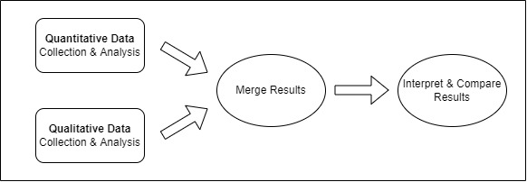
Source: Research Design: Qualitative, Quantitative, and Mixed Methods Approaches (5th ed.) Creswell, J., & Creswell, J. (2018).

3.1.2. Case Study Design
For this mixed methods study, a case study design has been adopted which entails the usage of exploratory design within the framework for qualitative analysis. The rationale of this design is to develop or generate cases based on both quantitative and qualitative results and their integration. An inductive approach has been adopted where the both quantitative and qualitative data are collected and then analyzed.
Overall, the purpose of this study is to explore the factors that affect the effectiveness of health-related e-governance interventions that aim to bring positive improvements in the way services are provisioned in Punjab. For this purpose, the research undertakes the HIMS intervention in THQ Raiwind as a case study. The research is particularly interested in determining the lessons that have been learnt about the health-related interventions as a result of HIMS intervention in THQ Raiwind. This is a hospital-centric and not patient centric study. Although patient responses may paint another picture, however, they are not the focus of the study.

3.1.3. Evaluation Framework
The evaluation framework that is used to evaluate the HIMS project is Organization for Economic Cooperation and Development’s (OECD) evaluation framework. The OECD evaluation framework provides a normative framework which serves as the basis upon which evaluative judgements are made. The framework has six evaluation criteria which are delineated below:
Figure 3-2: Evaluation Framework
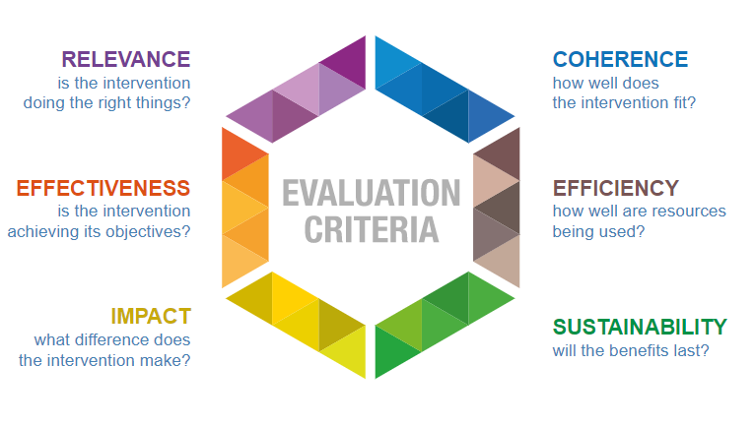
Source: OECD-DAC Network on Development Evaluation.
The OECD evaluation criteria provides a normative framework and serves as the basis upon which evaluative judgements are made. Relevance explores the extent to which the intervention responds to beneficiaries’ needs. Coherence determines the compatibility of the intervention with other interventions in a country, sector or institution. Effectiveness gauges the extent to which the intervention achieved its objectives. Efficiency is used to measure the extent to which the intervention delivers results in a productive and timely way. Impact ascertains the extent to which the intervention has generated significant positive or negative effects. Finally, sustainability determines the extent to which the net benefits of the intervention are likely to continue.

3.2. Population, Sampling Frame, Sample Size and Sampling Technique

3.2.1. Population
The research population comprises 131 Tehsil Headquarter Hospitals in which the HIMS software was implemented. This information is based on the data provided by the Primary & Secondary Healthcare Department (P&SHD). Due to time and other constraints, the research is unable to test all the THQs in the research population. Therefore, sampling frame and sample size have been identified.

3.2.2. Sampling Frame
The Tehsil Headquarter Hospital Raiwind, Lahore was chosen as the sampling frame, primarily because it is located in the outskirts of Lahore, has a semi-urban setting and is situated at a 1-hour drive from the nearest Tertiary care hospital in Lahore. The hospital is providing primary and secondary healthcare services to a catchment population of around 1 million.

3.2.3. Sample Size
Of the hospital staff at THQ Raiwind, 78 people are concerned with the usage of HIMS. The questionnaires for this research were answered by 69 staff members and 10 of these 69 staff members were interviewed in detail to explore their opinions, experiences, perceptions and satisfaction levels.

3.2.4. Sampling Technique
The quantitative portion of the questionnaire was answered by all 69 staff members of THQ Raiwind. For the qualitative portion, purposive sampling technique was employed to identify the staff members whose contact with HIMS was most frequent. The Primary & Secondary Healthcare Department (P&SHD) was requested to share the patient volume details of the different departments in THQ Raiwind. Based on the information provided, 10 different respondents (from the 69 respondents) were identified. The rationale for selecting these 10 staff members was largely influenced by the patient volume in the staff’s respective department and their concern with the project objectives of HIMS intervention. The respondents were contacted via telephone to decide on a suitable date and time for interviews.

3.3. Research Questionnaire Design
To aptly address the research questions, it is imperative to design a valid and reliable questionnaire. The questionnaire designed for the underlying research has three parts. First part is demographics where respondents were asked their gender, age, education, income. Second part is the user experiences. User experience represents (on Likert Scale) the overall experience of an individual in terms of how easy, effective and productive it is to use HIMS. Third part is the satisfaction levels of end-user. Each of the project objectives targeted different beneficiaries. The beneficiaries rated (on Likert Scale) their satisfaction with the attainment of project objectives. The questions in the first and second part were responded by all respondents, however, the questions in third part were responded by only those respondents who were concerned with that project objectives. The question-respondent mapping is delineated in table 3.1.
Table 3-1: Question-Respondent Mapping
Construct | Question Code | Measurement Problem | Respondent
Demographics | DM1 | Respondent’s gender | Consultant, Medical Officer, Nurse, Clerk
Demographics | DM2 | Respondent’s age | Consultant, Medical Officer, Nurse, Clerk
Demographics | DM3 | Respondent’s education level | Consultant, Medical Officer, Nurse, Clerk
Demographics | DM4 | Respondent’s monthly income | Consultant, Medical Officer, Nurse, Clerk
User Experience | UE1 | System improvement (In terms of time savings) | Consultant, Medical Officer, Nurse, Clerk
User Experience | UE2 | Fewest steps to accomplish a task | Consultant, Medical Officer, Nurse, Clerk
User Experience | UE3 | Using HIMS successfully every time | Consultant, Medical Officer, Nurse, Clerk
User Experience | UE4 | Effective Working | Consultant, Medical Officer, Nurse, Clerk
User Experience | UE5 | Greater Productivity | Consultant, Medical Officer, Nurse, Clerk
User Experience | UE6 | HIMS does everything that is expected | Consultant, Medical Officer, Nurse, Clerk
User Experience | UE7 | Accurate modelling of processes | Consultant, Medical Officer, Nurse, Clerk
User Experience | UE8 | Input from hospital | Consultant, Medical Officer, Nurse, Clerk
User Experience | UE9 | Extensive consultation with end-user | Consultant, Medical Officer, Nurse, Clerk
User Experience | UE10 | Adequate hardware and network resources | Consultant, Medical Officer, Nurse, Clerk
User Experience | UE11 | Training | Consultant, Medical Officer, Nurse, Clerk
User Experience | UE12 | Technical support mechanism | Consultant, Medical Officer, Nurse, Clerk
Satisfaction Level | SL1 | Satisfaction with patient registration module | Clerk
Satisfaction Level | SL2 | Satisfaction with the saving of repeat visits to patient profile module | Consultant, Medical Officer
Satisfaction Level | SL3 | Satisfaction with triage and vital statistics recording module | Nurse
Satisfaction Level | SL4 | Satisfaction with clinical notes’ entry provision and pre-configured frequently used templates | Consultant, Medical Officer
Satisfaction Level | SL5 | Satisfaction with digitized lab module | Clerk
Satisfaction Level | SL6 | Satisfaction with digitized prescriptions | Consultant, Medical Officer
Satisfaction Level | SL7 | Satisfaction with digitized pharmacy transactions | Clerk
Satisfaction Level | SL8 | Satisfaction with access of HIMS on mobile phone | Consultant, Medical Officer, Nurse, Clerk
Satisfaction Level | SL9 | Satisfaction with departmental/functional categorization of OPD, IPD, ER, Lab and Pharmacy | Consultant, Medical Officer, Nurse, Clerk
Satisfaction Level | SL10 | Satisfaction with appointment scheduling | Clerk
Satisfaction Level | SL11 | Satisfaction with the billing module for pathology and radiology billing | Clerk
Satisfaction Level | SL12 | Satisfaction with recording patients’ clinical and other In-Patient information module | Consultant, Medical Officer, Nurse
Satisfaction Level | SL13 | Satisfaction with Blood Bank module for donor profiling and blood stock management | Medical Officer, Nurse, Clerk
Satisfaction Level | SL14 | Satisfaction with the reports | Consultant, Medical Officer

3.4. Data Collection
For quantitative data collection, self-administered questionnaires were used to collect data from 69 members of the hospital staff. 10 of the 69 respondents were further interviewed in detail to gain better insights into their experiences. The participants were unwilling to have their responses recorded over tape. Therefore, while carrying out the research the interviewer asked the questions and noted the responses on paper to ensure that that the responses were recorded accurately and no portion of the responses was missed. All the participants were interviewed in-person. Furthermore, during the interviews, leading questions were avoided to prevent the researcher’s bias. During the interviews, when the participants digressed from the topic probes were used so that only relevant details were discussed.
Table 3.2 delineates the list of respondents that answered the qualitative portion of the research questionnaires.
Table 3-2: List of Respondents for Research Questionnaires
Respondent | Department/Organization | Number of Respondents | Interview Protocol
Consultant (Male) | THQ Raiwind, Lahore | 7 | Annexure A
Consultant (Female) | THQ Raiwind, Lahore | 2 | Annexure A
Medical Officer (Male) | THQ Raiwind, Lahore | 13 | Annexure A
Medical Officer (Female) | THQ Raiwind, Lahore | 5 | Annexure A
Nurse (Male) | THQ Raiwind, Lahore | 2 | Annexure A
Nurse (Female) | THQ Raiwind, Lahore | 24 | Annexure A
Clerk (Male) | THQ Raiwind, Lahore | 16 | Annexure A
Sample Size |  | 69
Table 3.3 delineates the respondents that were interviewed in detail to gain better insights into the factors influencing the effectiveness of HIMS.
Table 3-3: Hospital Staff Interviewed in Detail
Sr. No. | Designation | Department | Gender
1 | Consultant | Medicine | Male
2 | Consultant | Pediatrics | Male
3 | Medical Officer | Medicine | Male
4 | Medical Officer | Emergency | Male
5 | Medical Officer | Pediatrics | Female
6 | Nurse | Medicine | Female
7 | Nurse | Pediatrics | Female
8 | Nurse | Hepatitis Clinic | Female
9 | Clerk | Medicine | Male
10 | Clerk | Pathology | Male

- RESULTS AND DISCUSSION
To explore the effectiveness of health-related e-governance interventions, in the domain of public service delivery in Punjab, the Hospital Information Management System (HIMS) intervention in THQ Raiwind is undertaken as case study. The end users were questioned on their opinions, perceptions, experiences and satisfaction levels regarding HIMS. The findings in the succeeding sections are based on survey data and the experiences and satisfaction level of the respondents.
Based on the literature reviewed, two major themes have been identified namely; technological issues and non-technological issues. Each theme is further divided into four sub-themes.
Table 4-1: Major Themes and Sub-Themes
Technological Issues | Non-Technological Issues
Operational Functionality Modelling (OFM) | Communication and Coordination Issues (C&C)
Software Complexity (SC) | Negative Attitudes (NA)
Software Shortcomings (SS) | Data Non-Utilization (DNU)
Lack of Robust Technical Support Mechanism (LTS) | Lack of Robust Operations & Maintenance (LROM)
Source: Literature Reviewed
To evaluate HIMS project, OECD evaluation framework is used which has six facets. The sub-themes are used to answer the six facets of OECD evaluation criteria. Relevance is answered by the Operational Functionality Modelling (OFM) sub-theme. Coherence is answered by studying the Annual Development Programme for the province of Punjab and finding other interventions that are directly or indirectly linked to the data generated by HIMS. Effectiveness is answered by ascertaining if the project attained its objectives. The HIMS project has 13 objectives. Part III of research questionnaire (Satisfaction Level) asks the concerned staff that to rate their satisfaction with the attainment of objectives on a 5-point Likert Scale. There are 13 project objectives and 14 questions. This is because the first project objective is broken into two questions. Based on the responses of the hospital staff, a summary statistics table is computed which delineates the mean ratings, the highest rating and lowest rating. The researcher believes that based on these mean ratings, it may be possible to conclude if a certain objective was not attained, partially attained or completely attained. Efficiency is answered by the Software Complexity (SC), Software Shortcoming (SS) and Data Non-Utilization (DNU) sub-themes. Impact is primarily answered by questions that asked the hospital staff to rate system improvement (in terms of time savings) as a result of HIMS implementation and other questions that asked respondents that if they believed HIMS made them efficient and productive. Furthermore, Data Non-Utilization (DNU) sub-theme will also be considered to determine the impact of HIMS intervention. Sustainability is answered by the Lack of Robust Technical Support Mechanism (LTS), Negative Attitudes (NA) and Lack of Robust Operations and Maintenance (LROM) sub-themes.
Table 4-2: Evaluation Criteria to Sub-Theme Mapping
Evaluation Criteria | Answering Sub-Theme(s)
Relevance | OFM
Coherence | Ongoing Interventions that Depend of HIMS data
Effectiveness | Attainment of Project Objectives
Efficiency | SC, SS, DNU
Impact | Time Savings, Increased Productivity / Effectiveness
Sustainability | LTS, NA, LROM
Source: Researchers own design.
To answer the sub-themes, the survey questionnaires to sub-theme mapping matrix is devised and delineated in the table below. The code UE is used to refer to the User Experience portion of the questionnaire and the code SL is used to refer to the Satisfaction Level portion of the questionnaire.
Table 4-3: Survey Questionnaire to Sub-Theme Mapping
Sr. No. | Sub Theme | Related Questions
1 | Operational Functionality Modelling (OFM) | UE4, UE5, UE 6, UE7, SL9
2 | Software Complexity (SC) | UE2, UE3, UE5
3 | Software Shortcomings (SS) | UE4, UE6
4 | Lack of Robust Technical Support Mechanism (LTS) | UE11, UE12
5 | Communication and Coordination Issues (C&C) | UE8, UE9, UE10, UE11
6 | Negative Attitudes (NA) | N/A (Observed During Research Visit)
7 | Data Non-Utilization (DNU) | SL14
8 | Lack of Robust Operations & Maintenance (LROM) | UE10, UE11, UE12
Source: Researchers own design.

4.1. Descriptive Analysis
Table 4.3 delineates the survey questionnaires to sub-theme mapping matrix. Based on the questions concerned, mean ratings of the hospital staff vis a vis each sub-theme, are computed and viewed through the lens of summary statistics table (categorizing by designation variable) to identify trends (if any).

4.1.1. Technological Issues

4.1.1.1. Operational Functionality Modelling (OFM)
The summary statistics table for operational functionality modelling reveals that overall, the clerks appeared to be more satisfied with the functionalities and features that HIMS software had to offer. The consultants, medical officers and nurses were largely dissatisfied with functionalities and features that HIMS software had to offer.
Figure 4-1: Summary Statistics for Operational Functionality Modelling
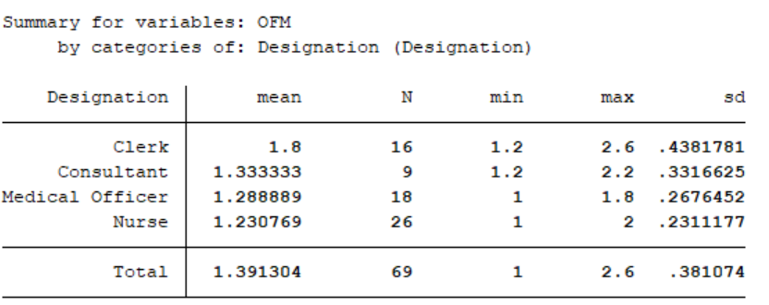
Source: Responses of Hospital Staff

4.1.1.2. Software Complexity (SC)
The summary statistics table for software complexity reveals that overall, the nurses and medical officers found HIMS software to be more complex than the consultants and clerks. This appears to be correlated to the software features that the respondents had to use and results indicated no apparent effect of educational level on the perceived ease of use.
Figure 4-2: Summary Statistics for Software Complexity
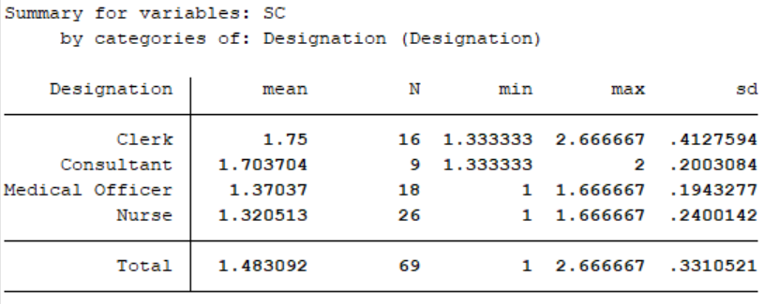
Source: Responses of Hospital Staff

4.1.1.3. Software Shortcomings (SS)
The summary statistics table for software shortcomings reveals that overall, the nurses and medical officers found that HIMS software had profound software shortcomings. In contrast, the clerks and consultants appear to be relatively more satisfied with the functionalities and features that HIMS software had to offer. The results for software shortcomings are consistent with the results for operational functionality modeling, where similar trend has been observed.
Figure 4-3: Summary Statistics for Software Shortcomings
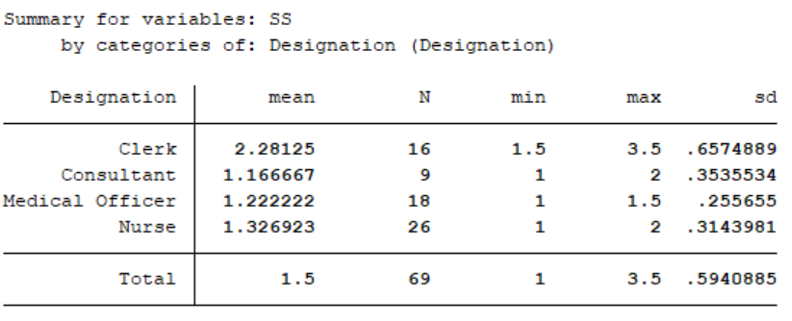
Source: Responses of Hospital Staff

4.1.1.4. Lack of Robust Technical Support Mechanism (LTS)
The summary statistics table for lack of robust technical support mechanism reveals that the nurses were highly dissatisfied with the technical support mechanism for HIMS. The clerks followed suit and appeared to be dissatisfied with the technical support mechanism. The consultants and medical officers appeared to be relatively more satisfied with the technical support mechanism, however, they also seem to believe that there is a lack of robust technical support mechanism.
Figure 4-4: Summary Statistics for Lack of Robust Technical Support Mechanism
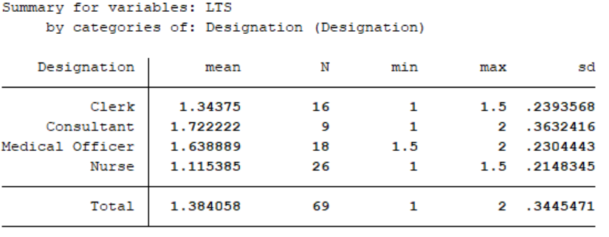
Source: Responses of Hospital Staff

4.1.2. Non-Technological Issues

4.1.2.1. Communication and Coordination Issues (C&C)
The summary statistics table for communication and coordination issues reveals that medical officers were the most satisfied when it came to coordination and communication issues. The consultants, clerks and nurses had similar overall opinion and were relatively dissatisfied with the communication and coordination strategy executed by the HIMS project team.
Figure 4-5: Summary Statistics for Communication and Coordination Issues
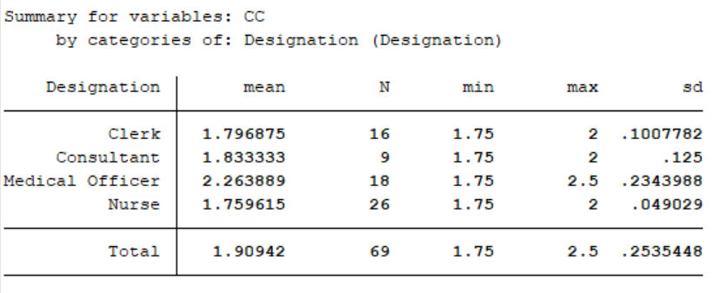
Source: Responses of Hospital Staff

4.1.2.2. Data Non-Utilization (DNU)
Only the clerks and medical officers – amongst the hospital staff – were concerned with the utilization of data generated by HIMS software. Therefore, the summary statistics table for data non-utilization pertains only to these designations. Results indicate that consultants were relatively more satisfied with the utilization of data, however, the results further indicate that overall, the respondents believe that data generated by HIMS is largely non-utilized for informed decision making.
Figure 4-6: Summary Statistics for Data Non-Utilization
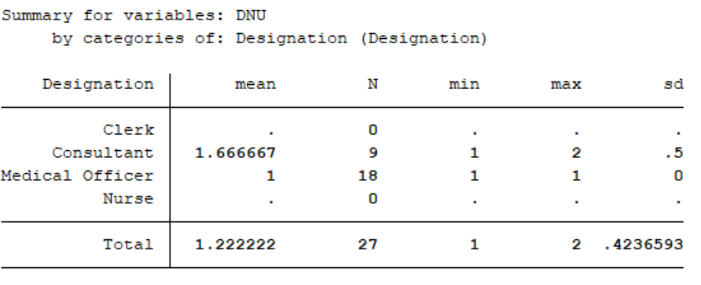
Source: Responses of Hospital Staff

4.1.2.3. Lack of Robust Operations & Maintenance (LROM)
On the question of robust operations & maintenance, the summary statistics table reveals that overall, the respondents (across designations) had similar opinions and believed that HIMS project did not have a robust operations & maintenance strategy.
Figure 4-7: Summary Statistics for Lack of Robust Operations & Maintenance
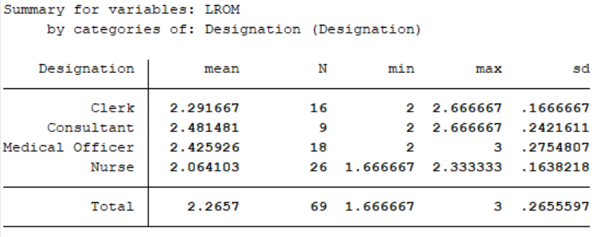
Source: Responses of Hospital Staff

4.1.3. User Experiences and Satisfaction Level
The respondents were asked to rate the perceived time improvements that stemmed from the implementation of HIMS software. The results do not paint an encouraging picture. Across designations, the clerks relatively rated time improvements as a result of HIMS software higher. The consultants, medical officer and nurses have no variance in their responses and overall rated time improvements at 10%. Although the clerks had relatively higher rating, however, their mean time improvements rating did not exceed 20%. Although these results are abysmal, they however are a testament that information technology can bring positive improvements to the health sector.
Figure 4-8: System Improvements Due To HIMS
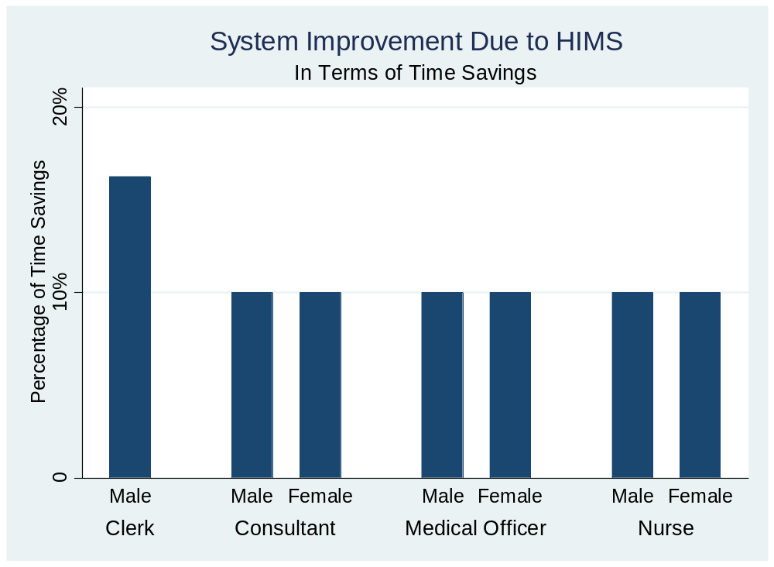
Source: Responses of Hospital Staff
Similarly, the respondents were asked to rate the improvements in productivity and effectiveness as a result of implementation of HIMS software. The results are depicted (categorized by gender and designation variables) in figure 4.9. do Across designations, the clerks relatively seemed to believe that HIMS software enabled them to work more efficiently. On the question of productivity, however, the clerks do not believe that usage of HIMS software made them highly productive. Respondents from other designations believed that usage of HIMS software did not make them significantly productive and efficient.
Figure 4-9: Improvements in Productivity & Effectiveness Due To HIMS
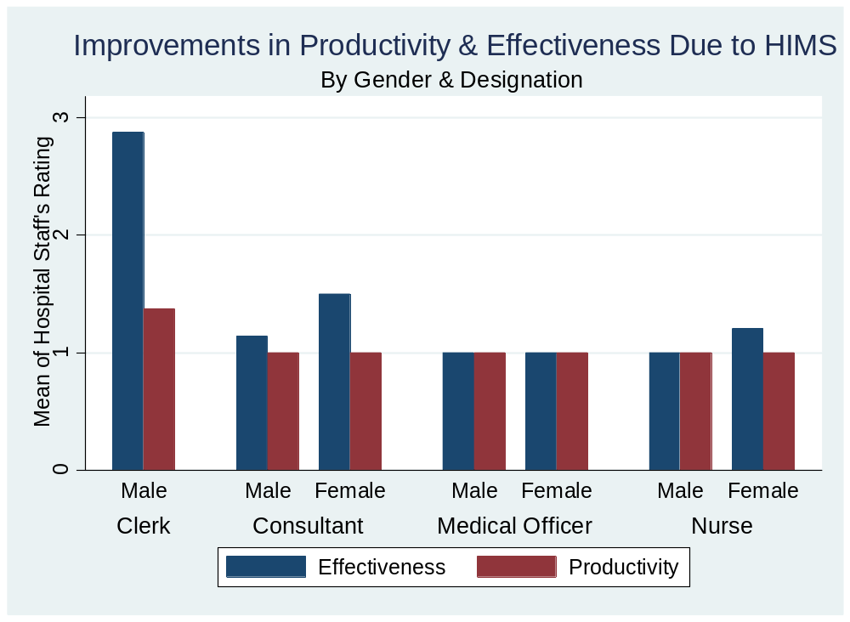
Source: Responses of Hospital Staff
To determine the overall user experiences and satisfaction levels of the hospital staff, the mean scores for each question in Part-II and Part-III of the research questionnaire were computed which were further used to compute the overall mean scores for user experiences and satisfaction. These mean scores are analyzed by gender and designation variables in figure 4.8. The results have found that overall, the clerks had a better experience and were more satisfied with the functioning of HIMS. The male and female medical officers had almost identical view on the HIMS experience and satisfaction with it. Their ratings were largely on the lower side. The male and female nurses had a better satisfaction level in contrast to their experience with usage of HIMS. The male consultants had similar experience and satisfaction levels, however, the female consultants ranked user experience higher than their satisfaction level.
Figure 4-10: HIMS - User Experiences & Satisfaction Level
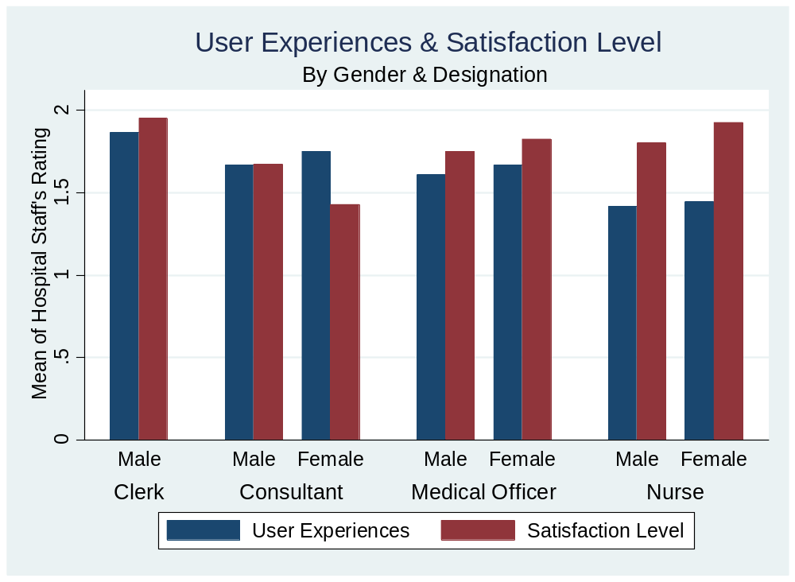
Source: Responses of Hospital Staff

4.2. Qualitative Analysis
Based on the literature reviewed, table 4.1 delineates two major themes and eight sub-themes. These themes and sub-themes are discussed in the ensuing sections in the light of the qualitative interviews with the hospital staff.

4.2.1. Technological Issues
Based on the responses of the hospital staff, mean scores for each of the technological sub-theme, as per the computing criteria in table 4.3, are calculated and plotted by categorizing for gender and designation variables. The overall results indicate that female staff of THQ Raiwind rated HIMS software better that their male counter parts across all four technological sub-themes. Across designations, the clerks reported to be better able to use HIMS software. A possible explanation for this could be that even before the implementation of HIMS software, clerks used to enter data on a different software. Being better accustomed to usage of a software system to perform their duties, the clerks found it relatively easier to use HIMS software.
Figure 4-11: HIMS - Technological Issues
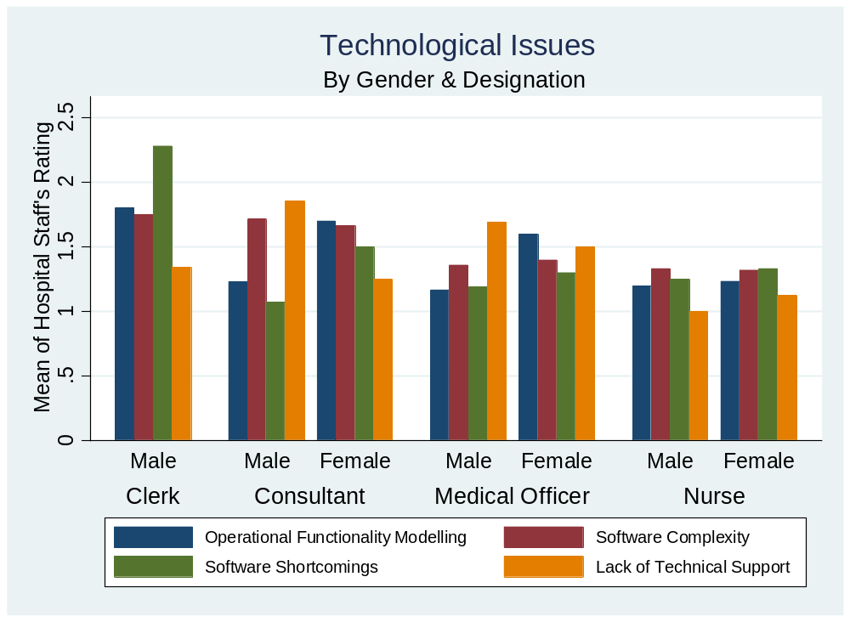
Source: Responses of Hospital Staff

4.2.1.1. Operational Functionality Modelling
The global literature contends that introduction of IT software to digitize hospital operations has positive impacts on the overall service delivery. However, conflicting views surfaced in the interviews with the hospital staff at THQ Raiwind. One of the major operational functionality modelling issues that was observed across all the interviews was non-integration of different departments of the hospital, The Consultant (Medicine) stated that “HIMS does not accurately model the processes followed in medicine department as there is no option to refer patient to other departments”. Another commonly reported functionality modelling issue was that the clinical notes’ entry provision features and the pre-configured frequently used templates in the system were not useful. “The clinical notes and the pre-configured templates are inaccurate” Consultant (Pediatrics), Medical Officer (Medicine). The Consultants, Medical Officers, Nurses and Clerk (Medical) unanimously highlighted the issue that HIMS had multiple points of contact with the patients.
The Clerk (Pathology), however, disagreed with the issues highlighted by other respondents. He contended “HIMS accurately models the processes followed in pathology department as the fields to enter data in HIMS are accurate”. Although majority of the respondents complained about multiple operational functionality issues, it was observed by the researcher that HIMS was not as inaccurate as the responses suggest. The respondents may perhaps be feeling this way because they were not consulted in the entire implementation period of HIMS and considered it to be an imposition “I do not know who approved the system but we came to work one day and the system was imposed on us”. Furthermore, non-provision of training to the hospital staff (end user) might have cemented their view of HIMS having multiple functionality modelling issues.

4.2.1.2. Software Complexity
All 69 respondents of THQ Raiwind unanimously responded that they were not given any training prior to the launch of HIMS. The software complexity issues, that the 10 in-depth interview respondents highlighted during the interviews, may have stemmed from this. The prime complexity issue, highlighted by the respondents, was searching patient by CNIC number. Furthermore, the Clerk (Medicine) alluded to the difficulties associated with registration of a patient in HIMS. He stated “Registering a patient is highly difficult. The system asks unnecessary questions such as allergies, medical history. Often patients do not know medical allergies and random allergies have to be chosen as system did not allow registering a patient without choosing allergies”. The respondents also pointed to multiple data entry streams that a patient had to pass through. When a patient first visits the OPD, s/he is registered by the Clerk. The already registered patients do not have to register again and only obtain a queue token. On their turn, the patients walk up to a nurse. The nurse asks the patient for CNIC, searches the patient and then records the vitals of patient in the system. The patient then walks up to the doctor who again searches the patient by inputting their CNIC number. The respondents further alluded to software complexities such as labyrinthine process of viewing the clinical notes. “New notes are not in continuation of the previous ones” Medical Officer (Medicine). The Clerk (Pathology), however, appeared to be neutral on the issue of software complexity. The respondent was of the opinion that he neither found the system complex nor did the software system reduce his workload. He stated, “The system is not efficient or productive. It is not counter-productive as well. Things are the same as they were before implementation of HIMS. For me only the interface has changed. I am still doing the same work”.

4.2.1.3. Software Shortcomings
On the subject of software shortcomings, those interviewed in detail had a plethora of insights to offer. Multiple respondents pointed to the session timeout issues. “The system keeps logging out. Any input in the system is lost. This is very frustrating” (Medical Officers, Clerks). A demonstration of HIMS to the researcher by the hospital staff, however, suggests that the system log out and session timeout issues which the respondents alluded to are not software shortcomings but internet connectivity issues. Although the respondents largely believed that the hospital had adequate hardware and network resources, frequent internet disconnections were observed during the research visit to THQ Raiwind. In this regard, it can be safely concluded that what the hospital staff perceives as a software shortcoming is not a shortcoming.
The hospital staff concerned with the project objectives was questioned on their satisfaction with the objective attainment to identify any shortcoming of HIMS. The respondents largely appeared to be dissatisfied with HIMS and alluded to multiple software shortcomings. The clerks unanimously agreed that HIMS did not have an appointment scheduling feature. The Clerk in Medicine Department stated “Had this feature been available in HIMS, it would have significantly improved the overall working in terms of time savings”. All the respondents pointed that contrary to the project objective, HIMS was not developed for the mobile platform. The hospital staff appeared to be indifferent to access of HIMS on their phones. “I think that availability of HIMS on mobile phone would not have made any significant difference in the system” (Nurse, Hepatitis Clinic).
Another shortcoming identified by the nurse in hepatitis department was that HIMS did not have triage feature. It is pertinent to note that the nurse was unaware of the term “triage” and the definition of triage had to be explained to her in her mother language (Urdu). This feature, however, was considered trivial by the respondent. The Clerk (Pathology) intimated that the lab orders were not digitized. This appears to be true only to some extent. When the researcher observed the workflow of HIMS, it was learned that the lab tests ordered by the doctor are visible in the patient’s profile, however, the lab orders were not tagged against prescriptions rather, all the lab tests ever ordered were listed. A customized interface for the clerks perhaps would have been a better way to design HIMS. The clerk further mentioned that the billing module to digitize transactions was not implemented in HIMS. This was seconded by the clerk in the Medicine Department who informed that the pharmacy transactions were not digitized in HIMS.
Another shortcoming identified by the Consultants and Medical Officers was that there were no meaningful data analysis reports available in HIMS. A significant shortcoming identified by multiple respondents and observed by the researcher was that HIMS was not integrated with Queue Management System (QMS) and rather than patient profile moving from one point of contact to another, based on the token number, the patient had to be searched using CNIC at each point of contact. In the researcher’s opinion, integration of QMS with HIMS is extremely important as it can improve the overall effectiveness of the hospital functioning.

4.2.1.4. Lack of Robust Technical Support Mechanism
It is widely believed by the academics that a robust support mechanism is imperative to the success of any intervention. HIMS, however, appears to have not fared well in this area. As figure 4.12 illustrates, a significant 49.28% of the 69 hospital staff members at THQ Raiwind strongly disagreed with the notion that there was a robust technical support mechanism in place for HIMS. 42.03% disagreed with this notion. This is manifested in the in-depth interview with the Consultant (Medicine) who stated: “Support could have been much better if a designated IT person was stationed in our hospital”. 8.696% respondents were undecided about support mechanism. This is evident from the in-depth interview of the Medical Officer in Emergency Department who contended that, “There is a support email at which I email if there is a problem with HIMS. I am not sure if I can categorize it as robust or non-robust”.
Figure 4-12: Availability of Robust Technical Support Mechanism
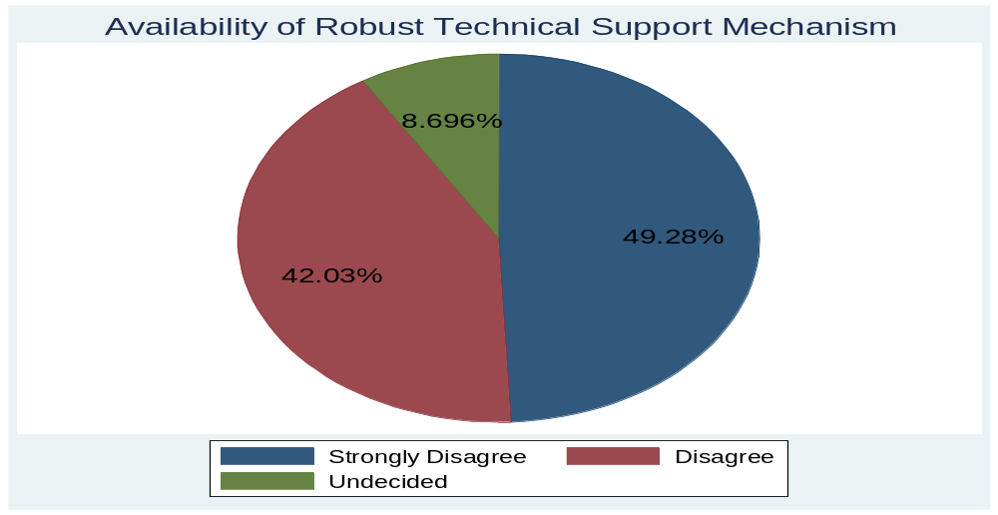
Source: Responses of Hospital Staff
The hospital staff intimated that a designated IT support team was available during the project implementation lifecycle, however, once the implementation period was complete the support staff was laid off. A common belief that was observed across the responses was that during the period in which support team was available, they found it less frustrating to use the system. “Back when we had an IT support team, I used to call the support person whenever an issue was encountered. Now, there is no one to help and this is frustrating” (Nurse Pediatrics). In the in-depth interviews, the Consultant (Medicine) appeared to be highly dissatisfied with the technical support mechanism. Similarly, in the in-depth interviews, the medical officers, nurses and clerks appeared to dissatisfied with the technical support mechanism.

4.2.2. Non-Technological Issues
Based on the responses of the hospital staff, mean scores for each of the non-technological sub-theme, as per the computing criteria in table 4.3, are calculated and plotted by categorizing for gender and designation variables. The negative attitude sub-theme had no questions, it was observed during the on-site research visits. The overall results indicate that male respondents, marginally, experienced lesser non-technological issues in contrast to their female counterparts. Across designations, clerks experienced least non-technological issues followed by consultants and nurses. The medical officers appear to be encountering most non-technological issues. On the question of robust operations and maintenance plan for HIMS project, the hospital staff generally appeared to be less satisfied in contrast to their high dissatisfaction with the communication and coordination strategy of HIMS project team. The consultants and medical officers, concerned with usage of data generated by HIMS, responded that data utilization could not be deemed satisfactory.
Figure 4-13: HIMS - Non-Technological Issues
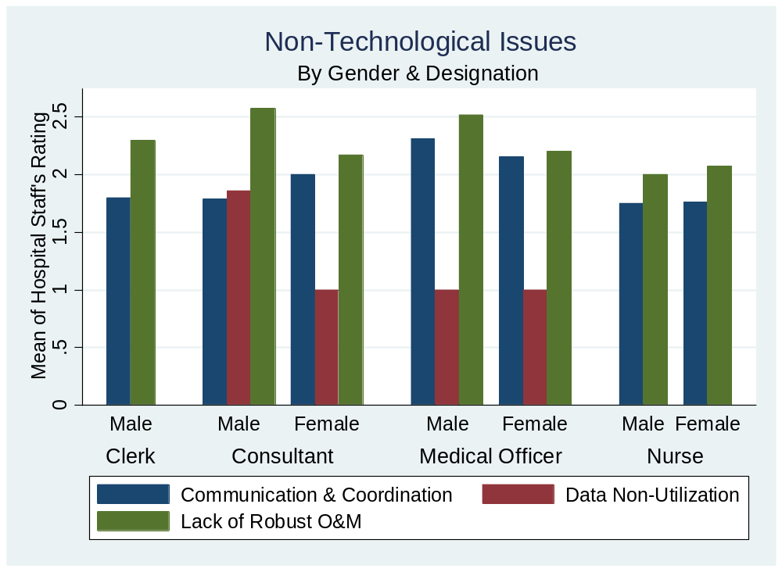
Source: Responses of Hospital Staff

4.2.2.1. Communication and Coordination Issues
During the in-depth interviews with the hospital staff, communication and coordination emerged as major issues that influenced the effectiveness of HIMS. This is evident in the overall system improvement ratings of the hospital staff. The in-depth interviews with the respondents revealed that HIMS was implemented in a haste rather than gradual phasing out. “The system was pretty much implemented without any prior notice” (Consultant Medicine). HIMS did not accurately model the processes followed in different departments. This was repeatedly highlighted by the respondents. While agreeing with other respondents that project team did not undertake system requirements gathering process holistically, the Medical Officer (Emergency) contended: “The clinical notes are not what we usually need. I do not know where did the project team gather requirements from but certainly not us. I have been transferred in three different hospitals since 2017 and none of them were neither provided training nor consulted”. The training issue highlighted by the Medical Officer (Emergency) was pointed out by the all the consultants, medical officers, nurses and clerks. This points to significant coordination shortcomings.
The respondents further pointed out that they learnt the system usage by trial and error. They, however, alluded to the fact that they faced less difficulty in system usage when the support team was available. “The system is poorly designed, and the issues are persistent. However, until the end of 2020, there was IT team available in our hospital. Whenever we faced an issue, we called the IT support person and he usually fixed the problem. I do not know why but the IT team was laid off and now we do not have anyone for help. This is very frustrating” (Medical Officer Pediatrics). Based on the responses of the hospital staff, the research finds that despite all the shortcomings and technical flaws HIMS was streamlined by the project gestation. However, laying off the project staff and non-availability of robust technical support mechanism negatively affected user attitudes and usage behavior. Furthermore, the researcher is of the opinion that had periodic trainings been provided during implementation stage, the user perceptions and perceived system improvements could have been on the higher side.

4.2.2.2. Negative Attitudes
The respondents (10) of the in-depth interviews have largely rated system improvements on the lower side. The descriptive analysis leads one to believe that the system failed to bring significant improvements in the overall functioning of the hospital. However, qualitative analysis of the in-depth interviews alludes to a previously ignored dimension. Although the views of hospital staff regarding system shortcomings are not unfounded but the research finds that the system is not as poor as the respondents suggest. Interviews with the hospital staff call attention to the in-built resistance to change and the negative attitudes, of the hospital staff, towards HIMS intervention. The end users, by and large, tended to focus on the shortcoming of the system and conveniently overlooked the potential of HIMS to bring positive improvements in the functioning of hospital. The Consultant (Medicine) stated: “I do not think using computers to write prescriptions is going to bring any improvements. Besides, these systems come and go. First it was HIMS and now we hear a new system DHIS2 will replace HIMS”. In addition to highlighting inconsistencies in the policy, the statement refers to the pessimistic attitudes of the end-users towards the system.
The objectives of this project included the most critical and key initiatives, which were non-trivial. The prime affectees of this intervention were the people, processes and systems. The people, it appears are rather dissatisfied with the system. The dissatisfaction could have stemmed from the resistance towards change. This is evident in the response of the Nurse (Pediatrics) who contended, “I am 55-year-old woman. My whole life I have done things manually. Now all of a sudden, I have to do things on a computer. It is really hard to learn computer at my age”. It is pertinent to note that the nurse who claims to be a technological novice had a smartphone and was using it without any apparent difficulty. This points to a dichotomy in the end users’ attitudes when it comes to the usage of smartphones and HIMS. The respondents further intimated that use of HIMS was discontinued, in THQ Raiwind, for a period of 6 month in the early 2021, but the usage of HIMS was resumed after Primary & Secondary Healthcare department issued a warning letter to the hospital administration. The casual and negative attitude of end users, towards HIMS, points towards a moral hazard. The respondents further conceded that the onus for failure of HIMS did not lie on them and they had no incentive to use it.

4.2.2.3. Data Non-Utilization
The results of in-depth interviews with end users of HIMS intervention reveal that the system largely failed to deliver on its objective of meaningful reporting and oversight dashboards. Although there is a central oversight dashboard available in the Primary & Secondary Healthcare department, there is no data utilization in the hospitals. The Consultant (Medicine) asserted “All the system does is take inputs on a web-based form rather than writing manual prescriptions”. These views were unequivocally seconded by the other consultants and medical officers. In the researcher’s opinion, we live in the age of data and data is proving itself as the blazing gun in the world of development. Non-utilization of data, for such non-trivial interventions, is an impediment and is preventing the system from realizing its potential.
The negative attitudes of the end users, discussed in the previous section, could have been softened had the respondents been enlightened about the benefits of HIMS by utilizing the raw data. The veracity of this assertion was confirmed by the Consultant (Pediatrics) who stated, “The data collected from HIMS should be analyzed to calculate patient workload of the doctors, predict epidemiological trends and identify the need of additional staff”. The patient-level data can be utilized in myriad ways to benefit the field of medicine. One such example, is the regulated availability of this data to medical research institutes which hold the potential for verification of original results with alternative or supplementary analyses, advancement of knowledge by providing new results by testing new hypotheses, larger scale analyses based on individual-patient data, enhanced multidisciplinary cooperation, improved clinical practice, and reduced cost and time for clinical research. This however could be susceptible to pitfalls such as possible failures in patients’ privacy protection, technical barriers such as the lack of standard formats, and possible data misinterpretation. Although a transition to data driven regime, in the case of HIMS, seems a far-fetched idea at this point, however, it is a process that will take time and the global best practices suggest that those who adopt the principles and practices of data-driven decision making will likely benefit from it.

4.2.2.4. Lack of Robust Operations and Maintenance
The presence of a robust O&M plan is highly imperative for the sustainability of a project. The HIMS intervention suffered from poor planning and mismanagement right from the onset. Multiple respondents pointed to system shortcomings and inaccurate functionality modelling. Overall, these technological issues stem from non-exhaustive requirements gathering. Holistic review of the project documents reveals that the project was initially planned as a pilot for 14 THQs, however, the project was shelved even before it kicked off and was later revived with scope that covered all THQs. Despite four revisions, the project was largely ailing during its gestation period. The non-provision of training, as highlighted by the hospital staff, points to poor operations management. The respondents stated that there was no feedback mechanism and this has been observed in the research as well. Had there been a feedback incorporation mechanism, the system functionality modelling would have been highly accurate and the overall improvement ratings would have been on the higher side. The literature on digital health interventions is replete with success stories where introduction of ICTs brought positive improvements in the overall system.
However, these successes were not achieved overnight. The interventions faced a plethora of challenges but their success was ensured by consistency in policy. Rather than bringing positive improvements in HIMS, the department has decided to reinvent the wheel by undertaking efforts to develop a new system that makes no significant additions to what HIMS offers. Apart from the operational challenges, the project had a poorly defined exit strategy. During the implementation stage, dedicated technical support teams were hired for all the THQs, however, once the gestation period was over, all the support staff was laid off and the end-users had no real-time technical support. The PC-I document should have mentioned a robust O&M mechanism in a post-project completion period. The already ailing project’s woes were exacerbated when the sponsoring agency and executing agency locked horns over the issue of project shortcomings. Rather than cooperating for the sustainability of the project, the inter-departmental tussle resulted in the closure of project on an as it is basis and ultimately led to a dip in users’ rating of system improvement in the post-project completion period.

4.3. Attainment of Project Objectives
The HIMS project has 13 objectives. Part III of research questionnaire (Satisfaction Level) asks the concerned staff to rate their satisfaction with the attainment of objectives on a 5-point Likert Scale. Highest rating was 5 and lowest rating 1. There are 13 project objectives and 14 questions. This is because the first project objective is broken into two questions. Based on the responses of the hospital staff, the summary statistics are reproduced in figure 4.14 which delineates the mean ratings, the highest rating and lowest rating of the hospital staff on attainment of a specific project objective. Mean rating 1 denotes that objective was not attained. Mean rating 1.1 – 3.9 denotes that objective was partially attained. Mean rating 4 – 5 denotes that objective was fully attained. The researcher believe that based on these mean ratings, it is possible to conclude if the objective was not attained, partially attained or completely attained. Based on the results obtained in summary statistics table, it can be concluded that objective 9, of HIMS project, was not attained. Similarly, it can be concluded that objective 1A, 1B, 2, 3, 4, 5, 6, 7, 8, 10, 11 and 13, of HIMS project, were partially attained. The objective 12 of HIMS software was fully attained.
Figure 4-14: Project Objective Attainment Matrix
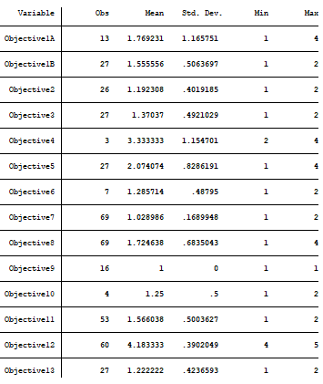
Source: Responses of Hospital Staff

- CONCLUSION AND POLICY RECOMMENDATIONS
Overall, the research aims to explore the effectiveness of health-related e-governance interventions, that seek to improve the delivery of public services in Punjab, and discuss the challenges faced in implementing the interventions. The underlying research is particularly interested in determining the lessons that have been learnt about the health-related interventions as a result of HIMS intervention in THQ Raiwind. The research study is primary in nature and a mixed method approach has been employed with the purpose of gaining meaningful insights into the factors influencing the effectiveness of HIMS. The qualitative part of the research discussed the opinions, experiences and perceptions of the end-users to identify the major technological and non-technological challenges faced the actual system usage. Furthermore, the qualitative portion enabled the research to ascertain the impact of personal characteristics on the usage attitude. The main findings of the research and policy recommendation, to design better service delivery related e-Governance interventions in health sector, are presented below in the respective order.

5.1. Observations and Conclusion
The research indicates that overall, HIMS intervention suffered from poor planning and mismanagement. However, HIMS software was not as inaccurate as the responses suggest. Respondents may perhaps be feeling this way because they were not consulted in the entire implementation period of HIMS software and considered it to be an imposition. Non-provision of training to the hospital staff (end users) might have cemented their view of HIMS having multiple functionality modelling issues. Non-availability of IT support team negatively affected user attitudes and usage behavior and perhaps a recurring training mechanism could have positively affected the user perceptions and perceived system improvements. The non-utilization of data for such non-trivial interventions, prevents the system from realizing its potential. The patient-level data, generated from HIMS, can and should be utilized in myriad ways to benefit the field of medicine. Finally, an already ailing project’s woes were exacerbated when the sponsoring agency and executing agency locked horns over the issue of project shortcomings rather than cooperating for its sustainability.
Table 4.2 provides the evaluation criteria to sub-theme mapping. These sub-themes have been discussed in detail, from a technological and non-technological perspective, in chapter 4. Based on these results and discussions, the research rates the HIMS project on six facets of OECD evaluation framework as follows:
- Relevance: Generally, respondents did not find functionality modelling accurate and different departments of hospital were non-integrated. Project is deemed to be moderately relevant.
- Coherence: Data generated from HIMS can prove useful for other interventions such as AIDS Control Programme, Center for Disease Control etc. Project is deemed to be highly coherent.
- Effectiveness: Of the 13 objectives, 1 was not attained, 11 were partially attained and 1 was fully attained. Project is deemed moderately effective.
- Efficiency: HIMS had multiple software complexities, failed to fully deliver on objectives such as appointment scheduling, access on mobile phones and data analysis reports for staff. HIMS was developed as a standalone system and without exhaustive business reengineering. The project is deemed moderately efficient.
- Impact: From a lens of time savings and improved staff productivity, the project is deemed to have a moderately positive impact.
- Sustainability: In-built resistance to change and negative attitudes of the hospital staff, coupled with inability of P&SHD to provide technical support and perform O&M of HIMS has resulted in its phasing out by DHIS2. Project is deemed not sustainable.
Overall, the research finds that HIMS intervention, to improve service-deliver, may be ranked as Partially Successful.

5.2. Main Findings and Lessons Learnt from HIMS Intervention
The research aimed to explore the effectiveness of HIMS intervention in Punjab and use these results to extrapolate the factor that influence the effectiveness of ICT interventions in the health sector. On the technological front, the lessons learnt from HIMS experience are that non-exhaustive requirements gathering phase leads to poor system design and ultimately causes problems. Therefore, extensive business requirement documentation is imperative for designing simple and user-friendly systems. The existing operations and functionalities should be modelled and digitized in an iterative manner with the system design improving with each iteration. The importance of data analyses is underpinned in the fact that data can enable the stakeholders to make informed decisions which bring positive improvements to the overall system. Resultantly, these improvements reinforce the overall system reliability and usability thereby strengthening the system ownership by the end users. Furthermore, standalone systems should be integrated to deliver better results because interacting with multiple systems is tedious and cumbersome for the end users resulting in lower perceived usefulness of the system.
On the non-technological front, the primary lesson that could be learnt from the HIMS experience is that development interventions should recognize the end users as key actor. An exclusive approach to ICT interventions may result in moral hazards. Contrarily, if the end users are engaged right from the start the intervention is owned by the end users and the resistance to change is attenuated. For seamless implementation of project deliverables, it is imperative to satisfy the relevant stakeholders. This is only possible if the stakeholders are provided recurring trainings, capacity-building workshops and their feedback is duly incorporated to bring positive improvements in the system. Another key lesson learnt is that the project exit strategy should be well defined as ineffective O&M leads to sustainability issues. The veracity of this assertion is confirmed by figure 4.19, which explains that the HIMS intervention showed promise in its initial stages, however, due to poor exit strategy the technical support staff at hospital sites was laid of leaving the system at the disposal of the hospital administrations which resulted in a decline in the overall system improvements. Project activities should be reviewed fortnightly to ensure adherence to project timelines and accomplishment of project objectives. Furthermore, Mid-Term Evaluations are highly important to bring a greater measure of exactitude in the overall project operations. The HIMS experience suggests that the benefits of a development intervention often take time to materialize and it is imperative to be patient and constantly improve the system rather than abandoning it or replacing it with another system.

5.3. Policy Recommendations
Based on the findings of the research, the following technical and non-technical recommendations are made to improve the effectiveness and minimize the challenges faced by service delivery related e-governance interventions, in the health sector in Punjab. It is further recommended that “DHIS2”, the software system being designed to replace HIMS, should account for the challenges and shortcoming that were faced by HIMS and incorporate the recommendations produced below.

5.3.1. Technical Recommendations
- The systems should not focus, specifically, on one department of the organization. Rather, to ensure sustainability, all the departments should be holistically explored, during the business process reengineering activity, to ensure cross-compatibility.
- Inter-departmental and intra-departmental integration should be ensured to avoid duplications and redundancy.
- Extensive business requirement documentation should be done so that the system design is simple and user-friendly.
- While designing the system, special attention should be paid to the user interface. The focus, primarily, should be on facilitating the end user and removing unnecessary bottlenecks.
- The organizational operations and functionalities should be modelled and digitized in an iterative manner rather than rolling out all the functionalities in a single go.
- Standalone systems should be avoided and the focus should be on building a single sign-on and integrated system because interacting with multiple systems is tedious and cumbersome for the end users.
- Before rolling out the system, it should be ensured that adequate and compatible hardware is available to the end users.
- The internet connectivity issues should be addressed during the planning stage to avoid any inconveniences later.
- Rigorous and extended training should be provided to the end users before rolling out the systems.
- There should be a robust technical support mechanism, with 24-hour turnaround time, in place.

5.3.2. Non-Technical Recommendations
- The Planning Manual should be revised to add an additional stage of communication for development (C4D), before the appraisal stage, so that the development interventions are based on participatory models that recognize end users as key actor.
- Project objectives should be specific, measurable, achievable, relevant and timely.
- The design and flow requirements of the IT software should be finalized at the start of the project, however, the positive feedback from the end users should continuously be incorporated.
- Project exit strategy should be clearly defined in the PC-I and contingency plan should be included in the PC-I as well.
- The project funds should be made available upfront at the start of each fiscal year so that no delays are experienced in the hiring of staff, services and procurement of equipment.
- A project steering committee, consisting of members from sponsoring agency, executing agency and end user, should hold fortnightly reviews to bring a greater measure of exactitude during the implementation stage.
- The raw data gathered as a result of system usage should be utilized and meaningful information should be made available to the relevant stakeholders for informed decision making.
- Mid-Term Evaluation is a highly useful tool to bring a greater measure of exactitude in the overall project operations.
- The project exit strategy and O&M plan should be comprehensive and should be all-encompassing as an ineffective O&M plan leads to sustainability issues.
- The benefits of a development intervention often take time to materialize and it is imperative to constantly improve the system rather than abandoning it or replacing it with another system.

– LIMITATIONS AND FUTURE LINE OF INQUIRY
Due to lack of accessibility and time constraints, the sampling frame for the choice of Tehsil Headquarter Hospitals (THQs) was kept small. Since, the study was conducted over a short period of time, time management proved to be quite difficult. Furthermore, the responses to research questionnaires are based on the presence of the hospital staff on the day of research visit. Therefore, it is imperative that the generalization of results should be made with extreme caution.
The future researchers should broaden their ambit to include all the THQs in the province of Punjab to ensure that representative and large data samples are obtained which lead to more conclusive results. Furthermore, the future researches need to evaluate to what extent “DHIS2” would be successful in overcoming the shortcomings of HIMS software found by the underlying research.

ANNEXURES

Annexure A
Research Questionnaire for Studying the Effective & Efficacy of Hospital Information Management System in Public Hospitals in Punjab
PART – I (Demographics)
- What is your gender?
Male | Female

- What is your age?
21-30 | 31-40 | 41-50 | 51-60

- What is your educational level?
12 Year of Education | 14 Year of Education | 16/17 Year of Education | 18 & Above Year of Education

- What is your monthly income level?
Less than PKR. 20,000 | Between PKR 20,000 and PKR 50,000 | Between PKR 50,000 and PKR 75,000 | Between PKR 75,000 and PKR 100,000 | Greater than PKR 100,000

PART – II (User Experience)
Please select the most suitable answer for the following statements:
- To what extent do you think the system (in terms of time savings) has improved after implementation of HIMS?
0 - 10% | 11 - 20% | 21 - 30% | 31 - 40% | >40%
Reason: _____________________________________________________________

- HIMS requires the fewest steps possible to accomplish what I want to do.
Strongly Disagree | Disagree | Undecided | Agree | Strongly Agree

Reason: _____________________________________________________________

- I can use HIMS successfully every time.
Strongly Disagree | Disagree | Undecided | Agree | Strongly Agree

Reason: _____________________________________________________________

- Using HIMS enables me to do my work effectively.
Strongly Disagree | Disagree | Undecided | Agree | Strongly Agree

Reason: _____________________________________________________________

- Using HIMS enables me to be more productive and saves the time it usually takes to interact with patients.
Strongly Disagree | Disagree | Undecided | Agree | Strongly Agree

Reason: _____________________________________________________________

- HIMS does everything I would expect it to do.
Strongly Disagree | Disagree | Undecided | Agree | Strongly Agree

Reason: _____________________________________________________________

- HIMS accurately models the processes that are followed in our department.
Strongly Disagree | Disagree | Undecided | Agree | Strongly Agree

Reason: _____________________________________________________________

- In the software development phase, the project planning team sought input from our hospital.
Strongly Disagree | Disagree | Undecided | Agree | Strongly Agree

Reason: _____________________________________________________________

- I believe HIMS was developed after extensive consultation with the end users.
Strongly Disagree | Disagree | Undecided | Agree | Strongly Agree

Reason: _____________________________________________________________

- Our hospital has adequate hardware and network resources available for usage of HIMS.
Strongly Disagree | Disagree | Undecided | Agree | Strongly Agree

Reason: _____________________________________________________________

- Training was provided to us before rolling out of HIMS.
Strongly Disagree | Disagree | Undecided | Agree | Strongly Agree

Reason: _____________________________________________________________

- There is a robust technical support mechanism in place.
Strongly Disagree | Disagree | Undecided | Agree | Strongly Agree

Reason: _____________________________________________________________

PART – III (Satisfaction Level)
To what extent do you agree with the following statements:
- I am satisfied with the patient registration module of HIMS. (Answer only if you’re a Clerk)
Strongly Disagree | Disagree | Undecided | Agree | Strongly Agree

Reason: _____________________________________________________________

- I am satisfied with the saving of repeat visits to patient profile module of HIMS. (Answer only if you’re a Consultant, Medical Officer)
Strongly Disagree | Disagree | Undecided | Agree | Strongly Agree

Reason: _____________________________________________________________

- I am satisfied with the triage and vital statistics recording module of HIMS. (Answer only if you’re a Nurse)
Strongly Disagree | Disagree | Undecided | Agree | Strongly Agree

Reason: _____________________________________________________________

- I am satisfied with the clinical notes’ entry provision module and the pre-configured frequently used templates in HIMS. (Answer only if you’re a Consultant, Medical Officer)
Strongly Disagree | Disagree | Undecided | Agree | Strongly Agree

Reason: _____________________________________________________________

- I am satisfied with the digitizing lab orders and entering lab tests’ results module of HIMS. (Answer only if you’re a Clerk in Pathology Department)
Strongly Disagree | Disagree | Undecided | Agree | Strongly Agree

Reason: _____________________________________________________________

- I am satisfied with the digitized prescriptions that are printed using HIMS. (Answer only if you’re a Consultant, Medical Officer)
Strongly Disagree | Disagree | Undecided | Agree | Strongly Agree

Reason: _____________________________________________________________

- I am satisfied with the digitization of pharmacy transactions module of HIMS. (Answer only if you’re a Clerk)
Strongly Disagree | Disagree | Undecided | Agree | Strongly Agree

Reason: _____________________________________________________________

- I am satisfied with the access of HIMS on mobile phone.
Strongly Disagree | Disagree | Undecided | Agree | Strongly Agree

Reason: _____________________________________________________________

- I am satisfied with the departmental/functional categorization of OPD, IPD, ER, Lab and Pharmacy.
Strongly Disagree | Disagree | Undecided | Agree | Strongly Agree

Reason: _____________________________________________________________

- I am satisfied with the appointment scheduling module of HIMS. (Answer only if you’re a Clerk)
Strongly Disagree | Disagree | Undecided | Agree | Strongly Agree

Reason: _____________________________________________________________

- I am satisfied with the billing module for pathology and radiology billing in HIMS is satisfactory. (Answer only if you’re a Clerk in Pathology or Radiology Department)
Strongly Disagree | Disagree | Undecided | Agree | Strongly Agree

Reason: _____________________________________________________________

- I am satisfied with the recording patients’ clinical and other In-Patient information module in HIMS. (Answer only if you’re a Consultant, Medical Officer, Nurse)
Strongly Disagree | Disagree | Undecided | Agree | Strongly Agree

Reason: _____________________________________________________________

- I am satisfied with the Blood Bank module for donor profiling and blood stock management in HIMS. (Answer only if you’re a Medical Officer, Nurse, Clerk)
Strongly Disagree | Disagree | Undecided | Agree | Strongly Agree

Reason: _____________________________________________________________

- I am satisfied with the variety of reports in HIMS. (Answer only if you’re a Consultant, Medical Officer)
Strongly Disagree | Disagree | Undecided | Agree | Strongly Agree

Reason: _____________________________________________________________

REFERENCES
Bahensky, J., Jaana, M., & Ward, M. (2008). Health Care Information Technology in Rural America: Electronic Medical Record Adoption Status in Meeting the National Agenda. The Journal of Rural Health, 24(2), 101-105. doi: 10.1111/j.1748-0361.2008.00145.x.
Baležentis, A., & Paražinskaitė, G. (2012). The Benchmarking of the Government to Employee (G2E) Technology Development: Theoretical Aspects of the Model Construction. Social Technologies, 2(1).
Balfour, D., Evans, S., Januska, J., Lee, H., Lewis, S., & Nolan, S. et al. (2009). Health Information Technology—Results from a Roundtable Discussion. Journal Of Managed Care Pharmacy, 15(1). doi: 10.18553/jmcp.2009.15.s1.10.
Barker, T., & Frolick, M. (2003). ERP Implementation Failure: A Case Study. Information Systems Management, 20(4), 43-49. doi: 10.1201/1078/43647.20.4.20030901/77292.7
Cortes, P. (2011). Hospital information systems: a study of electronic patient records. Journal of Information Systems and Technology Management, 8(1). doi: 10.1590/S1807-17752011000100008.
Creswell, J., & Creswell, J. (2018). Research Design: Qualitative, Quantitative, and Mixed Methods Approaches (5th ed.). SAGE Publications, Inc.
Dadashzadeh, M. (2010). Social Media in Government: From e-Government to e-Governance. Journal of Business & Economics Research (JBER), 8(11). doi: 10.19030/jber.v8i11.51.
Davenport, T. (1993). Process Innovation : Reengineering Work Through Information Technology. Harvard Business Review Press.
Din, I., Xue, M., Abdullah, Ali, S., Shah, T., & Ilyas, A. (2017). Role of information & communication technology (ICT) and e-governance in health sector of Pakistan: A case study of Peshawar. Cogent Social Sciences, 3(1). doi: 10.1080/23311886.2017.1308051.
Frankfurter, C. and Cuervo, L., 2016. E-Government as tool to advance health. GLOBAL JOURNAL OF MEDICINE AND PUBLIC HEALTH, 5(6).
Goldzweig, C., Towfigh, A., Maglione, M., & Shekelle, P. (2009). Costs And Benefits of Health Information Technology: New Trends from The Literature. Health Affairs, 28(2). doi: 10.1377/hlthaff.28.2.w282.
Government of Pakistan. (2020). Pakistan Economic Survey.
Government of the Punjab. (2011). Punjab Government Rules of Business 2011.
Government of the Punjab. (2015). Punjab Planning Manual.
Government of the Punjab. (2016). Manual of Secretariat Instructions, 2016.
Handayani, P., Hidayanto, A., Pinem, A., Hapsari, I., Sandhyaduhita, P., & Budi, I. (2017). Acceptance model of a Hospital Information System. International Journal of Medical Informatics, 99, 11-28. doi: 10.1016/j.ijmedinf.2016.12.004.
Haque, M., Kayadibi, S., Rafsanjani, K., & Billah, M. (2013). A Conceptual Study on Hospital Information System in Public Hospital of Bangladesh: Electronic Medical Record and Clinical Information System Perspective. Asian Social Science, 9(17). doi: 10.5539/ass.v9n17p180
Hing, E., Burt, C. & Woodwell, D. (2007). Electronic Medical Record Use by Office-Based Physicians and Their Practices: United States, 2006. Advance data. 393. 1-7.
Islam, S., & Tabassum, R. (2015). Implementation of information and communication technologies for health in Bangladesh. Bulletin of the World Health Organization, 93(11), 806-809. doi: 10.2471/blt.15.153684.
Ittefaq, M., & Iqbal, A. (2018). Digitization of the health sector in Pakistan: challenges and opportunities to online health communication: A case study of MARHAM social and mobile media. DIGITAL HEALTH, 4, 205520761878928. doi: 10.1177/2055207618789281.
Kazmi, S. N. A. (2010, July). Factors influencing e-Governance implementation: Issues and challenges in Pakistan. In 2010 Fifth International Conference on Digital Information Management (ICDIM) (pp. 326-331). IEEE.
Kerzner, H. (2013). Project Management: : A Systems Approach to Planning, Scheduling, and Controlling (11th ed.). Hoboken, NJ: Wiley.
Mahapatra, S., Das, R. and Patra, M., 2008. Current e-Governance Scenario in Healthcare sector of India.
Mahmood, S. (2007). Good Governance Reform Agenda in Pakistan: Current Challenges. Nova Publishers. pp. 196–199.
Marcelo, A., Medeiros, D., Ramesh, K., Roth, S., & Wyatt, P. (2018). Transforming Health Systems Through Good Digital Health Governance. ADB Sustainable Development Working Paper Series, 51.
Monga, A. (2008). E-government in India: Opportunities and challenges, JOAAG, 3(2).
Moon, Y. (2007). Enterprise Resource Planning (ERP): A Review of the Literature. International Journal of Management and Enterprise Development, 4(3).
Nuri, N., Sarker, M., Ahmed, H., Hossain, M., Dureab, F., & Jahn, A. (2018). Quality of the Mental Health Information System in a Specialized Mental Hospital in Bangladesh. Acta Informatica Medica, 26(2), 180. doi: 10.5455/aim.2018.26.180-184
Radhikaashree, M., Sowmya, Shruthiunnikrishnan and Kavipriya, N., 2018. Impact of E-governance in Health Sector. Indian Journal of Public Health Research & Development, 9(12).
Radhikaashree, M., Shruthiunnikrishnan and Sangeetha, 2018. E-Governance in Health Sector – Challenges. Eurasian Journal of Analytical Chemistry.
Ray, S., & Mukherjee, A. (2007). Development of a framework towards successful implementation of e‐governance initiatives in health sector in India. International Journal of Health Care Quality Assurance, 20(6), 464-483. doi: 10.1108/09526860710819413
Sabri, A., Sabri, O., & Al-Shargabi, B. (2012). A cultural e-Government readiness model. Intelligent Information Management, 4, 212–216.
Saltman, R., Bankauskaite, V., & Vrangbaek, K. (2007). Decentralization in health care. Maidenhead, Berkshire, England: McGraw Hill.
Sarfaraz, H. (2007). E-governance: a case for good governance in Pakistan. Communication Policy Research for Improving ICT Governance in the Asia-Pacific (pp. 1-18). Manila: Asian Institute of Management.
Shaikh, A. Z., Shah, U. L., & Wijekuruppu, C. (2016). Public service delivery and e-governance: The case of Pakistan. International Journal for Infonomics, 9(2), 1161-1170.
Shrivastava, S., Srikanth, T., & VS, D. (2020). e-Governance for healthcare service delivery in India. Proceedings of the 13th International Conference on Theory and Practice of Electronic Governance. doi: 10.1145/3428502.3428527.
Thuan, D., Hai, D., John, G., Amit, J. (2011). A Web-based Electronic Medical Records and Hospital Information System for Developing Countries. Journal of Health Informatics in Developing Countries (JHIDC). 5. 155-170.
United Nations Department of Economic and Social Affairs. (2012). Compendium of Innovative e-Government Practices Volume IV.
United Nations, Department of Economic and Social Affairs (2020). E-Government Survey 2020.
United Nations, Department of Economic and Social Affairs, Population Division (2019). World Population Prospects 2019: Highlights. ST/ESA/SER.A/423.
United Nations. Economic and Social Commission for Asia and the Pacific (2002). Development of the Automotive Sector in Selected Countries of the ESCAP Region: Proceedings and Country Papers Presented at the Regional Consultative Meeting on Promotion of Intraregional Trade and Economic Cooperation in the Automotive Sector. United Nations Publications. p. 85.
Upadhyay, A., & Kumbharana, C. (2012). Perceptual Study of Behavioral Implications of Usage of ICT for Sustainable e-Governance in Rural India. International Journal of Scientific and Research Publications, 2(4).
Wadhwa, M. (2020). e-Governance in healthcare sector in India. CSD Working Paper Series.
World Bank Group. (2016). World Development Report 2016. World Bank Publications.

In Bangladesh, an administrative unit is known as “upazila”.
It is important for the nurses to be aware of the triage feature as the assurance of the best possible patient management in emergency situations depends on the nurses’ ability to identify the most critical patients.
In medical jargon, the assignment of degree of urgency to patients or to decide the order of treatment is known as triage.

