ZIF-8 or Zn/Co-ZIF Filled PIM-1 Mixed Matrix Membranes for Separation of Ethanol and Butanol from Aqueous Solution via Pervaporation

By
Tahreem Hafeez Butt

This Thesis is submitted to the Lahore School of Economics
in partial fulfillment of the requirements for the degree of Environmental Science and Policy
2019

Supervised by: Dr. Rahma Tamime Wadho
Co-Supervised by: Dr. Asim Laeeq Khan

Table of Contents
List of Figures | 4
List of Tables | 6
List of Abbreviations | 5
Abstract | 6
1. Introduction | 8-12
2. Literature Review | 12
2.1 Introduction | 12
2.2 Biomass conversion into ethanol and Butanol | 12
2.2.2 Distillation | 13
2.2.3 Pervaporation | 13
2.2.4 Pervaporation Process | 14
2.2.5 Limitations of Pervaporation | 15
2.3 Polymers | 15
2.3.1 Hydrophobic Polymers | 15
2.3.2 Polymers of Intrinsic Micro porosity (PIM-1) | 16-18
2.3.3 Limitations of Polymeric Membranes | 18
2.4 Mixed Matrix Membranes (MMMs) | 18
2.4.1 Metal Organic Framework (MOF) | 19
2.4.2 Zeolitic Imidazolate Frameworks (ZIFs) | 19-21
2.5 Mixed Metal Organic Framework | 21-22
3. Experimental | 23
3.1 Materials | 23
3.2 Filler preparation | 23
3.2.1 Synthesis of ZIF-8 Particles | 23
3.2.2 Synthesis of Zn/Co-ZIF Particles | 23
3.3 Preparation of Membrane | 23
3.4 Characterization of Fillers and Membranes | 24
3.4.1 X-ray Diffraction (XRD) | 24
3.4.2 Scanning Electron Microscope (SEM) | 25
3.4.3 Fourier Transform Infrared Spectroscopy (FTIR) | 25
3.4.4 Contact Angle Measurements | 25
3.5 Pervaporation Experiment | 25-26
3.6 Membrane Uptake | 26
4. Results and Discussion | 27
4.1 Characterization of ZIF-8 and Zn/Co-ZIF | 27-30
4.2 Characterization of Mixed Matrix Membranes | 31-37
4.3 Pervaporation Performance | 39
Conclusion | 45
References | 46-51

List of Figures
1 | Graphic representation of biomass conversion into ethanol and butanol | 13
2 | Schematic Diagram of pervaporation process | 15
3 | Synthesis of PIM-1 from (TTSBI) and (TFTPN) | 17
4 | Custom made Pervaporation setup | 27
5 | XRD Comparison of Fillers ZIF-8and Zn/Co-ZIF | 29
6 | FTIR spectrum of ZIF-8 and Zn/Co-ZIF | 30
7 | SEM image of a) ZIF-8, b) Zn/Co-ZIF and SEM-EDX of c) Zn/Co-ZIF | 31
8 | SEM cross-section of (a) PIM-1, PIM-1/ZIF-8 MMMs with vol% ZIF-8 (b) 5 (c) 10 (d) 20, and PIM-1/Zn/Co-ZIF MMMs with vol% Zn/Co-ZIF (e) 5 (f) 10 (g) 20 | 32
9(a) | XRD comparison of ZIF-8 and PIM-1/ZIF-8 MMMs (5,10 and 20wt%) | 33
9(b) | XRD comparison of Zn/Co-ZIF and PIM-1/Zn/Co-ZIF MMMs (5,10 and 20wt%) | 34
10(a) | FTIR comparison of of ZIF-8 and PIM-1/ZIF-8 MMMs (5,10 and 20 wt%) | 35
10(b) | FTIR comparison of Zn/Co-ZIF and PIM-1/Zn/Co-ZIF MMMs (5,10 and 20wt %) | 36
11 | Solvent Uptake of membranes in Ethanol and Butanol | 39
12(a) | Effect of ZIF-8 loading on membrane flux and separation factor | 40
12(b) | Effect of Zn/Co-ZIF loading on membrane flux and separation factor | 40
13 | Effect of temperature on ethanol flux with a) ZIF-8 filler and b) Zn/Co-ZIF filler and on butanol flux with c) ZIF-8 filler and d) Zn/Co-ZIF filler | 42

List of Tables
Table No. | Title | Page No.
1 | Water Contact Angle | 36
2 | Activation Energies of membranes | 42
3 | Comparison of ethanol and butanol separation factor and fluxes with different fillers and polymers | 43

List of Abbreviations
PIM-1 | Polymer of Intrinsic Micro porosity
MOF | Metal Organic Framework
ZIF | Zeolitic Imidazolate Framework
PV | Pervaporation
MMMs | Mixed Matrix Membranes
SU | Solvent Uptake
CA | Contact Angle
XRD | X-ray Diffraction
FTIR | Fourier Transform Infrared
SEM | Scanning Electron Microscope

Abstract
Membranes with the promising abilities in application of ethanol and butanol removal from fermentation broth are essentially required. Therefore, in this study, hydrophobic mixed matrix membranes (MMMs) were synthesized with Polymer: of Intrinsic Microporosity (PIM-1) and two types of Zeolitic Imidazole Frameworks; ZIF-8 and a composite Zn/Co-ZIF. The prepared ZIF fillers and MMMs were analyzed by XRD, FTIR, SEM and contact angle measurements. The synthesized membranes were analyzed for their separation performance of two binary mixes made of ethanol/water and butanol/water comprising 5wt% alcohol, via pervaporation. Separation performances of membranes indicate that all membranes show higher separation factor for butanol as compared to ethanol. Moreover, PIM-1/Zn/Co-ZIF 20wt% membranes showed 129% higher separation in comparison with pristine PIM-1 membranes. PIM-1/ZIF-8 20wt% membrane showed highest flux of 139 kg µm/m²h. Comparison of results shows that PIM-1/ZIF-8 MMMs give better performances in terms of high fluxes, whereas PIM-1/Zn/Co-ZIF MMMs give better membrane performance by giving high separation factors. Water contact angle measurements of membranes indicate hydrophobic nature of PIM-1/Zn/Co-ZIF of 104.7 membranes. The flux increases with increasing filler loading which ensures the formation of defect free membranes without presence of any filler agglomerates. The enhanced separation factor of Zn/Co-ZIF makes it attractive filler in membrane separation techniques.
Keywords: PIM-1, ZIF-8, Zn/Co-ZIF, Mixed Matrix Membrane, Pervaporation

- Introduction
The current usage of fossil fuels needs to be reduced due to global warming caused by exhaust emissions and unsustainability of fuels. These problems have created the environmental awareness to look for alternate fuels which are renewable and environmentally safe. Among various viable alternative fuels, biological production of fuels has recently received great interest (Bai et al., 2013). Biofuels are expected to play a significant role in declining our dependency on fossil fuel consumption and emissions of greenhouse gasses (Black et al., 2010). Biofuels such as Ethanol and Butanol generated from renewable resources have emerged as attractive alternate to conventional fuels. Ethanol and Butanol are produced through acetone, ethanol, butanol (ABE) fermentation of sugar, glycerol or lignocellulose feed stocks by clostridium bacteria usually at 3:6:1 weight. Concentrations of ethanol and butanol in the broth are less than 2wt%, thus efficient operation process is required (Rdzanek et al., 2018). As compared to ethanol, butanol has high energy density, low volatility and flammability. Hence, butanol is getting more attention as compared to ethanol (Alberto et al., 2017).
Major concern with expansion of use of these biofuels is that purification process accounts for 60 to 80% of the whole biofuel production operating costs (Alberto et al., 2017). Distillation process traditionally used to recover these fuels is energy intensive and costly (Zhang & Wang, 2016). Because of creation of low-boiling azeotrope mixtures with water, purity of fuels through distillation is limited to 95 to 96% (Williams et al., 2015). Azeotropic distillation with the addition of an entrainer is carried out for further purification of these fuels. To overcome these limitations many other purification techniques were developed to replace distillation such as gas stripping, adsorption, liquid-liquid extraction and pervaporation (PV).
Pervaporation a membrane-based separation technique, a recent development in membrane technology applied for dehydrating organic solvents and water mixtures (Jia & Wu, 2016). Dense membranes are used for partial vaporization of liquid mixtures. The mechanism it is based on is solution diffusion (Zhang et al., 2017). Concentration of alcohol is low in the feed side and is preferentially diffused through the membranes.
Pervaporation have achieved great attention among other technologies due to their less energy consumption, high efficiency, environmental friendliness and ability to separate azeotropic mixtures (Ong et al., 2016). As compared to conventional distillation process, pervaporation has achieved great attention. It can save up to 50% energy as compared to conventional distillation process (Vane, 2008). It has high separation efficiency, specifically for the removal of azeotropic mixtures as compared to distillation (Zhang & Wang, 2016).
Despite of great advantages associated with pervaporation, its wide use is hampered due to lack of membranes through which high selectivity, high fluxes and high stability can be achieved. Membrane material and structure play a significant role in the seperation process. Therefore, development of membranes through which high permeation flux, better stability and selectivity can be achieved is crucial (Ong et al., 2016).

Polymer is the main material and their properties are crucial for pervaporation performance of membranes. Polymers with high selectivity, stability and permeability are useful to achieve better recovery (Yong et al., 2017). A number of researches has focused on ethanol and butanol recovery via PV by using organophilic membranes, such as polydimethylsiloxane (PDMS) (Li et al., 2013), polyether-block polyamide (PEBA) (Liu et al., 2013), polyvinylidene fluoride (PVDF), poly (octylmethyl siloxane) (POMS) and poly(1-trimethylsilyl-1-propyne) (PTMSP) (Claes et al., 2012), polytetrafluoroethylene (PTFE) (Moulik et al., 2018). Due to low selectivity, permeability and unstable performances of these polymers their application on industrial scale is limited (Wu et al., 2015).
A relatively novel category of polymers known as polymers of intrinsic micro porosity (PIMs) (PIMs) have appeared as very promising membrane forming materials in gas separation (Budd et al., 2006). They also play an essential part in achieving practical recovery techniques along with fermentation (Budd et al., 2006). PIM-1 is most widely used among all three synthesized PIMs (Budd et al., 2004). They seem to be appropriate candidates because of their unusual ladder like structure and contorted sites, preventing packing and rotating of polymer chains, proficiently creating high surface area of 700m²g⁻¹ (Yin et al., 2018). Their intrinsic micro porosity leads to formation of molecular sieves like structure providing high fraction free volume of 25% (Yong et al., 2017). PIM-1 has pore size of less than 2nm (Wu et al., 2015). PIM-1 has diffusion co-efficient higher than polysulfone and poly-carbonate and polyimide. Hence, are expected to provide higher flux and selectivity in pervaporation membranes. Their hydrophobic nature allows preferential passage of organic compounds rather than water in pervaporation performance (Adymkanov et al., 2008). The first publication regarding PIM-1 membrane recognized its potential in organophilic pervaporation (Budd et al., 2004). The publication described about pervaporative seperation of PIM-1 membrane for phenol/water mixture. The results demonstrated ten times enhancement of phenol on permeate side. Consequently, further researches observed the ethanol/water (Adymkanov et al., 2008) and butanol/water (Zak et al., 2015) mixtures pervaporation studies. However, the studies on pervaporation of PIM-1 based membranes are limited. This is due to the fact that PIM-1 membranes can be swollen in water and has poor stability due to plasticization effect resulting in reduced long-term stability (Alberto et al., 2017).
To overcome the performance of pure polymeric membranes, mixed matrix membranes (MMMs) containing inorganic porous fillers added into polymers are shown to be capable membrane forming material for pervaporation. Most generally fillers used in membranes are silicate-1 (Zhuang et al., 2015), carbon nanotubes (Xue et al., 2014), zeolites (Vankelecom et al., 1995) Metal Organic Frameworks (MOFs) (Wu et al., 2018) and ZIFs (Zhang et al., 2017). However, these MMMs are not widely applied on practical scale due to some issues. The major constrain with such membranes is incompatibility between inorganic filler and polymer, leading towards defected membranes (Jia & Wu, 2016). These defected membranes show slight or no betterment in selectivity in comparison with pure polymeric membranes (Naik et al., 2016). Another issue with MMMs is that their separation properties often show a tradeoff phenomenon between selectivity and permeability (Salehian et al., 2017). Several fillers have been used along with PIM-1 for improvement in their separation performance including silicate-1 (Mason et al., 2013), ZIFs (Bushell et al., 2013), carbon nanotubes (Khan et al., 2012) and layered graphene (Alberto et al., 2017).
Alberto et al., in 2017 synthesized membranes with PIM-1 polymer and Graphene Oxide as filler particles. Graphene oxide was functionalized by alkylamine- of different chain lengths, ctylamine (OA) 8 carbons and octadecylamine (ODA) 18 carbons. Pervaporation performance for 5 wt.% ethanol and butanol separation from water mixtures was carried out. Results indicate that separation factor of butanol for pure PIM-1 membrane was 13.5. By adding 0.1wt% of reduced functionalized Graphene Oxide separation factor for butanol reaches 32.9 for OA and 26.9 for ODA. Mason et al., prepared membranes with PIM-1 as polymer and silicate-1 as a filler. To increase the hydrophobicity of filler silicate-1 it was functionalized with 2-phenylethyl group. Membranes with different filler concentrations ranging from 8.4 to 35.5wt.% were prepared and tested for ethanol/water separation via pervaporation. Results indicate that high loadings of silicate-1 significantly increased ethanol separation from 1.53 to 5.7 as compared to neat membranes.
Addition of (MOFs) into the polymer matrix improves complete membrane performance by decreasing the degree of swelling of polymeric phase and a preferred compound is transported through membrane because of preferential sorption and diffusion (Liu et al., 2011). However, many enhancements are attained for higher filler ratios and compatibility between the inorganic filler and organic polymer, critical issues such as chain rigidification and pore obstruction limit the synthesis of defect free membrane (Alberto et al., 2017).
Zeolite imidazolate frameworks (ZIFs), a sub category of MOFs, having excellent chemical and thermal stability up to 500º C. They have crystalline structure with micropores, owning unique and desirable properties of both zeolites and MOFs (Bushell et al., 2013). Imidazolate linker in ZIFs makes them hydrophobic and confers good compatibility between ZIFs and organic polymers. (Zhang et al., 2015). Separation performance and mechanical properties of membranes are improved with incorporation of ZIFs (Y. Bai et al., 2015). Liu et al 2013 have used ZIF-71/PEBA to synthesize membranes for butanol separation from the fermentation broth via pervaporation. The results show high butanol separation factor of 18.8 but flux of 0.09(kg/m².h) of membranes is compromised. A similar trend of trade of between separation factor and flux is described by Liu et al., MMMs with ZSM-5/PDMS for ethanol separation from alcohol/water mixture were prepared. In this study high ethanol flux of 2.0(kg/m².h) is achieved with low ethanol separation factor of 4.5.
ZIF-8 is a nano-porous material with 11.6ºA diameter of its cavity, reachable by a 6-ring pore of 3ºA. It has high thermal stability of 450ºC and high surface area of 1300-1700m²g⁻¹. Due to small pore size and entrances in their structure, they act as molecular sieves, leading to enhanced separation of smaller molecules from larger molecules. The large internal cavities of their structure cause fast diffusion of molecules (Bushell et al., 2013). ZIF-8 has been reported to be used with number of polymers for pervaporation of alcohols. Li et al., in 2019 reported the use of ZIF-8 with PDMS. In butanol recovery from 5wt% aqueous solution, with 20wt% ZIF‐8 loading showed high separation factor of 56 but compromised total ethanol flux of 0.48(kg/m².h). The major limitation of ZIF-8 is that in terms of separation performance, either separation factor or flux are compromised (Fan et al., 2014).
A sodalite structure of ZIF-67 is obtained by bridging Co metal cations with 2-methylimdazolate anions. Possessing a high surface area of 1240m²/g. Khan et al., recently in his paper synthesized membranes with ZIF-67 filler and PDMS polymer. ZIF-67/PDMS MMMs were analyzed for ethanol separation from aqueous mixture through pervaporation. The results reported separation factor of 15.4 and flux of 2.78kg/m²h. Zhiou et al. stated the limitation of ZIF-67 of water stability. An ideal membrane for pervaporation should have high separation factor and along with long term stability and durability (Khan et al., 2018).
For this purpose, a new MOF is made with introduction of second metal specie to form mixed metal organic framework (M’MOF). M’MOFs will provide an efficient technique to tune and introduce new properties into the MOFs. Zhou et al., prepared Zn/Co-ZIF with 2 metal species Zn and Co with organic linker 2-methylimidazole. The chemical and physical properties of Zn/Co-ZIF were compared by ZIF-67 and ZIF-8. The results indicate that the crystalline Zn/Co-ZIF structure was not altered after all tested conditions. The beneficial properties of single metal ZIFs structures are added in structure of Zn/Co-ZIF with dual metals. Zhou et al reported that Zn/Co-ZIF shows enhanced stability in comparison to ZIFs with single metals i.e. ZIF-8 and Zn/Co-ZIF. Moreover, the porosity and structure of Zn/Co-ZIF remains unchanged after stability test. It shows a chance to design and tailor the sodalite structure for enhancement of chemical and physical properties (Yang et al., 2015). Yang et al reported the improved molecular sieving properties of Zn/Co-ZIF, which is a significant feature for pervaporation. Hence, high stability and enhanced molecular sieving properties make them promising filler in MMMs for pervaporative separation of butanol and ethanol from alcohol/water mixtures.
Therefore, we report novel synthesis of MMMs with M’MOF i.e. Zn/Co-ZIF filler. The objective of this work is to prepare MMMs with PIM-1 polymer and two types of fillers ZIF-8 and Zn/Co-ZIF. The as prepared membranes were tested for butanol and ethanol separation performance from alcohol/water mixtures through pervaporation. To best of our knowledge, MMMs with PIM-1 polymer and ZIFs for pervaporation separation have not been reported earlier in literature.

2. Literature Review
2.1 Introduction
For over two years world energy demands are majorly dependent on fossil fuels. From this demand 90% of it is estimated to be consumed to fulfill transportation and energy demands. Moreover, combustion of these fuels leads to emissions of carbon dioxide (CO₂), carbon monoxide (Co), nitrous oxides (NO_{x}) and Sulphur containing residues (Gorgojo et al., 2016). Emissions from fossil fuel combustion are the most significant cause of global warming. Energy demand is bound to increase with rapidly increasing population and industrial expansion in developing countries. Besides this fossil fuels reserves are predicted to deplete in less than 50 years at the present rate of consumption (Crabbe et al., 2001). There is a need to fulfill future demand of energy requirement with simultaneous substantial reduction in green house emissions.
Environmental impacts associated with burning of fossil fuels and increasing gap between limited reserves and increasing demand of fossil fuels have spurred the global need to look for alternate fuels. There is a need for such alternate fuels which have fewer environmental impacts and are renewable. To fulfill these problems bio-fuels have emerged as a great solution. These bio-fuels are produced from bio mass and can be used as an alternate for liquid transport fuels. Use of bio fuels can mitigate greenhouse gas emissions by providing clean and sustainable fuels (Gil et al., 2008).
2.2 Biomass conversion into ethanol and Butanol
ABE is a method of bacterial fermentation of sugar, lignocellulose or glycerol which results in production of acetone, butanol and ethanol in an average weight ratio of 3:6:1 respectively. Sugar cane and other starch containing materials are majorly used for production of ethanol and butanol. Two steps are involved in conversion of starch into ethanol and butanol: firstly, liquefication is to make soluble starch and secondly hydrolysis to produce glucose.
The conversion of starch into ethanol and butanol involves two steps; a liquefication step to make soluble starch and secondly hydrolysis to produce glucose. The produced glucose is fermented to produce ethanol and butanol. The process of biomass conversion into ethanol and butanol comprises of (Zak et al., 2015):
- The first step is pretreatment and size reduction of biomass. It includes pretreating biomass with acid and heat to degrade the hemicellulose present within the biomass.
- The pretreated biomass is hydrolyzed to convert cellulose and starch into simple sugars with the aid of enzymes.
- Than these simple sugars are fermented with microbes to produce ethanol and butanol.
- Ethanol and Butanol present in fermentation broth can be taken out with several purification techniques. (Hahn et al., 2006)
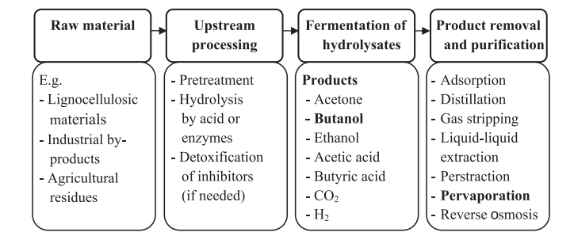
Figure 1: Graphic representation of biomass conversion into ethanol and butanol
After the fermentation process concentration of bio alcohol is 15-20 g/L which is than further purified by conventional distillation process (Liu et al., 2011). The diluted concentrations of these alcohols in fermentation broth are nearly 1-5wt%. Moreover, end-product inhabitation caused by bacteria lead to limited production of ethanol and butanol. Therefore, purification processes are energy intensive and account for 60-80% of total operating costs for biofuel production (Yang et al., 2015). Hence, leading to limited implementation of biofuels on larger scale. To mitigate these problems, in recent years, many in situ techniques have been employed for bio alcohol recovery. To improve the overall production of ethanol and butanol with minimal product inhabitation these technologies can be employed alongside ABE fermentation process. Therefore, several in situ technologies including liquid-liquid extraction, molecular sieves, adsorption and gas stripping were developed to minimize product inhabitation by continuous removal (Alberto et al., 2017). The application of these technologies is limited due to limitations of feed conditions, huge number of byproducts and high cost of post-treatments (Kim et al., 2002).
2.2.2 Distillation
Distillation is a process of partial vaporization. The process includes separation of pure liquid from mixture of liquids with varying boiling points. It is traditionally used for removal of alcohols from aqueous mixtures in fermentation broth. The distillation process converts the liquids into vapors and then are condensed into liquid form and collected afterwards. Distillation is unable to remove liquids with similar boiling points known as azeotropes. To remove these azeotropes a third component is added known as entrainer or separating agent. Entrainer is added in the azeotropic mixture to change relative volatility of main component without formation of additional azeotrope (Perry et al., 1992). Diverse range of solvents including cyclohexane, benzene, glycols, pentane, gasoline and glycols has been used as entrainers in azeotropic distillation (Lee and Pahl, 1985). Distillation has had industrial applications but have some limitations because of operational problems, high energy consumption and operation costs (Adymkanov et al., 2008).
2.2.3 Pervaporation
Major concern with commercial ethanol and butanol production is high energy and cost requirement in conventional distillation. Moreover, excessive amount of wastewater produced from distillation columns is also an environmental concern. Therefore, there is a need for a treatment technology which is cost effective, environment friendly and requires less energy. Hence, organoselective and hydrophobic pervaporation a membrane-based separation technique has emerged as promising technique. Pervaporation involves the separation of liquid mixtures into a liquid phase. It can separate varying components from mixtures including organic/organic mixtures, water/organic mixtures and organic/water mixtures. Pervaporation can separate minute components generally less than 10wt% from the liquid mixtures. The minute components of the feed consume only latent heat of energy; hence overall energy requirement is reduced. Therefore, pervapration has the potential to save upto 50% of energy as compared to conventional distillation technology (Manshad et al., 2016). Pervaporation shows unmatchable benefits in separating heat sensitive, close-boiling, and azeotropic mixtures because it has simple working requirements, eco-friendliness, high separation efficiency and no requirement of addition of any species (entrainer) into the feed stream (Hilmioglu 2008).
2.2.4 Pervaporation Process
In recent years, use of membranes for removal of ethanol and butanol from fermentation process has gained a lot of attention. Pervaporation has been used simultaneously along with fermentation process for the recovery of ethanol and butanol. It requires dense non-porous membranes to separate two or more components of a liquid mixture. Pervaporation works on combination of two phenomena’s; a differing rate of diffusion over thin polymeric membrane and an evaporative phase. The separation of components is based on difference in sorption and diffusion. The separation process works when separating liquid mixture comes in contacts with one side of the membrane (Manshad et al., 2016). Liquid mixture is absorbed by the one side of the membrane. After absorption the components are diffused through membrane and then evaporated on permeate side. One constituent is preferably permeated through membrane because of concentrate and vapor pressure gradient. A suitable vacuum is applied on permeate side along with instantaneous condensation of permeated vapors. The maintained pressure is usually lesser as compared to partial pressure of feed liquid. In end the condensed permeated vapors are collected at permeate side (Jia et al., 2016).
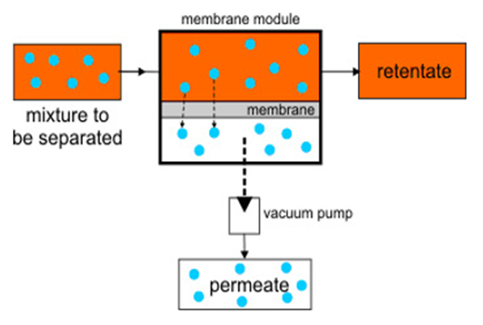
Figure 2: Diagram of pervaporation process
2.2.5 Limitations of Pervaporation
Pervaporation is essentially used to separate minor components in a liquid mixture, thus membranes through which high selectivity can be achieved are crucial (Adymkanov 2007). Use of pervaporation on industrial scale despite being very advantageous is hampered due to absence of high productivity membrane materials with respect to organic components. Due to unsatisfactory separation performance of pervaporation membranes, its wide use is limited. On the bases of solution–diffusion mechanism, separation performance is primarily dependent on membrane material and structure. The membrane pervaporation performance can be enhanced by improving sorption and diffusion proficiencies of specific solutes of interest and by improving the operative conditions (Jeon et al., 2012). Hence, it is essential to develop a new membrane possessing ability to provide high separation factors and fluxes (Zhang et al., 2016).
2.3 Polymers
Polymeric membranes are widely used in pervaporative separation for drying of organic solvents from aqueous mixtures. Choice of membrane material for pervaporation is dependent on its molecular and structural properties. Polymers high having permeability and stability under exposure to organic compounds are attractive to researchers. Polymers possessing high gas permeability are often potential pervaporation materials (Volkov et al., 2004). A number of researches have been carried to discover optimal membrane forming material possessing prefered interaction with specific constituent of the feed to fully enhance the separation performance in terms of separation factor, permeate flux and membrane stability (Verkerk et al., 2001).
2.3.1 Hydrophobic Polymers
A wide range of hydrophobic polymeric membranes have been used for ethanol and butanol recovery, including polyether block amide (PEBA) (Liu et al 2013), polydimethylsiloxane (PDMS) (Li et al 2013), polyvinylidene fluoride (PVDF), polyvinylidene fluoride (PVDF), poly(1-trimethylsilyl-1-propyne), (PTMSP) (Claes et al 2012) and poly (octylmethyl siloxane) (POMS). Application of these polymers on industrial scale is limited due to their low permeability, low selectivity, low fluxes and physical aging. Hence, there is a need for highly permeable polymer which leads to high selectivity and high flux.
2.3.2 Polymers of Intrinsic Micro porosity (PIM-1)
New polycondensation materials, namely, polymers with inner micro porosity known as PIM, have recently gained interest in field of pervaporation. PIM-1 is a hydrophobic polymer having intrinsic micro porosity selective towards organic compounds. Its structure is made of arrangement of rings along its backbone and Spiro Centre making chain twist and turn, consequently a randomly contorted structure with partial rotational freedom. PIM-1 possess high free volume which is formed due to inefficient molecular packing, leading to high permeability in comparison with conventional glassy polymers. PIM-1 falls in category of highly permeable polymers. It is an amorphous, glassy polymer with low density, ladder like structure, high thermal stability and surface area of 600-900 m²g⁻¹.
The physicochemical characteristics of PIM-1 are Mw = 2.7 × 105, Mn = 9.6 × 104, Mw/Mn = 2.8, Tg > 350°C, a density of 1.09 g/cm3, a fractional free volume of 22%, and the mean diameter of free volume element of 5 Å. (Budd et al., 2005).
This polymer PIM-1 was produced through polycondensation of 5,5',6,6'-tetrahydroxy-3,3, 3',3'-tetramethyl-1,1'-spirobisindane (TTSBI) and tetrafluoroterephthalonitrile (TFTPN). (Adymkanov et al., 2008)
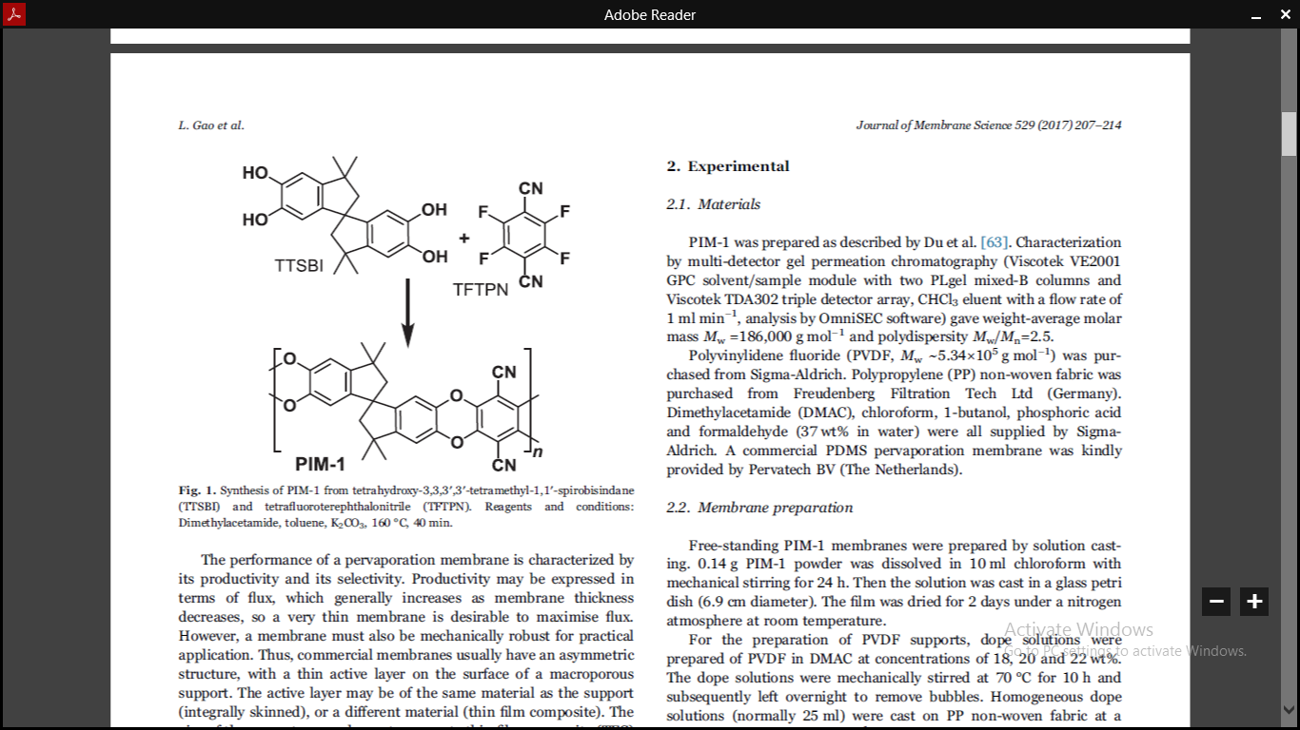
Figure 3: PIM-1 synthesis from (TTSBI) and (TFTPN)
Although PIM-1 is a promising polymer, its long-term stability is affected due to physical ageing. Due to excessive swelling of PIM-1 in presence of alcohols its application in pervaporation is limited (Alberto et al., 2017). A huge variety of fillers have been reported to be used alng with PIMs to overall enhance their separation performance. These fillers include silica, silicate-1 nanoparticles, carbon nanotubes and graphene.
Bennett et al., in 1997 first investigated PIM-1 for pervaporation of phenol water mixtures. The results revealed hydrophobic nature of the PIM-1. The permeate was enriched with phenol. Moreover, its permeability was higher than reported values of PIM-1.
Zak et al., used PIM-1 membranes for preferential removal of butanol from aqueous mixture through pervaporation. To study the effect of physical aging, freshly casted and aged PIM-1 membranes for 370 days were used for pervaporation experiments. The results for separation of 2wt% of butanol showed that aged membranes exhibited decrease in permeability as compared to freshly casted membranes. Due to aging effect polymer chains were rearranged resulting in denser and reduced available free volume. Besides this, selectivity of aged membranes increased from 2.8 to 5.1.
To increase the permeate flux Gao et al., prepared thin film composite membranes. In this study asymmetric polyvinylidene fluoride (PVDF) supports were made by coating of PIM-1 to form thin film composite membranes. The active layer thickness ranged from 1.0-2.9μm. The prepared membrane was analyzed for pervaporative separation of 1-butanol and water mixtures. The results revealed that flux and separation factor increased with increase in temperature, at 65ºC total flux of 9kg m⁻² h⁻¹ and separation factor of 18.5 was achieved through membranes.
Mason et al., prepared membranes with PIM-1 as polymer and silicate-1 as a filler. Silicate-1 was functionalized with 2-phenylethyl group to increase its hydrophobicity. Membranes with different filler loadings from 8.4 to 35.5wt% were prepared and analyzed for separation of ethanol from water mixtures by pervaporation. The results shows high loadings of silicate-1 significantly increased ethanol separation from 1.53 to 5.7 as compared to neat membranes.
Wu, et al., prepared PIM-1 membranes for Ethylene Glycol separation from water/methanol mixtures through pervaporation. The results indicate that membranes show high fluxes of 10.40kg μm m⁻² h⁻¹and good selectivity with separation factor of 24.2.
Alberto et al., in 2017 fabricated MMMs with PIM-1 polymer and Graphene oxide as filler. Graphene oxide have been alkylamine- functionalized with different chain legths, ctylamine (OA) 8 carbons and octadecylamine (ODA) 18 carbons, for obtaining homogeneous and well dispersion polymeric phase. Pervaporation performance for ethanol and butanol separation from water mixtures was carried out. Results indicate that separation factor of Butanol for pure PIM-1 membrane was 13.5. By adding 0.1wt% reduced functionalized Graphene Oxide reached 32.9 for OA and 26.9 for ODA.
2.3.3 Limitations of Polymeric Membranes
Polymeric membranes often show a limitation because of a general trade of amongst flux and selectivity. Another limitation with polymeric membranes is swelling of polymer material which results in reduction of selectivity due to plasticization effect. Industrial use of polymeric membranes is partial because of reduced long-term stability and physical aging of polymer films (Zhiqian et al., 2016). Low selectivity and permeability of polymers also result in limited application on industrial scale (Wu et al., 2015).
Due to limitations of polymeric membranes several researches are carried out to improve performance of membranes through which high and stable separation efficiency can be achieved while fulfilling the industrial requirements. These improvements can be made through modifications in membranes and changes in material properties (Ong et al.,2016). These methods include physical and chemical modifications such as cross linking, surface coating, fabrication of mixed matrix membranes and polymer blends.
2.4 Mixed Matrix Membranes (MMMs)
Problems encountered by simple polymeric membranes are overcome by mixed matrix membranes (MMMs). These MMMs are created by blending inorganic nanosized fillers into polymer matrix. Combination of unique properties of both materials makes membranes efficient for pervaporation. Wide range of fillers has been reported in formation of MMMs. These fillers include carbon nanotubes, activated carbon, silica, silicate, zeolites and Metal organic frameworks (MOFs) (Kang et al., 2013). Fabrication of MMMs is hindered by possible agglomeration of nanosized fillers resulting in a defective area and reduced selectivity. To overcome the problem of agglomeration several methods were proposed, including tailoring external surface of fillers via chemical modification and using less rigid fillers such as MOFs which contains both organic and inorganic materials. MOFs offer synergistic benefits of both organic and inorganic materials for pervaporation membranes.

2.4.1 Metal Organic Framework (MOF)
Metal-organic frameworks (MOFs) are hybrid crystal-like nano-porous materials, made by selection of metal centers and organic linkers. They have gotten huge attention in providing an attractive prospect because of their extraordinary properties, including high porosity with well-defined sites of adsorption, high thermal stability, chemical flexibility along with high surface area, designable and tunable framework topologies. MOFs are considered as excellent fillers in making of hybrid membranes (Jia, et al. 2016). Due to presence of organic ligand in their structure, they show excellent compatibility with polymer matrix. The overall membrane performance is enhanced by adding MOFs into polymer matrix. Addition of MOFs into polymer matrix targets to enhance the total membrane performance by reducing degree of swelling of polymeric matrix as well as favors passage of a prefered constituent by membrane because of selective sorption and diffusion (Alberto et al., 2017). Thus, the more concerns should be about completely exploiting the structural characteristics of MOFs, including framework with a specific functional group, strengthening interaction with polymer layer as well as improving selectivity of the target separating compound (Zhang et al., 2017). On the adsorption and desorption of guest molecules the unit cell volume of MOFs can alter in range of 40 to 230%, known as breathing effect. This is an important characteristic feature of MOF and is useful in membrane separation of liquid molecules by molecular sieving (Hsieh et al., 2014).
2.4.2 Zeolitic imidazolate frameworks (ZIFs)
Zeolitic imidazolate framework (ZIF) have immerged as crystalline porous nanofiller for preparation of mixed matrix membranes. ZIFs are subfamily of MOFs and possess tunable structures and favorable affinity with polymer matrix as compared to conventional inorganic fillers having firm frameworks. Their structure is linked amongst transition metals and imidazolate linkers. The imidazolate linkers present in their structures, make ZIFs more hydrophobic as compared to other fillers, conferring good interfacial compatibility between ZIFs and polymer matrix (Zhang et al., 2016). Moreover, they possess microporous crystalline structures combining unique and highly desirable properties of both zeolites and MOFs. They show high porosity and chemical functionality, with benefits of excellent chemical stability and large structural diversity, unusual for MOFs (Bai et al., 2015). Therefore, ZIFs are considered as excellent fillers in polymer matrix such as polymethylphenylsioxane, polydimethylsiloxane (PDMS) such as polymethylphenylsioxane, polydimethylsiloxane (PDMS), chitosan, PVA, polybenzimidazole, polyether-blockamide, polysulfone (PS), polyimide and polymerizable room temperature ionic liquid. ZIFs such as ZIF-8, ZIF-90, ZIF-67, ZIF-7, ZIF-71 have been reported to improve bio-alcohol recovery (Alberto et al., 2017). Incorporation of ZIFs in membranes can majorly enhance separation performance and mechanical properties of membranes (Wu et al., 2018).
Jin et al., synthesized MMMs with polyether-block-amide (PEBA) polymer and ZIF-71 filler for recovery of bio-butanol from ABE fermentation broth via pervaporation. The MMM with 20wt% ZIF-71 showed highest bio-butanol separation factor.
Kang et al. prepared MMMs with chitosan (CS) and ZIF-7 to separate water/ethanol mixtures. Membranes with different filler loadings of ZIF-7 (2.5,4,5,6,7.5 wt%) in Chitosan polymer have been prepared. Results indicate that separation efficiency with 5% filler loading was 19 times higher as in comparison with pristine chitosan membrane. The membrane performance improved with filler loadings as compared to pure Chitosan membrane due to rigidified polymer chains of mixed matrix membranes.
The dynamic apertures and highly hydrophobic surface of ZIF-8 lead to ability to selectively absorb alcohols. It provides accurate size for dehydrating alcohols with small aperture size of 3.4 Å and a larger cavity of 11.6 Å. By incorporating ZIF-8 into polymer matrix, provides preferential pathways for permeation of organic compounds and permit effective pervaporative removal of bio‐alcohols from fermentation broths.
Yang et al., synthesized ZIF-8/ PMPS membranes for removal of alcohol from an aqueous mixture. The MMM showed exceptional separation performance due to flexible pore size apertures and highly hydrophobic ZIF-8 surface.
Liu et al., prepared MMMs with ZIF-8 filler and PDMS polymer for butanol/water separation. Results showed that ZIF-8/PDMS membranes exhibited high selectivity and permeability in comparison to pristine PDMS membranes.
Amirilargani et al., prepared nanostructured ZIF- 8 particle and incorporated them in Poly (vinyl alcohol) (PVA) to prepare MMMs. Membranes with different filler loading of ZIF-8 (1, 2.5, 5, 7.5, 10wt%) were added into PVA polymer. Membranes with 5wt% ZIF-8 showed best pervaporation performance. The 5wt% ZIF-8 increases the permeation 5 times as compared to neat PVA membranes, without a significant decline in separation factor. Because of filler agglomerates of ZIF-8 particles in PVA matrix, separation factor declines with high filler loading.
Liu et al., prepared MMMs with ZIF-8/polymethyl-phenylsiloxane to recover bio-alcohols. The incorporation of ZIF-8 into polymethyl-phenylsiloxane enhances the adsorption and selectivity, resulting in enhanced separation performance.
Shi et al., synthesized MMMs with polybenzimidazole (PBI) polymer and ZIF-8 filler for pervaporation separation of ethanol. The results indicate that ZIF-8 nanoparticles are capable fillers to enhance the separation performance of materials with declined permeability but high performance like PBI. Incorporation of ZIF-8 increases permeability significantly without much decrease in selectivity.
Zhang et al., modified ZIF-8 particles with Ethane diamine to form ZIF-8-NH2 particles to enhance their hydrophilicity and affinity with poly (vinyl alcohol) PVA matrix through hydrogen bonding between ZIF-8-NH₂ molecules and PVA polymer. The pervaporation results indicate that by adding ZIF-8NH₂ filler overall pervaporation performance is improved because of improved hydrophilicity and affinity with PVA. The membranes with 7.5wt % ZIF-8-NH₂ loading shows high separation factor and flux for ethanol dehydration.
2.5 Mixed Metal Organic Framework
Metal organic frameworks studied during the past have been made by single metal species and their properties are dependent on single metal. By incorporation of another metal specie in the existing MOF to form Mixed Metal Organic Framework M’MOF would provide an efficient way to add in new properties in MOFs. Construction of M’MOF is based on addition of secondary metal specie into primary MOF through immersion, metal exchange and yolk shell structure. Direct synthesis of M’MOFs is challenging due to unknown complexity caused by addition of second metal specie. Majority of times individual metal specie can distinctly form discreet MOFs without any linking to other metal clusters (Zhou et al., 2017).
A few researchers have reported synthesis of Zn/Co-ZIF. ZIF-67 and ZIF-8 are isostructural a well-defined structure of Zn/Co-ZIF can be generated (Yang et al., 2015). Zhou et al., reported direct and straight-forward manufacturing of dual Co and Zn MOFs using 2-methylimidazole linker.

4. Results and Discussion
The membranes were prepared with 0, 5, 10, 20 and 30wt% filler loading. The membranes with 30wt% loading showed breakages and were not formed. Therefore, membranes with 30wt% were not characterized and used for pervaporation separation performance.
4.1 Characterization of ZIF-8 and Zn/Co-ZIF
The crystalline structure and phase purity of created fillers were validated by powder X-ray Diffraction (XRD) as shown in Figure.5. The X-ray Diffraction (XRD) of Zn/Co-ZIF was compared with diffractogram of ZIF-8. The diffraction planes (011), (002), (112), (022), (013) and (222), (014), (233), (224), (134), and (044) respectively match with ZIF-8 and Zn/Co-ZIF. The obtained Zn/Co-ZIF materials are crystalline and isostructural to ZIF-8 with typical reflections of the sodalite structure identical of ZIF-8 (Gao et al., 2016). Diffractogram shows no change in the peak positions from ZIF-8 to Zn/Co-ZIF, due to Co and Zn metals are occupy the similar lattice positions (Zhou et.al 2017). Moreover, diffractogram of samples also showed that they are free from water and other impurities and does not show any significant change in XRD planes. This confirmed successful synthesis of the ZIFs.
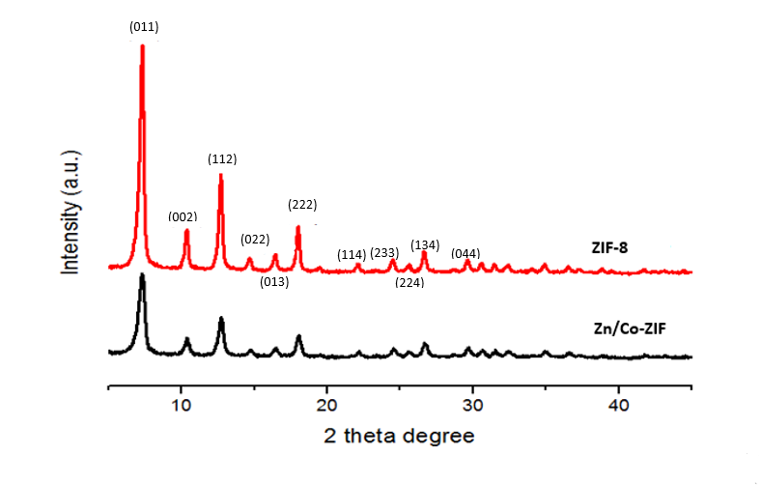
Figure 5: XRD Comparison of Fillers ZIF-8 and Zn/Co-ZIF
The FTIR spectra of synthesized ZIF-8 and Zn/Co-ZIF are plotted in Figure.6. Peaks in the spectra are primarily attributed to 2-methylimidazole ligand. The intense bands at 600cm⁻¹ to 1700cm⁻¹ are linked with stretching and blending vibrations of entire imidazole ring (Hu et al.,2011). The peaks at 2900cm⁻1and 3100cm⁻¹are linked to stretching of C-H vibrations of aliphatic methyl group and aromatic ring of 2-methylimidazole, respectively. A peak at 1849 cm⁻¹ assigned as C=N-H stretching of imidazole, accompanying along with wide strong peak between 2300-2500 cm⁻¹. The results coordinate well with literature and indicate purity of synthesized ZIFs (Yang et.al., 2015).
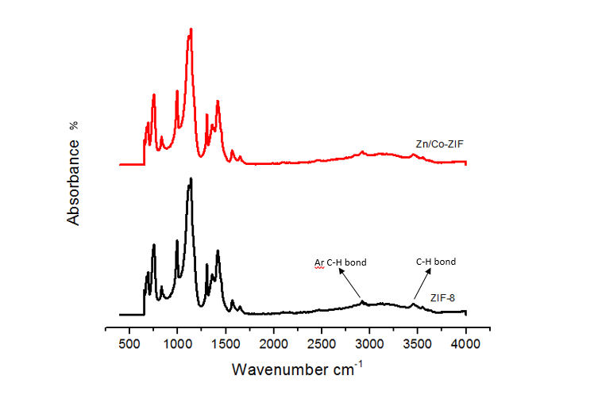
Figure 6: FTIR spectrum of ZIF-8 and Zn/Co-ZIF

SEM images Figure.7. of all samples revealed nano-sized rhombic dodecahedron shaped ZIFs crystals. The average particle size is 80nm of ZIF-8 and 120nm of Zn/Co-ZIF. SEM-EDX analysis of Zn/Co-ZIF nanoparticles shows homogeneous distribution of O, C, N, Zn and Co elements. Moreover, presence of both metals Zn and Co indicates successful synthesis of Zn/Co-ZIF.
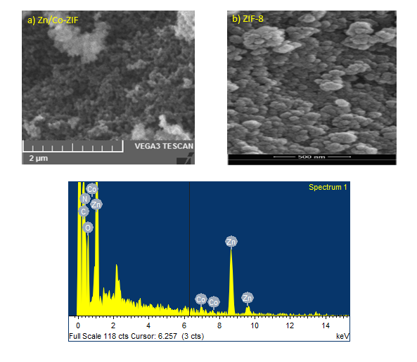
Figure 7: SEM image of a) ZIF-8, b) Zn/Co-ZIF and SEM-EDX of c) Zn/Co-ZIF
4.2 Characterization of Mixed Matrix Membranes
Cross sectional morphology of pure PIM-1 membranes and MMMs were observed by SEM. Figure 8. (a) shows a micrograph of defect free dense PIM-1 membrane. The rest of SEM images, all cross sections of PIM-1/ZIF-8 MMMs (Figure 8b, c, d) and Zn/Co-ZIF/PIM-1 MMMs (Figure 8e, f, g), also reveal defect free dense films. Moreover, SEM images suggest that by incorporating filler the packing of PIM-1 membranes is influenced with no significant sedimentation takes place, suggesting homogeneous dispersion of fillers is achieved. It can be seen for PIM-1/ZIF-8 MMMs or PIM-1/Zn/Co-ZIF that with increasing filler concentrations no visible large aggregates or macro voids were observed, indicating a good interfacial interaction of filler.
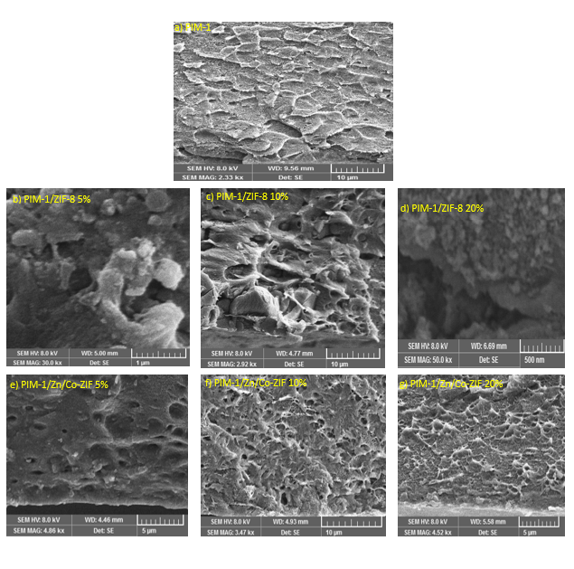
Figure 8: SEM cross-section of (a) PIM-1, PIM-1/ZIF-8 MMMs with vol% ZIF-8 (b) 5 (c) 10 (d) 20, and PIM-1/Zn/Co-ZIF MMMs with vol% Zn/Co-ZIF (e) 5 (f) 10 (g) 20
X-ray Diffraction (XRD) was carried out to investigate the microstructures of ZIF-8 and Zn/Co-ZIF in MMMs and polymer matrix Figure.9. (a & b). The characteristic peaks of pure PIM-1 membrane can be seen in Figure.9. (a & b) at 13.1º, 18.2º and 22.6º. By increasing the percentage of fillers in PIM-1/ZIF-8 MMMs and PIM-1/Zn/Co-ZIF MMMs from 5wt% to 20wt% the three characteristic peaks of PIM-1 appear to be much weaker, indicating that incorporation of ZIFs disturbs packing of PIM-1. Moreover, presence of characteristic peaks of ZIF-8 or Zn/Co-ZIF in MMMs indicate that their structure is not altered after being incorporated in PIM-1. Additionally, the characteristic peaks of ZIF-8 or Zn/Co-ZIF become clearer as a result of increasing filler loading, are in agreement with even distribution of filler in MMMs.
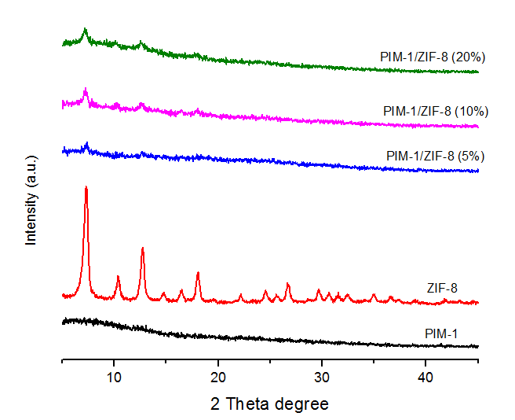
Figure 9 (a): XRD comparison of ZIF-8 and PIM-1/ZIF-8 MMMs (5,10 and 20wt%)
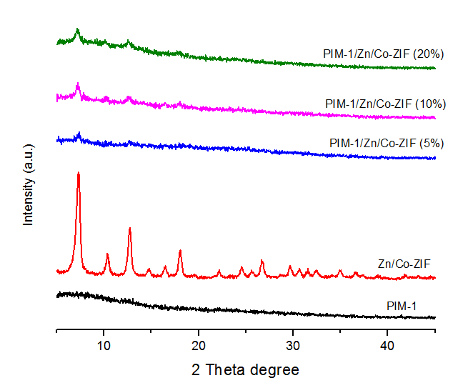
Figure 9 (b): XRD comparison of Zn/Co-ZIF and PIM-1/Zn/Co-ZIF MMMs (5,10 and 20wt%)
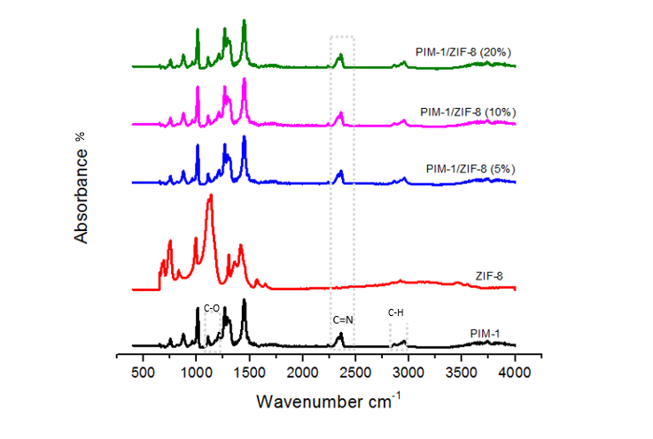
Figure 10 (a): FTIR comparison of of ZIF-8 and PIM-1/ZIF-8 MMMs (5,10 and 20 wt%)
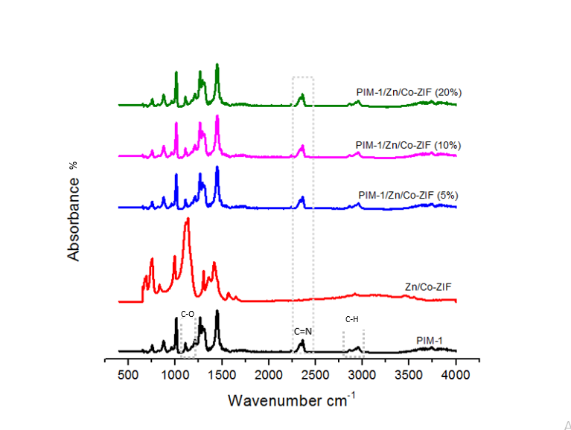
Figure 10 (b): FTIR comparison of Zn/Co-ZIF and PIM-1/Zn/Co-ZIF MMMs (5,10 and 20wt %)
FTIR analysis of pristine PIM-1 and MMMs with varying filler loading of ZIF-8 and Zn/Co-ZIF is shown in Figure.10. (a & b) respectively. The FTIR spectrum of pristine PIM-1 membrane was similar to literature (Wu et al., 2018). The stretching bands included C-H bond at 2840, 2930 and 2950cm⁻¹, nitrile group at 2280cm⁻¹, aromatic C-O at 1100-1300cm⁻¹, aromatic C=C at 1600cm⁻¹, alkane C-H at 1450cm⁻¹. FTIR spectra of ZIF-8 MMMs and Zn/Co-ZIF MMMs does not show any shift or disappearance of any peak. Both the fillers Figure.6a. ZIF-8 and Figure. 6b. Zn/Co-ZIF have identical peaks with an additional peak present at 2360cm⁻¹ corresponding to nitrile stretching in PIM-1. This indicates that there exists a favorable interaction between polymer PIM-1 and fillers ZIF-8 and Zn/Co-ZIF. On comparison with literature this nitrile stretch is also visible in ZIF-67/PIM-1 membranes. Furthermore, ZIF-67/PIM-1, ZIF-8/PIM-1 and Zn/Co-ZIF/PIM-1 membranes show identical FTIR spectra (Wu et al., 2018).
Table 1: Water Contact Angle
Filler Loading | Water Contact Angle (º)
Filler Loading | ZIF-8 | Zn/Co-ZIF
0 | 96 | 96
5 | 98.4 | 99.3
10 | 99.5 | 101
20 | 102 | 104.7

The hydrophobic nature of membranes is assessed through water contact angle. Water contact angle measurements on all MMMs were calculated and results are presented in table.1. The Water contact angle values for PIM-1/ZIF-8 and PIM-1/Co-Zn-ZIF MMMS were slightly different. With increasing loading of filler from 0 to 20wt%, the water contact angle increased slightly between (96º to 102º) for PIM-1/ZIF-8 MMMs whereas for PIM-1/Co-Zn-ZIF MMMS varied between (96º to 104.7º), which means that membrane hydrophobicity was slightly enhanced. This indicates that fillers are covered by PIM-1 with no substantial changes in surface roughness. As anticipated for hydrophobic PIM-1 membrane, high water contact angle shows more affinity of membrane towards alcohol molecules and consequently preferential permeation over water.
Solvent uptake (SU) in water, ethanol and butanol of PIM-1 membranes and MMMs was investigated to analyze the affinity between membranes and permeating molecules. The results are summarized in Figure.11. The incorporation of fillers ZIF-8 or Zn/Co-ZIF increases the SU for both butanol and ethanol by increasing filler loading from 5 to 20wt%. Indicating an increase in the membrane’s affinity towards ethanol and butanol by improving sorption towards alcohols leading to higher alcohols solubility in comparison to pristine PIM-1 membrane. However, PIM-1/ZIF-8 membranes show SU in ethanol & butanol, their SU in water also increases. The solvent uptake water, ethanol and butanol in PIM-1/ZIF-8 membranes increase at a constant rate of 4%. Whereas, PIM-1/Zn/Co-ZIF membranes show increasing solvent uptakes at a higher rate with varying filler loadings. On contrary the water uptake of PIM-1/Zn-Co-ZIF membranes does not increases significantly with increasing filler loadings due to their hydrophobic nature as demonstrated by Table.1. Moreover, PIM-1/ZIF-8 and PIM-1/Zn/Co-ZIF MMMs also shows that overall butanol uptake is higher as compared to ethanol. This can be driven primarily from high solubility of butanol in the membrane. Moreover, due to bigger kinetic diameter of butanol (0.5nm) as compared to ethanol (0.4nm), butanol will have more sites of sorption leading to more uptake. In addition, other phenomenon is further explained by (Liu et al., 2004) when an aqueous butanol solution contacts with membrane, forces retaining butanol molecules in water are relatively weaker due to partial miscibility of butanol with water as compared to ethanol’s complete miscibility with water.

Figure 11: Solvent Uptake of membranes in Ethanol and Butanol

4.3 Pervaporation Performance

Figure 12 (a): Effect of ZIF-8 loading on membrane flux and separation factor

Figure 12 (b): Separation factor for ethanol and butanol over water and total flux (alcohol plus water) permeating through the membranes normalized with thickness.
To evaluate separation performance of membranes, the effect of ZIFs loadings on pervaporation performance of mixed matrix membranes was examined to separate 5wt% binary aqueous solution having either ethanol or butanol with feed temperature of 65ºC. The performance of membranes is dependent on their preferred permeation of alcohol molecules over water. Consequently, higher separation factors leads to higher concentrations of alcohols recovered in permeate of given feed composition. Addition of fillers ZIF-8 and Zn/Co-ZIF will promote selective adsorption of alcohol molecules. Moreover, these fillers provide more nanochannels for penetrants to transport through membrane, enhancing membrane permeability. Figure.12. (a & b) depicts the obtained butanol and ethanol flux as well separation factors of the various loading membranes. Fluxes are normalized with thickness for better comparison. PIM-1/ZIF-8 membranes show separation factors similar to pure PIM-1 membrane from 2.8 to 3.14, whereas fluxes are increasing with increased filler loading. This constant separation factor can be linked with solvent uptake results Figure.11. As demonstrated by SU results PIM-1/ZIF-8 that addition of filler ZIF-8 increases the solvent uptake in water, ethanol and butanol at the same rate, thus resulting in no significant change in separation factor. Whereas, PIM-1/Zn-Co-ZIF membranes show increasing separation factors. As demonstrated by Solvent uptake results Figure.11. addition of Zn/Co-ZIF does not show any significant increment in water uptake but their solvent uptake in ethanol and butanol increases at a higher rate, thus leading to high separation factors. The normalized total flux is higher in PIM-1/ZIF-8 membranes as compared to PIM-1/Zn/Co-ZIF membranes. The high external surface area of ZIF-8 129(m²/g) ª as compared to Zn/Co-ZIF’s 61(m²/g) ª reported by Zhou et al., leads to higher fluxes.

Figure 13: Effect of temperature on ethanol flux with a) ZIF-8 filler and b) Zn/Co-ZIF filler and on butanol flux with c) ZIF-8 filler and d) Zn/Co-ZIF filler
The effect of feed temperature from 25°C to 65°C on total normalized flux was conducted Figure 13. Pure PIM-1 and all MMMs showed increase in total normalized flux with increase in temperature. At maximum filler loading of 20wt% and highest temperature of 65ºC all membranes show highest total normalized flux. On comparison of fillers MMMs with ZIF-8 show higher flux for ethanol and butanol as compared to Zn/Co-ZIF. The increasing temperature increases the free volume of membranes because of increased thermal movement of polymer chains leading to high fluxes. To further describe the effect of temperature on pervaporation flux Arrhenius equation is used:
$J=J_{o}\exp{ (\frac{-E_{J}}{RT})}$ (vi)
where J is the flux, J_{o} is the pre-exponential factor and E_{j} is the activation energy of flux. Table 2. shows the activation energies of flux calculated from temperature dependence. The values clearly show that all the MMMs have lower activation energy in comparison to pure PIM-1 membrane. Thus, these values validate the point that addition of fillers provide additional diffusion pathways for the molecules to permeate resulting in fewer mass transfer resistance, consequently resulting in high fluxes.
Table 2: Activation Energies of membranes
Filler | Filler Loading wt% | Ethanol E_{j} (kJ mol⁻¹) | Butanol E_{j} (kJ mol⁻¹)
ZIF-8 | 0  5  10  20 | 19.92  18.32  15.17  11.59 | 15.38  15.42  10.75  10.28
Zn/Co-ZIF | 0  5  10  20 | 19.92  14.005  13.88  11.33 | 15.38  14.002  9.72  8.303

Table 3: Comparison of ethanol and butanol separation factor and fluxes with different fillers and polymers
Sr No | Filler/Polymer | Filler Loading (wt%) | Membrane Thickness µm | Ethanol/Butanol Content in feed solution (wt%) | Temperature (ºC) | Normalized Total flux (kg.µm/m².h) | Separation factor | Reference
1 | ZIF-71/PDMS | 40 | 65 | 5 butanol | 50 | 1.7 | 30.2 | (Li et al., 2014)
2 | ZIF-71/PEBA | 20 | 100 | 5 butanol | 60 | 0.09 | 18.8 | (Liu et al., 2013)
3 | ZIF-8/PDMS | 10 | 50 | 5 butanol | 55 | 0.48 | 56 | (Li et al., 2019)
4 | ZIF-8/PDMS | 20 | 45 | 5 butanol | 80 | 2.8 | 52.81 | (Fan et al., 2014)
5 | ZIF-7/PDMS | 20 | 57 | 5 butanol | 60 | 1.6 | 66 | (Wang et al., 2016)
6 | Zn/Co-ZIF/PIM-1 | 20 | 60 | 5 butanol | 65 | 104.5 | 21.33 | This work
7 | ZIF-67/PDMS | 20 | 40 | 6 ethanol | 40 | 2.7 | 15.4 | (Khan et al., 2018)
8 | ZIF-90/PDMS | 2.5 | 55 | 5 ethanol | 60 | 0.09 | 15.1 | (Xu et al., 2018)
9 | MIL-53/PDMS | 40 | 35 | 5 ethanol | 80 | 5.5 | 11.1 | (Zhang et al., 2015)
10 | ZSM-5/PDMS | 30 | 70 | 5 ethanol | 50 | 0.16 | 17 | (Zhan et al., 2012)
11 | ZIF-8/PDMS | 10 | 65 | 5 ethanol | 60 | 1.2 | 9.9 | (Yan et al., 2015)
12 | MAF-6/PEBA | 7.5 | 57 | 5 ethanol | 60 | 2.0 | 4.5 | (Liu et al., 2019)
13 | ZIF-71/PDMS | 40 | 45 | 5 ethanol | 50 | 0.4 | 10 | (Likh et al., 2015)
14 | Zn/Co-ZIF/PIM-1 | 20 | 60 | 5 ethanol | 65 | 74.45 | 6.4 | This work

The above table shows the comparison of different membranes used for pervaporation separation of ethanol and butanol by incorporating diverse fillers. The comparison of membrane performance is difficult because of varying parameters including types of fillers and polymers used, loading of filler, filler and membrane treatments, membrane thickness and membrane casting techniques. To compare the performance of fillers two parameters flux and separation factor were considered.
The above table shows that separation factor for butanol lie in the range of 18.8 to 69.9. Our work shows butanol separation factor of 21.33 with 20wt% Zn/Co-ZIF. Whereas ethanol separation factor lies in the range of 4.5 to 17. The ethanol separation factor of our work is 6.4 with 20wt% Zn/Co-ZIF. Flux for ethanol and butanol lies in the range 0.07 to 5.5(kg. µm/m².h) and 0.09 to 2.8(kg. µm/m².h) respectively. This work shows butanol flux of 104.5(kg. µm/m².h) and ethanol flux of 74.45(kg. µm/m².h). This comparison shows that prepared membranes give high fluxes with moderate separation factors.
Conclusions
Novel MMMs with PIM-1 polymer and fillers ZIF-8 or Zn/Co-ZIF have been developed. XRD, FTIR and SEM analysis show uniform dispersion and good compatibility between fillers and polymer matrix with increasing filler loading. The prepared membranes were successfully tested for ethanol and butanol separation from alcohol/water mixture through pervaporation. Results indicate that hydrophobic fillers result in increasing the overall hydrophobicity of MMMs. Hence resulting in improved PV performance of MMMs. MMMs containing ZIF-8 show separation factors similar to pure PIM-1 whereas, increasing ethanol and butanol flux of 94.87(kg. µm/m².h) and 139(kg. µm/m²h), respectively. For the separation of ethanol there is not much improvement due to solubility and diffusivity coefficients closer to water.
Separation factor of all membranes for butanol is higher as compared to ethanol. The incorporation of Zn/Co-ZIF in pure PIM-1 increases the affinity towards butanol resulting in increased separation factor from 12.7 for pure PIM-1 membrane to 21.33 for MMM with 20wt% Zn/Co-ZIF. The fluxes of MMMs with Zn/Co-ZIF are 74.45(kg. µm/m²h) for ethanol and 104.5(kg. µm/m²h) for butanol, lower as compared to MMMs with ZIF-8.
Overall results indicate that MMMs with ZIF-8 give higher butanol fluxes. Whereas, MMMs with Zn/Co-ZIF give high butanol separation factors. All results agree with the fact that all membranes show higher affinity towards butanol.

References
- Amirilargani, M., & Sadatnia, B. (2014). Poly (vinyl alcohol)/zeolitic imidazolate frameworks (ZIF-8) mixed matrix membranes for pervaporation dehydration of isopropanol. Journal of Membrane Science, 469, 1-10.
- Adymkanov, S. V., Yampol’skii, Y. P., Polyakov, A. M., Budd, P. M., Reynolds, K. J., McKeown, N. B., & Msayib, K. J. (2008). Pervaporation of alcohols through highly permeable PIM-1 polymer films. Polymer Science Series A, 50(4), 444-450.
- Crabbe, E., Nolasco-Hipolito, C., Kobayashi, G., Sonomoto, K., & Ishizaki, A. (2001). Biodiesel production from crude palm oil and evaluation of butanol extraction and fuel properties. Process biochemistry, 37(1), 65-71.
- Alberto, M., Luque-Alled, J. M., Gao, L., Iliut, M., Prestat, E., Newman, L & Gorgojo, P. (2017). Enhanced organophilic separations with mixed matrix membranes of polymers of intrinsic microporosity and graphene-like fillers. Journal of Membrane Science, 526, 437-449.
- Anjum, M. W., Vermoortele, F., Khan, A. L., Bueken, B., De Vos, D. E., & Vankelecom, I. F. (2015). Modulated UiO-66-based mixed-matrix membranes for CO2 separation. ACS applied materials & interfaces, 7(45), 25193-25201.
- Albo, J., Hagiwara, H., Yanagishita, H., Ito, K., & Tsuru, T. (2014). Structural characterization of thin-film polyamide reverse osmosis membranes. Industrial & Engineering Chemistry Research, 53(4), 1442-1451.
- Basu, S., Maes, M., Cano-Odena, A., Alaerts, L., De Vos, D. E., & Vankelecom, I. F. (2009). Solvent resistant nanofiltration (SRNF) membranes based on metal-organic frameworks. Journal of membrane science, 344(1-2), 190-198.
- Budd, P. M., Ghanem, B. S., Makhseed, S., McKeown, N. B., Msayib, K. J., & Tattershall, C. E. (2004). Polymers of intrinsic microporosity (PIMs): robust, solution-processable, organic nanoporous materials. Chemical Communications, (2), 230-231.
- Budd, P. M., McKeown, N. B., & Fritsch, D. (2006). Polymers of intrinsic microporosity (PIMs): high free volume polymers for membrane applications. In Macromolecular Symposia, 245(1), 403-405.
- Budd, P. M., Msayib, K. J., Tattershall, C. E., Ghanem, B. S., Reynolds, K. J., McKeown, N. B., & Fritsch, D. (2005). Gas separation membranes from polymers of intrinsic microporosity. Journal of Membrane Science, 251(1-2), 263-269.
- Black, C., & Ditsler, D. E. (1972). Dehydration of aqueous ethanol mixtures by extractive distillation.
- Bai, Y., Dong, L., Zhang, C., Gu, J., Sun, Y., Zhang, L., & Chen, H. (2013). ZIF-8 filled polydimethylsiloxane membranes for pervaporative separation of n-butanol from aqueous solution. Separation Science and Technology, 48(17), 2531-2539.
- Bennett, M., Brisdon, B. J., England, R., & Field, R. W. (1997). Performance of PDMS and organofunctionalised PDMS membranes for the pervaporative recovery of organics from aqueous streams. Journal of membrane science, 137(1-2), 63-88.
- Black, G., Curran, H. J., Pichon, S., Simmie, J. M., & Zhukov, V. (2010). Bio-butanol: Combustion properties and detailed chemical kinetic model. Combustion and Flame, 157(2), 363-373.
- Bushell, A. F., Attfield, M. P., Mason, C. R., Budd, P. M., Yampolskii, Y., Starannikova, L. & Lanč, M. (2013). Gas permeation parameters of mixed matrix membranes based on the polymer of intrinsic microporosity PIM-1 and the zeolitic imidazolate framework ZIF-8. Journal of membrane science, 427, 48-62.
- Couper, J. R., Penney, W. R., & Fair, J. R. (2009). Chemical Process Equipment-Selection and Design (Revised 2nd Edition). Gulf Professional Publishing.
- Claes, S., Vandezande, P., Mullens, S., De Sitter, K., Peeters, R., & Van Bael, M. K. (2012). Preparation and benchmarking of thin film supported PTMSP-silica pervaporation membranes. Journal of membrane science, 389, 265-271.
- Durmaz Hilmioglu, N. (2009). Bioethanol recovery using the pervaporation separation technique. Management of Environmental Quality: An International Journal, 20(2), 165-174.
- Feng, X., & Huang, R. Y. (1992). Separation of isopropanol from water by pervaporation using silicone-based membranes. Journal of membrane science, 74(1-2), 171-181.
- Fan, H., Shi, Q., Yan, H., Ji, S., Dong, J., & Zhang, G. (2014). Simultaneous Spray Self‐Assembly of Highly Loaded ZIF‐8–PDMS Nanohybrid Membranes Exhibiting Exceptionally High Biobutanol‐Permselective Pervaporation. Angewandte Chemie International Edition, 53(22), 5578-5582.
- Gil, I. D., Uyazán, A. M., Aguilar, J. L., Rodríguez, G., & Caicedo, L. A. (2008). Separation of ethanol and water by extractive distillation with salt and solvent as entrainer: process simulation. Brazilian Journal of Chemical Engineering, 25(1), 207-215.
- Gao, L., Alberto, M., Gorgojo, P., Szekely, G., & Budd, P. M. (2017). High-flux PIM-1/PVDF thin film composite membranes for 1-butanol/water pervaporation. Journal of Membrane Science, 529, 207-214.
- Hua, D., Ong, Y. K., Wang, Y., Yang, T., & Chung, T. S. (2014). ZIF-90/P84 mixed matrix membranes for pervaporation dehydration of isopropanol. Journal of Membrane Science, 453, 155-167.
- Hsieh, J. O., Balkus Jr, K. J., Ferraris, J. P., & Musselman, I. H. (2014). MIL-53 frameworks in mixed-matrix membranes. Microporous and Mesoporous Materials, 196, 165-174.
- Hahn-Hägerdal, B., Galbe, M., Gorwa-Grauslund, M. F., Lidén, G., & Zacchi, G. (2006). Bio-ethanol–the fuel of tomorrow from the residues of today. Trends in biotechnology, 24(12), 549-556.
- Jia, Z., & Wu, G. (2016). Metal-organic frameworks based mixed matrix membranes for pervaporation. Microporous and Mesoporous Materials, 235, 151-159.
- Recent membrane development for pervaporation processes. Progress in Polymer Science, 57, 1-31.
- Jeffries, T. W., & Schartman, R. (1999). Bioconversion of secondary fiber fines to ethanol using counter-current enzymatic saccharification and co-fermentation. Applied biochemistry and biotechnology, 78(1-3), 435-444.
- Jeon, E. J., Kim, A. S., & Lee, Y. T. (2012). Pervaporation of butanol/water mixtures using siloxane polymer/ceramic composite membranes. Desalination and Water Treatment, 48(1-3), 17-26.
- Kim, H.J., Nah, S.S., Min, B.R., (2002). A new technique for preparation of PDMS pervaporation membrane for VOCs removal. Advanced in Environmental Research 6, 255–264.
- Kohoutova, M., Sikora, A., Hovorka, S., Randova, A., Schauer, J., Tisma, M., ... & Izak, P. (2009). Influence of ionic liquid content on properties of dense polymer membranes. European Polymer Journal, 45(3), 813-819.
- Kang, C. H., Lin, Y. F., Huang, Y. S., Tung, K. L., Chang, K. S., Chen, J. T., ... & Lai, J. Y. (2013). Synthesis of ZIF-7/chitosan mixed-matrix membranes with improved separation performance of water/ethanol mixtures. Journal of membrane science, 438, 105-111.
- Kang, C. H., Lin, Y. F., Huang, Y. S., Tung, K. L., Chang, K. S., Chen, J. T., ... & Lai, J. Y. (2013). Synthesis of ZIF-7/chitosan mixed-matrix membranes with improved separation performance of water/ethanol mixtures. Journal of membrane science, 438, 105-111.
- Khan, A., Ali, M., Ilyas, A., Naik, P., Vankelecom, I. F., Gilani, M. A., ... & Khan, A. L. (2018). ZIF-67 filled PDMS mixed matrix membranes for recovery of ethanol via pervaporation. Separation and Purification Technology, 206, 50-58.
- Williams, E., Sekar, A., Matteson, S., & Rittmann, B. E. (2015). Sun-to-wheels exergy efficiencies for bio-ethanol and photovoltaics. Environmental Science & Technology, 49(11), 6394-6401.
- Liu, S., Liu, G., Zhao, X., & Jin, W. (2013). Hydrophobic-ZIF-71 filled PEBA mixed matrix membranes for recovery of biobutanol via pervaporation. Journal of membrane science, 446, 181-188.
- Li, S., Chen, Z., Yang, Y., Si, Z., Li, P., Qin, P., & Tan, T. (2019). Improving the pervaporation performance of PDMS membranes for n-butanol by incorporating silane-modified ZIF-8 particles. Separation and Purification Technology, 215, 163-172.
- Li, Y., Wee, L. H., Martens, J. A., & Vankelecom, I. F. (2014). ZIF-71 as a potential filler to prepare pervaporation membranes for bio-alcohol recovery. Journal of Materials Chemistry A, 2(26), 10034-10040.
- Lee, F. M., & Pahl, R. H. (1985). Solvent screening study and conceptual extractive distillation process to produce anhydrous ethanol from fermentation broth. Industrial & Engineering Chemistry Process Design and Development, 24(1), 168-172.
- Liu, Y., Liu, D., & Wang, C. (2015). Bivalent metal-based MIL-53 analogues: Synthesis, properties and application. Journal of Solid State Chemistry, 223, 84-94.
- Liu, X. L., Li, Y. S., Zhu, G. Q., Ban, Y. J., Xu, L. Y., & Yang, W. S. (2011). An Organophilic Pervaporation Membrane Derived from Metal–Organic Framework Nanoparticles for Efficient Recovery of Bio‐Alcohols. Angewandte Chemie International Edition, 50(45), 10636-10639.
- Li, J., Chen, X., Qi, B., Luo, J., Zhuang, X., Su, Y., & Wan, Y. (2013). Continuous acetone–butanol–ethanol (ABE) fermentation with in situ solvent recovery by silicalite-1 filled PDMS/PAN composite membrane. Energy & Fuels, 28(1), 555-562.
- Liu, G., Wei, W., Wu, H., Dong, X., Jiang, M., & Jin, W. (2011). Pervaporation performance of PDMS/ceramic composite membrane in acetone butanol ethanol (ABE) fermentation–PV coupled process. Journal of Membrane Science, 373(1-2), 121-129.
- Mahajan, R., & Koros, W. J. (2000). Factors controlling successful formation of mixed-matrix gas separation materials. Industrial & Engineering Chemistry Research, 39(8), 2692-2696.
- Manshad, S., Nawawi, M. G. M., Sazegar, M. R., Hassan, H. B., & Alamaria, A. M. (2016). Membranes with favorable chemical materials for pervaporation process: A review. J. Membr. Sci. Technol, 6, 164.
- Mason, C. R., Buonomenna, M. G., Golemme, G., Budd, P. M., Galiano, F., Figoli, A., ... & Hynek, V. (2013). New organophilic mixed matrix membranes derived from a polymer of intrinsic microporosity and silicalite-1. Polymer, 54(9), 2222-2230.
- Moulik, S., Bukke, V., Sajja, S. C., & Sridhar, S. (2018). Chitosan-polytetrafluoroethylene composite membranes for separation of methanol and toluene by pervaporation. Carbohydrate polymers, 193, 28-38.
- Mason, C. R., Buonomenna, M. G., Golemme, G., Budd, P. M., Galiano, F., Figoli, A., ... & Hynek, V. (2013). New organophilic mixed matrix membranes derived from a polymer of intrinsic microporosity and silicalite-1. Polymer, 54(9), 2222-2230.
- Naik, P. V., Kerkhofs, S., Martens, J. A., & Vankelecom, I. F. (2016). PDMS mixed matrix membranes containing hollow silicalite sphere for ethanol/water separation by pervaporation. Journal of Membrane Science, 502, 48-56.
- Niemisto, J., Kujawski, W., & Keiski, R. L. (2013). Pervaporation performance of composite poly (dimethyl siloxane) membrane for butanol recovery from model solutions. Journal of membrane science, 434, 55-64.
- Ong, Y. K., Shi, G. M., Le, N. L., Tang, Y. P., Zuo, J., Nunes, S. P., & Chung, T. S. (2016). Recent membrane development for pervaporation processes. Progress in Polymer Science, 57, 1-31.
- Rdzanek, P., Marszałek, J., & Kamiński, W. (2018). Biobutanol concentration by pervaporation using supported ionic liquid membranes. Separation and Purification Technology, 196, 124-131.
- Salehian, P. (2017). Design and fabrication of high performance polymide membranes for pervaporation dehydration of isopropanol (Doctoral dissertation).
- Shi, G. M., Yang, T., & Chung, T. S. (2012). Polybenzimidazole (PBI)/zeolitic imidazolate frameworks (ZIF-8) mixed matrix membranes for pervaporation dehydration of alcohols. Journal of membrane science, 415, 577-586.
- Vane, L. M. (2008). Separation technologies for the recovery and dehydration of alcohols from fermentation broths. Biofuels, Bioproducts and Biorefining, 2(6), 553-588.
- Verkerk, A.W., Male, P.V., Vorstman, M.A.G., Keurentjes, J.T.F., (2001). Description of dehydration performance of amorphous silica pervaporation membranes. Journal of Membrane Science 193, 227– 238.
- Volkov, V. V., Fadeev, A. G., Khotimsky, V. S., Litvinova, E. G., Selinskaya, Y. A., McMillan, J. D., & Kelley, S. S. (2004). Effects of synthesis conditions on the pervaporation properties of poly [1‐(trimethylsilyl)‐1‐propyne] useful for membrane bioreactors. Journal of applied polymer science, 91(4), 2271-2277.
- Wang, X., Chen, J., Fang, M., Wang, T., Yu, L., & Li, J. (2016). ZIF-7/PDMS mixed matrix membranes for pervaporation recovery of butanol from aqueous solution. Separation and Purification Technology, 163, 39-47.
- Wee, L. H., Li, Y., Zhang, K., Davit, P., Bordiga, S., Jiang, J., ... & Martens, J. A. (2015). Submicrometer‐sized ZIF‐71 filled organophilic membranes for improved bioethanol recovery: mechanistic insights by Monte Carlo simulation and FTIR spectroscopy. Advanced Functional Materials, 25(4), 516-525.
- Wu, X. M., Guo, H., Soyekwo, F., Zhang, Q. G., Lin, C. X., Liu, Q. L., & Zhu, A. M. (2015). Pervaporation purification of ethylene glycol using the highly permeable PIM-1 membrane. Journal of Chemical & Engineering Data, 61(1), 579-586.
- Wu, X., Liu, W., Wu, H., Zong, X., Yang, L., Wu, Y., ... & Jiang, Z. (2018). Nanoporous ZIF-67 embedded polymers of intrinsic microporosity membranes with enhanced gas separation performance. Journal of Membrane Science, 548, 309-318.
- Xue, C., Du, G. Q., Chen, L. J., Ren, J. G., Sun, J. X., Bai, F. W., & Yang, S. T. (2014). A carbon nanotube filled polydimethylsiloxane hybrid membrane for enhanced butanol recovery. Scientific reports, 4, 5925.
- Xu, S., Zhang, H., Yu, F., Zhao, X., & Wang, Y. (2018). Enhanced ethanol recovery of PDMS mixed matrix membranes with hydrophobically modified ZIF-90. Separation and Purification Technology, 206, 80-89.
- Yan, H., Li, J., Fan, H., Ji, S., Zhang, G., & Zhang, Z. (2015). Sonication-enhanced in situ assembly of organic/inorganic hybrid membranes: Evolution of nanoparticle distribution and pervaporation performance. Journal of membrane science, 481, 94-105.
- Yang, J., Zhang, F., Lu, H., Hong, X., Jiang, H., Wu, Y., & Li, Y. (2015). Hollow Zn/Co ZIF Particles Derived from Core–Shell ZIF‐67@ ZIF‐8 as Selective Catalyst for the Semi‐Hydrogenation of Acetylene. Angewandte Chemie, 127(37), 11039-11043.
- Yong, W. F., Salehian, P., Zhang, L., & Chung, T. S. (2017). Effects of hydrolyzed PIM-1 in polyimide-based membranes on C2–C4 alcohols dehydration via pervaporation. Journal of Membrane Science, 523, 430-438.
- Yong, W. F., Li, F. Y., Xiao, Y. C., Li, P., Pramoda, K. P., Tong, Y. W., & Chung, T. S. (2012). Molecular engineering of PIM-1/Matrimid blend membranes for gas separation. Journal of membrane science, 407, 47-57.
- Yin, H., Chua, Y. Z., Yang, B., Schick, C., Harrison, W. J., Budd, P. M & Schönhals, A. (2018). First Clear-Cut Experimental Evidence of a Glass Transition in a Polymer with Intrinsic Microporosity: PIM-1. The journal of physical chemistry letters, 9(8), 2003-2008.
- Yin, H., Lau, C. Y., Rozowski, M., Howard, C., Xu, Y., Lai, T., ... & Lind, M. L. (2017). Free-standing ZIF-71/PDMS nanocomposite membranes for the recovery of ethanol and 1-butanol from water through pervaporation. Journal of Membrane Science, 529, 286-292.
- Zhou, K., Mousavi, B., Luo, Z., Phatanasri, S., Chaemchuen, S., & Verpoort, F. (2017). Characterization and properties of Zn/Co zeolitic imidazolate frameworks vs. ZIF-8 and ZIF-67. Journal of Materials Chemistry A, 5(3), 952-957.
- Zhang, W., Ying, Y., Ma, J., Guo, X., Huang, H., Liu, D., & Zhong, C. (2017). Mixed matrix membranes incorporated with polydopamine-coated metal-organic framework for dehydration of ethylene glycol by pervaporation. Journal of Membrane Science, 527, 8-17.
- Zhang, H., & Wang, Y. (2016). Poly (vinyl alcohol)/ZIF‐8‐NH2 mixed matrix membranes for ethanol dehydration via pervaporation. AIChE Journal, 62(5), 1728-1739.
- Zhang, G., Li, J., Wang, N., Fan, H., Zhang, R., & Ji, S. (2015). Enhanced flux of polydimethylsiloxane membrane for ethanol permselective pervaporation via incorporation of MIL-53 particles. Journal of Membrane Science, 492, 322-330.
- Zak, M., Klepic, M., Stastna, L. C., Sedlakova, Z., Vychodilova, H., Hovorka, S., & Khdhayyer, M. R. (2015). Selective removal of butanol from aqueous solution by pervaporation with a PIM-1 membrane and membrane aging. Separation and Purification Technology, 151, 108-114.
- Zhuang, X., Chen, X., Su, Y., Cao, W., & Wan, Y. (2015). Improved performance of PDMS/silicalite-1 pervaporation membranes via designing new silicalite-1 particles. Journal of Membrane Science, 493, 37-45.
- Zhan, X., Lu, J., Tan, T., & Li, J. (2012). Mixed matrix membranes with HF acid etched ZSM-5 for ethanol/water separation: preparation and pervaporation performance. Applied Surface Science, 259, 547-556.

