ZIF-7/PSF mixed matrix membranes: synthesis and performance for removal of chromium from water

By
Saba Khan

Thesis submitted to the Lahore School of Economics
in partial fulfillment of the requirements for the degree of
Environmental sciences and policy
2013-2015

Supervised by: Dr. Rahma Tamime Wadho
Co-supervisor: Dr. Asim Laeeq Khan

Abstract
In this contribution, a novel nanofiltration mixed matrix membrane (MMM) was prepared by incorporating zeolitic imidazolate framework (ZIF-7) nanoparticles in the polysulfone (PSF) polymer matrix for the removal of chromium ions Cr(VI) from aqueous solution. Results from different techniques (X-ray diffraction, Scanning electron microscope, X-ray photoelectron spectroscopy, Fourier transform infrared spectroscopy, Brunauer-Emmett-Teller surface areas and Thermal gravimetric analysis) showed that the ZIF-7 crystals were very standard as reported in the previous studies. Then, ZIF-7/PSF MMMs with three different loadings (5, 15 and 30wt%) were prepared and employed for the removal of Cr(VI) under varying pH and feed concentration. The results showed that the higher rejection with different ZIF-7 loading (5, 15, 30wt%) was achieved at pH 11. Overall, the fabricated ZIF-7/PSF MMMs showed very high levels of rejection for a number of combinations of ZIF-7 loading and chromium feed concentration. With pH 11, the highest rejection (99%) of Cr(VI) is achieved with 15wt% ZIF-7 loading and 500ppm feed concentration. The rejection of 98% of Cr(VI) is achieved with (15wt% ZIF-7 with 50ppm feed concentration), (5wt% ZIF-7 with 500ppm feed concentration), and (30wt% ZIF-7 with 25 and 50ppm feed concentration).

Table of Contents
Abstract ii
List of figures: v
List of tables: vii
List of Abbreviations: viii
Introduction: 1
Chapter 1: Literature review 6
1.1 What is a membrane? 6
1.2 What is nanofiltration? 8
1.3 Mixed matrix membrane for heavy metal removal 8
1.3.1 What is phase inversion? 9
1.3.2 Problems associated with MMMs: 10
1.4 What are MOFs? 12
1.5 MOF based MMMs: 13
1.6 What are ZIFs? 13
1.7 ZIFs based MMMs: 17
Chapter 2: Materials and methods: 20
2.1 Materials: 20
2.2 Synthesis of ZIF-7 particles: 20
2.3 Preparation of PSF/ZIF-7 MMMs and unfilled membrane: 20
2.4 Characterization of ZIF-7 particles and ZIF-7/PSF MMMs: 21
2.4.1 X-ray powder diffraction (XRD): 21
2.4.2 Scanning electron microscopy (SEM): 22
2.4.3 X-ray photoelectron spectroscopy (XPS): 22
2.4.4 Fourier transform infrared spectroscopy (FTIR): 22
2.4.5 The BET surface areas: 22
2.4.6 Thermogravimetric analysis (TGA): 23
2.5 Nanofiltration experiments: 23
2.6 Pure water permeability: 23
2.7 Measurement of Cr VI removal: 24
2.8 Atomic absorption spectroscopy (AAS): 25
Chapter 3: Results and discussion: 26
3.1 XRD: 26
3.2 SEM: 27
3.3 ATR-FTIR: 28
3.4 XPS: 29
3.5 BET: 29
3.6 TGA: 30
3.7 Water flux and permeability: 31
3.8 Effect of pH on rejection: 32
3.9 Effect of concentration on rejection: 35
Conclusion and Future perspective: 38
References: 40

List of figures:
Sr. no | title | Page no.
Figure 1: | Membrane processing. | 6
Figure 2: | Reverse osmosis, Nanofiltration, Ultrafiltration, Microfiltration are related processes differing principally in the average pore diameter of the membrane filter. | 7
Figure 3: | Coodination isoreticular relation between M-IM-M and Si-O-Si (top), and the sodalite topology crystal structure of ZIF-8. | 13
Figure 4: | Snapshots of the two different pores of the ZIF-7 material: the smaller on the left and the larger on the right. The yellow spheres represent the pore volume. The two joined sodalite cages of the SOD framework are represented by a green wire (Ortiz et al., 2014). | 14
Figure 5: | Scheme for the fabrication of ZIF-7/PSF MMM | 20
Figure 6: | Schematic diagram of filtration experiment | 24
Figure 7: | XRD pattern of ZIF-7 powder. | 25
Figure 8a: | SEM of ZIF-7 nanocrystals at HV 30 kV and magnitude of 70204x. | 26
Figure 8b: | SEM of ZIF-7 nanocrystals at HV 30 kV and magnitude 149836x. | 26
Figure 9: | FTIR spectrum of prepared ZIF-7 powder. | 27
Figure 10: | XPS spectrum for ZIF-7. | 28
Figure 11: | TGA curve of ZIF-7. | 29
Figure 12: | Water flux of membranes at four pressures. | 30
Figure 13: | Effect of pH on (a) rejection of Cr(VI)  (b) permeate flux | 32
Figure 14: | Effect of Feed concentration on rejection of Cr (VI) | 34

List of tables:
Sr. no. | title | Page no.
Table 1: | Comparison between the zeolites and zeolitic imidazolate frameworks (Chen et al., 2014). | 15

List of Abbreviations:

AAS Atomic Absorption Spectroscopy
BET Brunauer Emmett Teller
CMS Carbon Molecular Sieve
CNT Carbon Nanotube
DMF N,N-dimethylformamide
EDX Energy Dispersive X-ray
FTIR Fourier transform infrared spectroscopy
GO Graphene Oxide
HMO Hydrous manganese dioxide
IPA Isopropyl alcohol
MCL Maximum contamination level
MMM Mixed Matrix Membrane
MWCO Molecular weight cut-off
MOFs Metal-organic frameworks
MF Microfiltration
NF Nanofiltration
NMP N-Methyl-2-pyrrolidone
NOM Natural Organic matter
PAN Polyacrylonitrile
PA Polyamide
PES Polyethersulfone
PSF Polysulfone
PDMS Polydimethylsiloxane
PMM Porous Matrix Membrane
PMPS Polymethylphenylsiloxane
RO Reverse Osmosis
SRNF Solvent Resistant Nanofiltration
SEM Scanning Electron Microscopy
THF Tetrahydrofuran
TGA Thermogravimetric analysis
UF Ultrafiltration
WHO World health organization
XPS X-ray photoelectron spectroscopy
XRD X-ray Diffractometer
ZIFs Zeolitic Imidazolate Frameworks

Introduction:
Chromium is abundantly used in many industries such as metallurgy, paper production, leather tanning, manufacturing of pigments and paints, dye and textiles, chemical production, wood preservation, and pulp production. These industries are also shown to release the effluents containing large amount of chromium to subsurface at numerous sites (Rao et al., 2013; Sidiras et al., 2013). Chromium occurs in various oxidation states naturally in the environment, from Cr²⁺ extending to Cr⁶⁺ (Rodríguez et al., 2009). The only stable and commonly occurring forms in the environment are Trivalent Chromium Cr(III) and Hexavalent Cr(VI). Cr(III) is generally less toxic and can be a vital nutritional supplement for humans and animals. It plays an essential part in glucidic metabolism, backing up the glucose tolerance aspect compulsory for insulin-regulated metabolism. On the other hand, Cr(VI) is known to be more polluting and is extremely soluble in water and could easily find its way to underground water (Wolińska et al., 2013). Furthermore, the Cr(VI) is characterised as a group one human carcinogen due to its mutagenic properties by the International Agency for the Research on Cancer (Dayan and Paine, 2001). Thus, even at low concentration, the Cr(VI) is believed to harm human body (Sirk et al., 2009). The World Health Organization sets the maximum containment limit of 0.05 mg/L for Cr(VI) in drinking water. However, more often the concentration discharged in effluents by industries surpasses this limit. This is more common in developing countries with less stringent environmental regulations (Zhang, 2011).
The problem becomes more severe in the context of developing countries which are having less stringent environmental regulations and very weak implementation of those regulations. A lot of these pollutants are dumped untreated in the environment. Arifeen (2009) showed that a 30% of total chromium which is used during the tanning process remains unexhausted and is discharged by the industries without any treatment.
Given the high level of Cr(VI) concentration and its adverse effects on human and ecosystem, there is a need to treat the Cr(VI)-containing water to avoid its biological and ecological impact. In recent years, considerable efforts are made to remove chromium ions by using different techniques including the chemical oxidation or reduction (Kongsricharoern et al., 1996), precipitation (Barakat, 2010), adsorption (Sun et al., 2013), electrochemical treatment (Kurniawan et al., 2006), ion exchange (Galan et al., 2005), evaporation recovery (R. Bai, et al., 2005), biological treatment (Hsu et al., 2010), and membrane technology (Basha and Murthy, 2007, Olu-Owolabi et al., 2010 & T. Phuengprasop et al.,2011).
Two of the most common approaches used are the chemical reduction/precipitation and adsorption. Chemical reduction is widely used due to its simple nature of treatment (Kongsricharoern N. et al., 1996). Adsorption on the other hand has been extensively used because of its lower operational costs and high removal efficiency. Various adsorbents including iron materials (Zhang et al., 2010), active carbon (Wu. Y. et al., 2008), cellulose (Qui et al., 2014), polymers (Gu et al., 2012), and biomass (Hsu et al., 2010) have been employed as the typical adsorbents. However, adsorption often results in hazardous sludge which needs to be stored or disposed in a secured way (Jing et al., 2005, Eary et al., 1988, Lazaridis, et al.,2005).
Recently, membrane separation systems are getting more significance for water treatment and more lately for the removal of Cr(VI), specially due to its operational feasibility, high rejection, low cost of fabrication, and non-polluting properties (Yang et al., 2007). Among these systems, nanofilteration (NF) membrane is regarded as reliable and an innovative process to meet the strict discharge limits of chromium. NF works on two basic mechanisms: (i) electrostatic interactions between the ions and the charged membrane, and (ii) size exclusion mechanism (Ahmed et al., 2002; Muthukrishnan and Guha, 2008). NF membranes are generally associated with a lower rejection of monovalent ions and a high rejection of bivalent ions, as well with a higher flux as compared to the reverse osmosis (RO) membranes (Tang et al., 2010; Vatanpour et al., 2012). The other advantages of NF membranes are a relatively low investment and low energy consumption, and singular separation capability for ions of different valences (Yua et al., 2011).
Polymeric membranes are extensively used in nanofiltration for water treatment, and one of the widely used materials in their fabrication is Polysulfone (PSF). The reason for the use of PSF polymer is associated with its good characteristics. PSF has high desire mechanical and thermal properties along with fine film forming, high chemical stability, high resistant over a wide range of pH, and high solubility in a wide-ranging polar solvents (dimethylformamide, dimethysulfoxide dimethylacetamide) (Lee et al., 2013; Ganesh et al., 2015; Shah and Murthy, 2013). However, like any other polymeric membrane, the PSF nanofilteration membrane is also associated with a trade-off relationship between the selectivity and permeability analogous to the “Robeson plot” in gas separation. Thus, the major challenge that is faced while working on these type of membranes is how to simultaneously improve the permeability and selectivity of membrane. Achieving this goal has resulted in focusing on mixed matrix membrane (MMMs); combining the properties of both polymeric matrix and inorganic filler.
Organic–inorganic polymer hybrids have created an emerging research field that has unlocked the possibility of tailoring new materials by harmoniously combining desirable characteristics of inorganic fillers and the organic polymer matrix (Yong et al., 2013). These nanofillers could be mesoporous silicas, zeolites, activated carbon, layered silicas, carbon nanotubes, Iron oxides, titanium dioxide (TiO₂), and have been extensively studied for the elimination of heavy metals from aqueous systems. Gohari et al., (2013) successfully prepared a MMMs composed of organic polyethersulfone (PES) and inorganic Fe–Mn binary oxide (FMBO) for adsorptive elimination of As(III) from the contaminated water. Their results indicate that the PES/FMBO mixed matrix membranes could be utilized for effective removal of As(III) in a broad pH range.
A lot of work has been devoted to achieve a better separation performance by producing the best combination of polymer matrix and inorganic particles (Tsibranska, et al., 2011, Mohammad et al., 2015, Vatanpour, et al.,2012. Nonetheless, the fabrication of MMMs faces several critical challenges such as poor dispersion, pore blockage, interface compatibility between the organic polymer and inorganic filler, low adhesion, agglomeration, sedimentation and the chain rigidification (Jusoh et al., 2016, Mahajan et al., 2002). All these issues are detrimental to fabricate the MMMs that are defect-free and it poses new challenges for membrane researchers.
More recently consideration is given to alternative potential fillers such as Metal organic frameworks (MOFs). MOFs have attractive and desirable characteristics that are similar to or even better than the other conventional inorganic fillers, which has resulted in new and enormous opportunities to the growth of MMMs. MOFs are a hybrid of inorganic and organic porous materials, they are principally a coordination polymer formed by connecting metal ions with organic linkers. This coordination acquires flexible frameworks, pore geometries with attractive tunability, and intrinsic functionality, this opens a new gateway for the proficient application of MOFs, especially in membrane fabrication (Devic and Serre, 2009).
A sub-class of MOFs is zeolitic imidazolate frameworks (ZIFs) consisting of transition metal ions (Zn, Co, Cu, etc.) and imidazolate linkers, which forms 3D tetrahedral frameworks commonly similar to zeolite topologies with pore apertures from 0.2 to 1.5 nm (K.S. Park, et. al, 2006). ZIFs have become one of the growing research areas because they possess combined properties of zeolite and MOFs, such as micro-porosity, high surface area, adsorbate affinity, and exceptional thermal and chemical stability (Li et al., 2015). For example Zhao et al., (2015) studied the adsorption of single heavy metal ions and competitive adsorption properties of binary heavy metal ions Cd²⁺, Cu²⁺, Ni²⁺ and Co²⁺ on Zeolitic imidazolate frameworks-8 (ZIF-8). ZIF-8 materials showed a very distinctive selectivity towards Cu²⁺. The maximum adsorption capacities for Cu²⁺, Cd²⁺, Ni ²⁺ and Co²⁺ on ZIF-8 nanocrystals were 3.53, 0.69, 0.9 and 0.56 mmol g/l, respectively.
All the characteristics mentioned above make ZIF an outstanding contender for their application in the synthesis of molecular sieve membranes with greater performances. ZIFs with sodalite (SOD) topology, such as ZIF-7, ZIF-8, ZIF-9, and ZIF-90 are getting a growing interest for membrane applications due to their monomodal pore size distributions and special diffusion pathways (Phan et. al, 2009; Huang et al., 2003; Krishna, 2009).
ZIFs-based MMMs are at the forefront of novel nanocomposite membrane research aiming at both the gas and liquid separations and purification processes (Yang et al., 2012). ZIF-7 (zinc benzimidazolate) is one of the important representatives of ZIFs and was first discovered by Huang et al., (2003). ZIF-7 comprises of an open-framework structure with SOD topology in hexagonal symmetry made by linking benzimidazolate (bim) anions and zinc cations. ZIF-7 has a largest cavity diameter of 5.579Å and a pore limiting diameter of 2.371Å (Haldoupis et al., 2010).
So far, most of the research using ZIF-7-based MMMs has focused their application in gas separation and pervaporation (Hu et al., 2014, Ying et al., 2015). This literature shows outstanding performance of these membranes in gas separation. They are already shown not only to have improved performance in gas separation but also have made progress towards their industrial applications (Kang et al., 2013).
However, presumably, the application of ZIF nanoparticles in polymer matrix for the removal of heavy metals from aqueous solutions has not yet been reported. In this study, we incorporated ZIF-7 nanoparticles with different loadings into the PSF matrix to form ZIF-7/PSF MMMs. The membranes were prepared by phase inversion technique were used for removal of Cr(VI) from aqueous solutions under different conditions. The performance of synthesized membranes was assessed by pure water flux measurement and Cr(VI) rejection. Furthermore, the effect of ZIF-loading on removal of Cr(VI) was also studied.

Chapter 1: Literature review

1.1 What is a membrane?
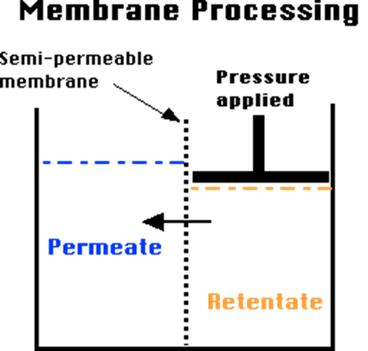
A membrane is a semi-permeable fence that demonstrate selective permeability among different species. In separation applications, selectively permitting one specie to pass through the membrane easily while obstructing the permeation of other constituents is the main objective. Hence, two different effluent streams are derived from the single influent stream: (1) lean phase of solute called permeate and (2) the rich phase of solute called the retentate. (Silva, 2007)
Figure 1: Membrane Processing
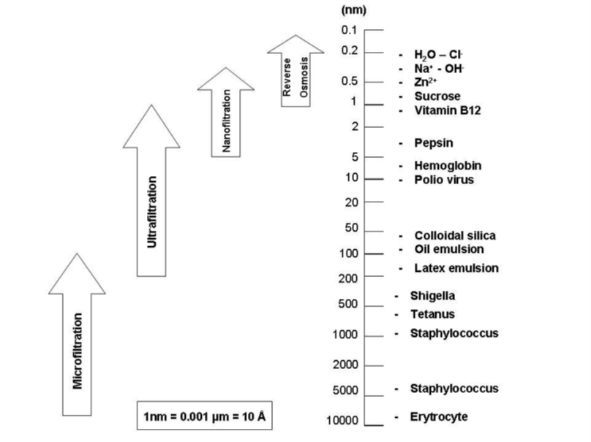
Membrane performance can be explained by two factors: retention/selectivity and flux: The rate of volumetric flow of the liquid passing through per unit area of the membrane in unit time is known as permeation rate or flux, where the retention is the amount of solute that is retained by the membrane. Selectivity refers to the comparative rate of permeation for different components through the membrane (Jalil, 2004). Numerous kind of separations membrane techniques have been developed for industrial applications over recent years. These techniques include: microfiltration (MF), ultrafiltration (UF), nanofiltration (NF), reverse Osmosis (RO), apply pressure to force the separation. These processes are effective for filtering molecules of various sizes where microfiltration removes the largest size molecules such as bacteria and other particulate matter on the other hand Reverse Osmosis separates smallest molecules such as those of salts (Xu et. al, 2002).
Figure-2: Reverse osmosis, Nanofiltration, Ultrafiltration, Microfiltration are related processes differing principally in the average pore diameter of the membrane filter.

Nanofiltration (NF) is among the most effective of membrane filtration systems, these membranes have excellent separation abilities to remove both inorganic and organic compounds, as well as natural organic matter (NOM), dissolved inorganic compounds, micro-pollutants, bivalent ions (multivalent ions) (Mohammad et al., 2015). Based on the interaction among the charged membranes and chromate anions, NF might possibly grow into an attractive and suitable mean to separate chromate from aqueous solution (Neelakandan et al., 2003; Hafiarle et al., 2000). NF Shows 0an efficient separation and concentration of chromium ions in case of treatment of tannery wastewater (Surtherland, 2000). Farhang (2012) reported separation of hexavalent chromium from water employing nanofiltration. The study explored the effect of operating parameters such as pressure, permeate flux, solution pH, and Cr(VI) feed concentration in removing chromium (VI) from water by means of a polyamide nanofiltration membrane.

1.2 What is nanofiltration?
NF is a pressure-driven membrane procedure with a pore sizes amid ultrafiltration (UF) and reverse osmosis (RO). Nanofiltartion includes a range of ultrafiltration and reverse osmosis with minimal molecular weight cut offs from 200 to 1000 Da for the elimination of neutral solutes by their active porous layer, with projected pore sizes of around 0.5–2 nm in diameter (Frank et. al, 2001). Moreover, most NF membranes are positively or negatively charged. Therefore, separation mechanisms of NF membranes is distinctive which associate steric effect which in other words is size exclusion and Donnan exclusion which is charge repulsion (Donnan, 1995; Yaroshchuk, 1998) with high rejection to multivalent anions compared to UF membranes. NF membranes compared to RO membranes, not only have higher water permeability as well as high rejection of multivalent ions, but also have a far lower operation pressure of 0.3–1.5MPa (Hong and Elimelch, 1997; Wang et al., 2002). NF has come to be an effective way for the removal of heavy metals from wastewater (Mohammad et al., 2004). Therefore, NF is an energy-saving process and is very appealing technique for removal of chromium ions.
Currently polymeric membrane is most abundantly used membrane for treatment of water because of its higher flexibility, straightforward pore forming mechanism, low costs, and compared to inorganic membranes these polymeric membrane requires smaller footprints for its installation (Ng et al., 2013). Nonetheless polymeric membranes compared to inorganic membranes are still limited by numerous challenges including trade-off connection between selectivity and permeability, as well as poor chemical stability under harsh environment (Robeson, 1991). The opportunity to combine the benefits of low cost as well as easy processing of polymeric materials with outstanding transport performance of inorganic fillers is provided by Mixed Matrix Membranes (MMMs), Kulprathipanja et al., (1988).

1.3 Mixed matrix membrane for heavy metal removal
Mixed-matrix membranes (MMMs) are synthesized by the incorporation of hybrid fillers or inorganic fillers, such as zeolites (Zimmerman, C.M. et al., 1997 and Gorgojo P. et al., 2008), carbon nanotubes (Cong et al., 2007 ; Kim et al., 2007), non-porous silica (Merkel et al., 2002 ; Ahn et al., 2008), carbon molecular sieves (Vu et al., 2003), ordered mesoporous silica (Reid et al., 2001; Kim et al., 2006 ) and metal-organic frameworks (MOFs) ( Zhang et al., 2008; Bae et al., 2010) into polymeric membrane materials by phase inversion.

1.3.1 What is phase inversion?
Phase inversion is a chemical phenomenon exploited in the fabrication of artificial membranes. It is performed by removing the solvent from a liquid-polymer solution, leaving a porous solid membrane. Once a solvent-polymer mixture is cast on the film, it is placed in a vapor atmosphere that contains a nonsolvent saturated with the same solvent. Due to the high concentration of solvent in the vapor atmosphere, the solvent from the cast film stays instead of evaporating into the atmosphere. Membrane forms by the diffusion of nonsolvent into the cast film. This process results in a porous membrane (Ye et al., 2010).
The hybrid membranes (organic and inorganic) have the benefit of merging the advantages of both phases: the higher transport properties of molecular sieves with the required mechanical properties of the inorganic filler, good process-ability and low price of the polymers. (Zimmerman, C.M. et al., 1997 and Chung et al., 2007).
The chemical and physical properties of inorganic filler and the polymer matrix govern the interface, the structure and performance of these innovative membrane materials, as well as the technique of nanoparticle incorporation. There are quite many studies on MMMs application in gas separation and a very few on its use in aqueous solutions (Zulhairuna et al., 2016). There is serious need of development of MMM for water purification more specifically for removal of heavy metals from water, which are cost effective and energy efficient, with high permeability and high rejection, membranes which possess good chemical and thermal stability.
In a polymer matrix, the selection of nanoparticles as an inorganic filler can have a promising potential for the removal of specific heavy metal ions from the aqueous media. Mukherjee et al., (2016) prepared a MMM using graphene oxide (GO), GO was impregnated into the polymer matrix. The process adopted for membrane preparation was phase inversion. Membrane was to remove the heavy metals such as Pb²⁺, Cu²⁺, Cd²⁺, Cr⁶⁺ at natural pH. The results indicated that the prepared membrane demonstrated ahigh adsorption capacity for Pb²⁺ (79 mg/g), Cr⁶⁺ (154 mg/g), Cd²⁺ (68 mg/g) and Cu²⁺ (75 mg/g), at natural pH, 6.7, 3.5, 6.4, and 6.5, respectively. Rejection of Pb, Cd, Cu, and Cr were in between 90% and 96% for several operating conditions.
Ion exchanger has been extensively used and is functional in removal of heavy metal from wastewater. Fong (2015) developed a MMM ion exchanger by integrating Amberlite IR120H into polyethersulfone (PES) dope polymer solution for copper removal. Membranes with different loadings were prepared (23wt%, 25wt%, 28wt% and 30wt%) with varying amount of polymer and keeping Amberlite IR120H constant (20g). maximum static binding capacity of the copper removal was accomplished in batch binding by membrane prepared from 30wt% PES with the binding efficacy of 64% from 500ppm standard solution of copper (II) sulphate pentahydrate. In cross flow filtration, the maximum binding efficiency (95 %) was shown by 30wt% PES membrane. Consequently, the greater the amount of PES in membrane, the greater the adsorptive performance, therefore 30wt% PES membrane was the optimum polyethersulfone composition.
Gohari et al., (2013) prepared a novel PES/hydrous manganese dioxide (HMO) UF/MMMs for adsorptive removal of lead Pb(II). They varied the ratio of HMO:PES ranging from 0-2. The results indicated that with increasing HMO:PES weight ratio, the membrane pore size tend to decrease whereas the water flux of the membrane was not affected negatively. The increased water flux could be due to (i) increased hydrophilicity caused by decreased contact angle (ii) increased surface roughness (iii) increased porosity. The highest Pb(II) uptake capability (i.e. 204.1 mg/g) was shown by the membrane synthesized from the highest HMO:PES ratio

1.3.2 Problems associated with MMMs:
There are several problems associated with MMMs that are highlighted in the recent literature. These include poor filler to polymer compatibility (Aroon et al., 2010), filler aggregation (Alpatova et al., 2015), pore blockage by the polymer (Zhu et al., 2015), and interfacial void formation (Ghanbari et al., 2015). The presence of interfacial voids creates additional channels that allow for the solvent to pass through the membrane (Alpatova et al., 2015, Zhu et al., 2015, Ghanbari et al., 2015). Since addition of fillers assert their effects on the morphology, which subsequently alters the transport phenomenon and finally determines the overall performance of the newly developed nanofiltration MMMs. Interfacial void formation, aggregation and pore blockage is some of the key effects witnessed in resulting MMMs (Alpatova et al., 2015, Balta et al., 2012). Non-selective void formation can be the result of the poor interaction among polymer and filler, which in turns results in higher fluxes but low selectivity (Chen et al., 2014; Dog et al., 2013).
Apart from this, MMMs have not yet crossed the lab scale barrier since the MMM technology is still in its developing phase and few lab scales developments have been reported so far (Tijink et al., 2013, Ying et al., 2013, Gunawan et al., 2011, Bonyadi et al., 2007).
Recent developments have shifted in the direction of the addition of new fillers, viz. metal organic frameworks (MOFs) as possible fillers in the polymer matrix. MOFs are amongst the most sophisticated nanostructured materials. MOFs designs have higher flexibility which allows them to precisely tune its properties towards high permeability and high selectivity for specific separations (Jeazet et al., 2012).
Zeolites are among the most versatile nanoporous fillers in terms of chemical composition, shape, and textural properties and particle size. However, from the perspective of compatibility between the filler and polymer phase, MOFs (metal-organic frameworks) have a clear edge on zeolites. In fact, in addition to having the same crystallinity and textural properties of zeolites (Yaghi O.M. et al., 2003 and Frey G. 2008), Metal-Organic Frameworks are highly adaptable materials and it is possible to mould their physical properties. By selecting the suitable organic ligand, it is possible to determine the shape, size, and chemical functionality of their cavities (Eddaoudi. et al., 2002, Kitagawa. et al., 2004, Chae et al., 2004; Qiu et al., 2009).
MOFs have a countless potential for application in gas storage, (Frey. 2008), gas and aqueous separation with membranes (Bae et al., 2010), drug delivery, (Horcajada et al., 2006), sensors, and heterogeneous catalysis (Takashima et al., 2011), enantioselective separations (Seo et al., 2000).
Lately, MOF have been employed in numerous applications comprising gas separation, adsorption/storage, , adsorption of organic molecules, catalysis, drug delivery, electrode materials, luminescence, magnetism, polymerization, carriers for nanomaterials, imaging, and so on (Shah, et al., 2012).

1.4 What are MOFs?
Based on hybrid properties there is a new category of porous materials these are calls metal-organic frameworks (MOFs), which are also called as “coordination polymers” or “hybrid organic frameworks”. The word MOFs was introduced by Yaghi and his co-workers for the first time in 1995.
MOFs are composed of metal ions/ clusters and coordinating linkers which is responsible for high porosity of the MOFs. They have high specific surface area which exhibits selective adsorption. These interesting features have break ground towards practical applications (Vinu et al., 2006). The porous coordination networks produced by the metal to organic ligand interactions have record setting surface areas overshadowing zeolites and activated carbons (Stephen and Adam J. 2009). The specific interest in MOFs is because the pore size and shape can easily be tuned, ranging from a microporous to a mesoporous scale, by altering the nature of the organic linkers and the connectivity of the inorganic moiety. The intrinsic functionality, provide these MOFs with attractive versatility for adsorption-related application (Shah et al., 2012).
The usage of MOFs as an adsorbent for various water contaminants have acknowledged an amplified interest in the past five years. The reasons behind this can be: (a) the increased awareness of ever increasing contaminants and its consequences (b) the understanding that MOFs have an exclusive and unique chemical and textural properties, making them suitable for gas and liquid separations (Liu et al., 2016).
Predominantly, Bueken (2014) review paper concentrated on the usage of MOFs for adsorption in liquid phase for organic and aqueous phase. Recently, Hasan and Jhung (2015) wrote a review emphasizing on the potential collaboration mechanisms among MOFs and hazardous organics present in water. The reported methods of selective adsorption were categorized into: hydrogen bonding, electrostatic, π-π interactions/stacking, pore/size-selective adsorption acid base, and hydrophobic interactions.

1.5 MOF based MMMs:
When comparing MOFs with other fillers, MOFs usually have lower density and a higher pore volume than zeolites, implying that the effect of MOFs on the membrane properties can be greater for a certain weight percentage of the filler (Wang and Cohen, 2009).
Yehia et al., (2004) made a pioneer effort to facilitate methane transport. In order to do so a MMM was prepared by incorporating MOF copper (II) biphenyl dicarboxylate-triethylenediamine as filler polymer matrix of the membrane. The study showed encouraging improvement in CH₄ selectivity, the unique sieving properties of MOFs makes them a potential candidate.
Jian-yuan in 2014 synthesized a novel Porous Matrix Membrane (PMM) using MOFs (i) F300, iron benzene-1,3,5-tricarboxylate (ii) A100, aluminium terephthalate and C300, copper benzene-1,3,5-tricarboxylate as Green Template for Water Treatment to boost interconnectivity and porosity of the water treatment membranes. They called the membrane green template because the conventional etching methods employs harsh chemicals as etching solutions, for instance use of hydrofluoric acid for removal of silica nanoparticles, or use of potassium iodide for removal of gold nanoparticles whereas they used water as the etching solution, which is easily available, low cost and environmental friendly.
Lately, a new class of MOF called zeolitic imidazolate framework (ZIF) with extraordinary chemical stability, sodalite cage like structure and tetrahedral network that resembles the structure of conventional zeolite has been acknowledged as an attractive molecular sieve (Li. et al., 2010).

1.6 What are ZIFs?
ZIFs are a class of MOFs which entails M–Im–M, where M metal ions: denotes Zn or Co cation and Im denotes the variety of imidazolate linker, formed by a self-assembly method. The varied structures of ZIFs are parallel to conventional aluminosilicate zeolites, where classically Zn²⁺ ions act as silicon and the imidazolate anions forms the bridge that impersonate the role of oxygen in zeolites, the angle of metal–imidazole– metal is ~145°. ZIFs have a tendency to form zeolite-like topologies with structures alike to those seen in zeolites (Figure: 3 & table: 1). The ZIF particles have a pore size ranging from 0.7 - 13.1 Angstrom, and the surface area od ZIFs is almost twice than that of inorganic zeolites (Banerjee et al., 2008).
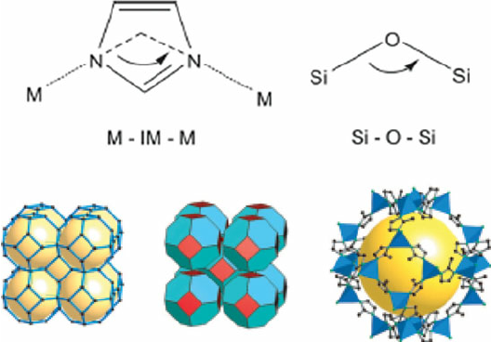
Their abundant functionalities, intrinsic porous characteristics, as well as extraordinary chemical and thermal stabilities have led to used them in MMM for a preferred separation (Li. et al., 2010).

Figure 3: Coordination isoreticular relation between M-IM-M and Si-O-Si

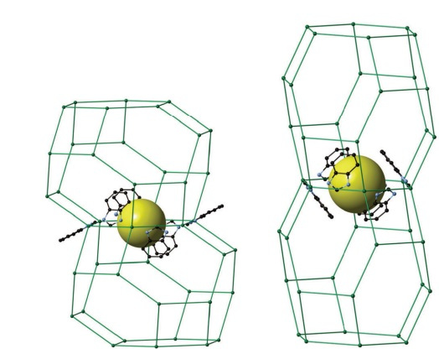
Figure 4: Snapshots of the two different pores of the ZIF-7 material: the smaller on the left and the larger on the right. The yellow spheres represent the pore volume. The two joined sodalite cages of the SOD framework are represented by a green wire (Ortiz et al., 2014).

Table 1: Comparison between the zeolites and zeolitic imidazolate frameworks (Chen et al., 2014).
Comparison content | Zeolites | Zeolitic imidazolate framework
Framework type | Inorganic | Inorganic-organic
Composition | Si;Al;O | Zn;Co; C; N; H and more
Secondary building units | [SiO₄]and [AlO₄] | M(Im)₂
Topology | Around 200 (SOD) | Fund over 100 (SOD); the number may increase exponentially
Stability | Depending on the Si/Al ratio, thermal & chemical stability are generally high | Thermal stability upto 500°C and high chemical stability in organic and aqueous media
Compatibility | Poor interaction with polymers | Better compatibility with organic polymers
Functionality | Tuneable Si/Al ratio; generally difficult in functionalisation | Rich chemical functionalities with organic linkers
Development | Over 50 years | Around 10 years
Application prospects | Low cost; large scale for industry applications | Expensive; potential for industrial application

N. Khan, 2015 for the first time reported adsorption and removal of diethyl phthalate and phthalic acid from water with MOFs and ZIFs, ZIF-8 was used for the elimination of phthalic acid (H₂-PA) and diethyl phthalate (DEP) from aqueous solutions through adsorption. ZIF-8 had adsorption capability much greater than that of a commercial activated carbon or other MOFs for H₂-PA. This could be because ZIF-8 with its positively charged surface might have electrostatic interaction with PA²⁻ or H-PA⁻ molecules (at higher pH). Furthermore, acid–base interactions among the basic sites (OH group of the methylimidazolate linker of ZIF-8 and N⁻ moieties or NH₂ of the amino functionalized MOFs) and the adsorption of H₂-PA was advocated by acidic H₂-PA molecules especially at low pH conditions. In contrast to organic contaminants, little attention has been given to the adsorption of heavy metals using MOFs or ZIFs.

1.7 ZIFs based MMMs:
ZIFs have acquired abundant consideration as fillers for the fabrication of ZIF/MMMs, due to its molecular sieving effect, facile synthesis, good compatibility with polymers because of the organic linker benzimidazolate anion present in the framework. A desirable MMM typically entails well-dispersed particles even at as high loading as probable. Greater MMM performance selectivity and permeability can be attained by pairing the properties of ZIF and the polymer. Normally, numerous focal issues, for instance the defect-free interface between ZIFs and the polymers, the tuneable fabrication of the sub-micrometer ZIF nanoparticles, and the manageable dispersal of ZIFs within the polymer, ought to be considered throughout the synthesis of ZIF/MMMs (Song et al., 2012).
X. Wu et al., (2014) studied kinetics and adsorption equilibria of CO₂ and CH₄ on ZIF-7 at several gas pressures and temperatures, to evaluate the practicability of removing CO2 from CH₄ in a vacuum swing adsorption process using ZIF-7 as adsorbent. Gate-opening mechanism of ZIF-7 was studied in detail on CO₂ adsorption isotherms with pressure up to 10 bar and temperature ranging from 273 to 373 K. Adsorption equilibrium selectivity and adsorbent selection parameter for pressure swing adsorption processes were calculated to forecast the adsorption performance of ZIF-7 sample for separating CO₂ and CH₄. These results implied that ZIF-7 has a huge potential to be used as an adsorbent.
Chen et al., (2014) utilized the gate-opening mechanism of ZIF-7 for discriminating two linear gas molecules, i.e., N₂O and CO₂. State-of-the-art periodic density functional theory (DFT) as well as dispersion correction was employed for calculations. The gate-opening mechanism of ZIF-7 is not only demonstrated by breakthrough measurements and the isotherm but also confirmed by the calculations. The experimental observations on the various gate-opening pressures between N₂O and CO₂ were described by the different adsorption energies at the neck sites in ZIF-7 through quantum chemical calculations. It was established that the gate-opening mechanism of ZIF-7 can possibly be used to separate N₂O/CO₂ gas mixtures with substantial efficiency.
Lately, several scientists have incorporated ZIF-8 and ZIF-7 particles into polymeric membranes to produce MMMs for gas separation. The as-prepared ZIF membranes not only enhance gas separation but also make huge strides toward industrial applications (Ordonez et al., 2010, Zhang et al., 2012).
Hsiang Kang et al., (2013) prepared ZIF-7/CS MMMs, by incorporating ZIF-7 crystals into chitosan (CS) membranes to form ZIF-7/CS mixed-matrix membranes (MMMs). These prepared ZIF-7/CS MMMs were used to isolate mixtures of water/ethanol in the pervaporation process at 25 °C. The crystal particles of ZIF-7 displayed good interfaces with the CS due to the nature of the organic linkers of ZIFs. When the original CS membranes were compared to the as synthesized ZIF-7/CS MMMs, the ZIF-7-doped CS membranes displayed smaller pore sizes because of the cross-linking amid the amino groups of the CS polymers and Zn atoms of ZIF-7. This cross-linking resulted in an increased separation between water and ethanol. Nonetheless, when the PSI values of the ZIF-7/CS membranes were compared to the pristine CS membranes, it was found that the PSI values of as prepared membranes were still higher than the original CS membranes, which specify that better pervaporation efficiency for the separation of water and ethanol was achieved after the incorporation of ZIF-7 particles into the CS membranes.
Ying et al., (2013) prepared MMMs with ZIF-7 and polydimethylsiloxane (PDMS) for the recovery of acetone from aqueous solution. The SEM results showed that prepared ZIF-7 were well dispersed in PDMS matrix without noticeable defects, and the hydrophobicity of the prepared MMMs enhanced both the separation factor and total flux of the MMMs. The recovery of acetone increased with increase in the loading of ZIF-7 in the PDMS matrix, this could be attributed to the high specific interactions between acetone and ZIF-7 nanocrystals. Moreover, pores of ZIF-7 provides preferential diffusion paths for acetone, the aggregation at high loadings may form voids that could also lead to the increase of flux.
Liu et al., 2011 successfully fabricated ZIF-8/polymethylphenylsiloxane (PMPS) mixed matrix membrane by integrating ZIF-8 nanoparticles into silicone rubber (PMPS) membrane. These modified membranes showed a promising result when used in dilute aqueous solutions for recovery of bop-alcohols.

Chapter 2: Materials and methods:

2.1 Materials:
A solid mixture of Zn(NO₃)₂·6H₂O, 98% extra pure and Benzimidazole 98% was purchased from Acros Organics. N,N-dimethylformamide (DMF) used was lab grade by Merck, and Methanol synthesis grade was purchased from Fisher chemicals. N-Methylpyrrolidinone (NMP) and Tetrahydrofuran (THF) were purchased from Merck Schuchardt OHG (Germany). Polysulfone pellets (M.W: 75000) purchased from Acros Organics. The non-woven polypropylene support was kindly supplied by Novatex 2471, Freudenberg, Switzerland.

2.2 Synthesis of ZIF-7 particles:
The synthesis of ZIF-7 crystals particles was carried out according to the procedure testified by Gücüyener et al., (2010). A 0.598 g of solid mixture of Zn(NO₃)₂·6H₂O and 0.479 g benzimidazole was dissolved in 75 mL of N,N-dimethylformamide (DMF) and stirred for 30 minutes at room temperature. The prepared solution was then transferred to a Teflon-lined stainless steel autoclave, and the synthesis was carried out in an oven at 130 °C for 48 h. The solid product was centrifugally separated and washed with methanol three times, and dried at 100 °C overnight. The as synthesized ZIF-7 crystals were then incorporated into PSF matrix to form PSF/ZIF-7 MMMs.

2.3 Preparation of PSF/ZIF-7 MMMs and unfilled membrane:
A typical membrane was synthesized via phase inversion technique. Three different PSF/ZIF-7 MMMs were prepared. The different ZIF-7 loadings in PSF polymer with 2.1g were 5, 15 and 30 wt% respectively.
10 g of (PSF/ZIF-7) casting solution was prepared by weighing the respective amounts of the ZIF-7 (5%, 15% and 30%) and mixing it in the solvent NMP/THF (ratio of 70/30%). The solution was stirred for 2 hours and sonicated for 15 minutes and stirred again for 15 minutes. 10% of the total PSF (i.e. 21%) was added to this ZIF solution and was stirred for 1 hour. Then 20% of the total PSF was added into the same solution and stirred for 1 hour, finally all of the left polymer was added into the solution and left for stirring overnight. The solution was sonicated in Wise Clean WUC-DO6H sonicator for 15 minutes and stirred for another 30 minutes.
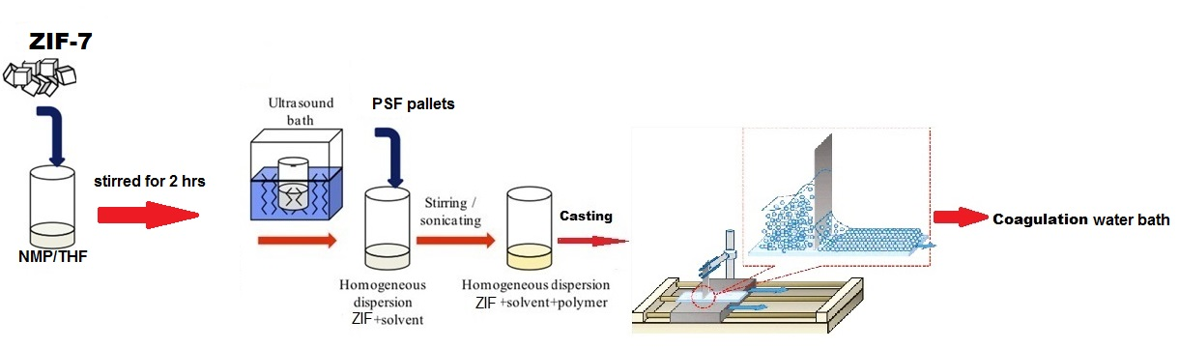
The resulting (PSF/ZIF-7) casting solution was casted on a support non-woven polypropylene impregnated with NMP at a casting speed of 2m/sec, with evaporation time of 30 sec and then was dropped in the water coagulation bath. Similar procedure was used for preparation of unfilled membrane PSF without ZIF-7 particles (Figure: 5).

Figure 5: Scheme for the fabrication of ZIF-7/PSF MMM

2.4 Characterization of ZIF-7 particles and ZIF-7/PSF MMMs:

2.4.1 X-ray powder diffraction (XRD):
The crystalline structure of ZIF-7 particles was determined by using Philips made PAN-analytical X’Pert powder, operating at 45 kV and 40 mA with CuKα radiation. At a wavelength λ= 0.1540 nm, sample analysed between the 2 Theta range of 5-30 with step size of 0.02° using time per steps of 20 seconds.

2.4.2 Scanning electron microscopy (SEM):
To examine the morphology of ZIF-7 particles and the PSF/ZIF-7 MMMs. SEM was performed by using a Tescan Orsay Holding VEGA-3 LMU Scanning Electron microscope Czech Republic. In scanning electron microscopy (SEM), the sample is incident by high energy electron beam striking the sample surface and generating various signals as the result of the impact. The signals mainly secondary electrons, back scattered electrons and X-rays are collected by a detector. The physical interaction of the incident electron beam with the sample surface forms the basis for generating valuable information; forming an image of the topography of sample surface and composition.

2.4.3 X-ray photoelectron spectroscopy (XPS):
X-ray photoelectron spectroscopy (XPS) is characterization technique used to check elemental composition of synthesized ZIF-7 particles. XPS analysis was performed on an ESCALab250 electron spectrometer from Thermo Scientific Corporation with monochromatic 150 W AI Kα radiation.

2.4.4 Fourier transform infrared spectroscopy (FTIR):
Fourier Transform Infrared Spectroscopy is used to identify the functional groups of the samples. FTIR measures the light absorbed or transmitted by the sample. ZIF-7 particles was analysed on Thermo-Nicolet 6700 P FTIR Spectrometer (USA), Purging: Helium Gas. The range of wavenumber for the test was from 500-4000 cm⁻¹.

2.4.5 The BET surface areas:
The Brunauer–Emmett–Teller (BET) goal is to elucidate the physical adsorption of gas molecules on a solid surface and aids as a foundation for a vital analysis technique for the determination of the specific surface area of the sample. BET was used to calculate the total surface area of ZIF-7 particles, it was analysed in Tristar II 3020 using nitrogen gas. The temperature range was from ambient to 4250°C.
$$S_{total}=\frac{v_{m}N_{s}}{V}$$ (Equation 1)
where v_{m} is in units of volume which are also the units of the molar volume of the adsorbate gas, N is Avogadro's number, the adsorption cross section of the adsorbing species, V the molar volume of the adsorbate gas, and a the mass of the solid sample or adsorbent.

2.4.6 Thermogravimetric analysis (TGA):
To verify the thermal stability of ZIF-7 particles, Thermogravimetric analysis (TGA) was carried out by using SDT Q600 TGA/DSC. Under a N₂ at the temperature range from 29 °C to 890 °C at ramp of 10°C/min.

2.5 Nanofiltration experiments:
The filtration experiments were performed on stainless steel dead end filtration cell (Sterlitech, USA) with stirrer in it. With inner diameter of 49 mm, maximum volume capacity of 300mL and effective area of the membrane 14.6 cm². Fluid that reserved in cell was pressed by nitrogen gas (Figure: 6).

2.6 Pure water permeability:
Each prepared ZIF-7/MMM was firstly subjected to water permeation experiments at various pressures, starting from 2bar till 41 bar. To measure the pure water flux (F) and hydraulic permeability coefficient of the membrane (Lp) (Equation 2a &2b)
Flux was calculated by following equation:
$F\left(L m^{-2} h^{-1}\right)=\frac{V}{t X A}$ (Equation 2a)
$L_{p}\left(Lm^{-2}h^{-1}{bar}^{-1}\right)=\frac{F}{∆P}$ (Equation 2b)
Where V was the volume of pure water (or solution) through the membrane (L), t was the operation time (h) and A was the effective area of the membrane (m²). ΔP was the transmembrane pressure (bar).
Subsequently, the membranes samples were conducted for chromium removal.

2.7 Measurement of Cr VI removal:
The stock solution was prepared by dissolving potassium dichromate (K₂Cr₂O₇) in the deionized water. This stock solution was diluted as required to obtain working solution of different concentrations: 5ppm, 10ppm, 25 ppm, 50 ppm and 500ppm. Different pH experiments were conducted in order to understand the effect of pH on the rejection of the chromium as it behaves differently at acidic and basic conditions. pH of the feed solutions was adjusted by adding NaOH and HCl.
After each filtration experiment a membrane was washed with deionized water till regeneration of initial permeability of membrane. For measured of Cr IV rejection following equation (Equation 3) was used:
$R\left(\%\right)=\left(1-\frac{C_{p}}{C_{f}}\right) X 100$ (Equation 3)
Where R is the rejection rate in percentage, C_{p} and C_{f} were the solute concentration in permeate and feed solution; respectively.
Concentration of Cr IV ions in permeate and feed solutions were measured by Atomic absorption spectroscopy (AAS)
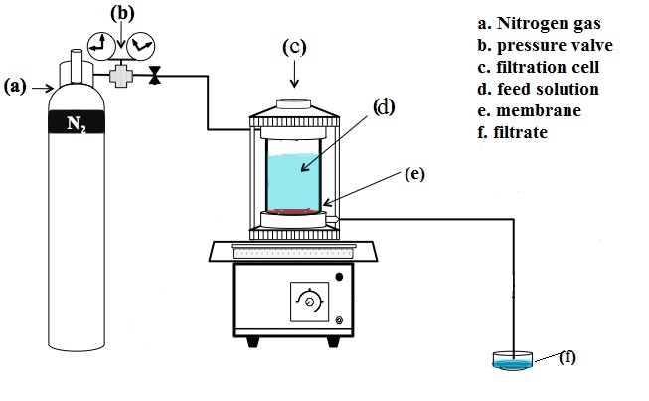
Figure 6: schematic diagram of Nanofiltration experiment

2.8 Atomic absorption spectroscopy (AAS):
Atomic absorption spectroscopy (AAS) is a spectroanalytical technique used for the quantitative assessment of chemical elements in the sample using the absorption of the optical radiation. In this study Agilent 140/240/280 Series AAS was used.

Chapter 3: Results and discussion:

3.1 XRD:
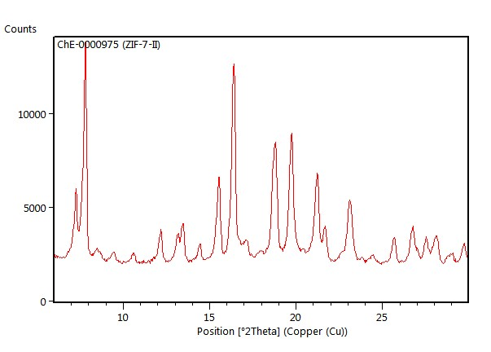
In order to confirm the crystalline structure and purity of the as-synthesized ZIF-7, XRD was performed before the other test were conducted. The results are reported in Figure. 7, where sharp peaks of the spectra indicate the crystallinity of the sample. In line with previously reported studies (Park et al., 2006, Huang et al., 2003) structural data results indicated that the synthesized crystal showed a very similar XRD patterns of ZIF-7 powders which exhibit typical peaks at 2q= 7.65°, 10.51°, 12.09°, 13.03°, 15.37°, 16.45°, 18.64°, 19.60°, and 21.10°(Gücüyener et al., 2010). This pattern is in agreement with the reported data which indicates that purity and crystallinity of prepared ZIF-7 is indeed there.
Figure 7: XRD pattern of the ZIF-7 particles

3.2 SEM:
The morphologies of the as-synthesized ZIF-7 nanocrystals were observed using the SEM. The SEM top view of ZIF-7 nanocrystals prepared in DMF is shown in Figure. 8-a and 8-b. The results show that ZIF-7 has a uniform particle size ranging from 50 to 70nm, and are smaller than those fabricated by Kang et al., (2013).
Figure. 8-a: SEM images of ZIF-7 particles at HV 30 kV (Magnitude 70204x)
Figure 8-b: SEM images of ZIF-7 particles at HV 30 kV (Magnitude of 149836x)

3.3 ATR-FTIR:
The main functional group of as-synthesized ZIF-7 could be detected with corresponding infrared adsorption peak. The results are presented in Figure. 9, which shows that the strong adsorption peak at 1600~1500 cm⁻¹ corresponds to the functional groups C=C stretch band of aromatic ring in ZIF-7 derived porous carbon. The peak at 1580 cm⁻¹ is related to C=O of carboxyl group in three carbons with glucose. The peaks at 1455 and 750 cm⁻¹ are identified as C=C and C-H bonds, respectively in the benzene functional group of benzimidazole in ZIF-7 particles. The C-H stretch vibration of benzimidazole occurs near 3100~3000 cm⁻¹. The band in spectral region of 2500-3100 cm⁻¹ could be ascribed to C-H, N-H and O-H stretching vibrations of methyl, hydroxyl and amine group of ZI7-nanoparticles. The results of FTIR indicates the abundance of –OH and C=O groups which can remarkably improve the hydrophilicity and wettability at the surface of the samples (Zhang et al., 2013 and Kang et al., 2013).
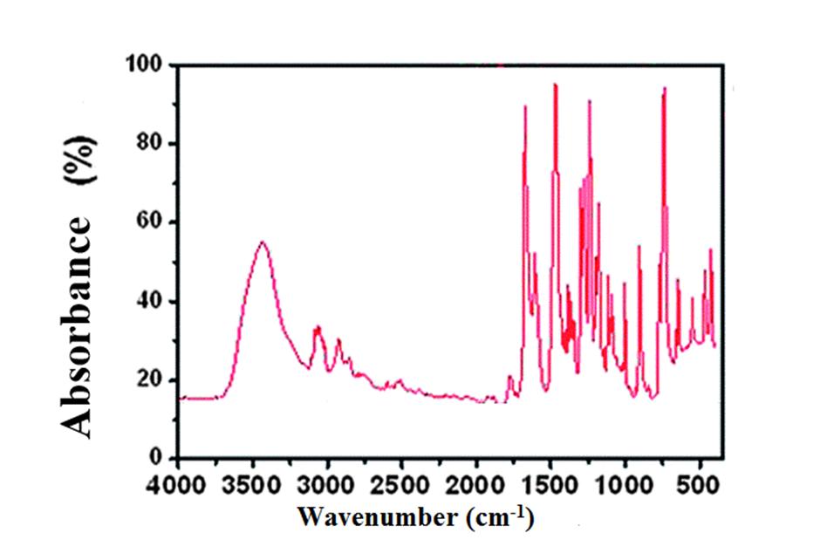
Figure 9: FTIR spectrum of prepared ZIF-7 particles

3.4 XPS:
ZIF-7 has zinc ions that act as coordination center and are attached with benzimidazole. Thus, it is evident that ZIF-7 contains four kind of elements namely zinc, oxygen, nitrogen and carbon. The XPS spectra distinctly indicated the presence of Zn, N1, C1, O1 peaks without any other signals as presented in Figure. 10. The as-synthetized ZIF-7 showed four distinct peaks at 1053, 400.9, 502 and 284.8 eV, which are related to the presence of Zn, O, N and C respectively.
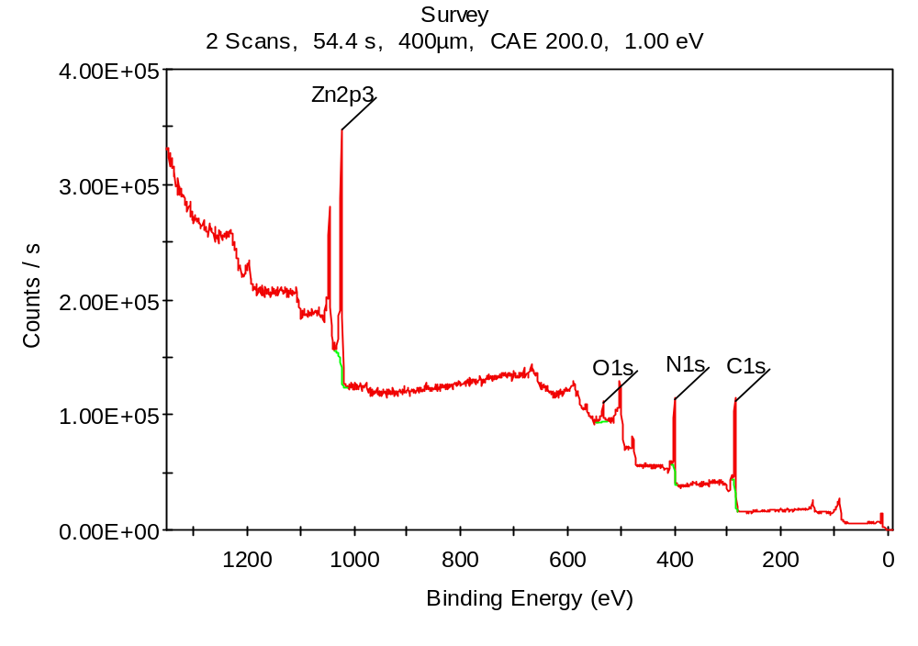
Figure 10: XPS spectrum for ZIF-7

3.5 BET:
Figure. 11 reports the BET surface areas for ZIF-7. The surface area of the ZIF-7 particles prepared in the study was 340m²/g. The results suggest that the prepared ZIF-7 BET surface area is within the range found in other studies. BET surface areas for ZIF-7 particles reported by Hughes et al., 2013 and Jiang et al., 2015, were between the ranges of 300-350m²/g.

3.6 TGA:
The TGA curve of prepared ZIF-7 particles is shown in Figure. 11 that is in agreement with the one reported by Zhang et al., 2013. The TGA indicates that the three-dimensional ZIF-7 framework possesses high thermal stability up to 600 °C. The TGA plot of prepared ZIF-7 particles relieved a 5% of weight loss starting at 150 °C and plateauing till 600 °C, which was attributed to the presence of solvent in ZIF-7. Between 600-700 °C, the decomposition of ZIF-7 occurred. A 65% of the material remained at 700 °C.
Figure 11: TGA curve of ZIF-7

3.7 Water flux and permeability:
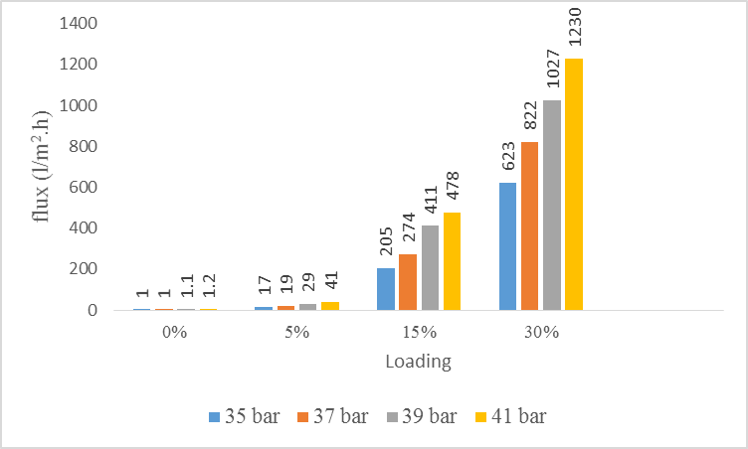
Water flux and permeability was tested in a dead end cell with an effective area of 14.6cm². Each ZIF-7/PSF MMM was subjected to water permeation experiments at various pressures, starting from 2 bar till 41 bar. The results indicated that the prepared ZIF-7/PSF MMM with 0wt% ZIF-7 showed flux starting from 35 bar pressure. However, other prepared ZIF-7/PSF MMM with ZIF-7 loadings of (5, 15, 30wt%) showed flux even at 2 bar pressure. Since ZIF-7/PSF MMM with 0wt% ZIF-7 showed flux starting from 35 bar pressure, for the comparability purposes, the experiments were carried out at 35 bar pressure and above. Figure. 12 reports the effect of ZIF-7 loading on water flux of ZIF-7/PSF MMMs. The histogram represents obtained water flux with respect to applied pressure of (35, 37, 39 and 41 bar).
Figure 12: Water flux for four ZIF-7 MMMs
It is clear that the plain PSF membrane shows very less water flux indicating lesser capacity to cause permeation of water. This could largely be due to the hydrophobic nature of PSF as shown by Heidi et al., 2012. The water flux is observed to increase with the addition of ZIF-7 particles fillers and the dosage of fillers. It was seen that as the loading of ZIF-7 increased the flux showed an increasing trend. For low pressure of 35 bar, water flux increases with increase in loading of ZIF-7 fillers from 17.1 to 205.5 L m⁻² h⁻¹ and further to 622.7L m⁻² h⁻¹ for ZIF-7/PSF MMMs with ZIF-7 loading of (0, 5, 15, 30 wt%), respectively. This could be because of the porous crystalline structure of ZIF-7 used as a pore forming agent to enhance the permeation properties of membranes (Park et al., 2006) and/or could be because of increasing the ZIF-7 in casting solution could enlarge free volume in matrix, thus, leading to increase pure water sorption into MMMs (Wang et al., 2016) and more water can pass through membranes.
By using equation 2b for the membrane permeability (Lp), the permeability was found to be 0.489, 5.87, 17.79 Lm⁻²h⁻¹bar⁻¹, for ZIF-7/PSF MMM with ZIF-7 loading of (5, 15, 30wt%), respectively. This indicates that the permeability of the NF membranes was higher than that of the typical PSF flat membranes i.e. 5.14 Lm⁻²h⁻¹bar⁻¹ (Habibi et al., 2015) for the ZIF-7 loading of (15 and 30wt%).

3.8 Effect of pH on rejection:
Many studies have shown that the steric and/or surface interaction mechanisms are the contributory factors for the separation of Cr(VI) from aqueous solution for NF membranes (Rajesh et al., 2008, Vahid Vatanpour). Tor et al., (2004) illustrated the Donnan exclusion mechanism for the removal of Cr ions, in this mechanism the transport of metal ions is reliant on concentration of protons in receiver phase. Solution pH of the feed solution influences both the distribution of Cr(VI) species, and binding sites on the membrane (Sankir et al., 2010), therefore it may have an important impact on Cr(VI) removal.

It is known that the chemical nature if chromium is highly dependent on pH and its total concentration. Principal Cr(VI) species is divalent anions of chromates (CrO₄²⁻) at higher pH values past 7. From the range of pH 1–7, the Cr(VI) species mainly exist in the monovalent acid chromate (HCrO₄⁻) form at lower concentration, and dichromate Cr₂O₇²⁻ ion as the dimmer of HCrO₄⁻ appears when the concentrations exceed 1000 ppm (Deng and Bai, 2004). The transport of these ions via the membrane is reliant on the size and nature of the ions (Silva et al., 2008).

Each ZIF-7/PSF MMM with different ZIF-7 loading (5, 15, 30 wt%), was tested for 3 different pH (3, 5 and 11) at 5ppm feed solution. This experiment was performed in order to select the optimum pH to work with.
The results of Cr(VI) rejection and membrane flux for different ZIF-7/PSF MMMs with (5, 15, 30 wt% ) loadings are presented in Figure 13-a and 13-b. After each experiment the membranes were washed with deionized water till the virgin membrane permeability was achieved.
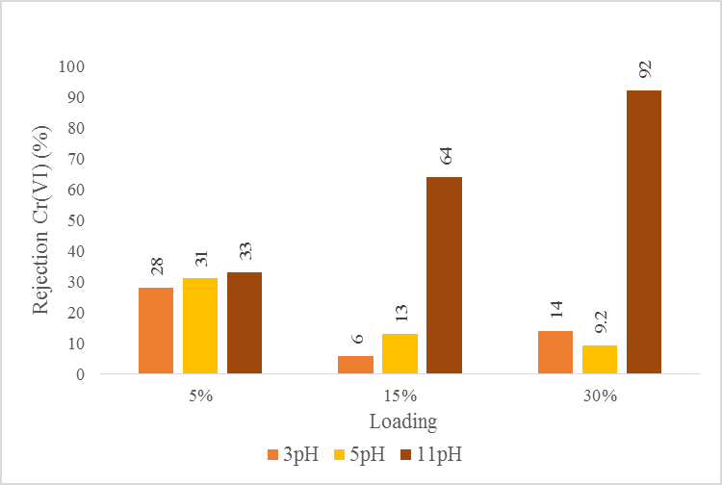
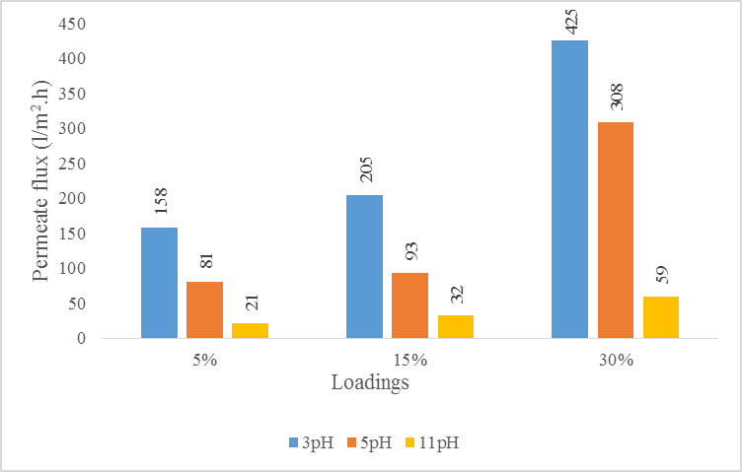

Figure 13: Effect of pH on (a) rejection of Cr(VI) and (b) Permeate flux.
For the ZIF-7/PSF MMM with 5 wt%, rejection of Cr(VI) ion does not seem very responsive to increased pH from acid to base. There is a very slight increase in rejection of two percent points when increasing pH from 5 to 11. Whereas, for ZIF-7/PSF MMMs with 15 and 30 wt%, the rejection is highly responsive to increased pH from acid to base when the loading is increased from 15 to 30 wt% with evidently bigger increase with the loading 30 wt%. The results indicated that at the alkaline pH 11, the ZIF-7/PSF MMMs with 15, 30 wt% loading showed promising rejection rates of 64% and 92%, respectively of Cr(VI).

Based on the existing observations, this increase could be attributed to these reasons: First, with increasing solution pH, the positive charge density on ZIF-7 nanoparticle such as positive sites (Zn-OH), and the protonated N atoms such as (C=NH⁺-, C-NH₂⁺-) groups, might decrease and ultimately turn to negative, resulting in electrostatic repulsion between Cr(VI) ions and ZIF-7. For example Jian et al., 2015 shows the same for the adsorptive removal of arsenic from aqueous solution by ZIF-8. Others show that inducing hydroxylic and carboxylic functional groups can produce negative charge on the membrane surface (Yin and Deng, 2015). Since ZIF-7 possess hydroxylic and carboxylic functional group, the negative charge of Cr ions and negative charge on the membrane surface result in increased Donnan repulsion, that in turn results in an increased rejection. Which is consistent with the prediction based on the Donnan exclusion mechanism for negative charged NF membranes that have been found in previous investigations (Hafiane et al., 2000; Muthukrishnan and Guha, 2008).

Second, by changing the pH values the predominant species of Cr(VI) will also change. So at acidic pH monovalent ions (HCrO₄⁻) are dominant, whereas at basic pH divalent ions (CrO₄²⁻/Cr₂O₇²⁻) are predominant (Deng and Bai 2004; Silva et al., 2008). Therefore, the repulsive effect of Donnan is imperative for divalent ions than monovalent ions (Rezaee et al., 2015), consequently the rejection increases in higher pH values. Which is consistent with the prediction based on the Donnan exclusion mechanism.

Third, the divalent ions of Cr (CrO₄²⁻/Cr₂O₇²⁻) are predominant species at pH 11 with molecular size of 0.375/1.34nm, respectively (Nightingale and phenomenological, 1959), that are larger than the pores aperture of ZIF-7 (0.2317nm) (Wu and al., 2014), the size exclusion mechanism could also be involved in the rejection of chromate ions

The permeate flux of all the ZIF-7/PSF MMMs declined as the pH of feed solution changed from acidic to basic conditions (Figure. 14-b), which could be described by the fact that the osmotic pressure near the membrane surface increased due to the higher retention of Cr₂O₄²⁻/Cr₂O₇²⁻ presented in the alkaline array, that resulted in a reduction in the permeate flux with the increase of pH (Gherasim et al., 2013)

Thus, our results, overall, conclude that the ZIF-7/PSF MMMs with loading of 15 and 30 wt%, can be efficiently employed in the removal of Cr(VI) when pH is adjusted to 11.

3.9 Effect of concentration on rejection:
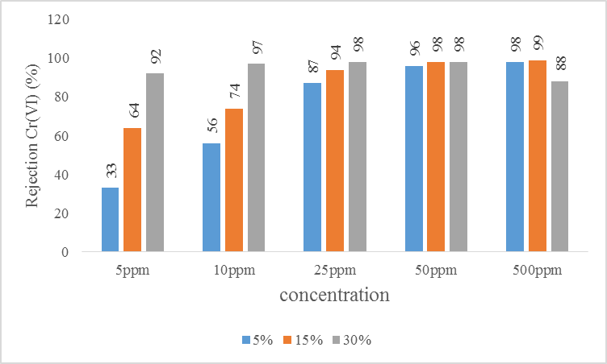
Based on our findings in the previous section, the performance of the membrane regarding ionic strength of Cr(VI) is studied and reported only at pH 11. The synthesized ZIF-7/PSF MMMs (5, 15 and 30 wt%) were then further evaluated for removal of chromium with different feed concentrations (5, 10, 25, 50, and 500ppm). The result are reported in Figure. 14.
Figure 14: Effect of Feed concentration on rejection of Cr (VI)
The results show that all three ZIF-7/PSF MMMs have a high potential of removing the chromium from the feed solution. The prepared membranes showed the increasing rejection trend with increased feed concentration for all except the ZIF-7/PSF MMM with 30% loading. Which showed equal rejection at 25 and 50ppm, and a decline at 500ppm feed concentration. This could be attributed to concentration polarization and the decrease of effective charge density on the membrane (Ren et al., 2010).

The increase in rejection with increased feed concentration for each ZIF-7/PSF MMM with 5 and 15wt%, is quite expected due to the changes in the relative amount of negative ions in the feed solution. This explains the result of higher rejection at high concentration (Szoke et al., 2002; Hafiane et al., 2000). Similarly, for each concentration of Cr (5, 10, 25, 50, and 500ppm), the increase in loading from 5 to 15 wt% increases the rejection. This can be due to the reasons that we discussed in the previous section. These two results along with the rejection levels with 30wt% loading suggest that the ion strength is another crucial factor to be considered for the removal Cr(VI).
One of the interesting findings is that with pH 11, for lower feed concentration (5 and 10ppm), the ZIF-7/PSF MMM with the highest ZIF-7 loading (30 wt%) is more efficient, and for the higher feed concentration (500ppm), lower ZIF-7 loading (5 and 15 wt%) are more efficient. For the intermediate feed concentration (50ppm), ZIF-7 loading (15 and 30 wt%) are equally efficient in Cr(VI) removal.
To the best of our knowledge, there are not many studies using the MMMs nanofiltration for the removal of Cr(VI) from water. Barikbin et al., (2012) investigated the removal of Cr(VI) from water using commercially available nanofiltration membrane. The best rejection of Cr (VI) (96%) was obtained at basic pH. Religa et al., (2011), worked on inﬂuence of tannery wastewater composition on chromium (III) concentration in the wastewaters during the nanoﬁltration process (NF). Their results suggest that the NF process could be successfully used for the concentration of chromium in the tannery wastewater with a retention rate of 80% for chromium.

Overall, our fabricated ZIF-7/PSF MMMs show very high levels of rejection for a number of combinations of ZIF-7 loading and chromium feed concentration. With pH 11, the highest rejection (99%) of Cr(VI) is achieved with 15wt% ZIF-7 loading and 500ppm feed concentration. The rejection of 98% of Cr(VI) is achieved with (15wt% ZIF-7 with 50ppm feed concentration), (5wt% ZIF-7 with 500ppm feed concentration), and (30wt% ZIF-7 with 25 and 50ppm feed concentration).

Conclusion and Future perspective:
In this work, a novel nanofiltration mixed matrix membrane (MMM) was prepared by incorporating ZIF-7 nanoparticles in the PSF polymer matrix. The ZIF-7 nanoparticles were successfully synthesized in a simple method. The synthesised ZIF-7 nanoparticles showed the standard characteristics. The XRD revealed the purity and crystallinity, the SEM revealed a relatively uniform morphology with particles sizes between 50 to 70nm, the FTIR was used to reveal the main functional group, the XPS was used to determine the elemental composition (Zn, N, O, C), the BET revealed high surface area of nanoparticles of 340m²/g, and the TGA revealed high thermal stability up to 600 °C. These finding were very standard and within those ranges found by other studies.

The ZIF-7 filled PSF MMMs, then, were fabricated with by phase inversion. The prepared ZIF-7/PSF MMMs were employed to remove Cr(VI) from aqueous solution. The results of filtration experiment showed that the flux of water increased with increased ZIF-7 loading. After, the effect of pH on rejection of Cr(VI) was studied. The results from this experiment showed that the higher rejection with different ZIF-7 loading (5, 15, 30wt%) was achieved at pH 11.

In the final experiment, the synthesized ZIF-7/PSF MMMs (5, 15 and 30wt%) were then further evaluated for removal of chromium with different feed concentrations (5, 10, 25, 50, and 500ppm) at pH 11. The results showed that all three ZIF-7/PSF MMMs have a high potential of removing the chromium from the feed solution. Overall, the synthesized ZIF-7/PSF MMMs show very high levels of rejection for a number of combinations of ZIF-7 loading and chromium feed concentration. The highest rejection (99%) of Cr(VI) is achieved with 15wt% of ZIF-7 loading and 500ppm feed concentration. The rejection of 98% of Cr(VI) is achieved with (15wt% ZIF-7 with 50ppm feed concentration), (5wt% ZIF-7 with 500ppm feed concentration), and (30wt% ZIF-7 with 25 and 50ppm feed concentration). Thus, the contribution in this work shows that ZIF-7/PSF MMMs hold great potential for the removal of chromium ions from water.
The field has attracted increasing interest since 2009 and is expected to continue flourishing in the future. A good knowledge of ZIF’s structure-transport property relationships is fundamental to screen potential candidates from the existing ZIF pool and to understand how to tune ZIF’s transport properties through rational synthesis and post synthetic modifications.
The electrical characterization of membranes is a very useful tool to help in the adequate interpretation and prediction of their filtration properties, therefore, zeta potential analyses of the membrane would be recommended.
Microscopic characterization such as TEM images of the prepared ZIF-7 and SEM surface analysis and SEM cross sectional analysis of the prepared ZIF-7/PSF MMMs would greatly help to validate the study.
Stability of ZIF-enabled membranes under realistic feed conditions needs to be verified. Commercialization of ZIF-enabled membranes requires the capability to economically fabricate high quality, defect-free ZIF membranes in scalable membrane geometry.

References:

A. Alpatova, M. Meshref, K.N. McPhedran, M. Gamal El-Din, Composite polyvinylidene fluoride (PVDF) membrane impregnated with Fe2O3 nanoparticles and multiwalled carbon nanotubes for catalytic degradation of organic contaminants. J. Membrane Sci., 490: 227-235 (2015).
A. Aroon, A. F. Ismail, T. Matsuura and M. M. Montazer- Rahmati, Sep. Purif. Technol., 75, 229–242 (2010).
A. Banerjee, A. Phan, B. Wang, C. Knobler, H. Furukawa, M. O’Keeffe, O. M. Yaghi, High-throughput synthesis of zeolitic imidazolate frameworks and application to CO2 capture. Science, 319 939–943 (2008).
A. Ghani Effect of chromium toxicity on growth, chlorophyll and some mineral nutrients of Brassica juncea, L. Egyptian Acad J Biol Sci. 2(1), 9–15 (2011).
A. Hafiane, D. Lemordant and M. Dhahbi., Removal of hexavalent chromium by nanofiltration, Desalination, 103, 305–312 (2000).
A. Moggach, T. D. Bennett and A. K. Cheetham, The Effect of Pressure on ZIF-8: Increasing Pore Size with Pressure and the Formation of a High-Pressure Phase at 1.47 GPa, Angew. Chem., 121: 7221–7223 (2009).
A. Phan, C.J. Doonan, F.J. Uribe-Romo, C.B. Knobler, M. O’Keeffe, O.M. Yaghi, Synthesis, structure, and carbon dioxide capture properties of zeolitic imidazolate frameworks, Acc, Chem. Res. 43 , 58–67 (2009).
A. U. Ortiz, Alexy P.Freitas, A.Boutin, A. H. Fuchs and F-Xavier Coudert , What makes zeolitic imidazolate frameworks hydrophobic or hydrophilic? The impact of geometry and functionalization on water adsorption, Phys. Chem. Chem. Phys., 16, 9940 (2014).
A. Vinu, M. Miyahara, T. Mori, K. Ariga, Carbon nanocage: a large-pore cage-type mesoporous carbon material as an adsorbent for biomolecules, J. Porous Mater. 13, 379–383 (2006).
A. Wolińska, Z. Stępniewska, R. Włosek. The influence of old leather tannery district on chromium contamination of soils, water and plants. Nat Sci.;5(2A):253–258 (2013).
A. Zayed Md. Badruddoza, Z. Zakir Shawon, Md. T. Rahman, K. Wei Hao, K. Hidajat, M. Shahab Uddin, Ionically modified magnetic nanomaterials for arsenic and chromium removal from water, Chem. Eng. J., 225, 607-615 (2013).
A. Zhang, R. Ma, Y. Xie, B. Xu, S. Xia & N. Gao: Preparation polyamide nanofiltration membrane by interfacial polymerization, State Key laboratory of Pollution Control and Resources Reuse, Tongji University Shanghai, 200092, (2012).
A.G. Fane, C.Y. Tang, R. Wang, Membrane Technology for Water: Microfiltration, Ultrafiltration, Nanofiltration, and Reverse Osmosis, in: P. Wilderer (Ed.) Treatise on Water Science, Academic Press, Oxford, 301-335 (2011).
A.J. Reuvers, J.W.A. van den Berg, C.A. Smolders, Formation of membranes by means of immersion precipitation. Part I. A model to describe mass transfer during immersion precipitation, J. Membr. Sci. 34 , 45–65 (1987).
A.M. Zayed, N. Terry, Chromium in the environment: factors affecting biological remediation. Plant Soil. 249(1):139–156 (2003).
A.P. Korikov, P.B. Kosaraju, K.K. Sirkar, Interfacially polymerized hydrophilic microporous thin film composite membranes on porous polypropylene hollow fibers and flat films, J. Membr. Sci. 279, 588–600 (2006).
A.W. Mohammad, Y.H. Teow, W.L. Ang, Y.T. Chung, D.L. Oatley-Radcliffe, N. Hilal, Nanofiltration membranes review: Recent advances and future prospects, Desalination, 356, 226–25 (2015).
Ali Tor, Yunus Cengeloglu, Mustafa Ersoz, Gulsin Arslan, Transport of chromium through cation-exchange membranes by Donnan dialysis in the presence of some metals of different valences, Desalination, 170: 151–159 (2004).
B. Barikbin, B. Mortazavi and G. Moussavi, Removal of Hexavalent Chromium and Total Dissolved Solids from Water Using Nanofiltration, Engineering International Proceedings of Chemical, Biological & Environmental. 43, 140 (2012)
B. Baskan, A. Pala, A statistical experiment design approach for arsenic removal by coagulation process using aluminum sulfate, Desalination, 254, 42–48 (2010).
B. Qiu, C. Xu, D. Sun, H. Qu, M. Guerrero, H. Yi, J. Guo, X. Zhang, Z. Luo, N. Noel, X. Wang, Z. Guo, S. Wei, Polyaniline Coated Ethyl Cellulose with Improved Hexavalent Chromium Removal, ACS Sustainable Chem. Eng., 2 (8): 2070–2080 (2014).
B. Seoane, J. M. Zamaro, C. Tellez and J. Coronas, RSC Adv., 1, 917–922 (2011).
B. Silva, H. Figueiredo, C. Quintelas, I. C. Neves and T. Tavares, “Zeolites as supports for the biorecovery of hexavalent and trivalent chromium”, Microporous and Mesoporous Mater., 116: 555–560 (2008).
B. Van de Voorde, B. Bueken, J. Denayer, D. De Vos. Adsorptive separation on metalorganic frameworks in the liquid phase. Chem Soc Rev. 43(16), 5766-88 (2014).
B. Van der Bruggen, C. Vandecasteele, T. Van Gestel, W. Doyenb and R. Leysen, A Review of Pressure-Driven Membrane Processes in Wastewater Treatment and Drinking Water Production Environmental Progress (V01.22, No.1) 2003
B. Wang, A. P. Côté, H. Furukawa, M. O’Keeffe and O. M. Yaghi, Colossal cages in zeolitic imidazolate frameworks as selective carbon dioxide reservoirs, Nature, 453, 207 (2008).
B. Zornoza, B. Seoane, J. M. Zamaro, C. T´ellez and J. Coronas, Combination of MOFs and zeolites for mixed-matrix membranes, Chem Phys Chem, 12: 2781–2785 (2011).
B. Zornoza, C. Tellez, J. Coronas, J. Gascon, F. Kapteijn, Metal organic framework based mixed matrix membranes: an increasingly important field of research with a large application potential. Microporous Mesoporous Mater. 166, 67–78 (2013).
B.B. Tang, C. Zou, P. Wu, Study on a novel polyester composite nanofiltration membrane by interfacial polymerization. II. The role of lithium bromide in the performance and formation of composite membrane, J. Membr. Sci, 365, 276-285 (2010).
B.M. Ganesh, A.M Isloor, A.F. Ismail, Enhanced hydrophilicity and salt rejection study of graphene oxidepolysulfone mixed matrix membrane, Desalination, 313:199–207 (2013).
C. Barnowski, N. Jakubowski, D. Stuewer & J. A. C Broekaert, Speciation of chromium by direct coupling of ion exchange chromatography with ICP-MS. At. Spectrom, 1155 (12), 1155–1161 (1997).
C. Cervantes, J. Campos-García, S. Devars, F. Gutiérrez-Corona, H. Loza-Tavera, J.C Torres-Guzmán, R. Moreno-Sánchez, FEMS, Interactions of chromium with microorganisms and plant, Microbiol Rev. 25(3):335-47 (2001).
C. Gü cü yener, J. van der Bergh, J. Gascon, F. Kapteijn, Ethane/Ethene Separation Turned on Its Head: Selective Ethane Adsorption on the Metal-Organic Framework ZIF-7 through a Gate Opening Mechanism. J. Am. Chem. Soc., 132, 17704−17706 (2010).
C. Janiak, J.K. Vieth, MOFs, MILs and more: Concepts, properties and applications for porous coordination networks (PCNs) New J. Chem., 34, 2366–2388 (2010).
C. Kang, Y. Lin, Y. Huang, K. Tung, K. Chang, J. Chen, W. Hung, K. Lee and J. Lai, Recovery of acetone from aqueous solution by ZIF-7/PDMS mixed matrix membranes. J. Membr. Sci., 438, 105 (2013).
C. Merkel, B. D. Freeman, R. J. Spontak, Z. He, I. Pinnau, P. Meakin, A. J.Hill, Ultrapermeable, reverse-selective nanocomposite membranes, Science, 296, 519 – 522 (2002).
C. Schlatter, U. Kissling, B. Gerichtl, Acute fatal bichromate poisoning, Med., 30, 382-388 (1973).
C. vincent funk, B.S, Microporous Mixed Matrix (ZeoTIPS) Membranes , (2008).
C. Zhang, Y. Dai, J.R. Johnson, O. Karvan, W.J. Koros, High performance ZIF-8/6FDA-DAM mixed matrix membrane for propylene/propane separations, J. Membr. Sci. 389, 34–42 (2012).
C-H. Kang, Y-F. Lin, Y-S. Huang, K-L. Tung, K-S. Chang, J-T. Chen, W-S. Hung, K. Rarn Lee Juin-Yih Lai, Synthesis of ZIF-7/chitosan mixed-matrix membranes with improved separation performance of water/ethanol mixtures, J. Membr. Sci. 438, 105–111 (2013).
D. Bastani, N. Esmaeili, M. Asadollahi, Polymeric mixed matrix membranes containing zeolites as a filler for gas separation applications: a review. J. Ind. Eng. Chem. 19 (2), 375-393 (2013).
D. M. L´opez-Gonz´alez, L. F. del Castillo and E. Riande, Effect of Zeolitic Imidazolate Frameworks on the Gas Transport Performance of ZIF8-poly(1,4-phenylene ether-ether-sulfone) Hybrid Membranes. J. Membr. Sci., 383, 206–213 (2011).
D. Peralta, G. Chaplais, A. Simon-Masseron, K. Barthelet and G. D. Pirngruber, Microporous Mesoporous Mater., 153 , 1–7 (2012).
D. Reid, A. Ruiz-Trevino, I. H. Musselman, K. J. Balkus, J. P. Ferraris, Chem. Mater. 13, 2366 – 2373 (2001).
D. Zhang, S. Wei, C. Kaila, X. Su, J. Wu, A.B. Karki, D.P. Young, Z. Guo, Carbon-stabilized Iron Nanoparticles for Environmental Remediation, Nanoscale, 2, 917-919 (2010).
D.R. Kemp, D.R. Paul, Gas sorption in polymer membranes containing adsorptive fillers. J. Polym. Sci. Polym. Phys. Ed. 12 (3), 485-500 (1974).
D-L Chen, N. Wang, F-F. Wang, J. Xie, Y. Zhong, W. Zhu, J. Karl Johnson and Rajamani Krishna, Utilizing the Gate-Opening Mechanism in ZIF‑7 for Adsorption Discrimination between N₂O and CO₂, J. Phys. Chem. C, 118, 17831−17837 (2014).
E. Nordmeier, Advances in polyelectrolyte research: counterion binding phenomena, dynamic processes, and the helix-coil transition of DNA, Macromol. Chem. Phys., 196 (5) 1321–1374 (1995).
E. Tsuchida, H. Nishide, Polymer–metal complexes and their catalytic activity, Advan. Polym. Sci., 24: 1–87 (1977).
E.Haldoupis, S.Nair, D.S.Sholl, Efficient calculation of diffusion limitations in metal organic framework materials: a tool for identifying materials for kinetic separations, J.Am.Chem.Soc.132, 7528-7539 (2010).
E.M. Vroenhoek, J.J. Waypa, Arsenic removal from drinking water by a "loose" nanofiltration membrane. Desalination, 130, 265-277 (2000).
E.O. Kartinen Jr., C.J. Martin, An overview of arsenic removal processes, Desalination 103 79–88 (1995).
F. Fong, Kiew (2015) Copper removal using ion exchanger flat sheet mixed matrix membrane: effect of polyethersulfone composition on membrane properties. Faculty of Chemical & Natural Resources Engineering, University Malaysia Pahang
F. Jimenez, S. A. Moggach, M. T. Wharmby, P. A. Wright, S. Parsons and T. D¨uren, J. Am. Chem. Soc., 133, 8900–8902 (2011).
F. Katz, & H. Slem, The biological and environmental chemistry of chromium (pp. 51–58) New York: VCH (1994).
F. Zhang, I. H. Musselman, J. P. Ferraris, K. J. Balkus, Gas permeability properties of Matrimid® membranes containing the metal-organic framework Cu–BPY–HFS, J. Membr. Sci., 313, 170 – 181 (2008).
G. Frey, Hybrid porous solids: past, present, future, Chem. Soc. Rev., 37, 191 – 214 (2008).
G.A. Koutras, A.S. Schneider, M. Hattori W.N. Valentine, studies on chromated erythrocytes mechanisms of chromate inhibition of gluthathione reductase, Br. J. Haematol. May; 11, 360-9 (1965).
H. Collier, X. Wang, J. Ziyuan, Zhang, D. Wilkinson, Degradation of polymer electrolyte membranes, Int. J. Hydrogen Energy, 31,1838-1854 (2006).
H. Hu, S. Liu, C. Chen, J. Wang, Y. Zou, L. Lin and S. Yao, Two novel zeolitic imidazolate frameworks (ZIFs) as sorbents for solid-phase extraction (SPE) of polycyclic aromatic hydrocarbons (PAHs) in environmental water samples, Analyst, 139, 5818-5826, (2014).
H. L. Cong, J. M. Zhang, M. Radosz, Y. Q. Shen, Carbon nanotube composite membranes of brominated poly(2,6-diphenyl-1,4-phenylene oxide) for gas separation, J. Membr. Sci., 294, 178 – 185 (2007).
H. L.Richards, P. G. L. Baker, E. Iwuoha, Metal Nanoparticle Modified Polysulfone Membranes for Use in Wastewater Treatment: A Critical Review, Journal of Surface Engineered Materials and Advanced Technology, 2, 183-193 (2012).
H. Yehia, T.J. Pisklak, J.P. Ferraris, K.J. Balkus Jr., I.H. Musselman, Methane Facilitated Transport Using Copper(II) Biphenyl Dicarboxylatetriethylenediamine/Poly(3-Acetoxyethylthiophene) Mixed Matrix Membranes, Polymer Prepr. 45, 35–36 (2004).
H.B.T. Jeazet, C. Staudt, C. Janiak, Metal‐organic frameworks in mixed‐matrix membranes for gas separation, Dalton Transactions, 41, 14003‐14027 (2012).
H.J. Ballav, S.B. Choi, Mishra, A. Maity, Synthesis, characterization of Fe₃O₄@glycine doped polypyrrole magnetic nanocomposites and their potential performance to remove toxic Cr(VI), J. Ind. Eng, Chem.,20(6), 4085-4093 (2014).
H-M. Xu, J-f. Wei, X-l. Wang, Nanofiltration hollow fiber membranes with high charge density prepared by simultaneous electron beam radiation-induced graft polymerization for removal of Cr(VI), Desalination. 346, 122–130 (2014).
I. Koyuncu, E. Kural, D. Topacik, Pilot scale nanofiltration membrane separation for waste management in textile industry, Water Sci. Technol. 43, 233–240 (2001).
J. Ahn, W.-J. Chung, I. Pinnau, M. D. Guiver, Polysulfone/silica nanoparticle mixed-matrix membranes for gas separation, J. Membr. Sci., 314, 123 – 133 (2008).
J. Coronas and J. Santamaría, Separations using zeolite membranes, Separation & Purification Reviews, 28, 127-177 (1999).
J. Crittenden, R. Trussell, D. Hand, K. Howe, & Tchobanoglous, G. Principles of Water Treatment, 2nd edn, John Wiley and Sons, New Jersey. 8.1, (2012)
J. Hu, G. Chen and I.M. C. Lo, Selective Removal of Heavy Metals from Industrial Wastewater Using Maghemite Nanoparticle: Performance and Mechanisms, M. ASCE J. Environ. Eng. 132(7) (2006).
J. Kotas, & Z. Stasicka, Chromium occurrence in the environment and methods of its speciation, Environmental Pollution, 107(3), 263–283 (2000).
J. Lee, H.R. Chae, Y.J Won, K. Lee, C.H. Lee, H.H. Lee, Graphene oxide nanoplatelets composite membrane with hydrophilic and antifouling properties for wastewater treatment. J Membr Sci., 448, 223–30 (2013).
J. Liu, H. Wang, L. Zhang, Chem. Mater. 16 (2004): 4205–4207
J. S. Seo, D. Whang, H. Lee, S. I. Jun, J. Oh, Y. J. Jeon, K. Kim, A homochiral metal-organic porous material for enantioselective separation and catalysis, Nature, 404, 982 – 986 (2000).
J. T. Hughes et al., Thermochemistry of Zeolitic Imidazolate Frameworks of Varying Porosity, J. Am. Chem. Soc., 135 (2), 598–601 (2013).
J. van der Bergh, C. Gü cü yener, E. A. Pidko, E. J. M. Hensen, J. Gascon, F. Kapteijn, Understanding the Anomalous Alkane Selectivity of ZIF-7 in the Separation of Light Alkane/Alkene Mixtures. Chem. Eur. J. 17, 8832−8840 (2011).
J. Xie, N. Yan, F. Liu, Z. Qu, S. Yang, P. Liu, CO₂, adsorption performance of ZIF-7 and its endurance in flue gas components, Front. Environ. Sci. Eng, 8 (2), 162–168 (2014).
J. Yin, B. Deng, Polymermatrix nanocomposite membranes for water treatment. J Membr Sci., 479:256–75 (2015).
J. Zhu, Y. Zhang, M. Tian, J. Liu, Fabrication of a Mixed Matrix Membrane with in Situ Synthesized Quaternized Polyethylenimine Nanoparticles for Dye Purification and Reuse. ACS Sustain. Chem. Eng., 3: 690-701 (2015).
J.A. Thompson, J.T. Vaughn, N.A. Brunelli, W.J. Koros, C.W. Jones, S. Nair, Mixed‐ linker zeolitic imidazolate framework mixed‐matrix membranes for aggressive CO2 separation from natural gas, Microporous and Mesoporous Mater., 192, 43-51 (2013).
J.-I. Oh, S.-H. Lee, K. Yamamoto, Relationship between molar volume and rejection of arsenic species in groundwater by low-pressure nanofiltration process, J. Membr. Sci. 234, 167–175 (2004).
J.-M. Laîné, D. Vial, Moulart, Pierre Status after 10 years of operation — overview of UF technology today, Desalination, 131 (1-3), 17–25 (2012).
J.R. Li, J. Sculley, H.C. Zhou, Metal-organic frameworks for separations. Chem Rev. 112(2), 869-932 (2012).
J.-Y. Lee, C.Y.Y. Tang, & F.W. Huo, Fabrication of Porous Matrix Membrane (PMM) Using Metal-Organic Framework as Green Template for Water Treatment. Sci. Rep. 4, 3740 (2014).
K. Chae, D. Y. Siberio-Perez, J. Kim, Y. Go, M. Eddaoudi, A. J. Matzger, M. O’Keeffe, O. M. Yaghi, A route to high surface area, porosity and inclusion of large molecules in crystals, Nature, 427, 523 – 527 (2004).
K. S. Park, Z. Ni, A.P. Côté, J.Y. Choi, R. Huang, F.J. Uribe- Romo, H. K. Chae, M. O’Keeffe, O. M. Yaghi, Exceptional Chemical and Thermal Stability of Zeolitic Imidazolate Frameworks. Proc. Natl. Acad. Sci. U. S. A., 103, 10186−10191 (2006).
K. Sutherland, Developments in filtration: what is nanofiltration? Filtr. Sep. 32–35 (2008).
K.S. Park, Z. Ni, A.P. Cote, J.Y. Choi, R. Huang, F.J. Uribe-Romo, H.K. Chae, M. OˇıKeeffe, O.M. Yaghi, Exceptional chemical and thermal stability of zeolitic imidazolate frameworks, Proc. Natl. Acad. Sci., 103 :10186–10191 (2006).
L.C. Hsu, S.L. Wang, Y.C. Lin, M.K. Wang, P.N. Chiang, J.C. Liu, W.H. Kuan, C.C. Chen, Y.M. Tzou, Cr(VI) Removal on Fungal Biomass of Neurospora crassa: the Importance of Dissolved Organic Carbons Derived from the Biomass to Cr(VI) Reduction, Environ. Sci. Technol., 44, 6202-6208 (2010).
L.M. Robeson, Correlation of separation factor versus permeability for polymeric membranes, J. Membr. Sci., 62, 165-185 (1991).
L.Y. Ng, A.W.Mohammad, C.P. Leo, N. Hilal, Polymeric membranes incorporated with metal/metal oxide nanoparticles: A comprehensive review, Desalination, 308, 15-33 (2013).
Lahore Chamber of Commerce and Industry, “Leather Sector facts and Statistics” Lahore chamber of commerce and Industry.
M. Arifeen, “Tanneries causing severe environmental degredation” Business and Finance Review Jang Online Newspaper
M. Cheryan, Ultrafiltration and microfiltration handbook, Technomic Publishing Co., Inc., Lancaster, 1998.
M. Clever, F. Jordt, R. Knauf, N. Räbiger, M. Rüdebusch, R. Hilker-Scheibel, Process water production from river water by ultrafiltration and reverse osmosis, Desalination, 131 (1-3): 325–336 (2000).
M. Eddaoudi, J. Kim, N. Rosi, D. Vodak, J. Wachter, M. O’Keeffe, O. M. Yaghi, Systematic design of pore size and functionality in isoreticular MOFs and their application in methane storage. Science, 295, 469 – 472 (2002).
M. Ghanbari, D. Emadzadeh, W.J. Lau, S.O. Lai, T. Matsuura, A.F. Ismail, Synthesis and characterization of novel thin film nanocomposite (TFN) membranes embedded with halloysite nanotubes (HNTs) for water desalination. Desalination, 358: 33-41 (2015).
M. Jian, B. Liu, G. Zhang, R. Liu, X. Zhang. Adsorptive removal of arsenic from aqueous solution by zeolitic imidazolate framework-8 (ZIF-8) nanoparticles. Colloids and Surfaces A: Physicochem. Eng. Aspects, 465: 67–76 (2015).
M. Moadded, W.J. Koros, “Gas barrier polymers”, Polymeric Materials Encyclopedia: Synthesis, Properties, and Applications, J. Membr. Sci. 111, 283–290 (1996).
M. Mohanty, H. Kumar Patra, Effect of ionic and chelate assisted hexavalent chromium on mung bean seedlings (Vigna Radiata l. Wilczek. Var k-851) during seedling growth. JSPB. 9(2), 232–241 (2013).
M. Muthukrishnan, B. Guha, Effect of pH on rejection of hexavalent chromium by nanofiltration, Desalination, 219, 171–17 (2008).
M. Sankir, S. Bozkr, B. Aran, Preparation and performance analysis of novel nanocomposite copolymer membranes for Cr(VI) removal from aqueous solutions, Desalination, 251:131–136 (2010).
M. Shah, M. C. McCarthy, S. Sachdeva, A. K. Lee, H. K. Jeong, Current status of metal-organic framework membranes for gas separations: Promises and challenges. Ind. Eng. Chem. Res. 51, 2179–2199 (2012).
M. Taleb-Ahmed, S. Taha, R. Maachi, G. Dorange, The influence of physico-chemistry on the retention of chromium ions during nanofiltration, Desalination, 145, 103–108 (2002).
M. Yaghi, M. O’Keeffe, N. W. Ockwig, H. K. Chae, M. Eddaoudi, J. Kim, Reticular synthesis and the design of new materials. Nature, 423, 705 – 714 (2003).
M. Zimmerman, A. Singh, W. J. Koros, tailoring Mixed Matrix Membranes for gas separation, J. Membr. Sci., 137, 145 – 154 (1997).
M.A. Aroon, A.F. Ismail, T. Matsuura, M.M. Montazer-Rahmati, Performance studies of mixed matrix membranes for gas separation: A review. Sep. Purif. Technol., 75: 229- 242 (2010).
M.A. Barakat Department of Environmental Sciences, Faculty of Meteorology and Environment, King Abdulaziz University (KAU), New trends in removing heavy metals from industrial wastewater Arabian Journal of Chemistry.
M.-E .Avramescu, Z. Borneman, M. Wessling, Dynamic behavior of adsorber membranes for protein recovery. Biotechnol. Bioeng. 84 (5), 564-572 (2003).
M.J.C. Ordonez, K.J. Balkus Jr., J.P. Ferraris, I.H. Musselman, J. Membr. Sci. 361 (2010) 28–37.
M.S.L. Tijink, M. Wester, G. Glorieux, K.G.F. Gerritsen, J. Sun, P.C. Swart, Z. Borneman, M. Wessling, R. Vanholder, J.A. Joles, D. Stamatialis, Mixed matrix hollow fiber membranes for removal of protein-bound toxins from human plasma. Biomaterials, 34: 7819-7828 (2013).
N. Ghaemi, S.S. Madaeni, A. Alizadeh, P. Daraei, F. Rahimpour, A.A. Zinatizadeh, Separation of nitrophenols using cellulose acetate nanofiltration membrane: Influence of surfactant additives, Sep. Purif. Technol., 85, 147-156 (2012).
N. Hilal, H. Al-Zoubi, N.A. Darwish, A.W. Mohammad and M.A. Arabi, A comprehensive review of nanofiltration membranes: Treatment, pretreatment, modelling, and atomic force microscopy, Desalination, 170, 281–308 (2004).
N. Jusoh, Y. Fong Yeong, T. Leng Chew, K. Keong Lau, A. Mohd Shariff, Current Development and Challenges of Mixed Matrix Membranes for CO₂/CH₄ Separation, Separation & Purification Reviews, 45 (4), 321-344 (2016).
N. Kongsricharoern, C. Polprasert, Chromium removal by a bipolar electro-chemical precipitation process, Water Sci. Technol., 34, 109-116 (1996).
N. Rajesh , Braja Gopal Mishra, Pawan Kumar Pareek, Solid phase extraction of chromium(VI) from aqueous solutions by adsorption of its diphenylcarbazide complex on a mixed bed adsorbent (acid activated montmorillonite–silica gel) column Spectrochimica Acta Part A 69, 612–618 (2008).
P. Gorgojo, S. Uriel, C. Tllez, J. Coronas, Development of mixed matrix membranes based on zeolite Nu-6(2) for gas separation, Microporous Mesoporous Mater., 115, 85 – 92 (2008).
P. Horcajada, C. Serre, M. Vallet-Regi, M. Sebban, F. Taulelle, G. Ferey, Metal-organic frameworks as efficient materials for drug delivery. Angew. Chem., 118, 6120 – 6124; Angew. Chem. Int. Ed., 45 (2006): 5974 – 5978 (2006).
P. Religa, , A. Kowalik, P. Gierycz, Application of nanofiltration for chromium concentration in the tannery wastewater, J. Hazard. Mater. 186: 288–292 (2011).
P. Shah, C.N. Murthy, Studies on the porosity control of MWCNT/polysulfone composite membrane and its effect on metal removal. J Membr Sci., 437, 90–98 (2013).
P. Zhang, F.Sun, Z. Xiang, Z.Shen, J. Yun, D.Cao, ZIF-derived in Situ Nitrogen-Doped Porous Carbons as Efficient Metal-free Electrocatalysts for Oxygen Reduction Reaction Electronic Supplementary Material (ESI) for Energy & Environmental Science This journal is © The Royal Society of Chemistry 2013.
P.S. Goh, A.F. Ismail, S.M. Sanip, B.C. Ng , M. Aziz, Recent advances of inorganic fillers in mixed matrix membrane for gas, Separation and Purification Technology, 81, 243–264 (2011).
Q. Song, S. K. Nataraj, M. V. Roussenova, J. C. Tan, D. J. Hughes, W. Li, P. Bourgoin, M. A. Alam, A. K. Cheetham, S. A. Al-Muhtaseb and E. Sivaniah, Zeolitic imidazolate framework (ZIF-8) based polymer nanocomposite membranes for gas separation, Energy Environ. Sci., 5: 8359–8369 (2012).
Q. Vu, W. J. Koros, S. J. Miller, Mixed matrix membranes using carbon molecular sieves - II. Modeling permeation behaviour, J. Membr. Sci., 211, 335 – 348 (2003).
Q. Wang and S. M. Cohen, Postsynthetic modification of metal-organic frameworks, Chem. Soc. Rev., 38: 1315–1329 (2009).
Q. Ye , L. Cheng , L. Zhang , L.Xing & H. Chen, Preparation of Symmetric Network PVDF Membranes for Protein Adsorption via Vapor-Induced Phase Separation, J. Macromol. Sci., Phys. 10: 2004-2022 (2011)
R. Stephen Caskey, J. Adam Matzger, Selected Applications of Metal-Organic Frameworks in Sustainable Energy Technologies, Material Matters, 4.4, 111 (2009).
R. A. Gil, S. Cerutti, J.A. G’asquez, R.A. Olsina, & L.D. Martinez, Pre-concentration and speciation of chromium in drinking water samples by coupling of online sorption on activated carbon to ETAAS determination. Talanta, 1065(68), 1065- 1070 (2006).
R. Baker, Microfiltration, in Membrane Technology and Applications, 3rd edn, John Wiley & Sons Ltd, California. p. 303 (2012)
R. Gürkan, H.I. Ulusoy, M. Akçay, Simultaneous determination of dissolved inorganic chromium species in wastewater/natural waters by surfactant sensitized catalytic kinetic spectrophotometry, Arabian J Chem. (in press) 2012.
R. Jamshidi Gohari, W.J. Lau , T. Matsuura , A.F. Ismail, Fabrication and characterization of novel PES/Fe–Mn binary oxide UF mixed matrix membrane for adsorptive removal of As(III) from contaminated water solution, Separation and Purification Technology ,118, 64–72 (2013).
R. Jamshidi Gohari, W.J. Lau, T. Matsuura, A. F. Ismail, Adsorptive removal of Pb(II) from aqueous solution by novel PES/HMO ultrafiltration mixed matrix membrane Separation and Purification Technology 120, 59–68 (2013).
R. Krishna, Describing the diffusion of guest molecules inside porous structures, J. Phys. Chem. C 113, 19756–19781 (2009).
R. Mahajan and W. J. Koros, Factors controlling successful formation of mixed-matrix gas separation materials, Ind. Eng. Chem. Res., 39, 2692–2696 (2000).
R. Mahajan, R. Burns, M. Schaeffer, W.J. Koros, Challenges in forming successful mixed matrix membranes with rigid polymeric materials. J. Appl. Polym. Sci., 86: 881-890 (2002).
R. Mukherjee, P. Bhunia, S. De, Impact of graphene oxide on removal of heavy metals using mixed matrix membrane, Chem. Eng. Journal, 292, 284-297 (2016).
R. Nasir, H. Mukhtar, Z. Man, M. Shima Shaharun, M.Z. Abubakar, Effect of fixed carbon molecular sieve (CMS) loading and various di-ethanolamine (DEA) concentrations on the performance of a mixed matrix membrane for CO2/CH4 separation, J. Membr. Sci. 303, 194–203 (2007).
R.D. Noble, Perspectives on mixed matrix membranes. J. Membr. Sci. 378 (1-2), 393-397 (2011).
R.H. Perry, & D.W. Green, Perry's Chemical Engineers' Handbook, 8th Edn. McGraw-Hill Professional, New York. p. 2072 (2007).
S. Basu, M. Maes, A. Cano-Odena, L. Alaerts, D. E. De Vos and I. F. J. Vankelecom, Solvent resistant nanofiltration (SRNF) membranes based on metal-organic frameworks, J. Membr. Sci., 344, 190–198 (2009).
S. Deng and R. Bai, “Removal of trivalent and hexavalent chromium with aminated polyacrylonitrile fibers: performance and mechanisms”, Water Research, vol. 38, pp. 2424-2432 (2004).
S. Husain, W.J. Koros, Preparation and Characterization of complex nano-composite membrane, Ind. Eng. Chem. Res. 48, 2372–2379 (2009).
S. Kim, E. Marand, High permeability nano-composite membranes based on mesoporous MCM-41 nanoparticles in a polysulfone matrix, Microporous Mesoporous Mater. 114 129 – 136 (2008).
S. Kim, E. Marand, J. Ida, V. V. Guliants, Polysulfone and Mesoporous Molecular Sieve MCM-48 Mixed Matrix Membranes for Gas Separation, Chem. Mater., 18, 1149 – 1155 (2006).
S. Kim, L. Chen, J. K. Johnson, E. Marand, Polysulfone and functionalized carbon nanotube mixed matrix membranes for gas separation: theory and experiment, J. Membr. Sci., 294, 147 – 158 (2007).
S. Kitagawa, R. Kitaura and S. Noro, Functional porous coordination polymers, Angew. Chem., Int. Ed., 43: 2334–2375 (2004).
S. Kitagawa, R. Kitaura, S. Noro, Functional porous coordination polymers. Angew. Chem., 116 2388 – 2430 (2004); Angew. Chem. Int. Ed., 43 2334 – 2375 (2004).
S. Kulprathipanja, R.W.Neuzil, N.N.Li, Gas separation by means of matrix membranes, US Patent 5, 127, 925 (1992).
S. L. Qiu, G. S. Zhu, Coord. Molecular engineering for synthesizing novel structures of metal-organic frameworks with multifunctional properties, Chem. Rev., 253, 2891 – 2911 (2009).
S. Matteucci, V.A. Kusuma, D. Sanders, S. Swinnea, B.D. Freeman, Gas transport in TiO 2 nanoparticle-filled poly (1-trimethylsilyl-1-propyne), J. Membr. Sci. 307, 196–217 (2008).
S. Szoke, G. Patzay and L. Weiser, Characteristics of thin-film nanofiltration membranes at various pHvalues, Desalination, 151, 123–129 (2002).
S. Takahashi, D.R. Paul, Gas permeation in poly(ether imide) nanocomposite membranes based on surface-treated silica. Part 2: With chemical coupling to matrix, Polymer, 47 7535–7547 (2006).
S. Verissimo, K.-V. Peinemann, J. Bordado, Influence of the diamine structure on the nanofiltration performance, surface morphology and surface charge of the composite polyamide membranes, J. Membr. Sci. 279, 266–275 (2006).
S. Yua, M. Maa, J. Liua, J. Tao, M. Liua, C. Gao, study on polyamide thin-film composite nanofiltration membrane by interfacial polymerization of polyvinylamine (PVAm) and isophthaloyl chloride (IPC) J. Membr.Sci., 379, 164-173 (2011).
S.A. Hashemifard, A.F. Ismail, T. Matsuura, A new theoretical gas permeability model using resistance modeling for mixed matrix membrane systems, J. Membr. Sci. 350, 259–268 (2010).
S.B. Gu, J. Rapole, Y. Sharma, D. Huang, H.A. Cao, Z. Colorado, N. Luo, Haldolaarachchige, D.P. Young, B. Walters, S. Wei, Z. Guo, Magnetic polyaniline nanocomposites toward toxic hexavalent chromium removal, RSC Adv., 2, 11007- 11018 (2012).
S.J. Stohs, D. Bagchi, Oxidative mechanisms in the toxicity of metal ions, Free Radic Biol Med. 18(2), 321-36 (1995).
S.S. Hosseini, Y. Li, T.-S. Chung, Y. Liu, Enhanced gas separation performance of nanocomposite membranes using MgO nanoparticles, J. Membr. Sci. 302, 207–217 (2007).
S.T. Matsumoto, M.S. Mantovani, M.I.A. Malaguttii, A.L Dias, I.C. Fonseca, M.A. Marin-Morales, Genotoxicity and mutagenicity of water contaminated with tannery effluents, as evaluated by the micronucleus test and comet assay using the fish Oreochromis niloticus and chromosome aberrations in onion root-tips. Genet Mol Biol. 29(1),148–158 (2006).
Saiful, Borneman, Z., Wessling, M., Enzyme capturing and concentration with mixed matrix membrane adsorbers. J. Membr. Sci. 280, 406-417 (2006).
T. Borge, M.-B. Hägg, J. Samseth, K. Redford, Norwegian University of Science and Technology; Dept. of Chemical Engineering SINTEF Materials and Chemistry, Trondheim, Norway Akershus University College, Kjeller, Norway.
T. Devic, C. Serre, Porous Metal Organic Frameworks: From Synthesis to Applications. In Ordered Porous Solids, 2009 (Chapter 4).
T. H. Bae, J. S. Lee, W. L. Qiu, W. J. Koros, C. W. Jones, S. Nair, A High-Performance Gas-Separation Membrane Containing Submicrometer-Sized Metal–Organic Framework Crystals, Angew. Chem., 122, 10059 – 10062 (2010); Angew. Chem. Int. Ed., 49, 9863 – 9866 (2010).
T. Li, Y. Pan, K-V. Peinemann, Z. Lai, Carbon dioxide selective mixed matrix composite membrane containing ZIF-7 nano-fillers, J. Membr. Sci., 425–426: 235–242 (2013).
T. O'Brien, J. Xu, S.R. Patierno, Effects of glutathione on chromium-induced DNA crosslinking and DNA polymerase arrest. Mol Cell Biochem. 222(1-2), 173-82 (2001).
T. Rodenas, M. van Dalen, P. Serra-Crespo, F. Kapteijn and J. Gascon, Mixed Matrix Membranes Based on NH₂-functionalized MIL-type MOFs: Influence of Structural and Operational Parameters on the CO₂/CH₄ Separation Performance, Microporous Mesoporous Mater., 192, 35–42 (2014).
T. S. Chung, L. Y. Jiang, Y. Li, S. Kulprathipanja, Mixed matrix membranes (MMMs) comprising organic polymers with dispersed inorganic fillers for gas separation, Prog. Polym. Sci., 32, 483 – 507 (2007).
T. T. Moore, R. Mahajan, D. Q. Vu & W. J. Koros, Hybrid membrane materials comprising organic polymers with rigid dispersed phases, AIChE J., 50, 311–321 (2004).
T.-S. Chung, L. Y. Jiang, Y. Li and S. Kulprathipanja, Mixed matrix membranes (MMMs) comprising organic polymers with dispersed inorganic fillers for gas separation, Prog. Polym. Sci., 32, 483–507 (2007).
T.-S.Chung, L.Y. Jiang, Y. Li, S. Kulprathipanja, Mixed matrix membranes (MMMs) comprising organic polymers with dispersed inorganic fillers for gas separation. Prog. Polym. Sci., 32: 483-507 (2007).
T.X. Yang, G.M. Shi, T.S. Chung, Symmetric and Asymmetric Zeolitic Imidazolate Frameworks (ZIFs)/Polybenzimidazole (PBI) Nanocomposite Membranes for Hydrogen Purification at High Temperatures, Adv. Energy Mater, 2 1358-1367 (2012).
T.X. Yang, Y.C. Xiao, T.S. Chung, Poly-/metal-benzimidazole ... membranes for hydrogen purification, Energy Environ. Sci. 4, 4171–4180 (2011).
U. Farooq, J.A Kozinski, M.A. Khan, M. Athar, Biosorption of heavy metal ions using wheat based biosorbents-a review of the recent literature. Bioresour. Technol., 101: 5043- 5053 (2010).
V. Vatanpour, S. Siavash Madaeni, A. Reza Khataee, E. Salehi, S. Zinadini, H. Ahmadi Monfared, TiO₂ embedded mixed matrix PES nanocomposite membranes: Influence of different sizes and types of nanoparticles on antifouling and performance, Desalination, 292, 19-29 (2012).
V. Vatanpour, S.S. Madaeni, L. Rajabi, S. Zinadini, A.A. Derakhshan, Boehmite nanoparticles as a new nanofiller for preparation of antifouling mixed matrix membranes, J. Membr. Sci. 401–402, 132–143 (2012).
V. Vatanpour, S.S. Madaeni, R. Moradian, S. Zinadini, B. Astinchap, Separation and Purification Technology 90, 69 (2012).
W.-J. Ahn, I. Chung, I. Pinnau, J. Song, N. Du, G.P. Robertson, M.D. Guiver, Gas transport behavior of mixed-matrix membranes composed of silica nanoparticles in a polymer of intrinsic microporosity (PIM-1), J. Membr. Sci. 346, 280–287 (2010).
W.S. Winston Ho, K.K. Sirkar, Chapter 1: overview, in: W.S. Winston Ho, K.K. Sirkar (Eds.), Membrane Handbook, Chapman & Hall, New York, London, 1992, pp. 3–15.
W-P. Zhu, S-P. Sun, J. Gao, F-J. Fu, T-S Chung, Dual-layer polybenzimidazole/polyethersulfone (PBI/PES) nanofiltration (NF) hollow fiber membranes for heavy metals removal from wastewater, J. Membr. Sci. 456, 117-127 (2014).
X. Liu, H. Yong Ng, Fabrication of Layered Silica-Polysulfone Mixed Matrix Substrate Membrane for Enhancing Performance of Thin-film Composite Forward Osmosis Membrane, J. Membr. Sci., 81, 148-163 (2015).
X. Lu, X. Bian, L. Shi, Preparation and characterization of NF composite membrane, J. Membr. Sci. 210, 3–11 (2002).
X. Ren, C.Zhao, S. Du, T.Wang, Z. Luan, J. Wang, D. Hou. Fabrication of asymmetric poly (m-phenylene isophthalamide) nanofiltration membrane for chromium (VI) removal. J. Environ. Sci., 22(9), 1335–1341 (2010).
X. Wu, M. Niknam Shahrak, B. Yuan, S. Deng, Synthesis and characterization of zeolitic imidazolate framework ZIF-7 for CO₂ and CH₄ separation, Microporous and Mesoporous Mater., 190, 189–196 (2014).
X.-C. Huang, J.-P. Zhang, X.-M. Chen, [Zn(bim)₂]·(H₂O)1.67: a metalorganic open framework with sodalite topology, Chin. Sci. Bull. 48, 1531–1534 (2003).
X.-L. Liu, Y.-S. Li, G.-Q. Zhu, Y.-J. Ban, L.-Y. Xu and W.-S. Yang, An Organophilic Pervaporation Membrane Derived from Metal–Organic Framework Nanoparticles for Efficient Recovery of Bio‐Alcohols, Angew. Chem., Int. Ed., 50, 10636–10639 (2011).
X-W. Liu, T-J Sun, J-L. Hu and S-D. Wang, Composites of metal–organic frameworks and carbon-based materials: preparations, functionalities and applications, J. Mater. Chem. A, 4 (10), 3584-3616, (2016).
Y. Cengeloglu, E. Kir, M. Ersoz, Recovery and concentration of Al(III), Fe(III), Ti(IV) and Na(I) from red mud, J. Coll. Interface Sci., 244, 342–346 (2001).
Y. Li, F. Liang, H. Bux, W. Yang, J. Caro, Zeolitic imidazolate framework ZIF-7 based molecular sieve membrane for hydrogen separation, J. Membr. Sci. 354, 48–54 (2010).
Y. Li, F. Liang, H. Bux, W. Yang, J. Caro, Zeolitic imidazolate framework ZIF-7 based molecular sieve membrane for hydrogen separation, J. Membr. Sci., 354, 48–54 (2010).
Y. Takashima, V. M. Martinez, S. Furukawa, M. Kondo, S. Shimomura, H. Uehara, M. Nakahama, K. Sugimoto, S. Kitagawa, Molecular decoding using luminescence from an entangled porous framework. Nat. Commun., 2, 1 – 8 (2011).
Y. Wu, X. Ma, M. Feng, M. Liu, Behavior of chromium and arsenic on activated carbon, J. Hazard. Mater., 159, 380-384 (2008).
Y. Ying, Y. Xiao, J. Ma, X. Guo, H. Huang, Q. Yang, D. Liu and C. Zhong, Recovery of Acetone from Aqueous Solution by ZIF-7/PDMS Mixed Matrix Membranes, RSC Adv., 1-8 (2015).
Y. Zhao, Y. Pan, W.Liu, and L. Zhang. Removal of Heavy Metal Ions from Aqueous Solutions by Adsorption onto ZIF-8. Chem. Lett, 44, 758–760 (2015).
Y.-S. Li, F.-Y. Liang, H. Bux, A. Feldhoff, W.-S. Yang, J. Caro, Molecular sievemembranes: supported metal-organic framework with high hydrogen selectivity, Angew. Chem. Int. Ed. 49, 548–551 (2010).
Z. Hasan, S.H. Jhung, Removal of hazardous organics from water using metal-organic frameworks (MOFs): plausible mechanisms for selective adsorptions. J Hazard Mater.;283, 329-39 (2015).

